Document: FCILekha GL User Guide | Version:12.19



Error: Reference source not found

User Guide
General Ledger



July 2022

Confidentiality

© 2010 TECH MAHINDRA

This document contains information that is proprietary and confidential to TECH MAHINDRA which shall not be disclosed outside Flex Industries Ltd, India, transmitted, or duplicated, used in whole or in part for any purpose other than its intended purpose. Any use or disclosure in whole or in part of this information without express written permission of TECH MAHINDRA Limited is prohibited. Any other company and product names mentioned are used for identification purposes only, and may be trademarks of their respective owners.

Document Control

Revision Details

Date | Author | Version | Page No | Change Reference
28-Jul-2016 | Avinash Kumar | 12.0 | 30-32  78-82  83-85  128  129  130 | Manual Journal Entry – Auto Copy  GL Reconcilition  Recurring Journals  Account Analysis Report (SLA)  Reconciliation – Reconciled Transaction  Reconciliation – Unreconciled Transaction
09-Jan-2017 | Nupur Pal | 12.1 | 121 | FCI Consolidated report available in PDF format for CR 631.
25-Jan-2017 | Sankalp Sanghi | 12.2 |  | FCI Data Entry Report
29-May-2017 | Saurav Sunny | 12.3 |  | FCI Receipts and Payment Summary Report and FCI Receipts and Payment Detail Report
01-July-2017 | Prerna Mittal | 12.4 | 157 | Goods and Services inclusion in General Ledger (as per plan B)
10-July-2017 | Gagandeep  Singh | 12.5 | 127  145 | FCI Stock Ledger Summary for ALL Products
11-July-2017 | Saurav Sunny | 12.6 | 102  125 | CR 694 :Rectification in Existing reports FCI SLS for Stores and Spares & FCI Stock Ledger Summary Report
25-Aug-2017 | Amit Dhyani | 12.7 |  | GST Changes
07-Nov-2017 | Sankalp Sanghi | 12.8 | 161-162 | New Report Journal Voucher Detail added
06-Dec-2017 | Saurav Sunny | 12.9 | 143 | CR-572(Changes in FCI Profit & Loss Statement Report) (MID:40339)
18-Feb-2017 | Saurav Sunny | 12.10 |  | CR- 707: Addition of new classification for supplier and changes in reports "FCI Receipt and Payment Detail Report" and "FCI Receipt and Payment Summary Report"
05-MAR-2018 | Abhishek Mahajan | 12.11 |  | CR-641 Modification in FCI Trial Balance Detail With Document Sequence Report to introduce A to S, Balance Sheet, P&L and P&L statement Grouping.
14-Mar-2018 | Sankalp Sanghi | 12.12 | 170 | FCI Subledger Exception Report added in Custom Period
4-JUN-2018 | Amit Dhayni | 12.13 | 10 | Disabled EF16 and EF20 CR 743
24-Jul-2018 | Prerna Mittal | 12.14 | 80-81,  119 | CR: 589 (Activation of account heads ,creation of new category and changes in FCI Stock Ledger Summary Report) (MID: 46633)
2-AUG-2018 | Amit Dhyani | 12.15 | 171 | CR:792 Period Closure rights of SF region
26-OCT-2018 | Abhishek Mahajan | 12.16 | 187 | CR-678 Creation of new Report- FCI Purchase Tally
28-feb-2019 | Manoj Kumar | 12.17 | 120 | CR-3 Changes in existing SLS mapping for account code 5231
8-Nov-2019 | Amit Dhyani | 12.18 |  | CR-91, Development of New report ‘FCI Comparative Analysis Report’
8-Jul-2021 | Amit Dhyani | 12.19 |  | CR-214, Creation of new JE category 'Interco IOPS New'

Distribution
Copy No. Sl No | Name | Location | Role | Position
1 | FCILekha | Delhi HQ

DOCUMENT RELEASE NOTICE

Notice No. :
Client : Food Corporation of India
Project : Oracle Application 11i Implementation at Food Corporation of India
Document Details:

Name | Version No. | Description
FCI Training Doc -GL | 12.0 | Training document for General Ledger

Revision Details:

Action taken  (Add / delete / change) | Preceding  Page No. | New  Page No. | Revision  Description
4
Change Register serial numbers covered:
The documents or revised pages are subject to document control.
Please keep them up-to-date using the release notices from the distributor of the document.
These are confidential documents. Unauthorized access or copying is prohibited.
Approved by: Date:

Authorized by: Date:

DOCUMENT REVISION LIST

Client : Food Corporation of India
Project : Oracle Application R12 Upgrade at FCI
Document Name: FCI Training Document – General Ledger
Release Notice Reference (for release):

Rev.  No | Revision  Date | Revision  Description | Page  No. | Prev  page no | Action  Taken | Addenda/New page | Release  Notice reference

TABLE OF CONTENTS
Document: FCILekha GL User Guide 0
FCI Receipts and Payment Summary Report and FCI Receipts and Payment Detail Report 2
Goods and Services inclusion in General Ledger (as per plan B) 2
FCI Stock Ledger Summary for ALL Products 2
CR 694 :Rectification in Existing reports FCI SLS for Stores and Spares & FCI Stock Ledger Summary Report 2
GST Changes 2
New Report Journal Voucher Detail added 3
CR-572(Changes in FCI Profit & Loss Statement Report) (MID:40339) 3
CR- 707: Addition of new classification for supplier and changes in reports "FCI Receipt and Payment Detail Report" and "FCI Receipt and Payment Summary Report" 3
CR-641 Modification in FCI Trial Balance Detail With Document Sequence Report to introduce A to S, Balance Sheet, P&L and P&L statement Grouping. 3
FCI Subledger Exception Report added in Custom Period 3
Disabled EF16 and EF20 CR 743 3
CR: 589 (Activation of account heads ,creation of new category and changes in FCI Stock Ledger Summary Report) (MID: 46633) 3
CR:792 Period Closure rights of SF region 3
CR-678 Creation of new Report- FCI Purchase Tally 3
CR-91, Development of New report ‘FCI Comparative Analysis Report’ 3
CR-214, Creation of new JE category 'Interco IOPS New' 3
Distribution 4
TABLE OF CONTENTS 7
1. Overview 11
2. Simple Manual Journal Entry 12
3. Simple Manual Inter Company Journal Entry - IOGA 14
4. Journal - Check Funds 16
5. Journal – Reserve Funds 20
6. Journal Approval for Other than Inter Company Entries 21
7. Journal Approval for InterCo Entries 23
8. Journal Deletion 30
9. Journal Posting 31
10. Manual Journal Entry – Auto copy 32
11. Manual Journal Entry – FCI Paddy Milling 35
12. Manual Journal Entry – FCI Paddy Milling OUT 37
13. Manual Journal Entry – FCI Paddy Milling IN 40
14. Manual Journal Entry – FCI ASSET TRANSFER IN 43
15. Manual Journal Entry – FCI ASSET TRANSFER OUT 45
16. Manual Journal Entry – FCI Unconnected/ Missing Wagon 49
17. Manual Journal Entry – FCI Prior Period Item 54
18. Manual Journal Entry – FCI InterCo Fast Collection Account 57
19. Manual Journal Entry: Inter Office Remittances (IOR) 59
20. Manual Journal Entry –InterCo IOM RailRoad 63
21. Manual Journal Entry –InterCo IOCPF 68
22. Manual Journal Entry –InterCo IOPS and INTERCO IOPS NEW 70
23. manual journal entry-iom within same unit 72
24. Manual JOURNALS SAME UNIT- IOR 75
25. Manual Journal Entry – Transfer In Against Stocks Received 76
26. Manual Journal Entry – FCI Loss regularization 80
27. MANUAL JOURNAL ENTRY- StOCK 82
28. Journal Reversal 83
29. Exporting a Journal into Excel 85
29.1 Exporting the Trial Balance to excel 85
29.2 System report on trial balance 88
30. Verification Procedure for General Ledger Stock Ledger Summary 90
30.1 Exporting the Journal ENTRY TO excel 90
31. Journal Inquiry 93
32. Account Inquiry 97
33. Parent/ Summary Account Inquiry 98
34. gl rECONCILIATION 101
35. rECURRING jOURNALS 106
36. Run Reports - Standard 108
36.1 Unconnected Wagon Report 109
36.2 Missing Wagon Report 112
36.3 Paddy Milling Report 113
36.4 FCI Transfer Out Report 115
36.5 FCI –transfer out report new 118
36.6 FCI - Transfer In against stocks received 120
36.7 FCI - Transfer In against stocks received new 121
36.8 FCI Stock Ledger Summary Report 121
36.9 Prior Period Item Report 124
36.10 FCI Journals by Document Number 125
36.11 Journals Day Book 127
36.12 General Ledger – 132 Char 128
36.13 FCI Users Detail 129
36.14 Account ANALYSIS (132 Char and 180 Char) 130
36.15 FCI Journal approval report 132
36.16 FCI Journal BATCH APPROVAL Status Correction Program 133
36.17 FCI Intercompany Reconciliation Report 134
36.18 FCI Interco IOM Voucher 136
36.19 FCI GL balance reconciliation Summary report 138
36.20 FCI GL Balance Reconciliation Detail 140
36.21 FCI Consolidated Trial Balance Report 141
36.22 FCI Trial Balance Detail with document sequence 144
36.23 FCI SLS For Stores And spares 145
36.24 FCI Profit & Loss Statements Report 147
36.25 FCI A2S Report: Statement A to S 148
36.26 Program - Maintain Summary Templates 150
36.27 Program - Incremental Add/Delete Summary Templates 150
36.28 FCI Account Head Balance Report 151
36.29 FCI Part I & Part II Account Variance Master (REQUEST SET) 154
36.30 FCI Stock Detail Report 154
36.31 account analysis REPORT (sla) 156
36.32 RECONCILIATION - RECONCILED Transactions 157
36.33 Reconciliation – unreconciled transaction 158
36.34 FCI Data Entry Report 159
36.35 FCI Account Analysis Report 159
36.36 FCI Receipts and Payment Summary Report 161
36.37 FCI Receipts and Payment Detail Report 162
36.38 FCI Stock Ledger Summary Report for ALL products 164
36.39 FCI GST Inward Supply Register 165
36.40 FCI GST Outward Supply Register 166
36.41 FCI Journal Voucher Detail Report 167
36.42 FCI Comparative Analysis Report 168
37. EXPORT THE REPORT OUTPUT IN EXCEL FORMAT 169
38. Super User Activities - Journal Import 170
39. Super User Activities - Open/ Close Accounting Periods 174
40. Custom Closure of periods 175
41. Role creation and assignment of roles to users 176
41.1 Creation of Roles 176
41.2 Assignment of Users to Roles 178
41.3 Solution For NO ROLE FOUND PROBLEM 179
42. Summary Template 181
43. GOODS AND SERVICES INCLUSION IN GENERAL LEDGER (AS PER PLAN B) 182
Appendix 1: List of Accounts for which Unit of Measure is allowed 189
44. To change NA11 for ZCC Account (40637198512) of Zonal Office(NA!!) instead of existing practice i.e. HA11. 191
45. allow Product Codes of fortified rice i.e. 206 to 209 in J.E. Category "Paddy Mill - Rice in". 191
46. Generation of QTD ( Quarter to Date) Balance Report. 192
47. modify “FCI Profit And Loss Annexures” and “FCI Balance Sheet annexures” 192

Overview

The purpose of this training document is to give the intended users step by step operating instructions in doing the General Ledger related activities in Oracle Applications 12 ERP system.
The GL module of the Oracle Applications 12 is configured to meet the requirements of financials of Food Corporation of India.
The system is configured as per the GL Set Up document. To perform General Ledger related activities in the configured system, it is essential for the business users to know the operating steps. In this context, the User Guide document is prepared and distributed to the intended users.
The entry into some forms might affect certain LOV’s, thereby please follow the step mentioned in the user guide.
NOTE: Two units EF16 (CALCUTTA NORTH) and EF20 (HOWRAH) have been disable in the system with effective end date ’31-Mar-2017’. User will not be able to create any new transactions on these units. However, user can run reports for these two units for MIS purpose.

Simple Manual Journal Entry

llll
Function Path: Normal General Ledger responsibility>> Journals >> Enter >> New Journal.
The following steps are common for each of the journal categories. The specific steps applicable to each of the categories, are explained in individual sections.
Steps:
Note: Due to the security rule applied on journals, in JE distribution lines, user will not be able to use account pertaining to other unit (Except with the InterCo General Ledger Responsibility).
- To create a new manual journal entry, click on new journal in the find journals window.
- Journal Name: Leave the Journal name blank. It will automatically take the system date and time as Journal name.
- Period: Enter the Period, effective date. Adjusting periods are available at the end of each quarter and year beginning with ‘ADJ’
- Currency: Enter currency details. The currency will be ‘INR’ for all transactions in Indian Rupees. The currency will be ‘STAT’ for all statistical transactions. This refers to those transactions for which only quantity is to be recorded and the currency is not Indian Rupee. For entering ‘Single Entry’ Journal Entry, the currency has to be ‘STAT’
- Category: Enter the category. Journal entries for each of the categories. The category name will be appended with the unit name. Enter the journal category with the unit name beginning with the unit to which the user belongs.
Simple Manual entries will be entered in the category ‘Other’. For all other types of entries specific categories exist.
- Enter the JV in the lines and save the transaction. In the Line Number column of the Journal Entry, the numbering to be followed is in series of 10, i.e. numbering would be 10, 20, 30 and so on.
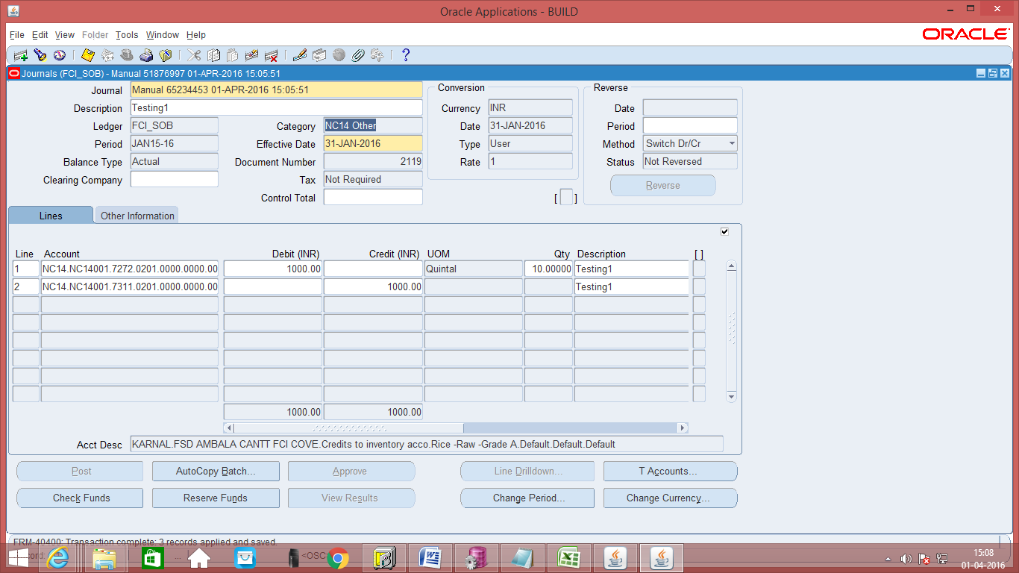
- Save the Journal and click on ‘Check Funds’, explained in the section ‘Journal – Check Funds’
Note: Check is added on Journal entry form which will prevent Approval / Reserve funds and posting of another unit’s Journals. The user will not be able to view the journals that belongs to some other unit.
Another check is added on Journal Entry form which prevent user from entering zero amount in credit and debit fields of journal lines.
Note: When the process of disabling the code combination id is in progress. . The user will not be able to make any new entry. The user will get an error-“The code combination is obsolete”.

Simple Manual Inter Company Journal Entry - IOGA
llll

Function Path: Normal General Ledger responsibility>> Journals >> Enter >> New Journal.
The following steps are common for each of the journal categories. The specific steps applicable to each of the categories, are explained in individual sections.
Steps:
- To create a new manual journal entry, click on new journal in the find journals window.
- Journal Name: Leave the Journal name blank. It will automatically take the system date and time as Journal name.
- Period: Enter the Period, effective date. Adjusting periods are available at the end of each quarter and year beginning with ‘ADJ’
- Currency: Enter currency details. The currency will be ‘INR’ for all transactions in Indian Rupees. The currency will be ‘STAT’ for all statistical transactions. This refers to those transactions for which only quantity is to be recorded and the currency is not Indian Rupee. For entering ‘Single Entry’ Journal Entry, the currency has to be ‘STAT’
- Category: Enter the category. Journal entries for each of the categories. The category name will be appended with the unit name. Enter the journal category with the unit name beginning with the unit to which the user belongs.
Simple Manual entries will be entered in the category ‘InterCo IOGA’. For all other types of entries specific categories exist.
- Enter the JV in the lines and save the transaction. In the Line Number column of the Journal Entry, the numbering to be followed is in series of 10, i.e. numbering would be 10, 20, 30 and so on.
- Also while making the lines entry, the user has to enter line for his own unit and other line (of his own unit) with respective intercompany account and intercompany segment having the unit to which IOGA is to be sent.
Note: When the process of disabling the code combination id is in progress. . The user will not be able to make any new entry. The user will get an error-“The code combination is obsolete”.

Screen shot of Journal Form:
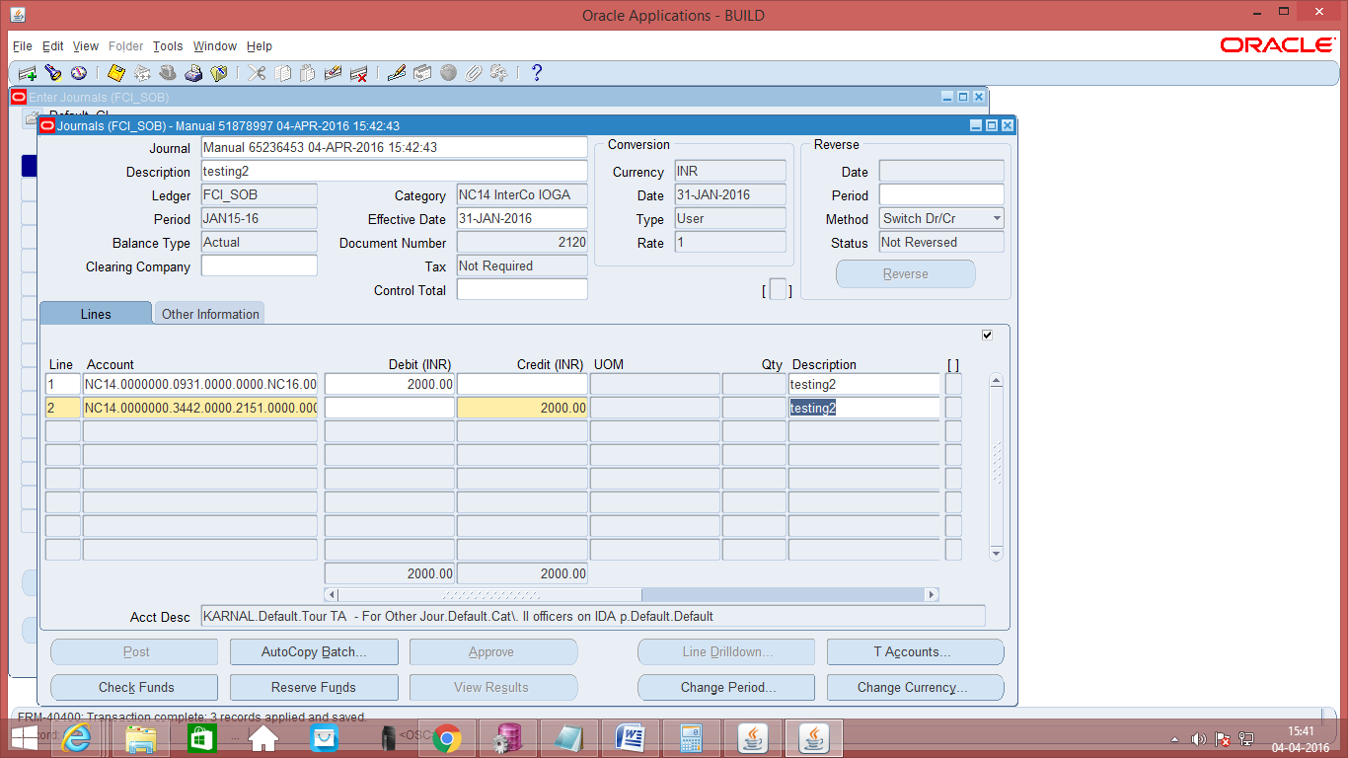
- Save the Journal and click on ‘Check Funds’, explained in the section ‘Journal – Check Funds’

Journal - Check Funds
- As Budgetary Control is enabled, click on ‘Check Funds’.
Navigation Path: Journals> Enter
- To find Journal Entries which require posting, select the entries with the state funds check ‘Required’. Click on ‘Find’.

Screen shot of Enter Journal Form:
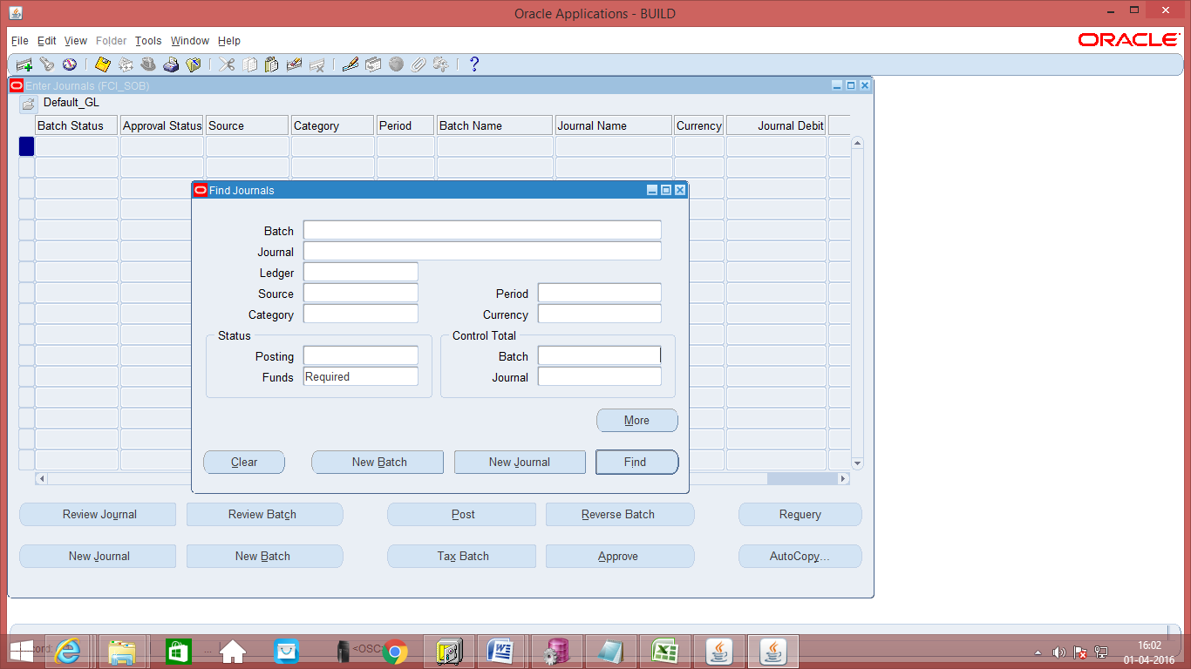
- For all the Journal Entries for which Funds Check is ‘Required’ would be displayed.
- Click on ‘Check Funds’.

Screen shot of Journal Form:
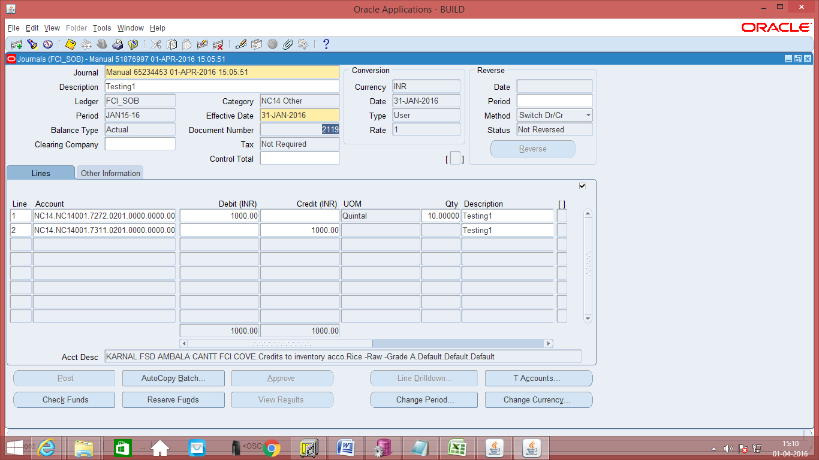
- Check Funds Status Message: On clicking ‘Check Funds’, the process checks funds with respect to the budget allocated to those accounts. If the accounts do not require funds check or if funds are available, the message would be given your transaction passes Funds check. Clicking ‘Check Funds’ also automatically saves the transaction
Pass Funds Check: On a Journal Entry passing the funds check, it allows the user to proceed further. The next step to Check Funds is ‘Reserve Funds’
Fails Funds Check: On a Journal Entry failing the funds check, it gives a message that ‘Your transaction failed funds check’ and does not allow to proceed any further.

Screen shot of Journal Form:
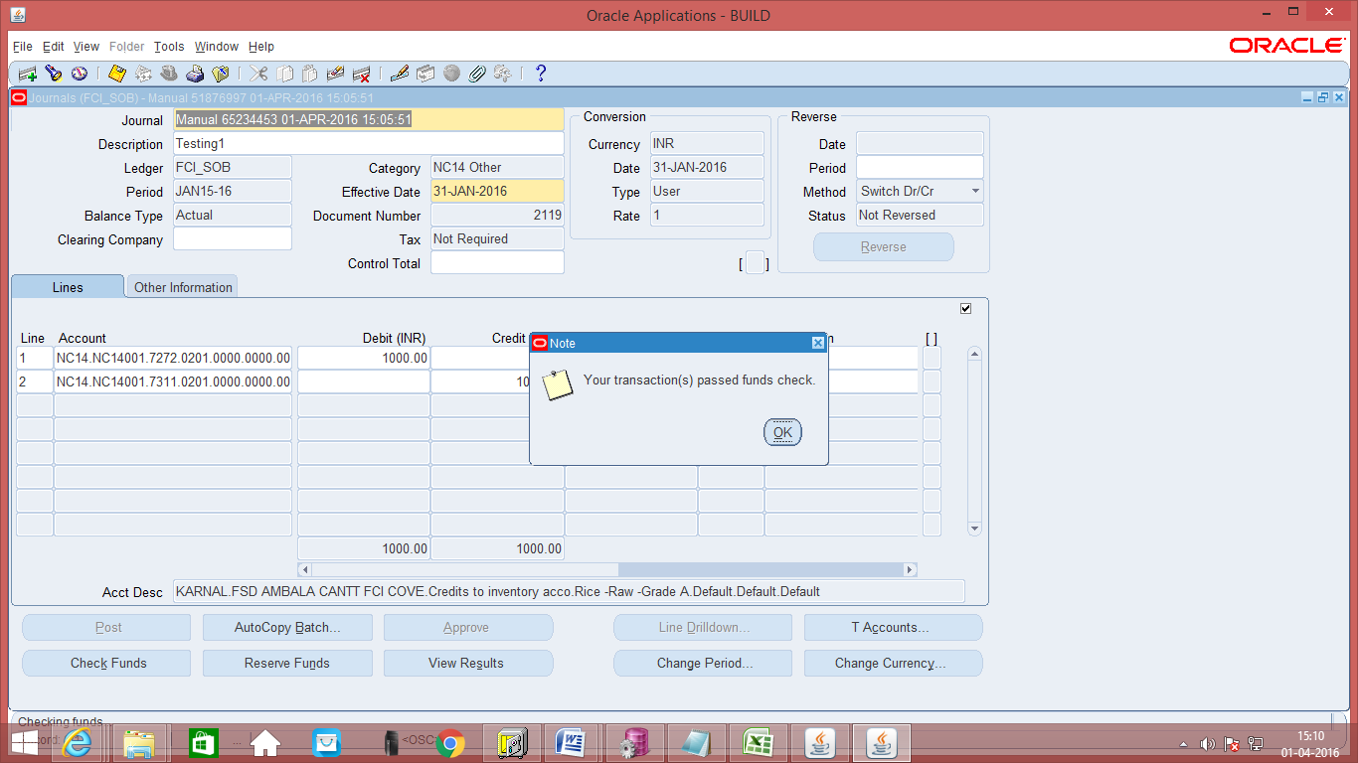

View Results Button
Check Funds Button

- View Results message: On clicking ‘OK’, the ‘View Results’ button is enable. Details of the Funds check ‘Passed’ or ‘Failed’ are displayed account wise. The status is ‘Passed’, if the accounts do not require funds check or if they pass the funds check. The status is failed if adequate funds are not available in the Budget for that account.
The following snap shot shows the funds check status as ‘Passed’ , in a case where funds check is not required.

Screen shot of Journal Form:
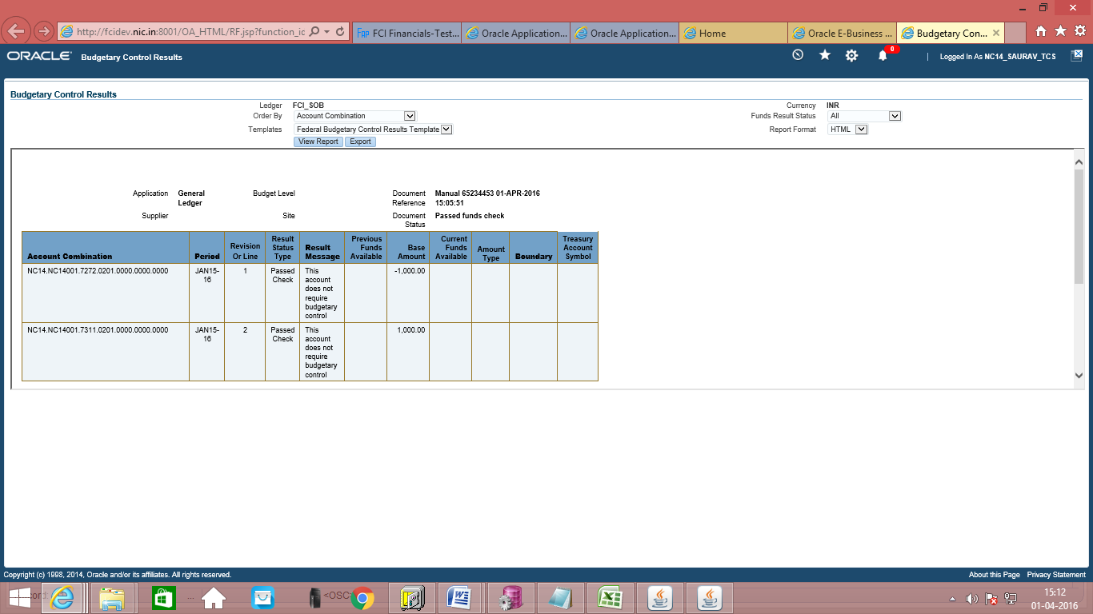
- On successful completion of Check Funds, proceed to Reserve Funds explained in the section below.

Journal – Reserve Funds

Note: There is a restriction on journal form that will not let the user, reserve funds for any other unit’s journal. The changes can only be done when first four characters of the Category of the Journal and first four characters of the responsibility being used are same, otherwise it will not let the user view the journal.

Navigation Path: Journals> Enter
- Click on ‘Reserve Funds’. This reserves funds for the transaction, wherever budgets are applicable.
- On passing ‘Reserve Funds’, it gives the message that ‘Your transaction pass funds reservation’.

Screen shot of Journal Form:
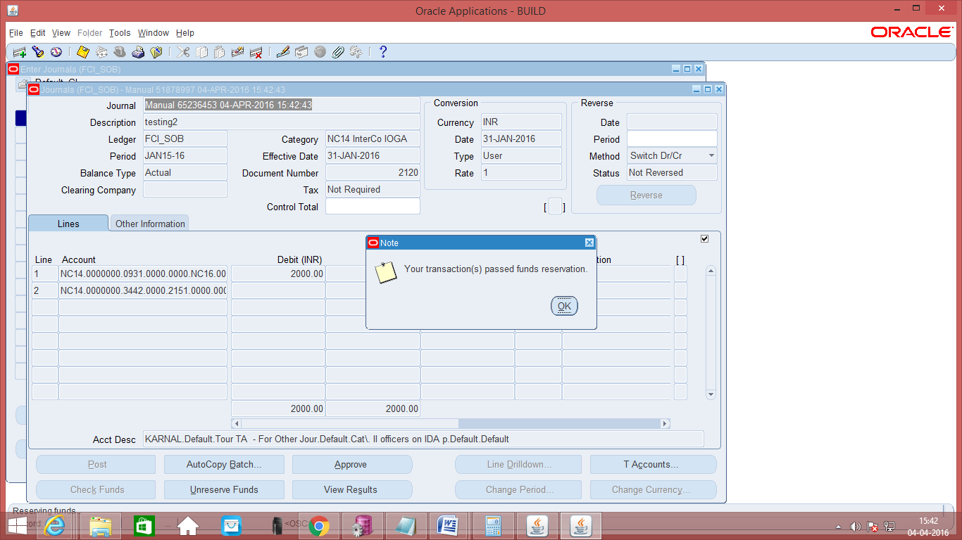
- On successful completion of ‘Reserve Funds’, the ‘Unreserve Funds’ becomes enabled and the funds reservation can be reversed.
- On successful completion of ‘Reserve Funds’, proceed to Approval explained in the section below.

Journal Approval for Other than Inter Company Entries

Note: There is a restriction on journal form that will not let the user, approve funds for any other unit’s journal. The changes can only be done when first four characters of the Category of the Journal and first four characters of the responsibility being used are same, otherwise it will not let the user view the journal.
The journal approval will be done by same unit (which has created the journal) for all kind of journals, except InterCo IOR and Fast Collection.

Responsibility: Workflow User Web Applications
Function Path: Advanced Work List
Steps:
- All the journal entries have to be approved before being posted. Approval is based on the limits of the employee.
- Open the required notification.
Screen shot of Workflow Form:
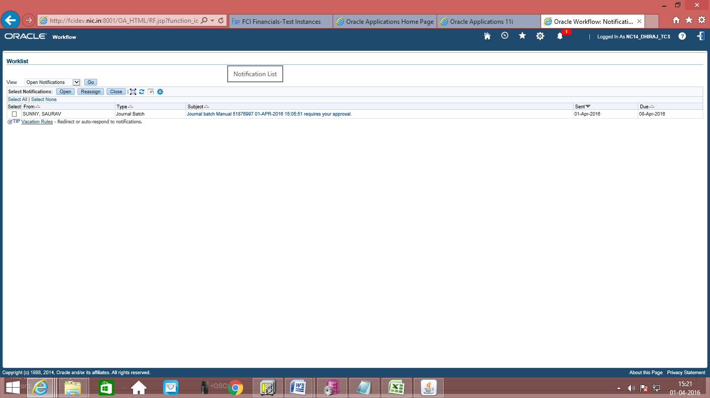

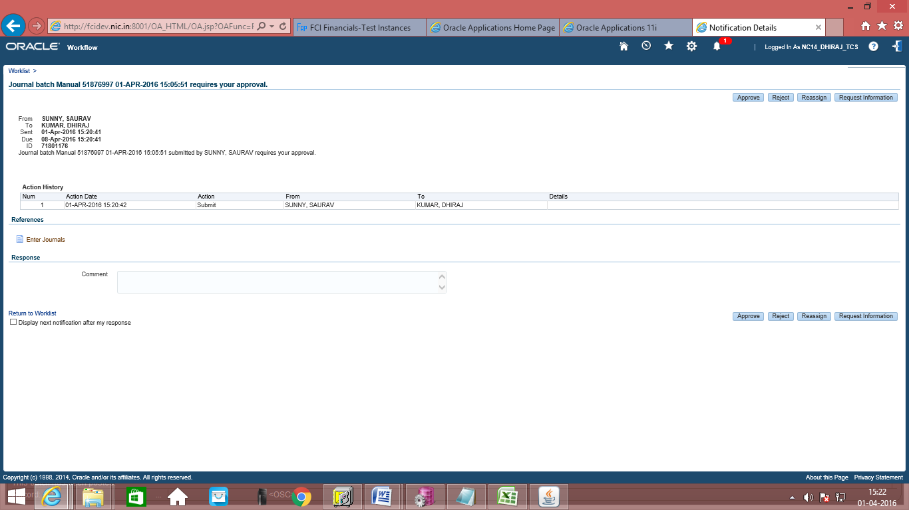
- Select the journal batch individually to approve and then click on ‘Approve’.
- On successful completion of Journal Approval, proceed to Journal Posting explained in the section on Journal Posting.

Journal Approval for InterCo Entries
Responsibility: Workflow User Web Applications
Note: The journal will be passed for approval of other units only in the case of IOR and Fast Collection and IOCPF categories. Rest all other type of journals will be approved by the same unit, which has created the journal.
Function Path: Advanced Work List
Steps:
- The Status of the Journal entries (Status is displayed in the top right hand corner) is Funds Status ‘Passed’ and Approval Status ‘Required’ as seen in the screen shot below.
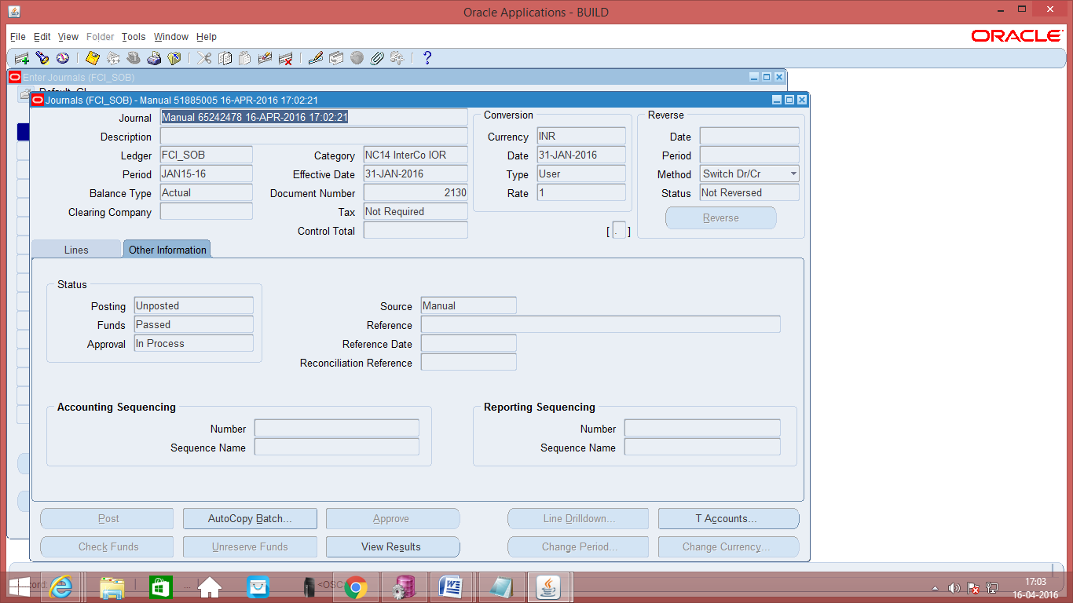
Status
- All the journal entries have to be approved before being posted. Approval is based on the limits of the employee. For seeking approval, click on the ‘Approve’ button. The Journal entry would be forwarded to an approver as seen in the snap shot below.

Screen shot of Journal Form:
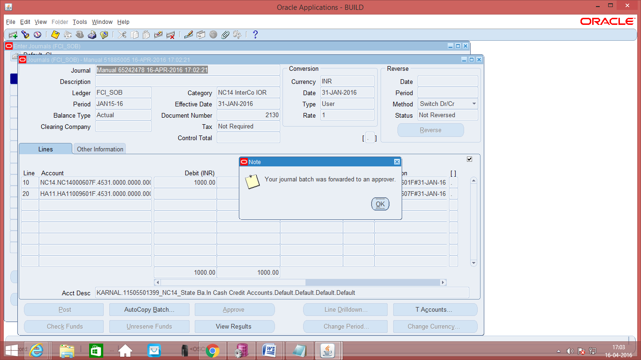
- The approver will then switch to the responsibility.
Responsibility: First approver logged in with the responsibility ‘Workflow User Web Applications’
Navigation Path: Self Service Workflow > Notifications
- The approver can sort the transactions by date, by clicking on the small triangle in the Sent Column. The dates can be sorted in ascending or descending order.
Screen shot of Workflow Form:
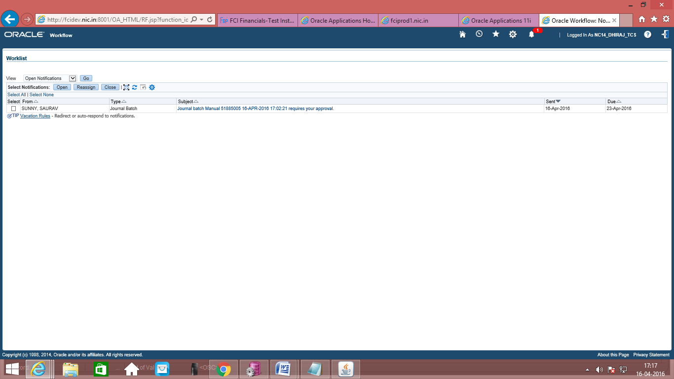
Click here to sort by date
- Open the required notification by clicking on it.
- Rejection case of first approver: If the approver is not satisfied with the journal entry, he can reject the journal entry. The approver can enter the Comments in the Comments text box.
- Need more information of first approver: If the approver needs more information before approving or rejecting the Journal entry, he can click on the ‘Request Information’ button.
- Approval by reassignment in case of first approver: For Inter Company (FCI InterCo) entries, these have to be reassigned. The logic for inter company entries is that these have to be known for both the units involved. As these would be passed by one of the units (say Unit A), involving unit A and unit B. These would be in the approval workflow process of the manager of the unit (Unit A). The manager of unit A would review the entry without clicking on the Approve button, instead the manager of unit A if satisfied with the entry would click on the Reassign Button. If the manager of unit A is not satisfied with the Journal entry, he would click on Reject Button and transfer the work flow.

Screen shot of Workflow Form:
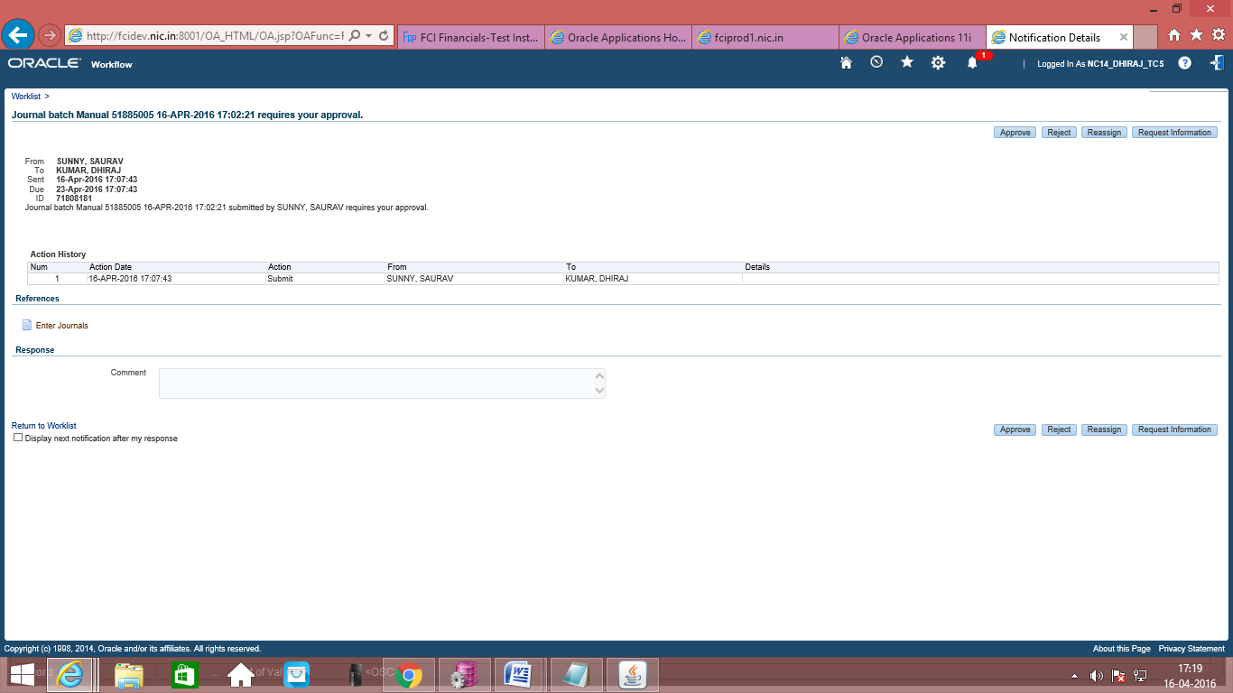
Reassign Button to be used for approval of Intercompany entries

Note: User has to select “Transfer notification Ownership” for the approval process of InterCo journals i.e. User has to transfer the journals in this case. Delegating the journals will not serve the process.
- Second Approver: In case, the workflow is assigned to role of unit B, then the person attached to that particular role will in turn reassign the workflow to the concerned person of unit B. He has to choose the approver from the list, depending on to whom it has to be assigned. The second approver of unit B can approve or reject the journal.
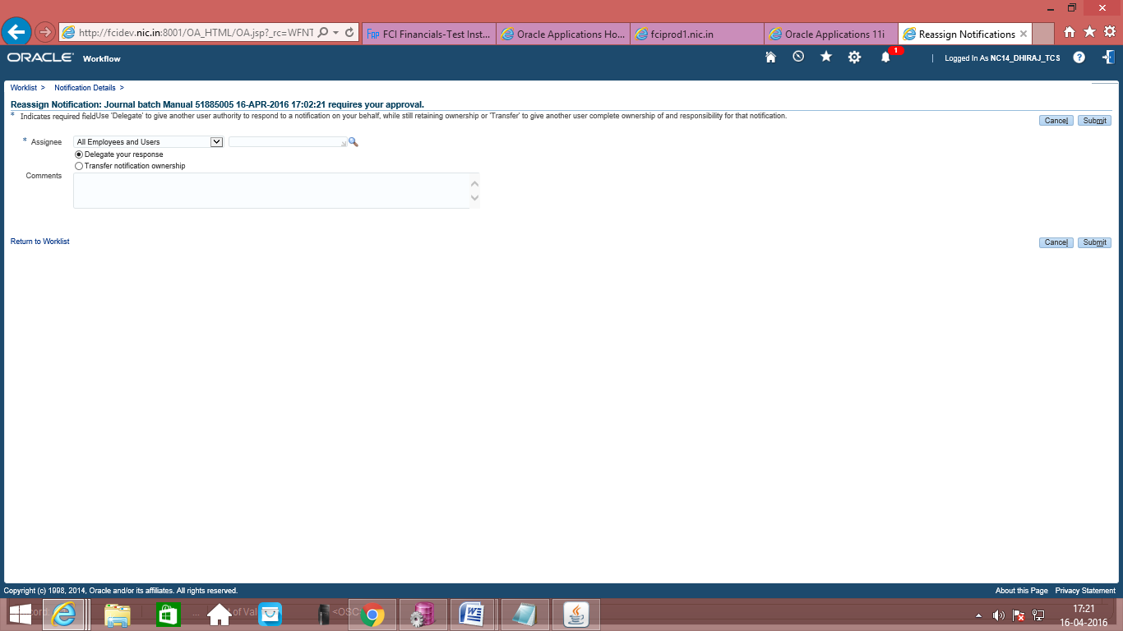

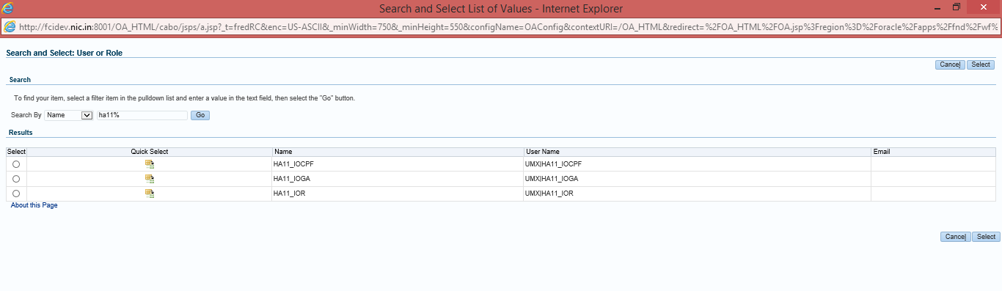
- The second approver would then need to log in to the system with the Workflow User Web Applications responsibility. .
Responsibility: Second approver logged in with the responsibility ‘Workflow User Web Applications’
Navigation Path: Self Service Workflow > Notifications
- The second approver will also be able to see the user who has originated the journal entry and the user (first approver) who has reassigned the journal entry. The second approver has the option to ‘Reject’, ‘Approve’ or ‘Request More Information’. The following snapshot appears to the second approver.
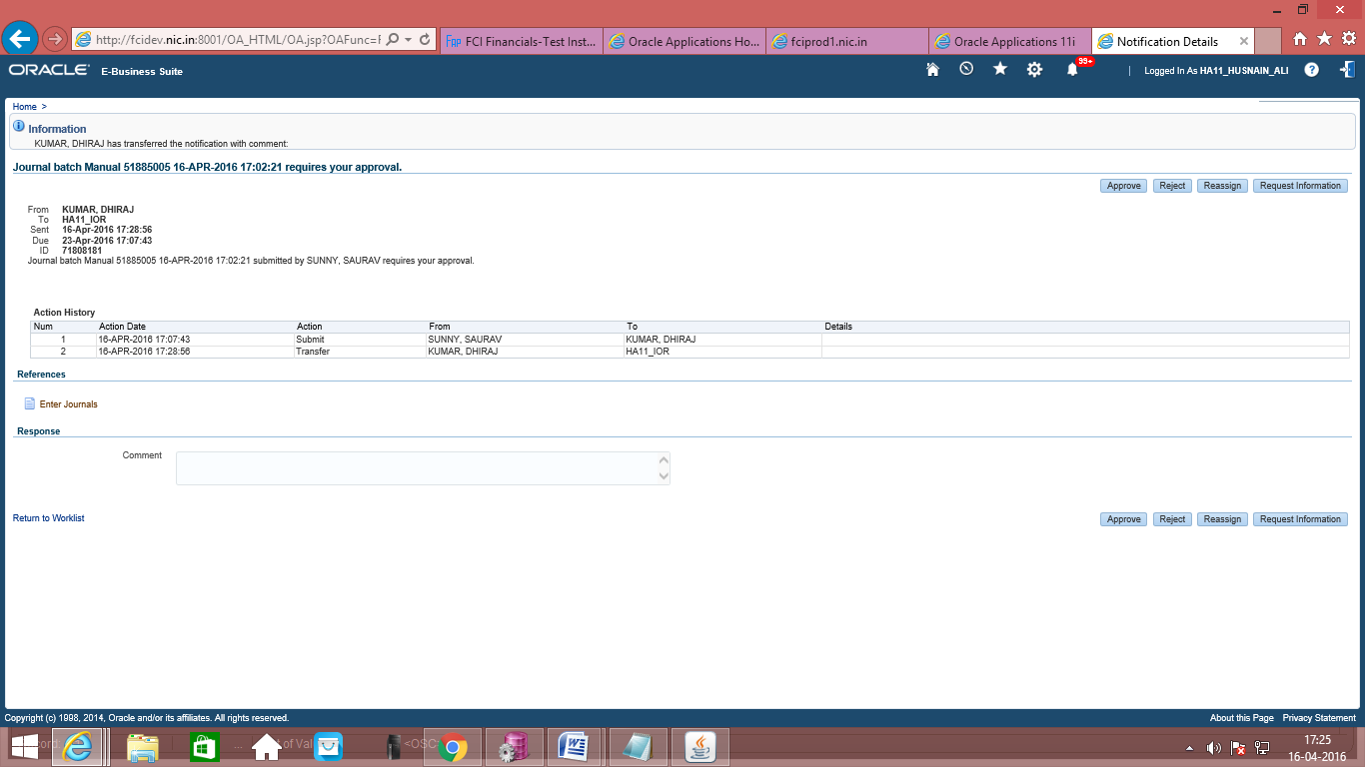
- On successful completion of Journal Approval, proceed to Journal Posting explained in the section on Journal Posting.

To search for a role from workflow: If a workflow notification has to be re-assigned to a role rather than to a user, and then select ‘User Management’ in ‘Assignee’ and search for the role. You can then assign the notification to this role.

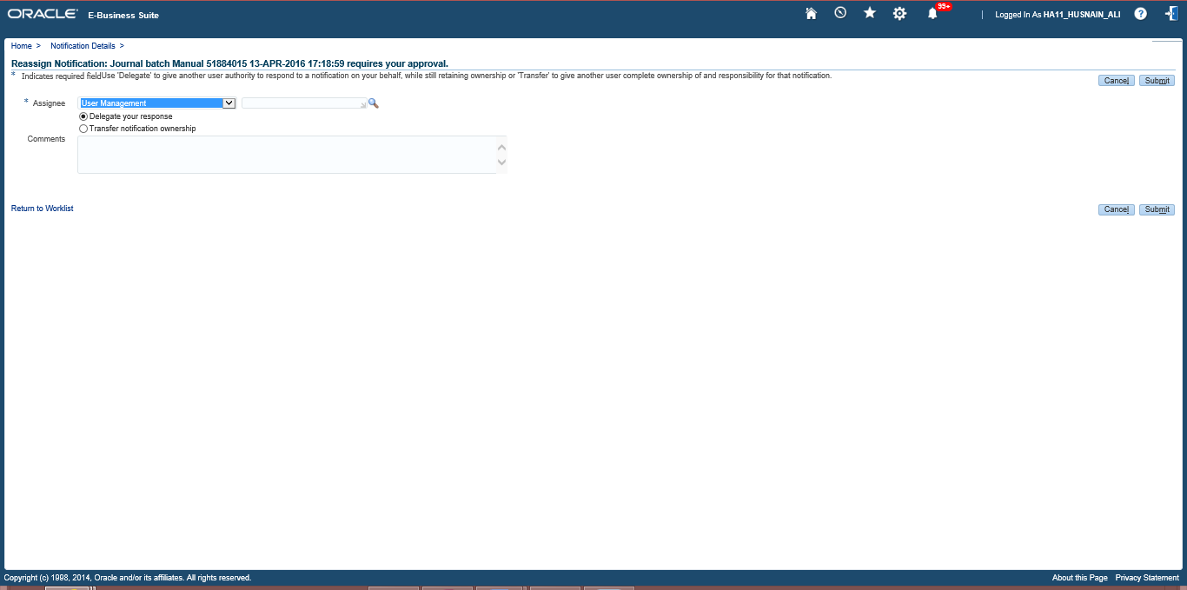

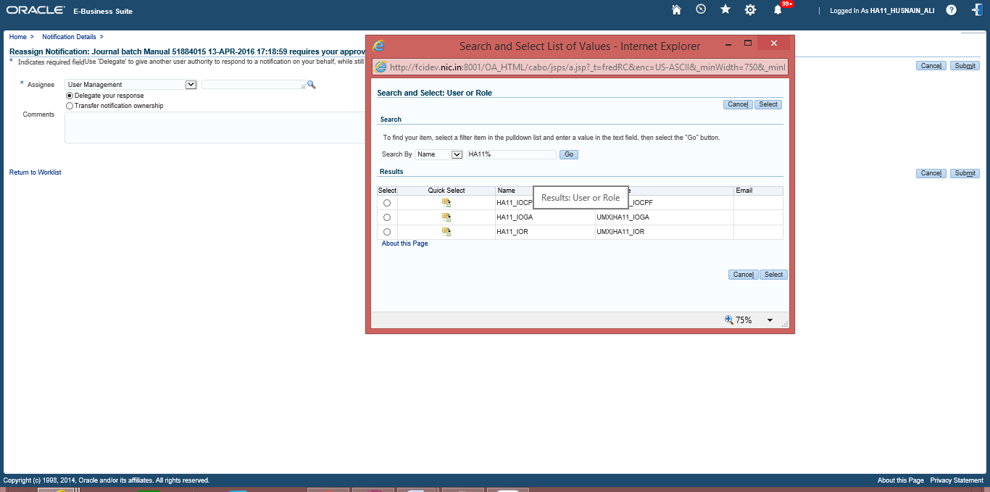

Journal Deletion

Note: There is a restriction on journal form that will not let the user, make changes for any other unit’s journal. The changes can only be done when first four characters of the Category of the Journal and first four characters of the responsibility being used are same, otherwise it will not let the user view the journal.

Function Path: Journals >> Enter
A journal can be deleted any time until it is approved. However, once approved a Journal cannot be deleted. A Journal can be deleted by clicking the ‘X’ button on the toolbar or by the Edit -> Delete Option.

Screen shot of Journal Form:
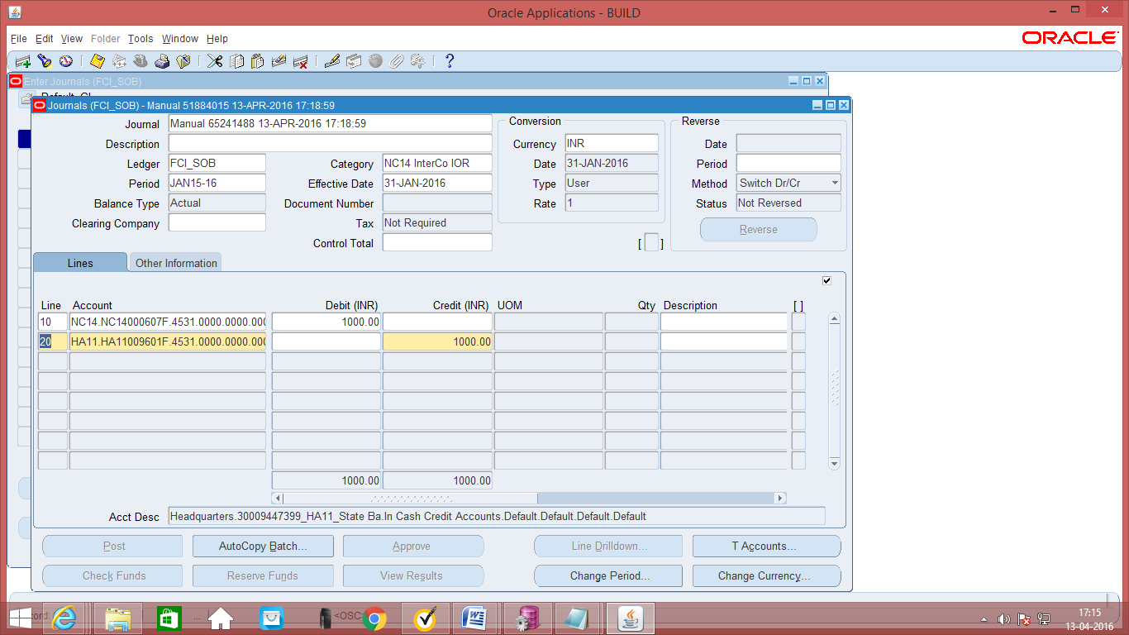
Click here to delete the JVs

Journal Posting

Note: There is a restriction on journal form that will not let the user, post journals for any other unit’s journal. The changes can only be done when first four characters of the Category of the Journal and first four characters of the responsibility being used are same, otherwise it will not let the user view the journal.
Function Path: Journals >> Post
Note: Posting would be done automatically by the system, within a specified period for example every day at day end. The following steps would be done only if immediate posting is required.
Steps:
- Journal Entries which are approved can be posted.
- Enter the Period and the batch name to find the journal batch(es) which you want to post.
- Select the journal batch individually to post and then click on post.
- Alternatively, Posting can also be done by clicking on the ‘Post’ button in the Journals >> Enter Screen.
Screen shot of Journal Form:
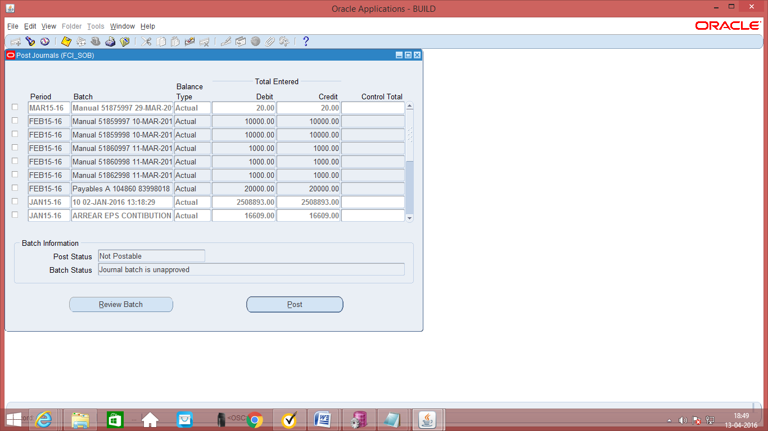

- Click on ‘Approve’. The journal will be forwarded to the approver for approval. Post-approval the transaction will be available for posting.
- Click on Post to post the transaction. This can also be done by JVs from Journals >> Post window.

Manual Journal Entry – Auto copy

Users can copy the existing Journal Batches by simply clicking on the Auto Copy Batch button provided in the Journal Entry form.
Function Path: Journals >> Enter
Steps:
1. Query the existing the batch.
2. Click on the AutoCopy Button and enter the batch name and period.
3. Click on OK button. An Autocopy journal request will be submitted.
4. Query the resultant batch and perform Check fund, Reserve Fund, Approval and Posting.
5. The source of the resultant batch will be ‘AutoCopy’

Screen shot of Journal Form:

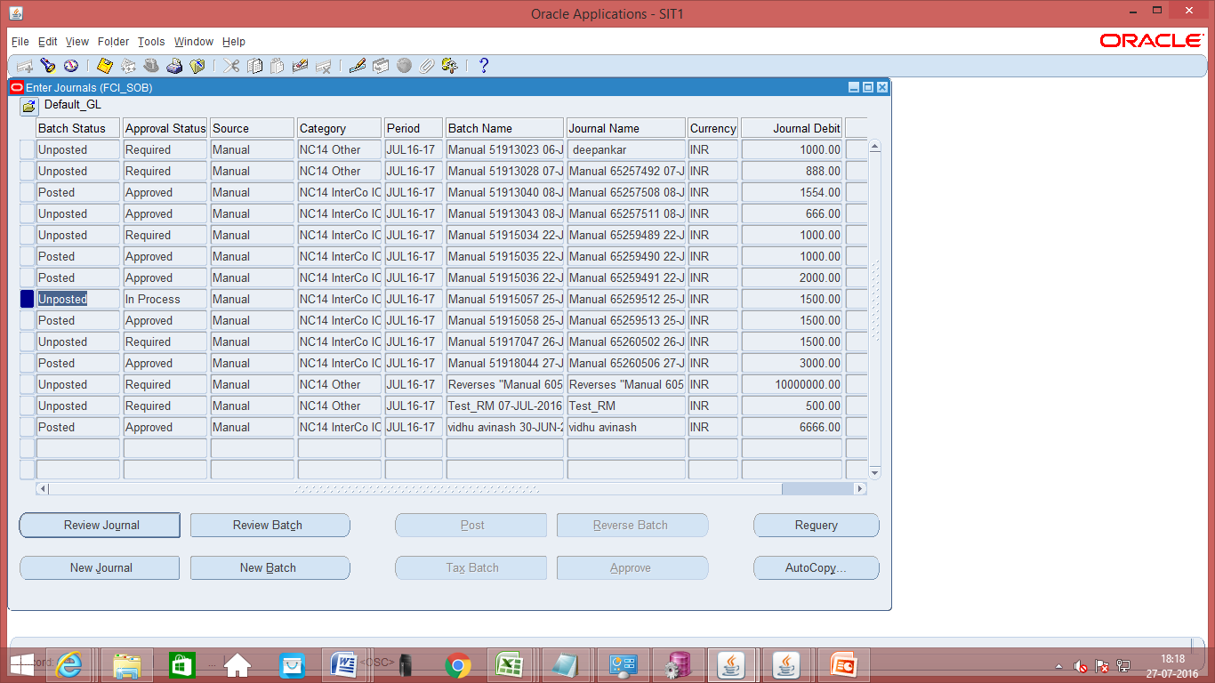

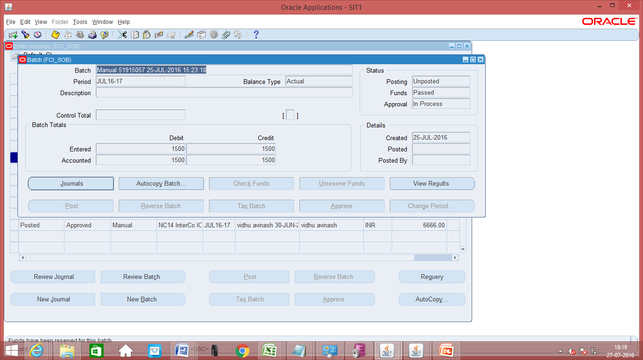

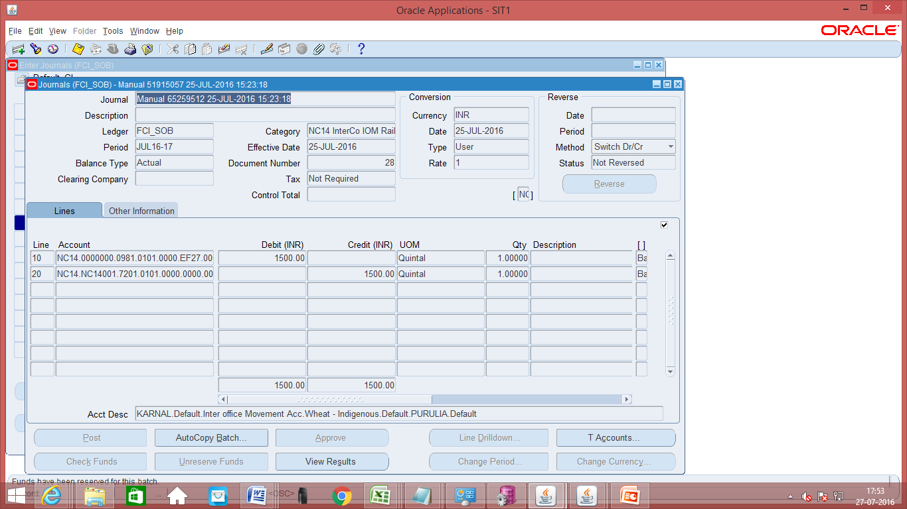

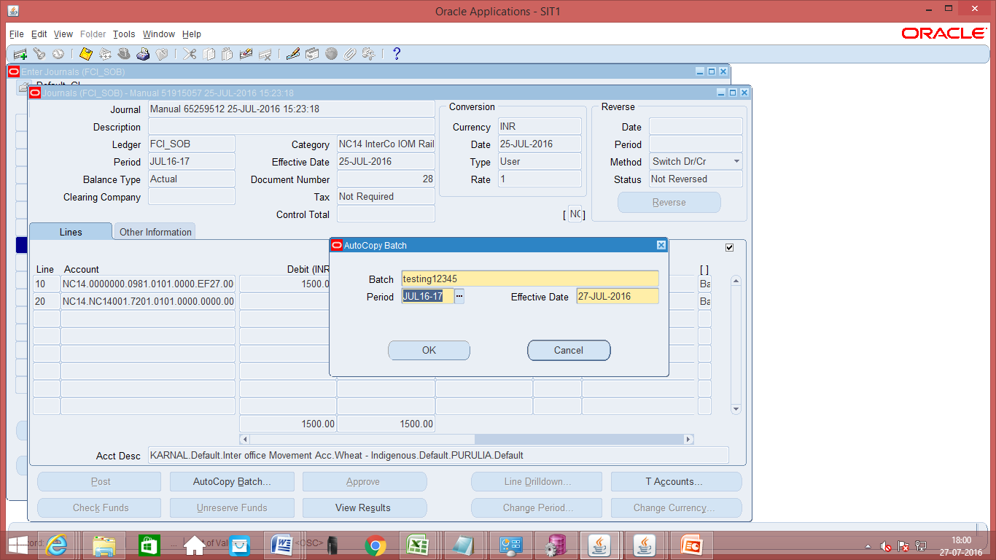

Manual Journal Entry – FCI Paddy Milling
This category will be in use for entries with GL Date less than or equal to 31-AUG-2017 only. For entering GST related information for such entries refer section -37(GOODS AND SERVICES INCLUSION IN GENERAL LEDGER (AS PER PLAN B)).

For entries after 31-AUG-2017, user can use two new categories ‘Paddy Milling OUT’ for Paddy related entries and ‘Paddy Milling IN’ for Rice related entries. Please refer the sections below for more details.
Function Path: Normal General Ledger responsibility>> Journals >> Enter >> New Journal.
The Journal entry for paddy milling is required to capture the transactions of stocks conversions due to paddy milling i.e. conversion of paddy into rice. The quantitative transactions are to be captured through the journal entry as explained below and the paddy milling bills would be passed through Accounts Payable for payment action only.
Steps:
Note: Due to the security rule applied on journals, in JE distribution lines, user will not be able to use account pertaining to other unit (Except with the InterCo General Ledger Responsibility).

- To create a new manual journal entry, click on new journal in the find journals window.
- Journal Name: Leave the Journal name blank. It will automatically take the system date and time as Journal name.
- Period: Enter the Period, effective date. Adjusting periods are available at the end of each quarter and year beginning with ‘ADJ’
- Currency: Enter currency details. The currency will be ‘INR’ for the category ‘FCI Paddy Milling’.
- Category: Enter the category as ‘Unit name (e.g. SB16, NC 14) Paddy Milling ‘.
- Header Level DFF (Descriptive Flex field): For the category Paddy Milling, Supplier details have to be captured. DFF is nothing but place to record additional information about the category of the Journal entry being passed. Click on the angular bracket of the DFF indicated as follows:
Screen shot of Journal Form:

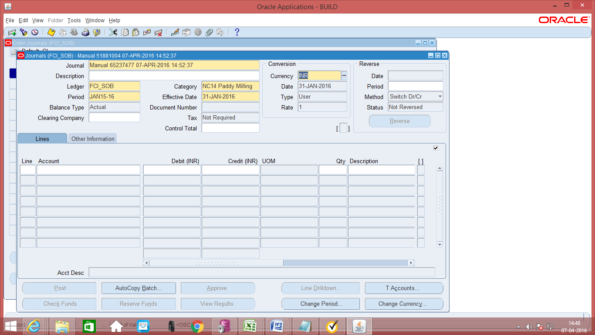
Click here to open the Header Level DFF
Screen shot of Journal Form:

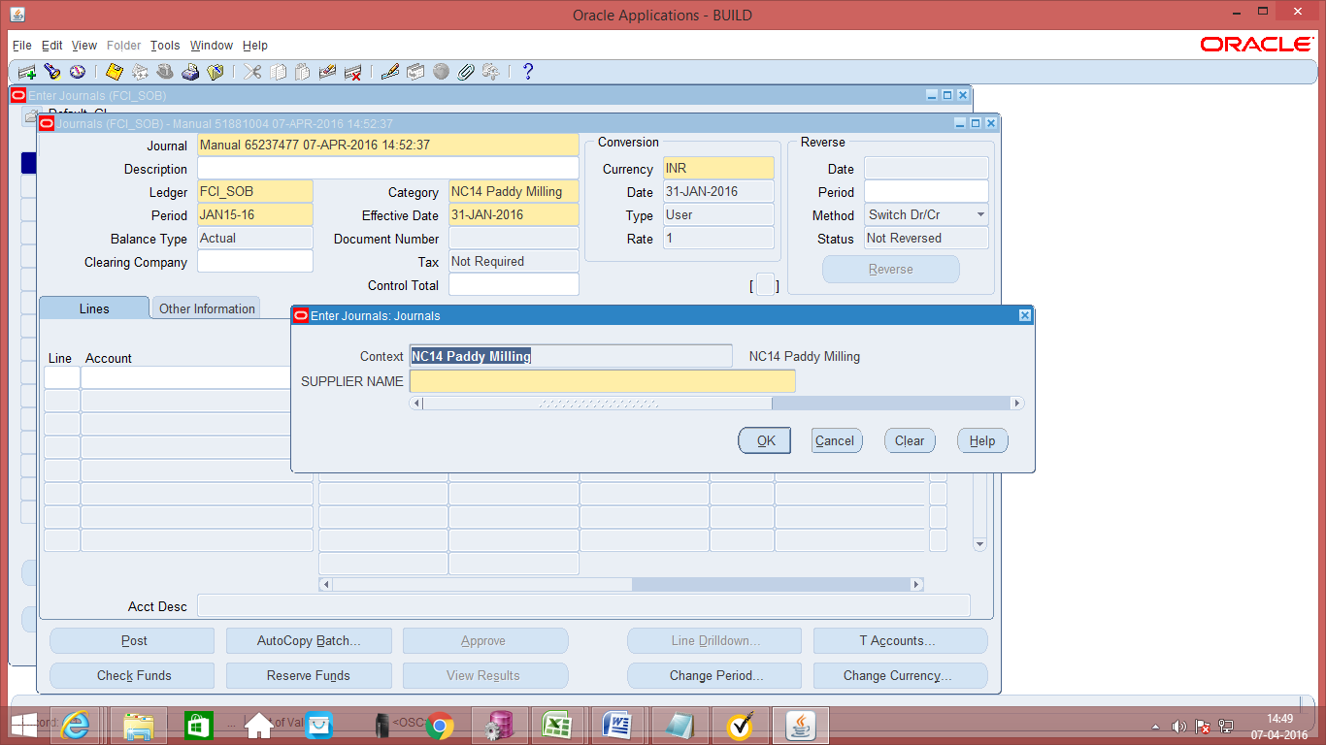

- Data entry in the Header Level DFF (Descriptive Flex field): On clicking the DFF symbol, fields to capture the Supplier Name will appear. This field is mandatory. This field is picked up from the Accounts Payable module and only the suppliers defined in the Accounts Payable Module will be picked up here.
- Enter the JV in the lines and save the transaction. In the Line Number column of the Journal Entry, the numbering to be followed is in series of 10, i.e. numbering would be 10, 20, 30 and so on. The Journal Entry for Paddy Milling would be:
Transfer In – Stocks Received (Rice) Dr.
Transfer Out – Stocks Issued (paddy) Cr.
As Budgetary Control is enabled, click on ‘Check Funds’ and ‘Reserve Funds’. If Budgetary Control is enabled on those accounts, these actions will check and reserve funds on the same. If no funds are available for that particular account combination, it will not allow the transaction to proceed.
- Click on ‘Approve’. The journal will be forwarded to the approver for approval. Post-approval the transaction will be available for posting.
- Click on Post to post the transaction. This can also be done by JVs from Journals >> Post window
- Payment of Milling Charges will be done from the Accounts Payable module.
The steps of ‘Check Funds’, ‘Reserve Funds’, ‘Approve’, ‘Post’ are also explained in detail in separate sections of this document.

Note: There is a restriction on journal form that will not let the user, approve/post/reserve funds for any other unit’s journal. The changes can only be done when first four characters of the Category of the Journal and first four characters of the responsibility being used are same, otherwise it will not let the user view the journal.
Note: When the process of disabling the code combination id is in progress. . The user will not be able to make any new entry. The user will get an error-“The code combination is obsolete”.

Manual Journal Entry – FCI Paddy Milling OUT
This category will be in use form GL Date 1-SEP-2017 onwards only.
Function Path: Normal General Ledger responsibility>> Journals >> Enter >> New Journal.
The Journal entry for paddy milling is required to capture the transactions of stocks conversions due to paddy milling i.e. conversion of paddy into rice. The quantitative transactions are to be captured through the journal entry as explained below and the paddy milling bills would be passed through Accounts Payable for payment action only.
Steps:
Note: Due to the security rule applied on journals, in JE distribution lines, user will not be able to use account pertaining to other unit (Except with the InterCo General Ledger Responsibility).

- To create a new manual journal entry, click on new journal in the find journals window.
- Journal Name: Leave the Journal name blank. It will automatically take the system date and time as Journal name.
- Period: Enter the Period, effective date. Adjusting periods are available at the end of each quarter and year beginning with ‘ADJ’
- Currency: Enter currency details. The currency will be ‘INR’ for the category ‘FCI Paddy Milling OUT’.
- Category: Enter the category as ‘Unit name (e.g. SB16, NC 14) Paddy Milling OUT‘.
- Header Level DFF (Descriptive Flex field): For the category Paddy Milling OUT, Supplier details have to be captured. DFF is nothing but place to record additional information about the category of the Journal entry being passed. Click on the angular bracket of the DFF indicated as follows:
Screen shot of Journal Form:
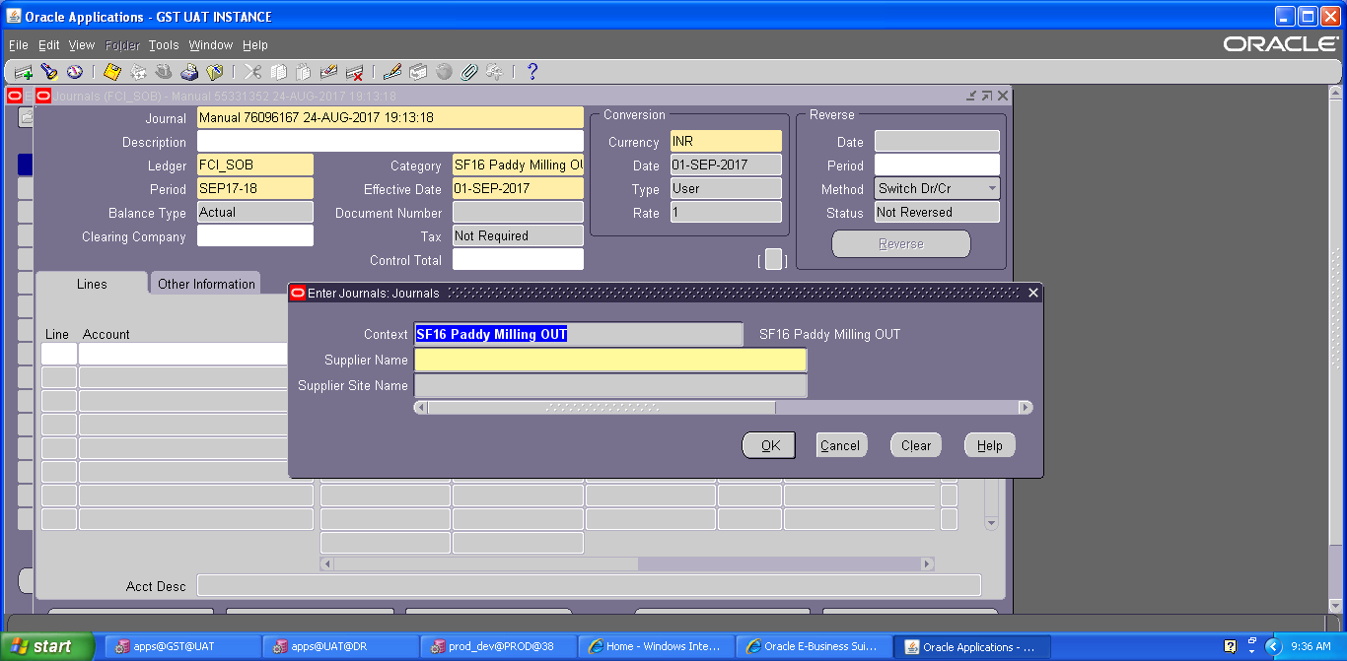

- Data entry in the Header Level DFF (Descriptive Flex field): On clicking the DFF symbol, fields to capture the Supplier Name and Supplier Site will appear. Both the fields are mandatory. This field is picked up from the Accounts Payable module and only the suppliers defined in the Accounts Payable Module will be picked up here.
For supplier site, only those sites will appear in the list, for which supplier GST registration exists in the system.
- For this category, user will also enter the GST tax related information in line level DFF. Following fields are mandatory at line level DFF (effective from 1-SEP-2017), leaving these fields blank will give an error as shown in the screen shots below: -
From GSTN: Enter the unit from which stock is transferred.
HSN code: Enter the HSN code of the product transferred (4-8 Digit Numeric value only).
Place of supply: Enter the place where stock is supplied.
Tax Rate: Enter the tax rate for tax applicable.
Invoice/ challan No.: Invoice /challan received from other party against the entry.
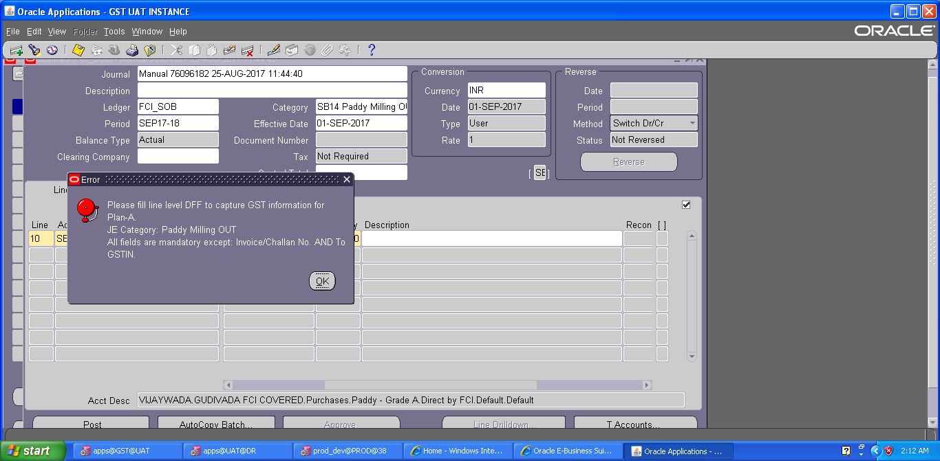
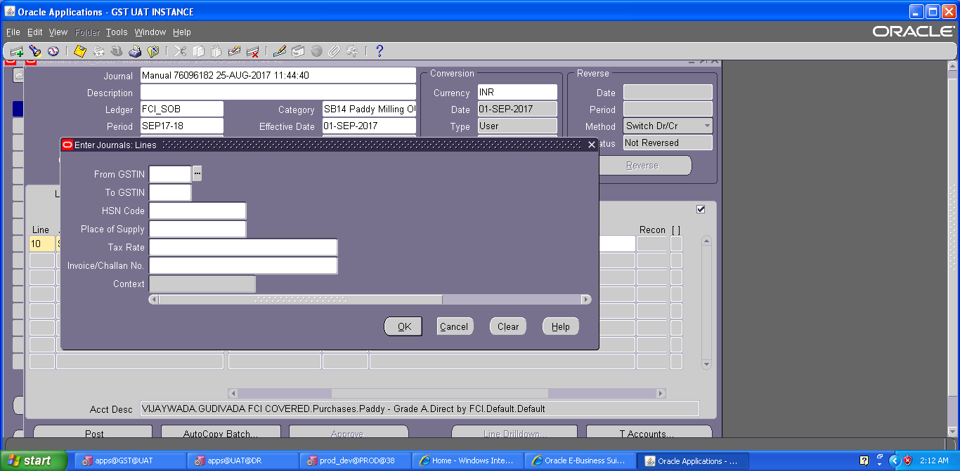
- Enter the JV in the lines and save the transaction. In the Line Number column of the Journal Entry, the numbering to be followed is in series of 10, i.e. numbering would be 10, 20, 30 and so on. The Journal Entry for Paddy Milling OUT would be:
Intercompany– Intercompany Account (Paddy) Dr.
Transfer Out – Stocks Issued (paddy) Cr.
A check is implemented in the system, which will allow user to take only Paddy products with this category (0301, 0302, 1301, 1302).
As Budgetary Control is enabled, click on ‘Check Funds’ and ‘Reserve Funds’. If Budgetary Control is enabled on those accounts, these actions will check and reserve funds on the same. If no funds are available for that particular account combination, it will not allow the transaction to proceed.
- Click on ‘Approve’. The journal will be forwarded to the approver for approval. Post-approval the transaction will be available for posting.
- Once the journal approval is initiated, user is required to generate GST sequence for this journal category, the same can be done by following path:
Click on Tools→FCI GST SEQ
A new form will appear, on this form select the document type (Delivery Challan/Bill of supply/tax invoice) and click ‘Generate Sequence’.
System will generate the GST sequence for journal category by below logic:
Unit will be the prefix followed by sequence for GL Category – Paddy- OUT, which is ‘02’, followed by ‘100000’ for Delivery Challan
For example if a user from NC12 is entering the transaction for Paddy- OUT, and selected delivery Challan, then sequence will be NC1202100000.
- Click on Post to post the transaction. This can also be done by JVs from Journals >> Post window
- Payment of Milling Charges will be done from the Accounts Payable module.
The steps of ‘Check Funds’, ‘Reserve Funds’, ‘Approve’, ‘Post’ are also explained in detail in separate sections of this document.

Note: There is a restriction on journal form that will not let the user, approve/post/reserve funds for any other unit’s journal. The changes can only be done when first four characters of the Category of the Journal and first four characters of the responsibility being used are same, otherwise it will not let the user view the journal.
Note: When the process of disabling the code combination id is in progress. . The user will not be able to make any new entry. The user will get an error-“The code combination is obsolete”.

Manual Journal Entry – FCI Paddy Milling IN
This category will be in use form GL Date 1-SEP-2017 onwards only.
Function Path: Normal General Ledger responsibility>> Journals >> Enter >> New Journal.
The Journal entry for paddy milling is required to capture the transactions of stocks conversions due to paddy milling i.e. conversion of paddy into rice. The quantitative transactions are to be captured through the journal entry as explained below and the paddy milling bills would be passed through Accounts Payable for payment action only.
Steps:
Note: Due to the security rule applied on journals, in JE distribution lines, user will not be able to use account pertaining to other unit (Except with the InterCo General Ledger Responsibility).

- To create a new manual journal entry, click on new journal in the find journals window.
- Journal Name: Leave the Journal name blank. It will automatically take the system date and time as Journal name.
- Period: Enter the Period, effective date. Adjusting periods are available at the end of each quarter and year beginning with ‘ADJ’
- Currency: Enter currency details. The currency will be ‘INR’ for the category ‘FCI Paddy Milling IN’.
- Category: Enter the category as ‘Unit name (e.g. SB16, NC 14) Paddy Milling IN ‘.
- Header Level DFF (Descriptive Flex field): For the category Paddy Milling IN, Supplier details have to be captured. DFF is nothing but place to record additional information about the category of the Journal entry being passed. Click on the angular bracket of the DFF indicated as follows:
Screen shot of Journal Form:
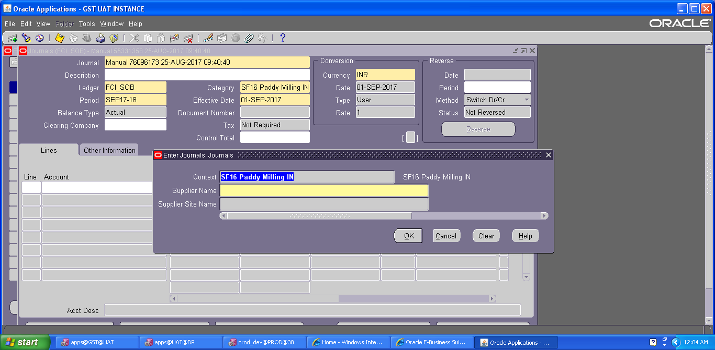

- Data entry in the Header Level DFF (Descriptive Flex field): On clicking the DFF symbol, fields to capture the Supplier Name and Supplier Site will appear. Both the fields are mandatory. This field is picked up from the Accounts Payable module and only the suppliers defined in the Accounts Payable Module will be picked up here.
For supplier site, only those sites will appear in the list, for which supplier GST registration exists in the system.
- For this category, user will also enter the GST tax related information in line level DFF. Following fields are mandatory at line level DFF (effective from 1-SEP-2017), leaving these fields blank will give an error as shown in the screen shots below: -
To GSTN: Enter the unit to which stock is transferred.
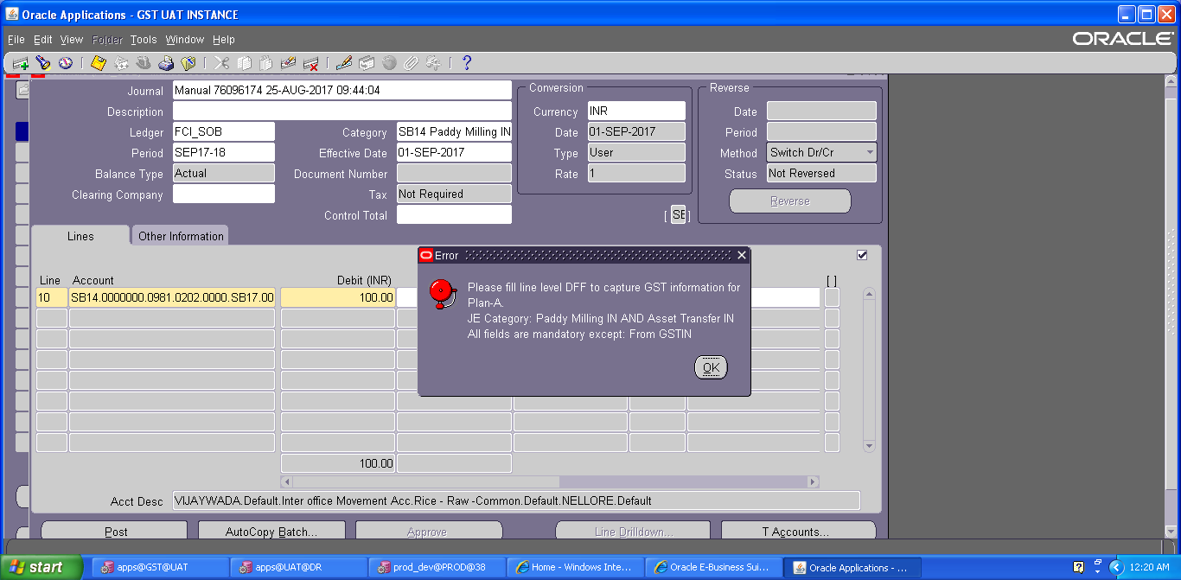
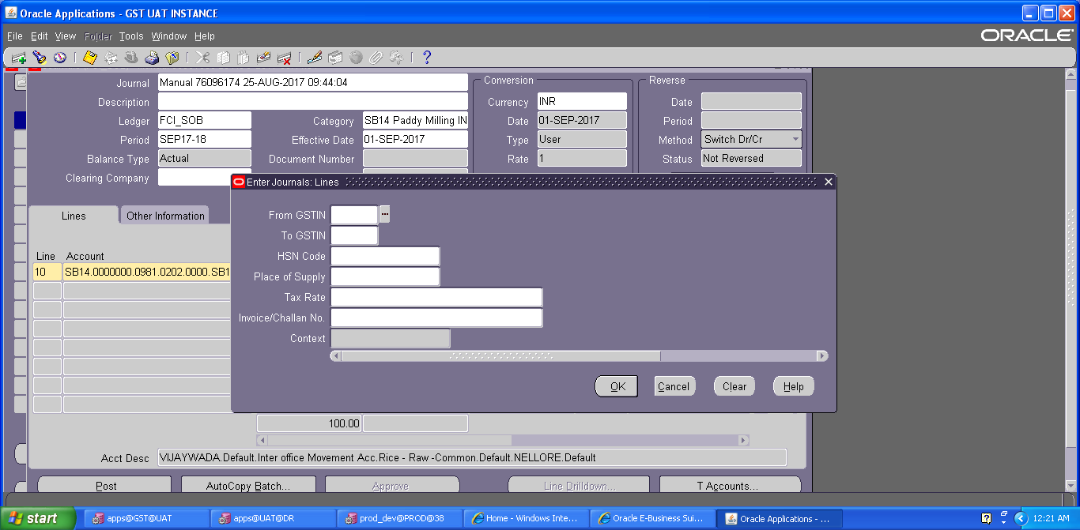
HSN code: Enter the HSN code of the product transferred (4-8 Digit Numeric value only).
Place of supply: Enter the place where stock is supplied.
Tax Rate: Enter the tax rate for tax applicable.
Invoice/ challan No.: Invoice /challan received from other party against the entry.

- Enter the JV in the lines and save the transaction. In the Line Number column of the Journal Entry, the numbering to be followed is in series of 10, i.e. numbering would be 10, 20, 30 and so on. The Journal Entry for Paddy Milling IN would be:
Intercompany– Intercompany Account (Rice) Cr.
Transfer IN – Stocks Received (Rice) Dr.
A check is implemented in the system, which will allow user to take only Rice products with this category (0201, 0202, 0203, 0204, 0205, 1201, 1202, 1203, 1204, 1205).
As Budgetary Control is enabled, click on ‘Check Funds’ and ‘Reserve Funds’. If Budgetary Control is enabled on those accounts, these actions will check and reserve funds on the same. If no funds are available for that particular account combination, it will not allow the transaction to proceed.
- Click on ‘Approve’. The journal will be forwarded to the approver for approval. Post-approval the transaction will be available for posting.
- Click on Post to post the transaction. This can also be done by JVs from Journals >> Post window
- Payment of Milling Charges will be done from the Accounts Payable module.
The steps of ‘Check Funds’, ‘Reserve Funds’, ‘Approve’, ‘Post’ are also explained in detail in separate sections of this document.

Note: There is a restriction on journal form that will not let the user, approve/post/reserve funds for any other unit’s journal. The changes can only be done when first four characters of the Category of the Journal and first four characters of the responsibility being used are same, otherwise it will not let the user view the journal.
Note: When the process of disabling the code combination id is in progress. . The user will not be able to make any new entry. The user will get an error-“The code combination is obsolete”.

Manual Journal Entry – FCI ASSET TRANSFER IN
This category will be in use form GL Date 1-SEP-2017 onwards only. It is a new category which is introduced in GST.
- To create a new manual journal entry, click on new journal in the find journals window.
- Journal Name: Leave the Journal name blank. It will automatically take the system date and time as Journal name.
- Period: Enter the Period, effective date. Adjusting periods are available at the end of each quarter and year beginning with ‘ADJ’
- Currency: Enter currency details. The currency will be ‘INR’.
- Category: Enter the category as ‘Unit name (eg SB16, WD12) Asset Transfer IN’
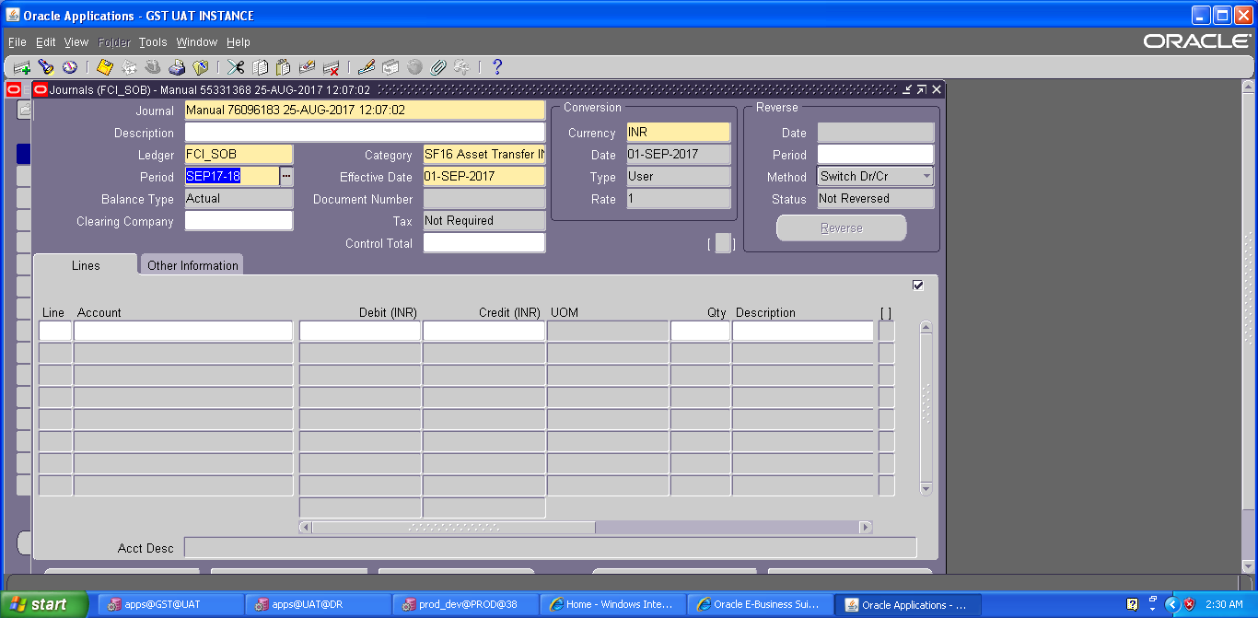
- For this category, user will also enter the GST tax related information in line level DFF. Following fields are mandatory at line level DFF (effective from 1-SEP-2017), leaving these fields blank will give an error as shown in the screen shots below: -
From GSTN: Enter the unit from which stock is transferred.
To GSTN: Enter the unit to which stock is transferred.
HSN code: Enter the HSN code of the product transferred (4-8 Digit Numeric value only).
Place of supply: Enter the place where stock is supplied.
Tax Rate: Enter the tax rate for tax applicable.
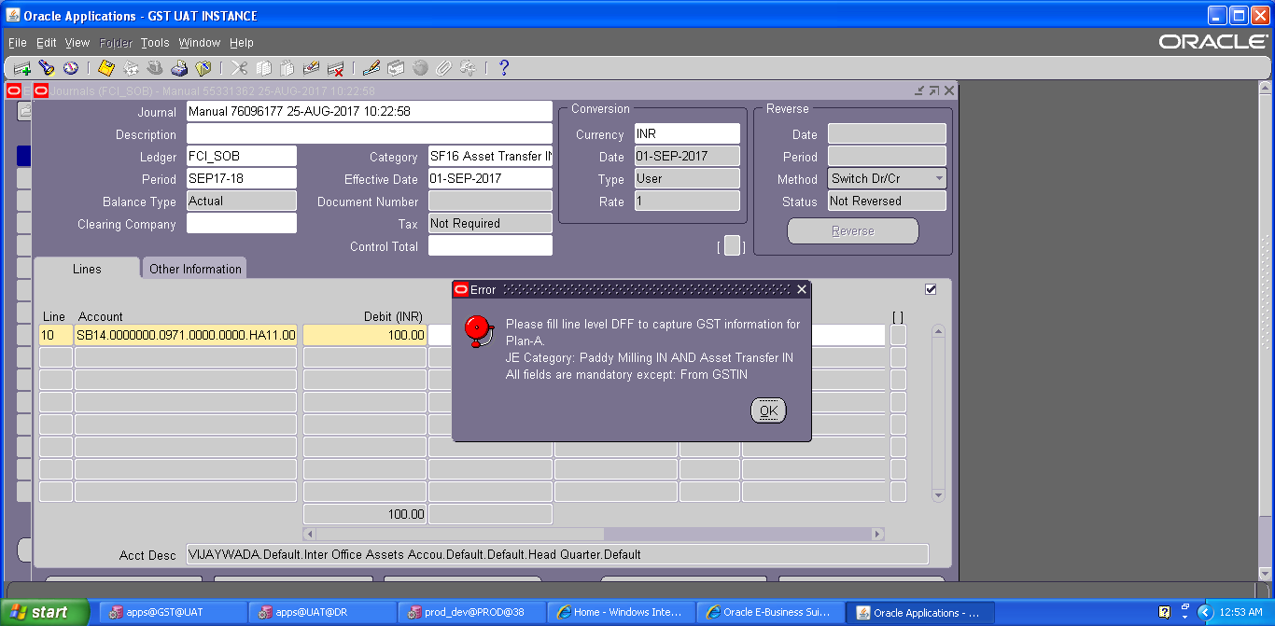
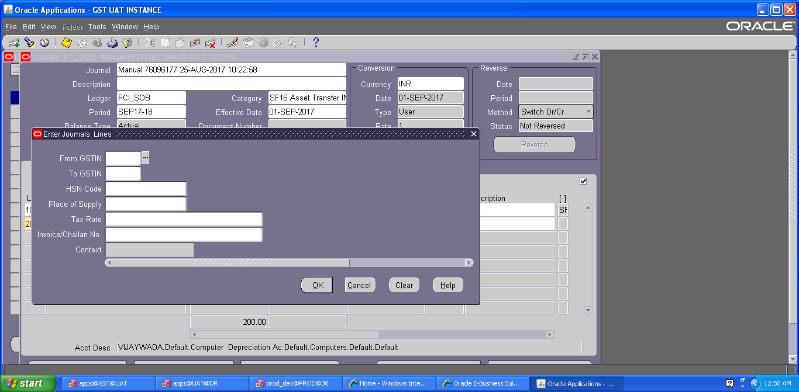
- Enter the JV in the lines and save the transaction.
As Budgetary Control is enabled, click on ‘Check Funds’ and ‘Reserve Funds’. If Budgetary Control is enabled on those accounts, these actions will check and reserve funds on the same. If no funds are available for that particular account combination, it will not allow the transaction to proceed.
- Click on ‘Approve’. The journal will be forwarded to the approver for approval. Post-approval the transaction will be available for posting.
- Click on Post to post the transaction. This can also be done by JVs from Journals >> Post window
The steps of ‘Check Funds’, ‘Reserve Funds’, ‘Approve’, ‘Post’ are also explained in detail in separate sections of this document.

Note: There is a restriction on journal form that will not let the user, approve/post/reserve funds for any other unit’s journal. The changes can only be done when first four characters of the Category of the Journal and first four characters of the responsibility being used are same, otherwise it will not let the user view the journal.
Note: When the process of disabling the code combination id is in progress. . The user will not be able to make any new entry. The user will get an error-“The code combination is obsolete”.

Manual Journal Entry – FCI ASSET TRANSFER OUT
This category will be in use form GL Date 1-SEP-2017 onwards only. It is a new category which is introduced in GST.
- To create a new manual journal entry, click on new journal in the find journals window.
- Journal Name: Leave the Journal name blank. It will automatically take the system date and time as Journal name.
- Period: Enter the Period, effective date. Adjusting periods are available at the end of each quarter and year beginning with ‘ADJ’
- Currency: Enter currency details. The currency will be ‘INR’.
- Category: Enter the category as ‘Unit name (eg SB16, WD12) Asset Transfer OUT’
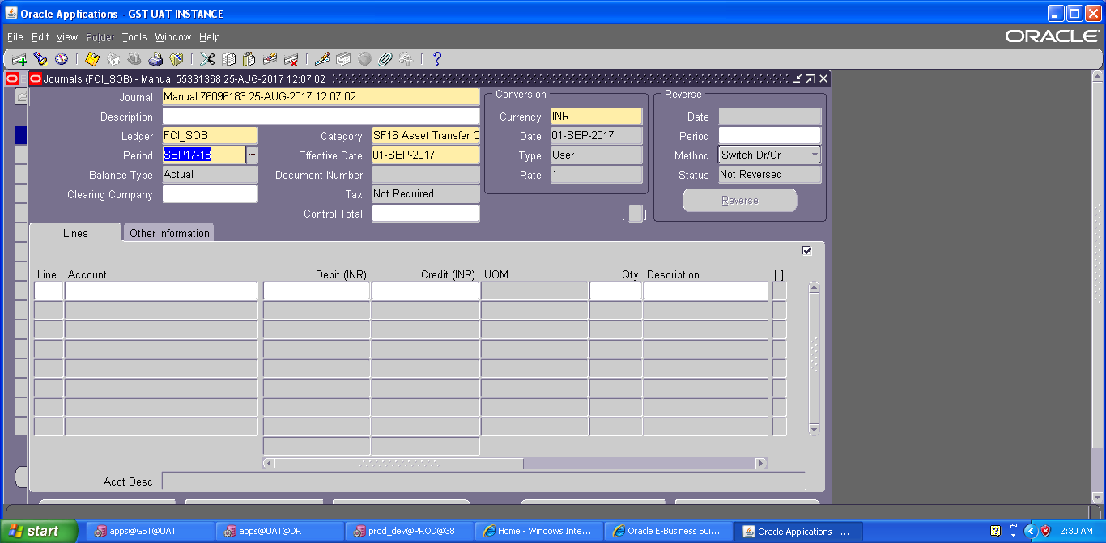
- For this category, user will also enter the GST tax related information in line level DFF. Following fields are mandatory at line level DFF (effective from 1-SEP-2017), leaving these fields blank will give an error as shown in the screen shots below: -
To GSTN: Enter the unit to which stock is transferred.
HSN code: Enter the HSN code of the product transferred (4-8 Digit Numeric value only).
Place of supply: Enter the place where stock is supplied.
Tax Rate: Enter the tax rate for tax applicable.
Invoice/ challan No.: Invoice /challan received from other party against the entry.
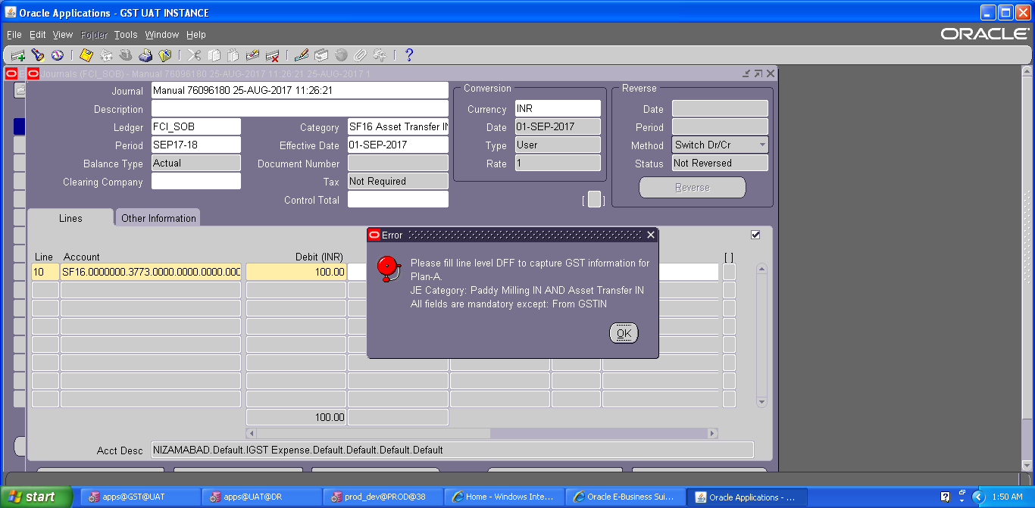
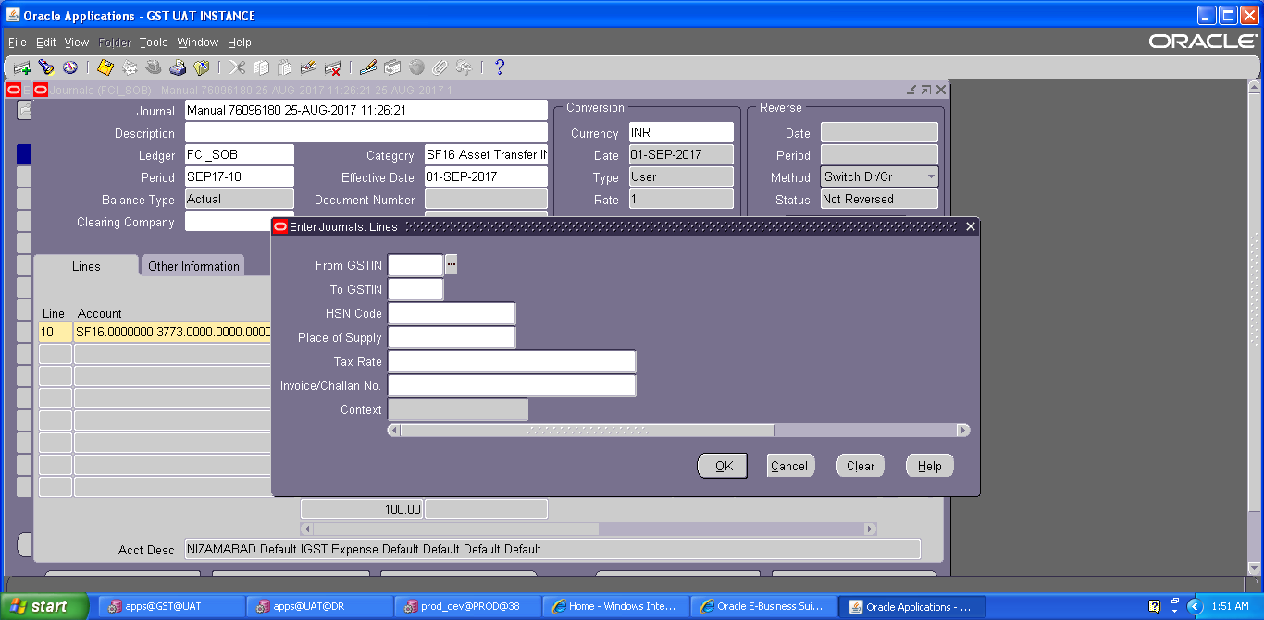

- Enter the JV in the lines and save the transaction.
As Budgetary Control is enabled, click on ‘Check Funds’ and ‘Reserve Funds’. If Budgetary Control is enabled on those accounts, these actions will check and reserve funds on the same. If no funds are available for that particular account combination, it will not allow the transaction to proceed.
- Click on ‘Approve’. The journal will be forwarded to the approver for approval. Post-approval the transaction will be available for posting.
- Once the journal approval is initiated, user is required to generate GST sequence for this journal category, the same can be done by following path:
Click on Tools→FCI GST SEQ

A new form will appear, on this form select the document type (Delivery Challan/Bill of supply/tax invoice) and click ‘Generate Sequence’.
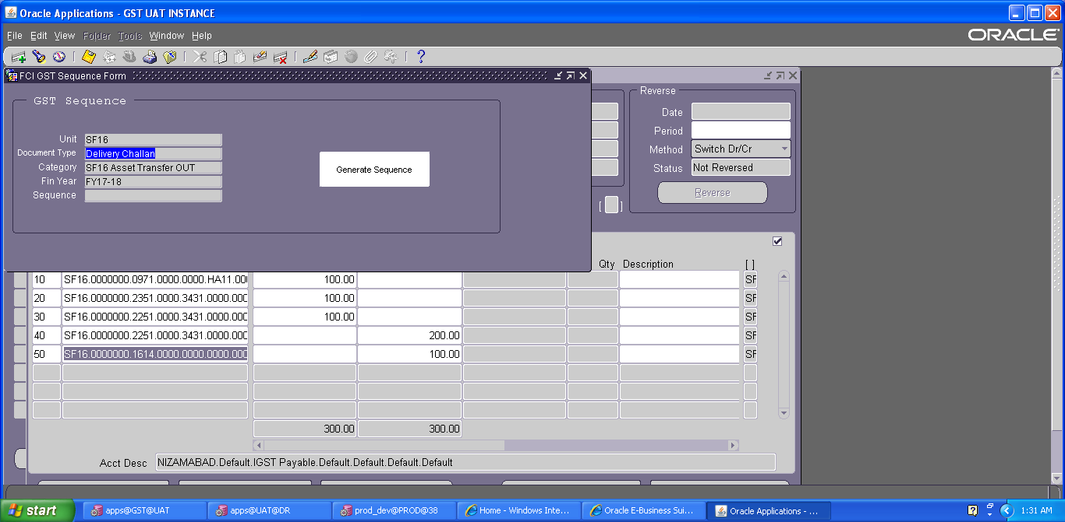
System will generate the GST sequence for journal category by below logic:
Unit will be the prefix followed by sequence for GL Category – Asset Transfer- OUT, which is ‘03’, followed by ‘100000’ for Delivery Challan or ‘200000’ for Bill of Supply- or ‘300000’ for Tax Invoice.
For example if a user from NC12 is entering the transaction for Asset Transfer - OUT, and selected delivery Challan, then sequence will be NC1203100000.
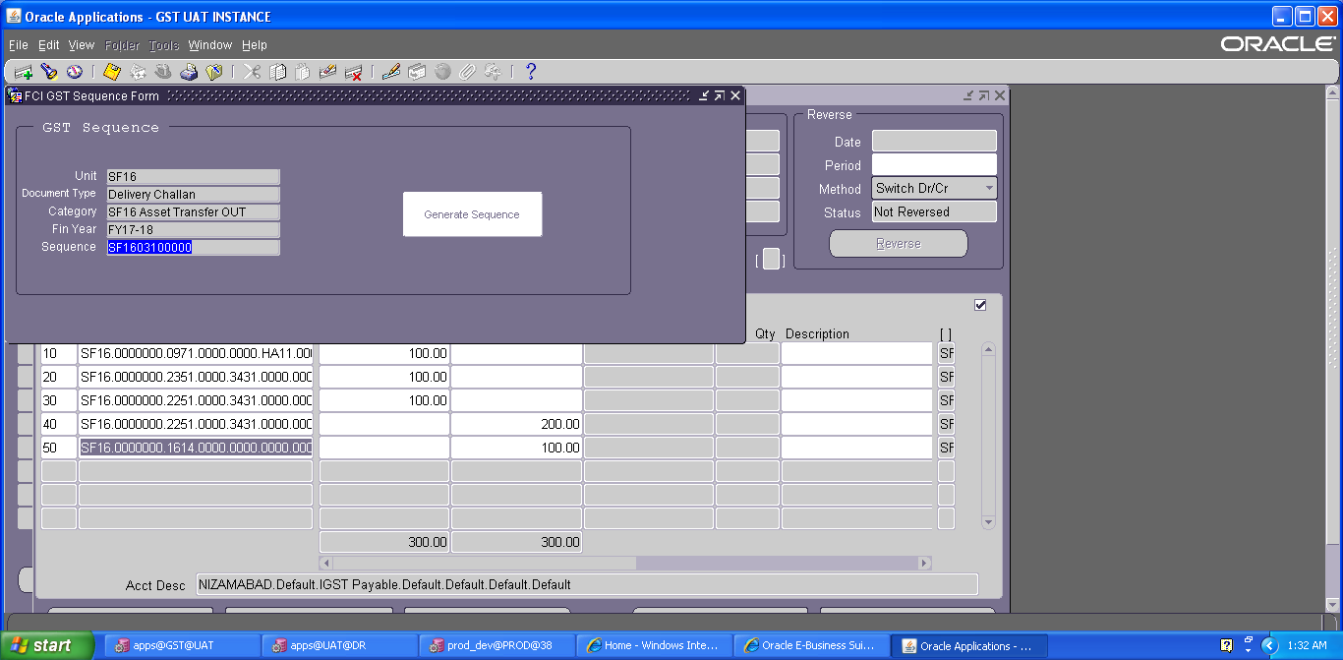
- Click on Post to post the transaction. This can also be done by JVs from Journals >> Post window
The steps of ‘Check Funds’, ‘Reserve Funds’, ‘Approve’, ‘Post’ are also explained in detail in separate sections of this document.

Note: There is a restriction on journal form that will not let the user, approve/post/reserve funds for any other unit’s journal. The changes can only be done when first four characters of the Category of the Journal and first four characters of the responsibility being used are same, otherwise it will not let the user view the journal.
Note: When the process of disabling the code combination id is in progress. . The user will not be able to make any new entry. The user will get an error-“The code combination is obsolete”.

Manual Journal Entry – FCI Unconnected/ Missing Wagon
To capture GST related information for Journal entries with GL Date less than or equal to 31-AUG-2017, please refer section -37(GOODS AND SERVICES INCLUSION IN GENERAL LEDGER (AS PER PLAN B)).

Function Path: Normal General Ledger responsibility>> Journals >> Enter >> New Journal.
The Journal entry for Missing and Unconnected entry is required to be made for recording the transactions of claims and liabilities against railways for Missing and unconnected wagons.
Steps:
Note: Due to the security rule applied on journals, in JE distribution lines, user will not be able to use account pertaining to other unit (Except with the InterCo General Ledger Responsibility).

- To create a new manual journal entry, click on new journal in the find journals window.
- Journal Name: Leave the Journal name blank. It will automatically take the system date and time as Journal name.
- Period: Enter the Period, effective date. Adjusting periods are available at the end of each quarter and year beginning with ‘ADJ’
- Currency: Enter currency details. The currency will be ‘INR’ for the category ‘FCI Unconnec/ Missing Wagon’.
- Category: Enter the category as ‘Unit name (e.g. SB16, NC 14) Unconnec/ Missing Wagon ‘.
- Header Level DFF (Descriptive Flex field): For the category FCI Unconnected/ Missing, the RR No., Wagon No., No. Of Bags, Quantity, Consignor District, Consignor Depot, Consignee Depot and Original Wagon has to be captured. DFF is nothing but place to record additional information about the category of the Journal entry being passed. Click on the angular bracket of the DFF indicated as follows:
Click here to open the Header Level DFF

Screen shot of Journal Form:
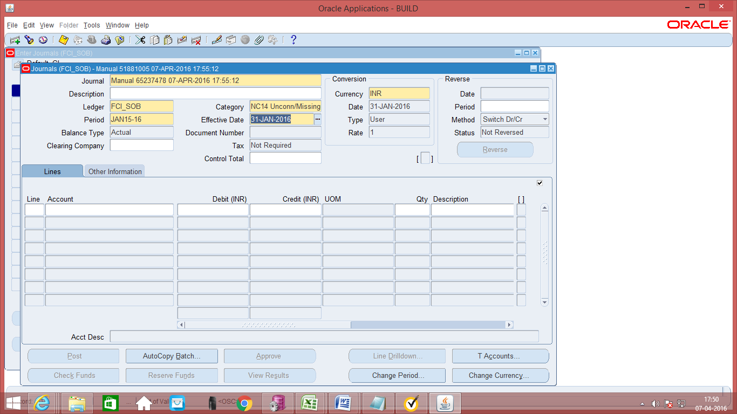
Click here to open the Header Level DFF

Screen shot of Journal Form:
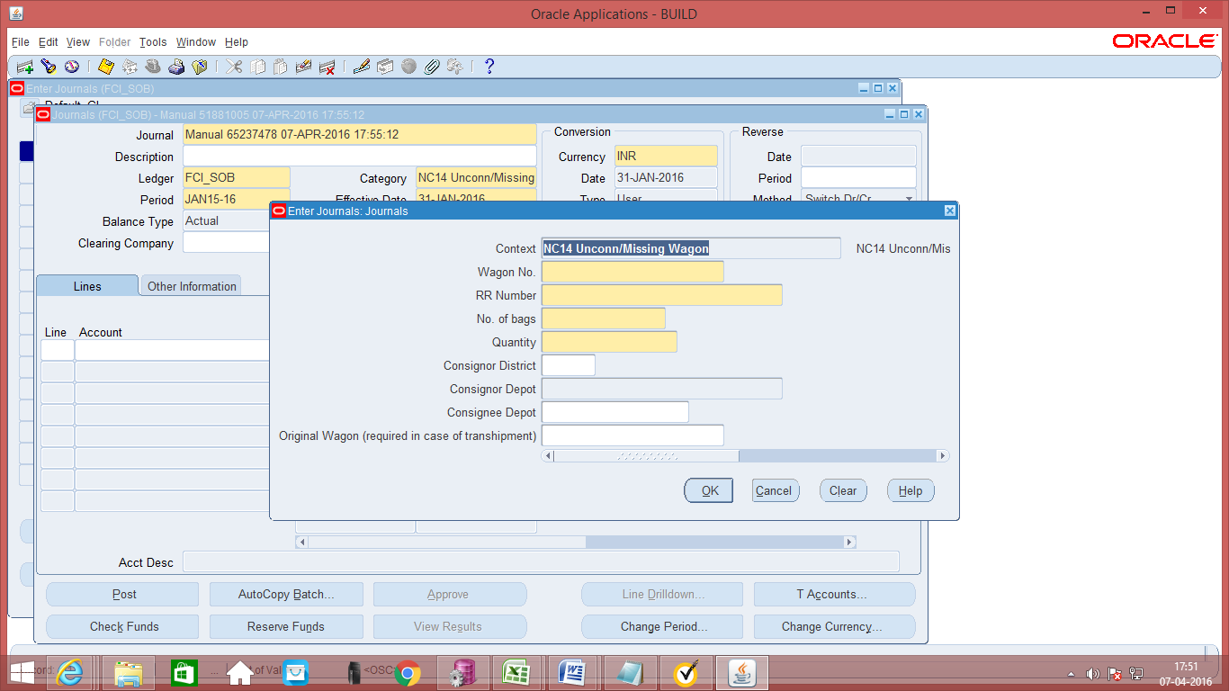

- Data entry in the Header Level DFF (Descriptive Flex field): On clicking the DFF symbol, fields to capture the following fields will appear:
Sr. No. | DFF Field | Maximum Length allowed | Whether mandatory
 | Wagon No. | Maximum length 10 characters | Mandatory
 | RR No | Maximum length 20 characters | Optional
 | No. of Bags | Number field upto 6 characters | Mandatory
 | Consignor Unit (Optional) | This is a list of all FCI units | Optional
 | Consignor Depot | The depots relevant to that unit will be picked up | Optional
 | Original Wagon No. | Maximum length 10 characters. This is required in case of Transhipment. | Optional

- Enter the JV in the lines and save the transaction. In the Line Number column of the Journal Entry, the numbering to be followed is in series of 10, i.e. numbering would be 10, 20, and 30 and so on.
First entry that is input for:
Missing wagon is:
Unit. No Depot. 2817 (Claims Acccount). Product. No Scheme Dr.
To,
Same unit. No Depot. 3971 (Income from claim for Missing wagon).Product. No Scheme

Wagon Number would have to be input in DFF.

Second Entry for reconciliation of Missing Wagon
The same entry is reversed, when it is reconciled.

Third Entry, for unconnected Wagon is:
Unit. Depot. 5231(Purchases for Unconnected Wagon ). Product.
To,
Unit. No Depot. 1408 (Sundry Creditors for unconnected Wagon).Product.

- Entering Quantity for Natural Accounts: It is possible to enter quantity for some of the Natural Accounts. The unit of measure (UOM) is ‘Quintal’. The Natural Accounts for which presently quantity is allowed are listed in Appendix 1. In case of Unconn/ Missing Wagon also, quantity is enabled for accounts like 2817 and 3971 and would have to be entered.
- For this category, user will also enter the GST tax related information in line level DFF. Following fields are mandatory at line level DFF (effective from 1-SEP-2017), leaving these fields blank will give an error as shown in the screen shots below: -
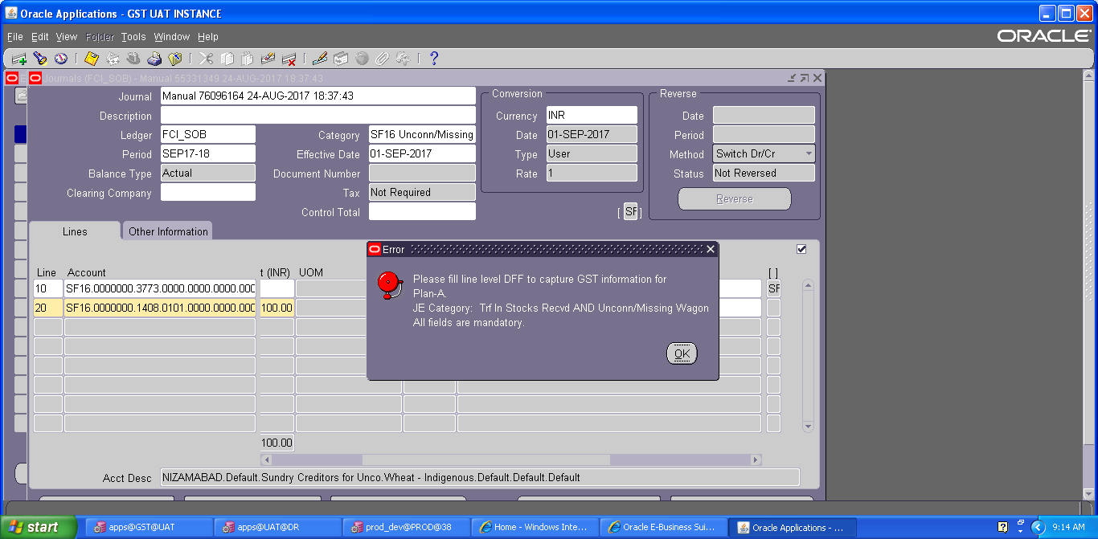
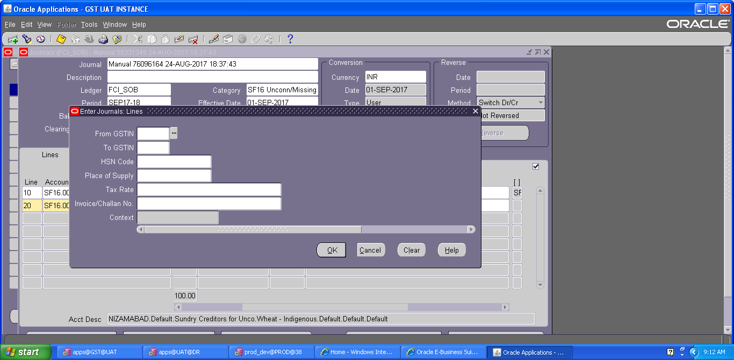
From GSTN: Enter the unit from which stock is transferred.
To GSTN: Enter the unit to which stock is transferred.
HSN code: Enter the HSN code of the product transferred (4-8 Digit Numeric value only).
Place of supply: Enter the place where stock is supplied.
Tax Rate: Enter the tax rate for tax applicable.
Invoice/ challan No.: Invoice /challan received from other party against the entry.
Save your work.
- As Budgetary Control is enabled, click on ‘Check Funds’ and ‘Reserve Funds’. If Budgetary Control is enabled on those accounts, these actions will check and reserve funds on the same. If no funds are available for that particular account combination, it will not allow the transaction to proceed.
- Click on ‘Approve’. The journal will be forwarded to the approver for approval. Post-approval the transaction will be available for posting.
- Click on Post to post the transaction. This can also be done by JVs from Journals >> Post window
- As Budgetary Control is enabled, click on ‘Check Funds’ and ‘Reserve Funds’. If Budgetary Control is enabled on those accounts, these actions will check and reserve funds on the same. If no funds are available for that particular account combination, it will not allow the transaction to proceed.
- Click on ‘Approve’. The journal will be forwarded to the approver for approval. Post-approval the transaction will be available for posting.
- Click on Post to post the transaction. This can also be done by JVs from Journals >> Post window
The steps of ‘Check Funds’, ‘Reserve Funds’, ‘Approve’, ‘ Post’ are also explained in detail in separate sections of this document.

Note: There is a restriction on journal form that will not let the user, approve/post/reserve funds for any other unit’s journal. The changes can only be done when first four characters of the Category of the Journal and first four characters of the responsibility being used are same, otherwise it will not let the user view the journal.
Note: When the process of disabling the code combination id is in progress. . The user will not be able to make any new entry. The user will get an error-“The code combination is obsolete”.

Manual Journal Entry – FCI Prior Period Item
Function Path: Normal General Ledger responsibility>> Journals >> Enter >> New Journal.
The journal entries for Prior period items are required to be made where an effect is given to the account head prior period income or prior period expenditure. By entering the transaction in this category we can enter the classification in which the expense should have been booked in case it was not a prior period item.
Steps:
Note: Due to the security rule applied on journals, in JE distribution lines, user will not be able to use account pertaining to other unit (Except with the InterCo General Ledger Responsibility).

- To create a new manual journal entry, click on new journal in the find journals window.
- Journal Name: Leave the Journal name blank. It will automatically take the system date and time as Journal name.
- Period: Enter the Period, effective date. Adjusting periods are available at the end of each quarter and year beginning with ‘ADJ’
- Currency: Enter currency details. The currency will be ‘INR’.
- Category: Enter the category as ‘Unit name (eg SB16, NC 14) FCI/ Prior Period Item
- Header Level DFF (Descriptive Flex field): For the category FCI Prior Period Item, the header level DFF has to be captured. DFF is nothing but place to record additional information about the category of the Journal entry being passed. Click on the angular bracket of the DFF indicated as follows:

Screen shot of Journal Form:
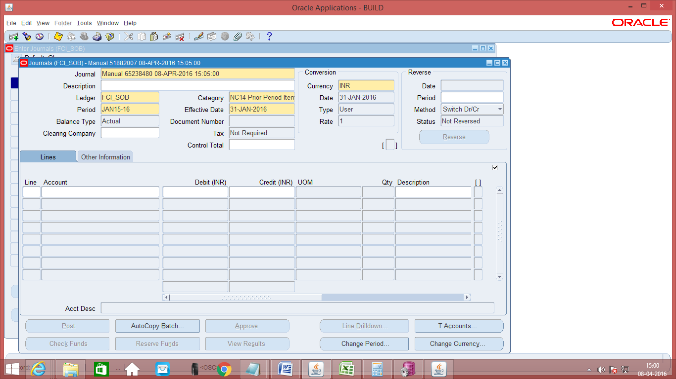
Click here to open the Header Level DFF

Screen shot of Journal Form:
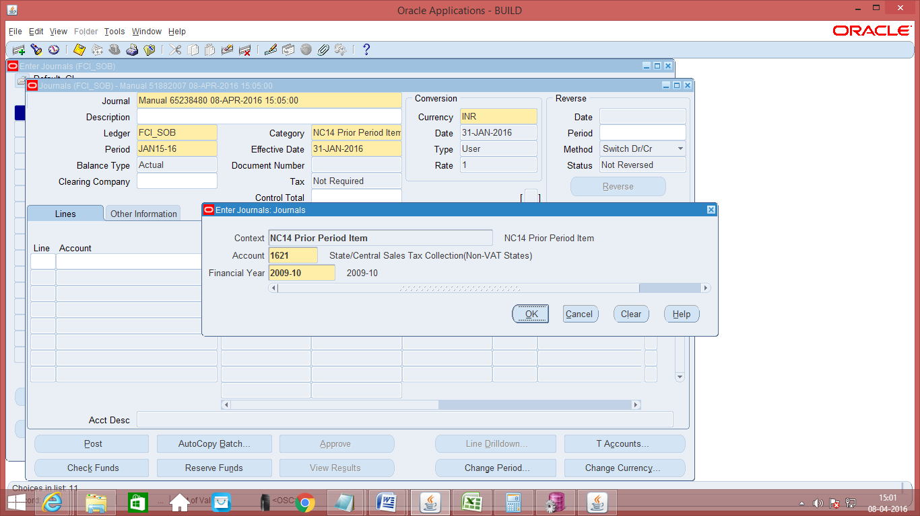
- Data entry in the Header Level DFF (Descriptive Flex field): On clicking the DFF symbol, fields to capture the following fields will appear: Account Type and Financial Year will appear. Both the fields are mandatory.
- Enter the JV in the lines and save the transaction. In the Line Number column of the Journal Entry, the numbering to be followed is in series of 10, i.e. numbering would be 10, 20, 30 and so on.
Entries used in Prior Period Items would involve:
3600 | Adjustment relating to Previous Years Income
3601 | Adjustment relating to Previous Years Income - For Levy sugar
3603 | Adjustment relating to Previous Years Income - For un-connected wagons upto the year 1980-81
3604 | Adjustment relating to Previous Years Income - Adjustments in respect of Previous Years Income - Others
3620 | Adjustment relating to Previous Years Expenses
3621 | Adjustment relating to Previous Years Expenses - For Levy Sugar
3623 | Adjustment relating to Previous Years Expenses - Exports - STC Contracts
3624 | Adjustment relating to Previous Years Expenses - Exports - other than STC Contracts
3625 | Adjustment relating to Previous Years Expenses - Adjustment in respect of Prev. Years Expenditure - Others
- Save your work.
- As Budgetary Control is enabled, click on ‘Check Funds’ and ‘Reserve Funds’. If Budgetary Control is enabled on those accounts, these actions will check and reserve funds on the same. If no funds are available for that particular account combination, it will not allow the transaction to proceed.
- Click on ‘Approve’. The journal will be forwarded to the approver for approval. Post-approval the transaction will be available for posting.
- Click on Post to post the transaction. This can also be done by JVs from Journals >> Post window
The steps of ‘Check Funds’, ‘Reserve Funds’, ‘Approve’, ‘Post’ are also explained in detail in separate sections of this document.
Note: When the process of disabling the code combination id is in progress. . The user will not be able to make any new entry. The user will get an error-“The code combination is obsolete”.

Manual Journal Entry – FCI InterCo Fast Collection Account
.
The entry for InterCo fast collections are required to be made for IOR through fast collection service.
Navigation Path: General Ledger InterCo responsibility>> Journals> Enter
- To create a new manual journal entry, click on new journal in the find journals window.
- Journal Name: Leave the Journal name blank. It will automatically take the system date and time as Journal name.
- Effective Date: Enter the Effective Date. This date is of great importance as it denotes the transaction date for which fast collection balances are being transferred.
- Period: The period will automatically flow as per the effective date chosen.
- Currency: Enter currency details. The currency will be ‘INR’ for all transactions in Indian Rupees for the category ‘FCI InterCo Fast Collection’.
- Category: Select the category ‘FCI InterCo Fast Collection’. Intercompany entries can be entered only if the user has the requisite rights and privileges. Intercompany entries belong to the categories beginning with ‘InterCo’ and Intercompany entry is created only on POSTING.
- Enter the PIF Reference No. has to be written in the ‘Description’ part of the Journal Entry. Entering the PIF No. is mandatory. The PIF number flows from the Header level description to the line level description and this is essential for reconciliation. If for any reason, the header level description does not flow to the line level, enter the line level description. Ensure that the line level description has the correct PIF number and do not enter any other description or else reconciliation will not take place.
- Enter the journal entry in the lines and save the transaction. In the Line Number column of the Journal Entry, the numbering to be followed is in series of 10, i.e. numbering would be 10 and 20.
Note: For this to work, only one pair of entries must be passed in InterCo remittances. If you try to entry more than two lines in the category InterCo remittances, the system will give error and not allow the same.
- In the journal entry, the depot segment denotes the branch code for which day end balance is to be transferred and needs to be carefully entered. If the depot segment is wrongly chosen, the entry will flow to the wrong branch of the bank and will not be reconciled. The depot segment denotes the branch code for which the fast collection is to be done and needs to be carefully entered. A separate natural account has to be maintained for each Collecting Banks and individual bank branches are distinguished by the depot segment. For example if the following entry is passed on 30-May-2008 to transfer the fast collection done at district Karnal on 30-May-2008, to HA1101 (Central Cash Credit Account) having PIF No. 48357 for the amount Rs. 200

Enter the PIF no. only the number 48357 in the header level description.
Central Collecting Banker A/c Dr.
To,
Unit Collecting Banker A/c
In terms of Oracle Applications, the following entry will be passed at district level:
HA11.HA1101.4531.0000.0000.0000.0000 Dr. 200
To,
NC14.NC1407F.4535.0000.0000.0000.0000 Cr. 200
- The line level description will flow in Cash Management and will be displayed in the number column of the concerned bank in the transactions available for reconciliation. Ensure that the line level description has the correct PIF number and do not enter any other description or else reconciliation will not take place.
- Save your work.
- As Budgetary Control is enabled, click on ‘Check Funds’ and ‘Reserve Funds’. If Budgetary Control is enabled on those accounts, these actions will check and reserve funds on the same. If no funds are available for that particular account combination, it will not allow the transaction to proceed.
- Click on ‘Approve’. The journal will be forwarded to the approver for approval. Post-approval the transaction will be available for posting.
- Click on Post to post the transaction. This can also be done by JVs from Journals >> Post window
The steps of ‘Check Funds’, ‘Reserve Funds’, ‘Approve’, ‘Post’ are also explained in detail in separate sections of this document.
Note: When the process of disabling the code combination id is in progress. . The user will not be able to make any new entry. The user will get an error-“The code combination is obsolete”.

Manual Journal Entry: Inter Office Remittances (IOR)
The entries for IOR are required to be made for transferring the day end bank balances to the RCC/ZCC account.
Navigation Path: General Ledger Inter Co responsibility>> Journals> Enter
- To create a new manual journal entry, click on new journal in the find journals window.
- Journal Name: Leave the Journal name blank. It will automatically take the system date and time as Journal name.
- Effective Date: Enter the Effective Date. This date is of great importance as it denotes the transaction date for which the day end balances are being transferred.
- Period: The period will automatically flow as per the effective date chosen.
- Currency: Enter currency details. The currency will be ‘INR’ for all transactions in Indian Rupees for the category ‘FCI InterCo IOR’.
- Category: Select the category ‘FCI InterCo IOR’. Intercompany entries can be entered only if the user has the requisite rights and privileges. Intercompany entries belong to the categories beginning with ‘InterCo’ and Intercompany entry is created only on POSTING.
- Enter the journal entry in the lines and save the transaction. In the Line Number column of the Journal Entry, the numbering to be followed is in series of 10, i.e. numbering would be 10 and 20.
- Note: For this to work, only one pair of entries must be passed in InterCo remittances. If you try to entry more than two lines in the category InterCo remittances, the system will give error and not allow the same. For each day end balance transferred, a separate Journal entry needs to be created.
- In the journal entry, the depot segment denotes the branch code for which day end balance is to be transferred and needs to be carefully entered. If the depot segment is wrongly chosen, the entry will flow to the wrong branch of the bank and will not be reconciled. The depot segment denotes the branch code for which day end balance is to be transferred and needs to be carefully entered. If the depot segment is wrongly chosen, the entry will flow to the wrong branch of the bank and will not be reconciled.
Screen shot of Journal Form:
- For example if the following entry is passed on 30-May-2008 to transfer the day end balance of 30-May-2008, for NC1407F (i.e. SBI Nilokheri in Karnal District) to HA1101 (Central Cash Credit Account):
HA11.HA1101.3111.0000.0000.0000.0000 Dr. 200
To,
NC14.NC1407F.3111.0000.0000.0000.0000 Cr. 200
Submit the request for populating description. Request name is ‘FCI Populate GL Description’. This can be auto scheduled daily.
- In the journal entry, do not enter any description either at the header level or at the line level. The description entered by the user will be overwritten by the system for the category ‘InterCo IOR’. The system by itself runs a program which picks up the corresponding branch code from the counterparty depot segment, concatenates it with the effective date and populates it in the description column at line level. In this case for HA1101, the corresponding branch code would be NC1407F. Hence in the line level description for HA11 unit, the branch code NC1407F would be appended with the date 30-May-2008. So, the complete description of the HA11 line would be NC1407F#30-May-2008. The description will be populated by the system. In the NC14 line, the corresponding branch code would be HA1101. So, the complete description of the NC14 line would be HA1101#30-May-2008.
- The line level description will flow in Cash Management and will be displayed in the number column of the concerned bank in the transactions available for reconciliation.
- Save your work.
- As Budgetary Control is enabled, click on ‘Check Funds’ and ‘Reserve Funds’. If Budgetary Control is enabled on those accounts, these actions will check and reserve funds on the same. If no funds are available for that particular account combination, it will not allow the transaction to proceed.
- Click on ‘Approve’. The journal will be forwarded to the approver for approval. Post-approval the transaction will be available for posting.
- Click on Post to post the transaction. This can also be done by JVs from Journals >> Post window
The steps of ‘Check Funds’, ‘Reserve Funds’, ‘Approve’, ‘Post’ are also explained in detail in separate sections of this document.

Restrictions during the IOR Creation:-
- One line entered, should be of the UNIT for which category has been chosen.
- Restriction’s for Other unit line are listed below
  - All DO’s can send IOR to their respective ZO’s (North Region can send its IOR to HQ or Rajasthan RO or Punjab RO)
  - ZO can send IOR to HQ and DO’s.
  - HQR can send IOR to all north region (unit code starting with N and H) and ZO’s in other regions.
  - RO Punjab and RO Rajasthan can send IOR’s to the units starting from ‘N’ and HQs (HA11).
  - IOR can be send on above criteria or vice versa.
  - Account numbers are provided by FCI for the same are listed below.
SR. NO | ZONES/HQRS | Bank A/c No.
1 | HQs /North Zone | 30009447399
2 | RO Punjab | 55023970098
3 | West Zone | 30156609067
4 | South Zone | 10640630597
5 | South Zone | 62007252020
6 | North East Zone | 10824154519
7 | East Zone | 1104390666
8 | RO Rajasthan | 51091726718
9 | R.O.CHANDIGARH(HR) | 55023970101

Note: When the process of disabling the code combination id is in progress. . The user will not be able to make any new entry. The user will get an error-“The code combination is obsolete”.

Manual Journal Entry –InterCo IOM RailRoad

To capture GST related information for Journal entries with GL Date less than or equal to 31-AUG-2017, please refer section -37( GOODS AND SERVICES INCLUSION IN GENERAL LEDGER (AS PER PLAN B)).
This entry is passed by the unit sending the goods.
Function Path: Normal General Ledger responsibility>> Journals >> Enter >> New Journal.
Steps:
- To create a new manual journal entry, click on new journal in the find journals window.
- Journal Name: Leave the Journal name blank. It will automatically take the system date and time as Journal name.
- Period: Enter the Period, effective date. Adjusting periods are available at the end of each quarter and year beginning with ‘ADJ’
- Currency: Enter currency details. The currency will be ‘INR’.
- Category: Enter the category as ‘Unit name (e.g. SB16, NC 14) FCI IOM by RailRoad
- Enter the JV in the lines and save the transaction. In the Line Number column of the Journal Entry, the numbering to be followed is in series of 10, i.e. numbering would be 10, 20, and 30 and so on.
- Entering Quantity for Natural Accounts: It is possible to enter quantity for some of the Natural Accounts. The unit of measure (UOM) is ‘Quintal’. The Natural Accounts for which presently quantity is allowed are listed in Appendix 1.
- Header Level DFF (Descriptive Flex field): For the category FCI IOM by railroad, certain information needs to be captured in the header level DFF. DFF is nothing but place to record additional information about the category of the Journal entry being passed. Click on the angular
- bracket of the DFF indicated as follows to open the header level DFF:

Screen shot of Journal Form:

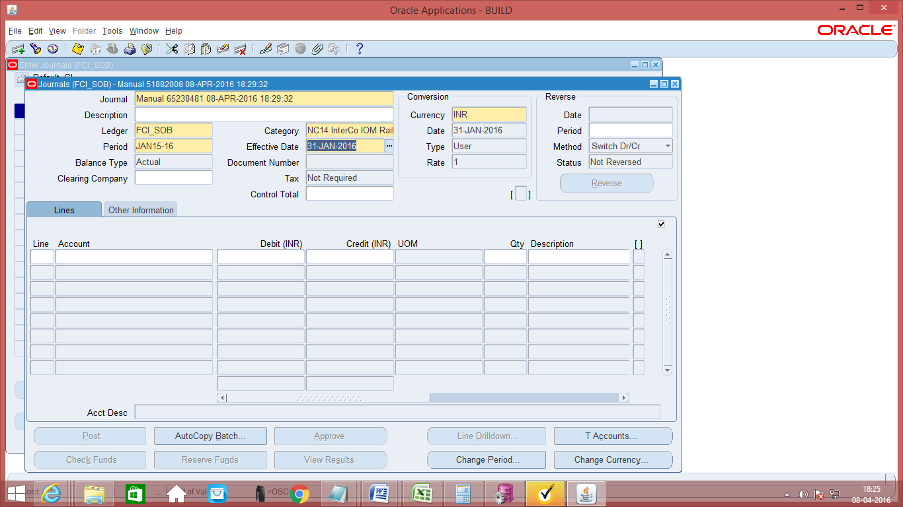

- Data entry in the Header Level DFF (Descriptive Flex field): On clicking the DFF symbol, fields to capture the following fields will appear to capture the Railway Receipt number and the Railway receipt number quantity. User has to enter Receipt, receipt Quantity and To Account and Depot to which the IOM is to be sent.
Screen shot of Journal Form:
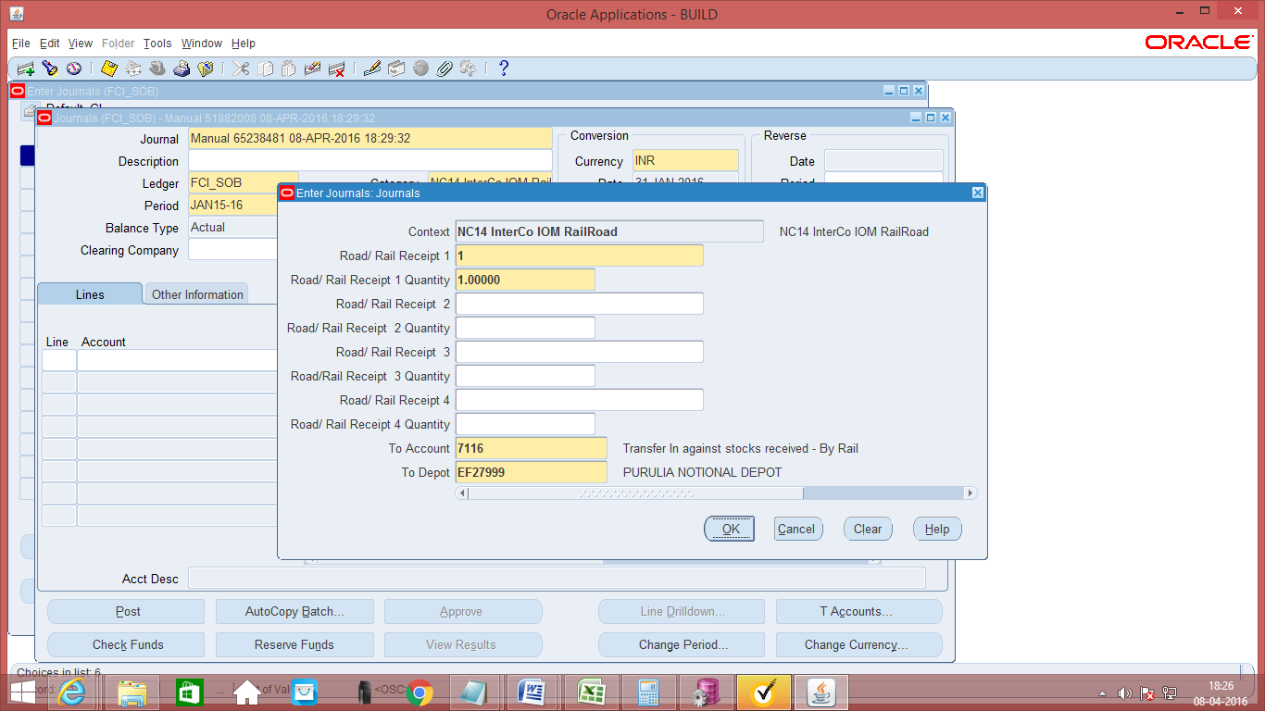

- For interco IOM Rail Road category following checks have been added.
  - Product can be same or default (0000) across all the lines.
  - Default product is allowed with CGST/IGST/SGST/UTGST liability accounts (1612, 1613, 1614) only.
  - Same depot for all or default depot (for account head 0981) can be used.
  - Exactly 1 line with account head 0981.
  - Intercompany segment cannot be default for line with account head ‘0981’.
  - Intercompany segment provided in line with account head 0981 should match with ‘To Depot ‘segment of descriptive field in case of Interco IOM Rail Road.
  - IOM Transfer Out category allows only account codes 7111, 7112 and from 7201 to 7210,7216,7611,7612,7616,7617,7621,7701,7702,7703,7709,7710,1612,1613,1614.
Screen shot of Journal Form:
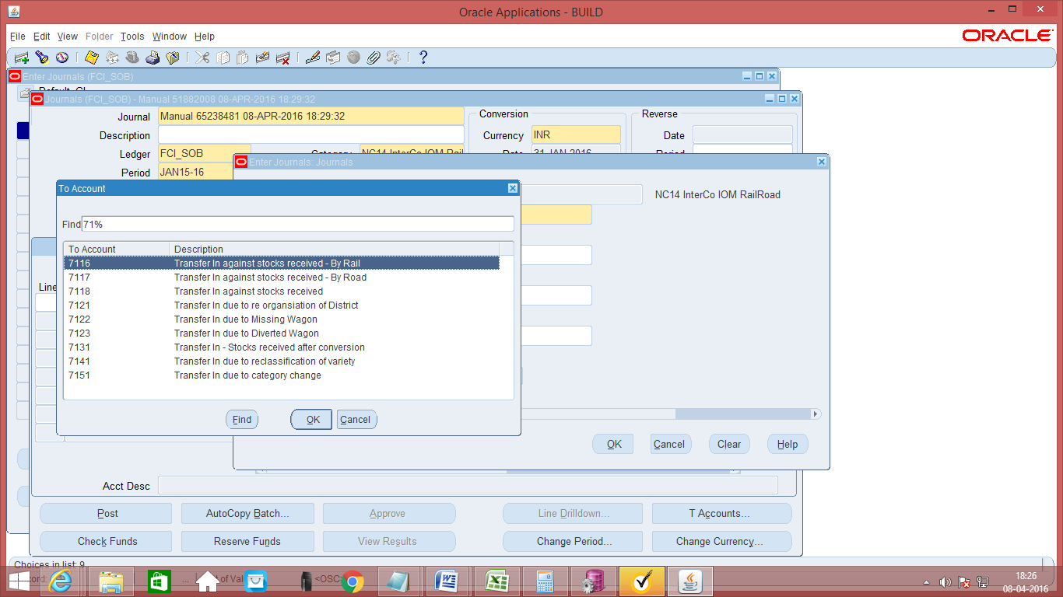

- Data entry in the Line Level DFF (Descriptive Flex field):
On clicking the DFF symbol, fields will appear to capture the Gunny bag number. Field value should be a whole number only. The DFF will be enabled only for food grains product. For other product like chemical, gunnies etc. the DFF will be disabled.
For this category, user will also enter the GST tax related information in line level DFF. Following fields are mandatory at line level DFF (effective from 1-SEP-2017), leaving these fields blank will give an error as shown in the screen shots below: -
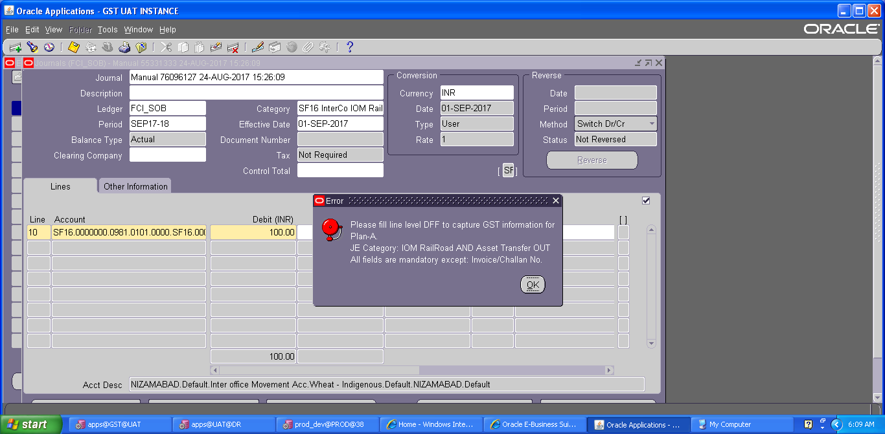
From GSTN: Enter the unit from which stock is transferred.
To GSTN: Enter the unit to which stock is transferred.
HSN code: Enter the HSN code of the product transferred (4-8 Digit Numeric value only).
Place of supply: Enter the place where stock is supplied.
Tax Rate: Enter the tax rate for tax applicable.

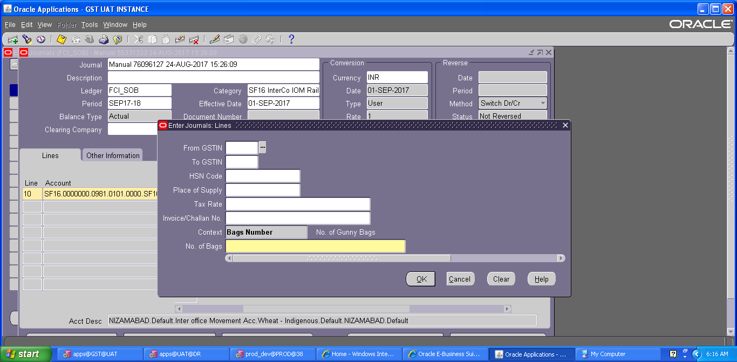

- Save your work.
- As Budgetary Control is enabled, click on ‘Check Funds’ and ‘Reserve Funds’. If Budgetary Control is enabled on those accounts, these actions will check and reserve funds on the same. If no funds are available for that particular account combination, it will not allow the transaction to proceed.
- Click on ‘Approve’. The journal will be forwarded to the approver for approval. Post-approval the transaction will be available for posting.
- Once the journal approval is initiated, user is required to generate GST sequence for this journal category, the same can be done by following path:
Click on Tools→FCI GST SEQ
A new form will appear, on this form select the document type (Delivery Challan/Bill of supply/tax invoice) and click ‘Generate Sequence’.
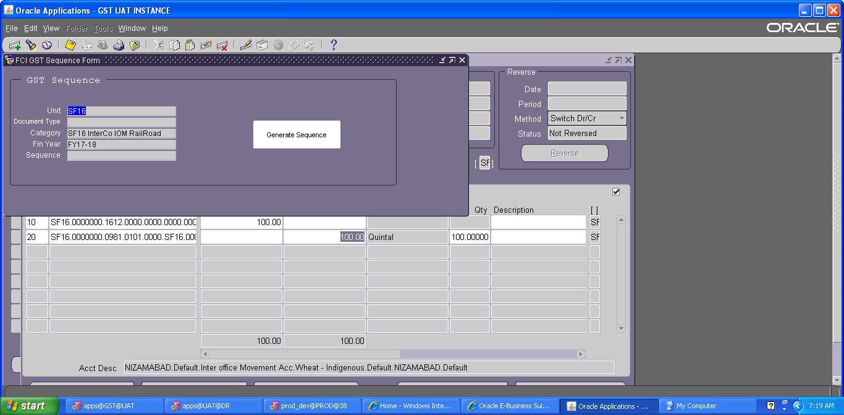
System will generate the GST sequence for journal category by below logic:
Unit will be the prefix followed by sequence for GL Category – Interco IOM RailRoad which is ‘01’, followed by ‘100000’ for Delivery Challan or ‘200000’ for Bill of Supply- or ‘300000’ for Tax Invoice.
For example if a user from NC12 is entering the transaction for IOM RailRoad and selected delivery Challan, then sequence will be NC1201100000.
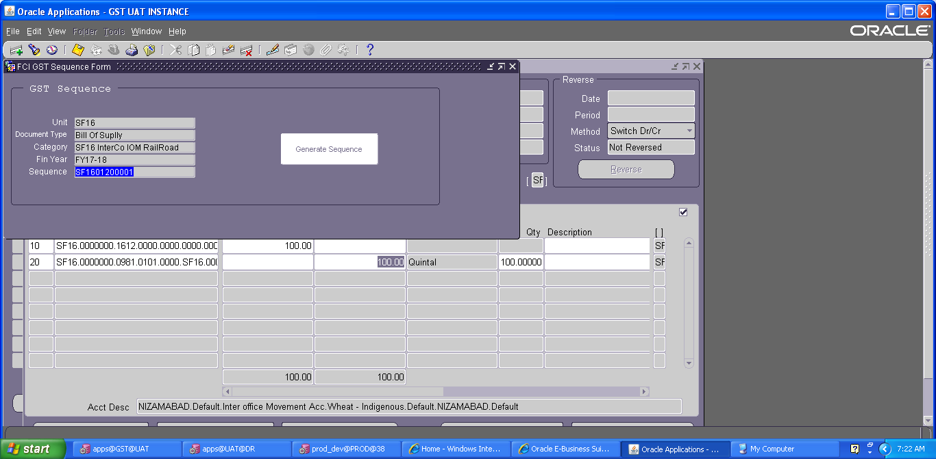
- Click on Post to post the transaction. This can also be done by JVs from Journals >> Post window
- As Budgetary Control is enabled, click on ‘Check Funds’ and ‘Reserve Funds’. If Budgetary Control is enabled on those accounts, these actions will check and reserve funds on the same. If no funds are available for that particular account combination, it will not allow the transaction to proceed.
- Click on ‘Approve’. The journal will be forwarded to the approver for approval. Post-approval the transaction will be available for posting.
- Click on Post to post the transaction. This can also be done by JVs from Journals >> Post window
Note: When the process of disabling the code combination id is in progress. . The user will not be able to make any new entry. The user will get an error-“The code combination is obsolete”.

Manual Journal Entry –InterCo IOCPF
These entries are used to transfer the CPF balances between the units.
Navigation Path: General Ledger Inter Co responsibility>> Journals> Enter
- To create a new manual journal entry, click on new journal in the find journals window.
- Journal Name: Leave the Journal name blank. It will automatically take the system date and time as Journal name.
- Effective Date: Enter the Effective Date. This date is of great importance as it denotes the transaction date for which the day end balances are being transferred.
- Period: The period will automatically flow as per the effective date chosen.
- Currency: Enter currency details. The currency will be ‘INR’ for all transactions in Indian Rupees for the category ‘InterCo IOCPF’.
- Category: Select the category ‘InterCo IOCPF’. Intercompany entries can be entered only if the user has the requisite rights and privileges. Intercompany entries belong to the categories beginning with ‘InterCo’ and Intercompany entry is created only on POSTING.
- Enter the journal entry in the lines and save the transaction. In the Line Number column of the Journal Entry, the numbering to be followed is in series of 10, i.e. numbering would be 10 and 20.

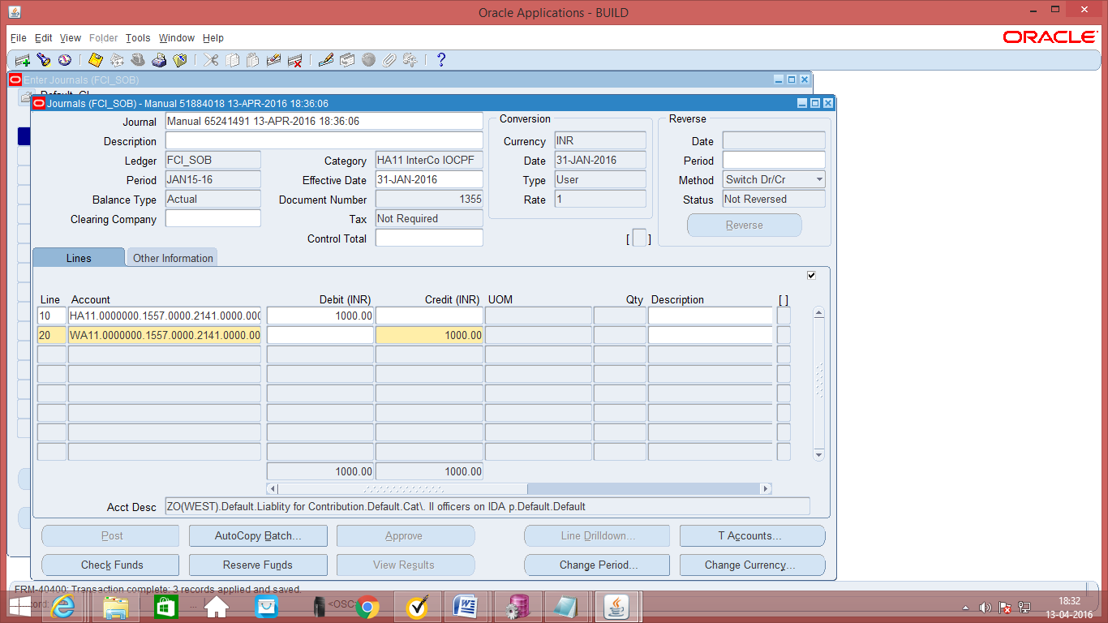

- Save your work.
- As Budgetary Control is enabled, click on ‘Check Funds’ and ‘Reserve Funds’. If Budgetary Control is enabled on those accounts, these actions will check and reserve funds on the same. If no funds are available for that particular account combination, it will not allow the transaction to proceed.
- Click on ‘Approve’. The journal will be forwarded to the approver for approval. Post-approval the transaction will be available for posting.
- Click on Post to post the transaction. This can also be done by JVs from Journals >> Post window
The steps of ‘Check Funds’, ‘Reserve Funds’, ‘Approve’, ‘Post’ are also explained in detail in separate sections of this document.
Note: Interco IOCPF category is only available from General Ledger InterCo User responsibility; it is not available from normal General Ledger User responsibility.
Note: When the process of disabling the code combination id is in progress. . The user will not be able to make any new entry. The user will get an error-“The code combination is obsolete”.

Manual Journal Entry –InterCo IOPS and INTERCO IOPS NEW
These entries are used to transfer the DCPS balances from the units to FCI HQ .
Navigation Path: General Ledger Inter Co responsibility>> Journals> Enter
- To create a new manual journal entry, click on new journal in the find journals window.
- Journal Name: Leave the Journal name blank. It will automatically take the system date and time as Journal name.
- Effective Date: Enter the Effective Date. This date is of great importance as it denotes the transaction date for which the day end balances are being transferred.
- Period: The period will automatically flow as per the effective date chosen.
- Currency: Enter currency details. The currency will be ‘INR’ for all transactions in Indian Rupees for the category ‘InterCo IOPS’/‘InterCo IOPS New’.
- Category: Select the category ‘InterCo IOPS’/‘InterCo IOPS New’. Intercompany entries can be entered only if the user has the requisite rights and privileges. Intercompany entries belong to the categories beginning with ‘InterCo’ and Intercompany entry is created only on POSTING.
- Enter the journal entry in the lines and save the transaction. In the Line Number column of the Journal Entry, the numbering to be followed is in series of 10, i.e. numbering would be 10 and 20.

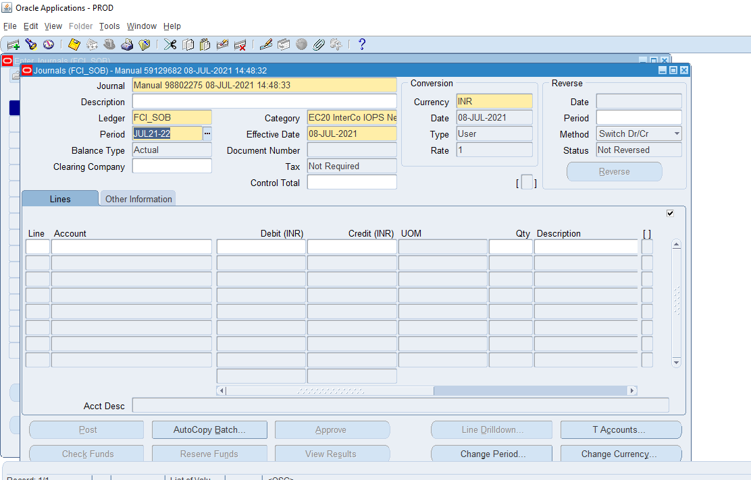

- Save your work.
- As Budgetary Control is enabled, click on ‘Check Funds’ and ‘Reserve Funds’. If Budgetary Control is enabled on those accounts, these actions will check and reserve funds on the same. If no funds are available for that particular account combination, it will not allow the transaction to proceed.
- Click on ‘Approve’. The journal will be forwarded to the approver for approval. Post-approval the transaction will be available for posting.
- Click on Post to post the transaction. This can also be done by JVs from Journals >> Post window
The steps of ‘Check Funds’, ‘Reserve Funds’, ‘Approve’, ‘Post’ are also explained in detail in separate sections of this document.
Note: ‘InterCo IOPS’/‘InterCo IOPS New’ category is only available from General Ledger InterCo User responsibility; it is not available from normal General Ledger User responsibility.
Only accounts 1602 to 1610 are allowed with ‘InterCo IOPS’/‘InterCo IOPS New’ category.
Note: When the process of disabling the code combination id is in progress. . The user will not be able to make any new entry. The user will get an error-“The code combination is obsolete”.

manual journal entry-iom within same unit

The entry for Inter Company movement within same unit is made in the category IOM Within Same Unit.
This entry is passed by the unit sending the goods.
Function Path: Normal General Ledger responsibility>> Journals >> Enter >> New Journal.
Steps:
- To create a new manual journal entry, click on new journal in the find journals window.
- Journal Name: Leave the Journal name blank. It will automatically take the system date and time as Journal name.
- Period: Enter the Period, effective date. Adjusting periods are available at the end of each quarter and year beginning with ‘ADJ’
- Currency: Enter currency details. The currency will be ‘INR’.
- Category: Enter the category as ‘Unit name (e.g. SB16, NC 14) FCI IOM within same unit
- Enter the JV in the lines and save the transaction. In the Line Number column of the Journal Entry, the numbering to be followed is in series of 10, i.e. numbering would be 10, 20, and 30 and so on.
- Entering Quantity for Natural Accounts: It is possible to enter quantity for some of the Natural Accounts. The unit of measure (UOM) is ‘Quintal’. The Natural Accounts for which presently quantity is allowed are listed in Appendix 1.
- Header Level DFF (Descriptive Flex field): For the category IOM Within Same Unit, certain information needs to be captured in the header level DFF. DFF is nothing but place to record additional information about the category of the Journal entry being passed. Click on the angular bracket of the DFF indicated as follows to open the header level DFF:
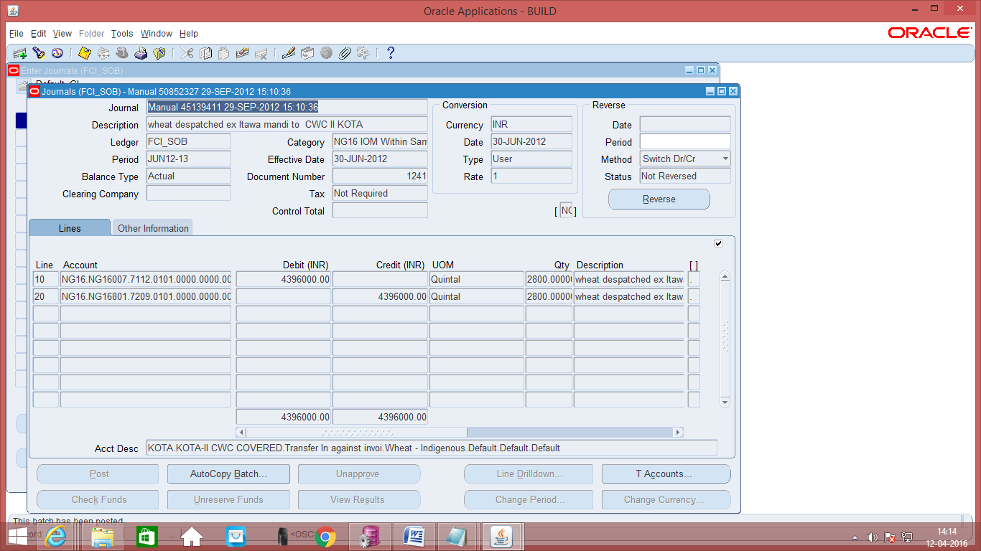

- Data entry in the Header Level DFF (Descriptive Flex field): On clicking the DFF symbol, fields to capture the following fields will appear to capture the Railway Receipt number and the Railway receipt number quantity. All the fields here are optional. Provision is made to enter up to 5 railway receipt numbers and their respective quantities.
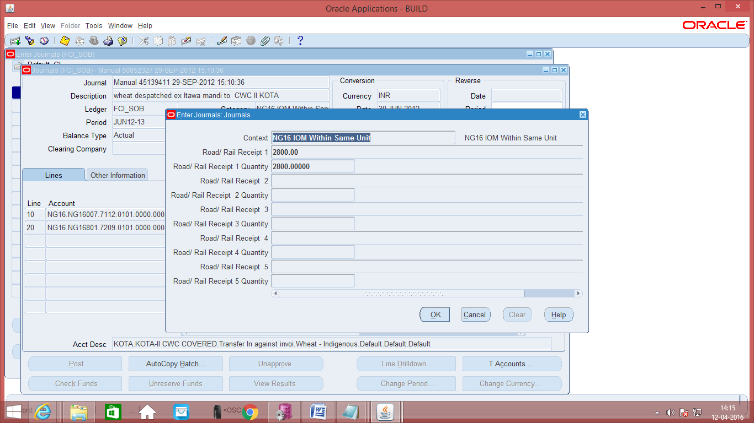

- Data entry in the Line Level DFF (Descriptive Flex field): On clicking the DFF symbol, fields will appear to capture the Gunny bag number. Field value should be a whole number only. The DFF will be enabled only for food grains product. For other product like chemical, gunnies etc. the DFF will be disabled.
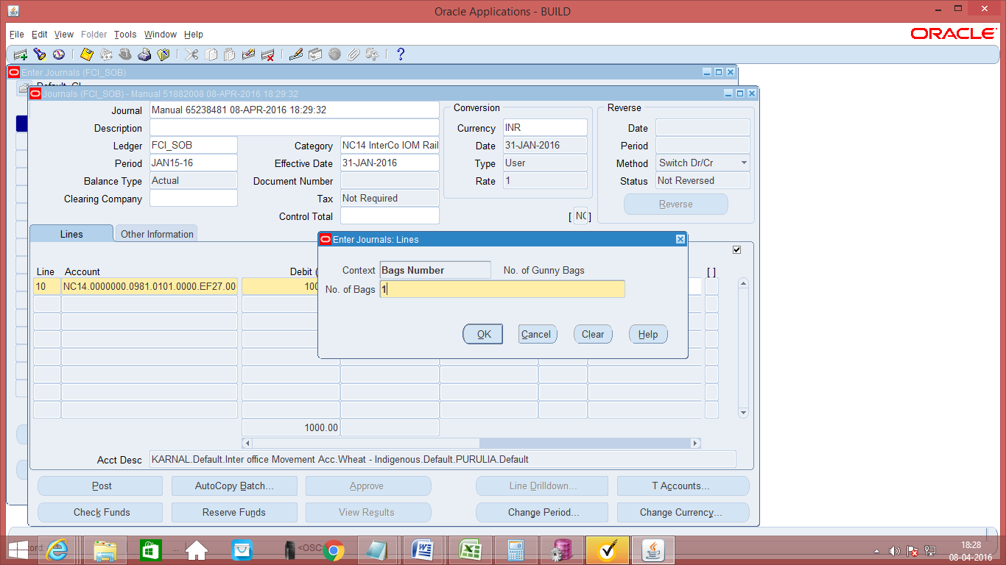

- Save your work.
- As Budgetary Control is enabled, click on ‘Check Funds’ and ‘Reserve Funds’. If Budgetary Control is enabled on those accounts, these actions will check and reserve funds on the same. If no funds are available for that particular account combination, it will not allow the transaction to proceed.
- Click on ‘Approve’. The journal will be forwarded to the approver for approval. Post-approval the transaction will be available for posting.
- Click on Post to post the transaction. This can also be done by JVs from Journals >> Post window
- As Budgetary Control is enabled, click on ‘Check Funds’ and ‘Reserve Funds’. If Budgetary Control is enabled on those accounts, these actions will check and reserve funds on the same. If no funds are available for that particular account combination, it will not allow the transaction to proceed.
- Click on ‘Approve’. The journal will be forwarded to the approver for approval. Post-approval the transaction will be available for posting.
- Click on Post to post the transaction. This can also be done by JVs from Journals >> Post window
Note: This category (IOM within same unit) has been removed from financial year 2013-14 as FCI does not require this anymore. User can query old journal with this category but cannot create new journals.
Note: When the process of disabling the code combination id is in progress. The user will not be able to make any new entry. The user will get an error-“The code combination is obsolete”.

Manual JOURNALS SAME UNIT- IOR

It is only applicable only for Zonal Offices and Headquarter.
Function Path: Normal General Ledger responsibility>> Journals >> Enter >> New Journal.
The following steps are common for each of the journal categories. The specific steps applicable to each of the categories, are explained in individual sections.
Steps:
- To create a new manual journal entry, click on new journal in the find journals window.
- Journal Name: Leave the Journal name blank. It will automatically take the system date and time as Journal name.
- Period: Enter the Period, effective date. Adjusting periods are available at the end of each quarter and year beginning with ‘ADJ’
- Currency: Enter currency details. The currency will be ‘INR’ for all transactions in Indian Rupees. The currency will be ‘STAT’ for all statistical transactions. This refers to those transactions for which only quantity is to be recorded and the currency is not Indian Rupee. For entering ‘Single Entry’ Journal Entry, the currency has to be ‘STAT’
- Category: Enter the category. Journal entries for each of the categories. The category name will be appended with the unit name. Enter the journal category with the unit name beginning with the unit to which the user belongs.
Simple Manual entries will be entered in the category ‘IOR WITHIN SAME UNIT’. For all other types of entries specific categories exist.
- Enter the JV in the lines and save the transaction. These lines must be of same unit. In the Line Number column of the Journal Entry, the numbering to be followed is in series of 10, i.e. numbering would be 10, 20, and 30 and so on.
- Save the Journal and click on ‘Check Funds’, explained in the section ‘Journal – Check Funds’.
Note: When the process of disabling the code combination id is in progress. . The user will not be able to make any new entry. The user will get an error-“The code combination is obsolete”.

Manual Journal Entry – Transfer In Against Stocks Received
To capture GST related information for Journal entries with GL Date less than or equal to 31-AUG-2017, please refer section -37( GOODS AND SERVICES INCLUSION IN GENERAL LEDGER (AS PER PLAN B)).

The unit sending the goods passed the entry in InterCo IOM Rail/ Raid.
The entry in the category Transfer in against Stocks Received is passed by the unit received the goods. This entry also accounts for the transit gains and losses.
Function Path: Normal General Ledger responsibility>> Journals >> Enter >> New Journal.
Steps:
- To create a new manual journal entry, click on new journal in the find journals window.
- Journal Name: Leave the Journal name blank. It will automatically take the system date and time as Journal name.
- Period: Enter the Period, effective date. Adjusting periods are available at the end of each quarter and year beginning with ‘ADJ’
- Currency: Enter currency details. The currency will be ‘INR’.
- Category: Enter the category as ‘Unit name (eg SB16, NC 14) Trf IN Stocks Recvd’
- Enter the JV in the lines and save the transaction. In the Line Number column of the Journal Entry, the numbering to be followed is in series of 10, i.e. numbering would be 10, 20, and 30 and so on.
- Entering Quantity for Natural Accounts: It is possible to enter quantity for some of the Natural Accounts. The unit of measure (UOM) is ‘Quintal’. The Natural Accounts for which presently quantity is allowed are listed in Appendix 1.
- Header Level DFF (Descriptive Flex field): The category ‘Trf In Stocks Recvd’ has a close relation with the category ‘InterCo IOM Rail/ Road’. The unit sending the goods passes the entry in InterCO IOM Rail/Road and when the goods are received by the receiving unit, it passes the enry in ‘Trf In Stocks Recvd’. Hence in the DFF of the category ‘Trf In Stocks Recvd’, reference has to be made to the entry passed by the sending unit while sending the goods. Hence the corresponding entry has to be reference in this DFF.

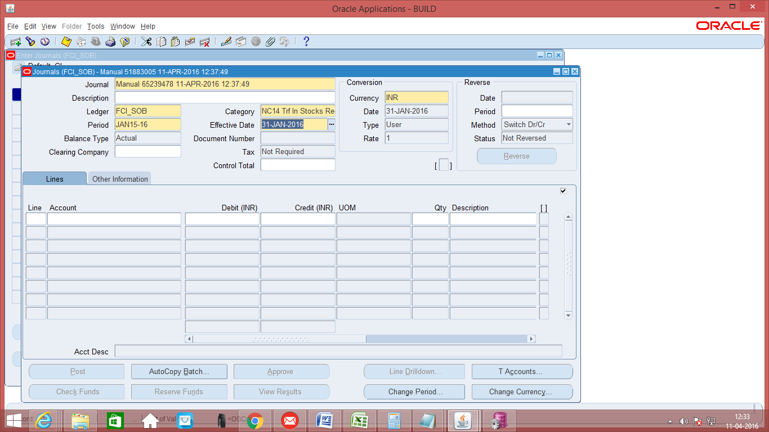

- Data entry in the Header Level DFF (Descriptive Flex field): On clicking the DFF symbol, fields to capture the following fields will appear to capture the Railway Receipt number and the Railway receipt number quantity. From account and Depot from which the stock has been received has to be also entered.

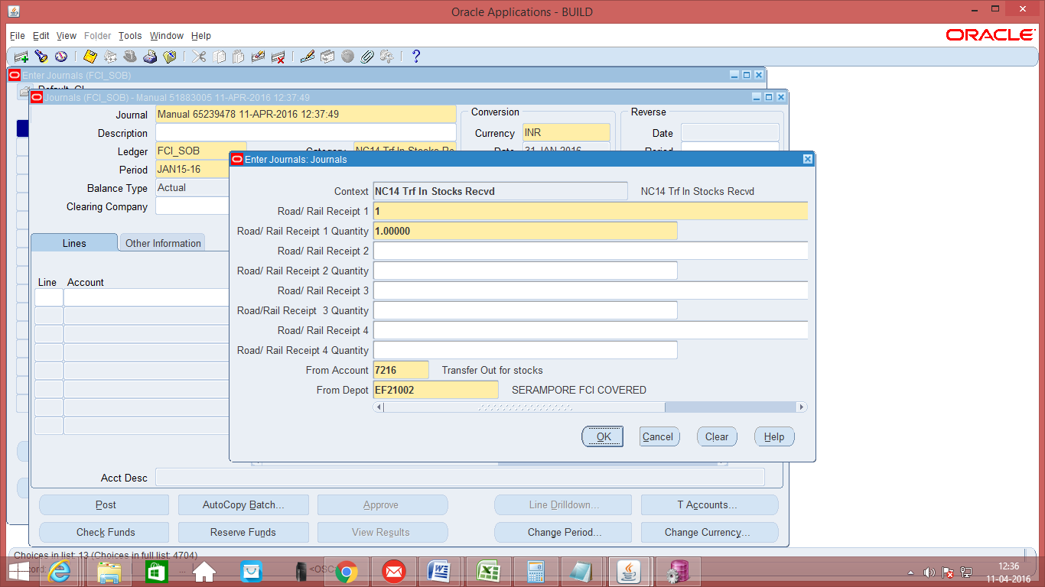

The following accounts are allowed in the DFF
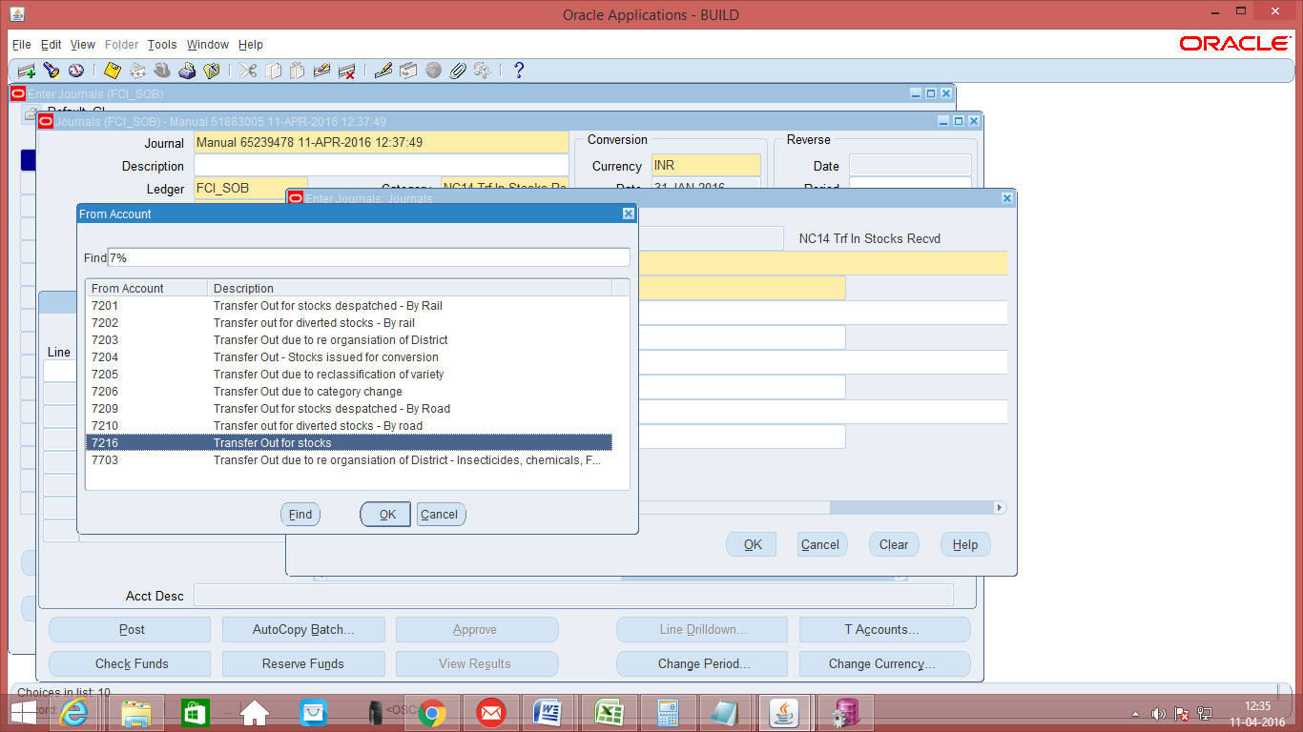

- The following checks have been added for Transfer in against stock received category.
  - Product can be same or default (0000) across all lines.
  - Default product is allowed with CGST/IGST/SGST/UTGST Expense accounts (3771,3773,3775) only.
  - Same depot for all or default depot (for account head 0981) can be used.
  - Exactly 1 line with account head 0981.
  - Intercompany segment cannot be default for line with account head ‘0981’.
  - Intercompany segment provided in line with account head 0981 should match with ‘From Depot’ segment of descriptive field in case of Transfer in stock received.
- For this category, user will also enter the GST tax related information in line level DFF. Following fields are mandatory at line level DFF (effective from 1-SEP-2017), leaving these fields blank will give an error as shown in the screen shots below: -
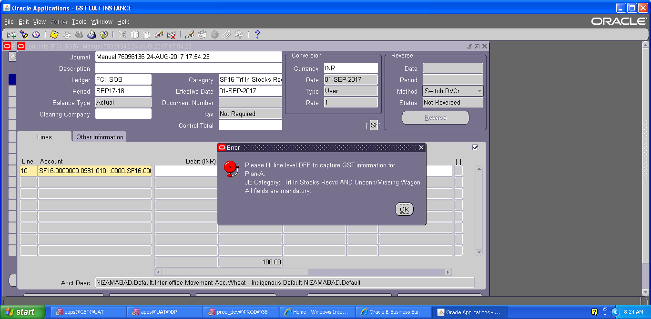
From GSTN: Enter the unit from which stock is transferred.
To GSTN: Enter the unit to which stock is transferred.
HSN code: Enter the HSN code of the product transferred (4-8 Digit Numeric value only).
Place of supply: Enter the place where stock is supplied.
Tax Rate: Enter the tax rate for tax applicable.
Invoice/ challan No.: Invoice /challan received from other party against the entry.
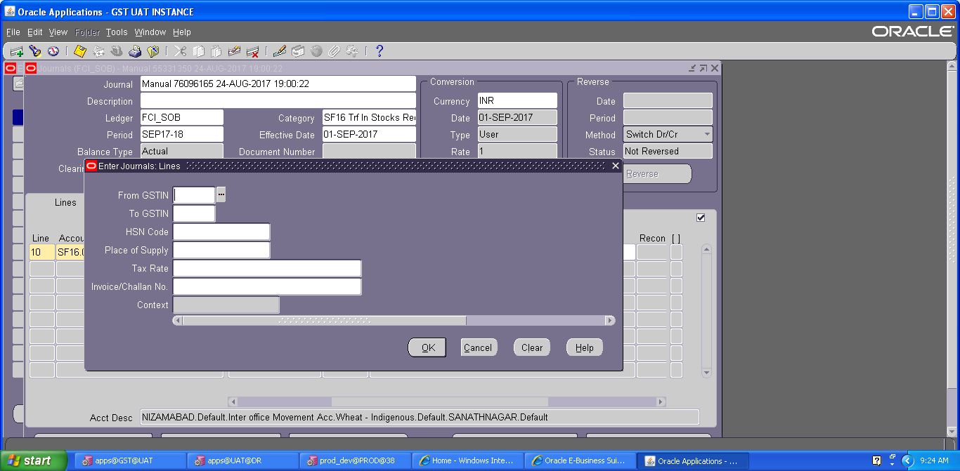
- Save your work.
- As Budgetary Control is enabled, click on ‘Check Funds’ and ‘Reserve Funds’. If Budgetary Control is enabled on those accounts, these actions will check and reserve funds on the same. If no funds are available for that particular account combination, it will not allow the transaction to proceed.
- Click on ‘Approve’. The journal will be forwarded to the approver for approval. Post-approval the transaction will be available for posting.
- Click on Post to post the transaction. This can also be done by JVs from Journals >> Post window
- As Budgetary Control is enabled, click on ‘Check Funds’ and ‘Reserve Funds’. If Budgetary Control is enabled on those accounts, these actions will check and reserve funds on the same. If no funds are available for that particular account combination, it will not allow the transaction to proceed.
- Click on ‘Approve’. The journal will be forwarded to the approver for approval. Post-approval the transaction will be available for posting.
- Click on Post to post the transaction. This can also be done by JVs from Journals >> Post window
Note: When the process of disabling the code combination id is in progress. . The user will not be able to make any new entry. The user will get an error-“The code combination is obsolete”.

Manual Journal Entry – FCI Loss regularization
Function Path: Normal General Ledger responsibility>> Journals >> Enter >> New Journal.
The FCI loss regularization entries are made for recording the write off sanctions of the transit losses, storage losses and voyage losses etc. Recording these transactions would help in preparing the statement of loss regularization.
Steps:
  - To create a new manual journal entry, click on new journal in the find journals window.
  - Journal Name: Leave the Journal name blank. It will automatically take the system date and time as Journal name.
  - Period: Enter the Period, effective date. Adjusting periods are available at the end of each quarter and year beginning with ‘ADJ’
  - Currency: Enter currency details. The currency will be ‘INR’ for the category ‘FCI Loss regularization’.
  - Category: Enter the category as ‘Unit name (e.g. SB16, NC 14) FCI Loss regularization ‘.
  - Header Level DFF (Descriptive Flex field): For the category FCI Loss regularization, the information has to be captured in the HEADER level DFF. The month and year of loss has to be captured. DFF is nothing but place to record additional information about the category of the Journal entry being passed. Click on the angular bracket of the DFF indicated as follows:

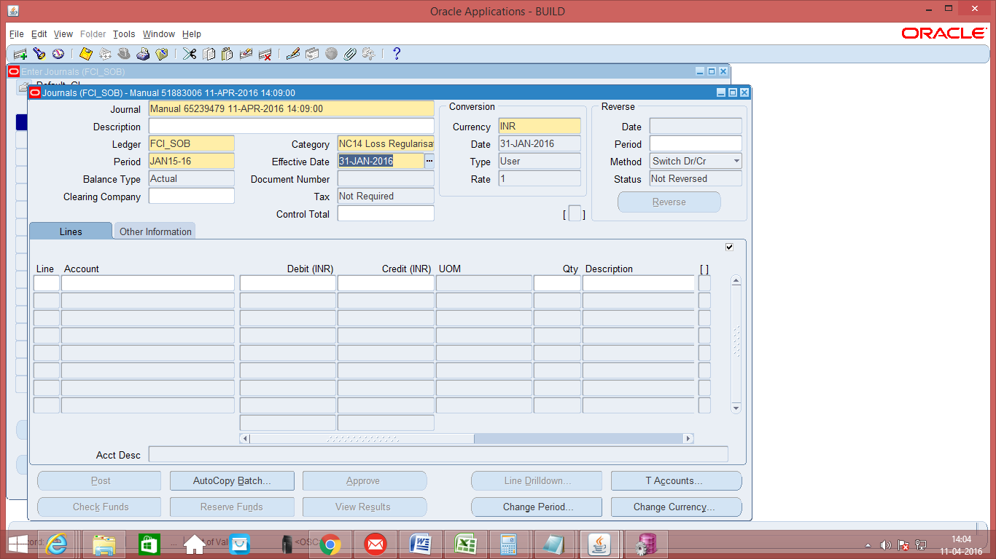

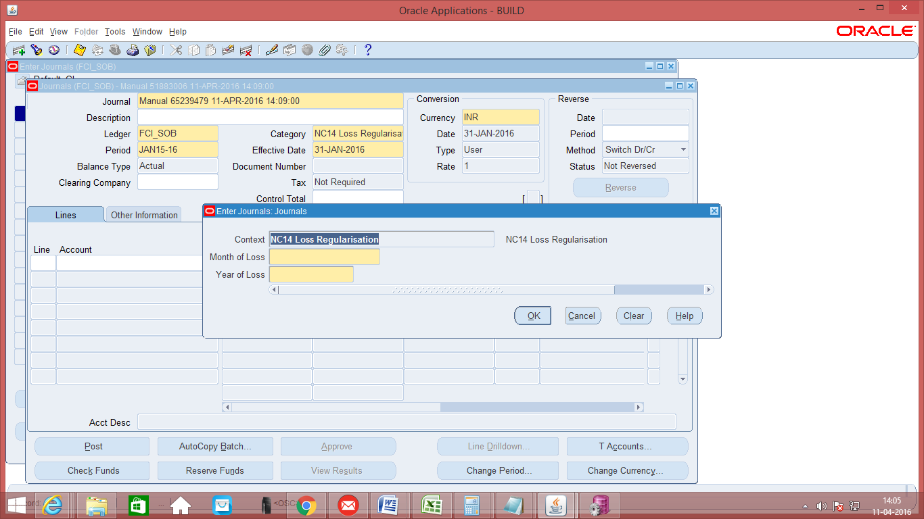
  - Data entry in the Header Level DFF (Descriptive Flex field): On clicking the DFF symbol, fields to capture, the month and year of loss will appear. Both the fields Month of Loss and Year of Loss are mandatory.
  - Enter the JV in the lines taking the account code for loss regularization with respective commodity and save the transaction. In the Line Number column of the Journal Entry, the numbering to be followed is in series of 10, i.e. numbering would be 10, 20, and 30 and so on.
  - As Budgetary Control is enabled, click on ‘Check Funds’ and ‘Reserve Funds’. If Budgetary Control is enabled on those accounts, these actions will check and reserve funds on the same. If no funds are available for that particular account combination, it will not allow the transaction to proceed.
  - Click on ‘Approve’. The journal will be forwarded to the approver for approval. Post-approval the transaction will be available for posting.
  - Click on Post to post the transaction. This can also be done by JVs from Journals >> Post window
The steps of ‘Check Funds’, ‘Reserve Funds’, ‘Approve’, ‘ Post’ are also explained in detail in separate sections of this document.
Note: There is a restriction on journal form that will not let the user, approve/post/reserve funds for any other unit’s journal. The changes can only be done when first four characters of the Category of the Journal and first four characters of the responsibility being used are same, otherwise it will not let the user view the journal.
Note: When the process of disabling the code combination id is in progress. . The user will not be able to make any new entry. The user will get an error-“The code combination is obsolete”.

MANUAL JOURNAL ENTRY- StOCK
Function Path: Unit GL USER STAT ENTRY responsibility>> Journals >> Enter >> New Journal
Note: New responsibility is created to enter single line entry STAT journals under the category Unit_Stock (w.e.f. 01-APR-2018).
- To create a new manual journal entry, click on new journal in the find journals window.
- Journal Name: Leave the Journal name blank. It will automatically take the system date and time as Journal name.
- Period: Enter the Period, effective date. Adjusting periods are available at the end of each quarter and year beginning with ‘ADJ’.
- Currency: Enter currency details. The currency will be ‘STAT’ for all statistical transactions. This refers to those transactions for which only quantity is to be recorded.
- Category: Enter the category. The category name will be appended with the unit name. Enter the journal category with the unit name beginning with the unit to which the user belongs.
Simple Manual entries will be entered in the category ‘Stock’.
- Enter the JV in the lines and save the transaction. In the Line Number column of the Journal Entry, the numbering to be followed is in series of 10. Further for this category only single line journal entry is allowed.
- Also while making the lines entry, user can make entry only in the following accounts (7411, 7421, 7422, 7423, 7424, 7431, 7432, 7442 and 7441) and these accounts are not allowed in Normal General Ledger responsibility.
Note: When the process of disabling the code combination id is in progress. . The user will not be able to make any new entry. The user will get an error-“The code combination is obsolete”.
Screen shot of Journal Form:
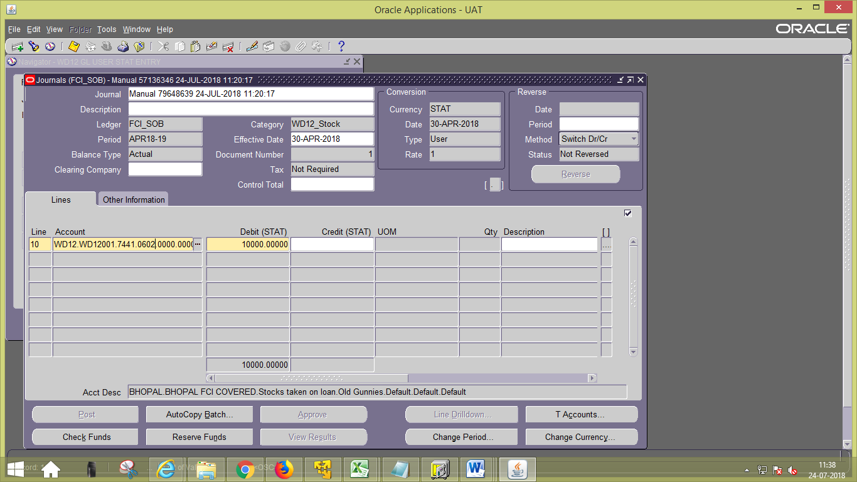
- Save the Journal and click on ‘Check Funds’, explained in the section ‘Journal – Check Funds’
The steps of ‘Check Funds’, ‘Reserve Funds’, ‘Approve’, ‘Post’ are also explained in detail in separate sections of this document.

Journal Reversal

Function Path: Journal >> Enter
Steps:
- Enter the search criteria viz. source, category, period and the batch name etc. to find the journal batch (es) which you want to query/review.
- Click on Reverse. Enter the Period in which the journal is to be reversed in the Reverse Region and save it.
- The reversed entry will have the name beginning with ‘Rev’

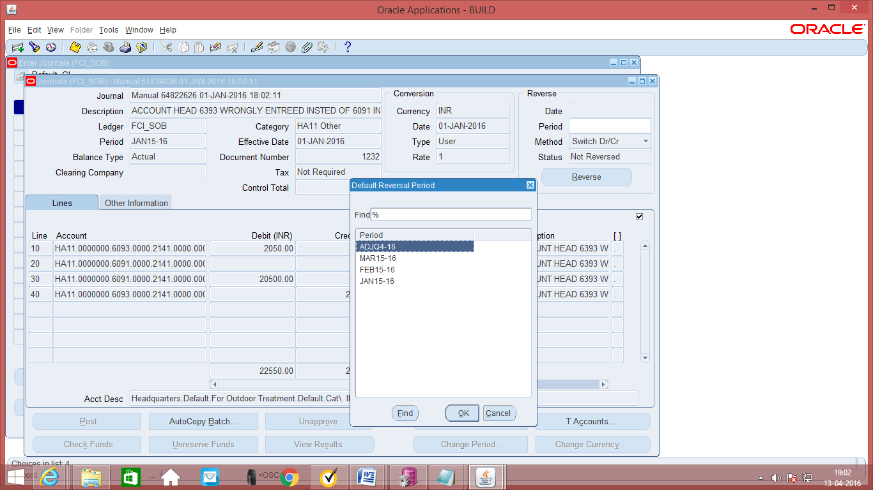
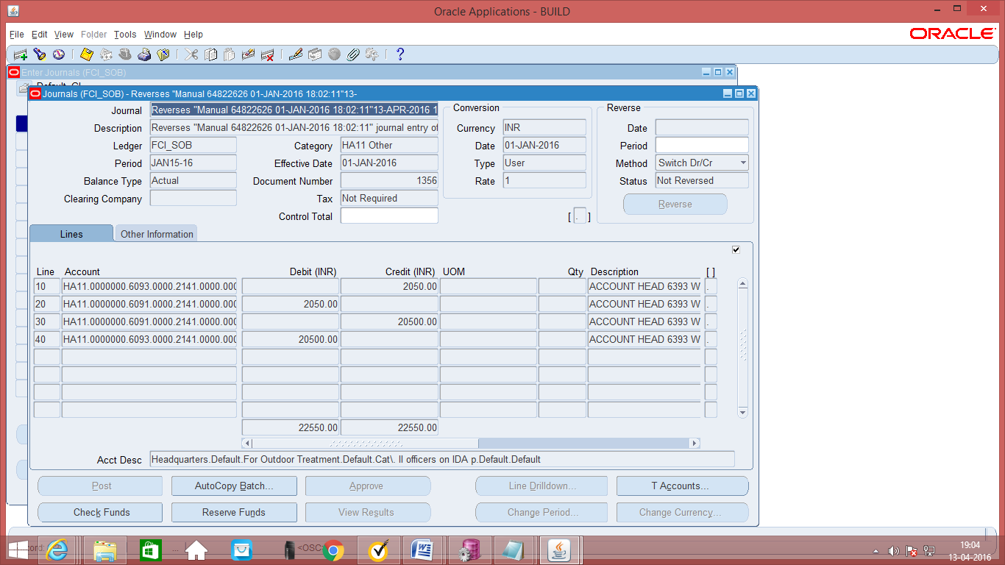
As per the security check applied in the system, user will not be able to reverse the journals having source as Payables, receivables or Treasury.
Only the journals with source Manual could be reversed, and for this also, journal should contain only single unit at line level.
Note 1: As per CR- 357, user will be able to reverse the journals of his unit, having source as assets. Customization has been applied in such a way that, if the journal contains two different units in lines, he will not be able to reverse it, but if it contains a single unit he can reverse it from general ledger responsibility of that unit.
For instance : If the user is logged in from EC17 , then he can reverse the journals with source as asset, that only contain EC17 at line level, if SB17 also exist at line level, neither EC17 nor SB17 can reverse it.

Note 2: In R12 instance, users are no longer allowed to reverse 'Unposted’ journals. Also, Journals with frozen journal sources are prevented from being reversed to streamline the reconciliation of data from Sub ledger Accounting sources.

Exporting a Journal into Excel
The following procedure explains how to export into GL.

Exporting the Trial Balance to excel
Log in to the system with General Ledger Responsibility
Function Path: Journals >> Enter >> New Journal.
Steps:
- Click on Find and Find the requisite journal. Search parameters may be entered to narrow down the search to the required entry. To facilitate quick finding, you may find on the category for the Trial Balance, which is ‘Unit Name ‘
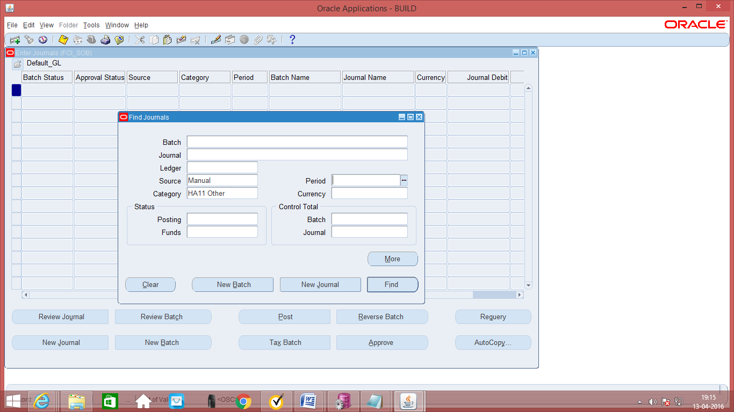
- Review Journal: Click on review Journal to review the Journal.
- Export to Excel: On opening the Journal, click the first line of the Journal entry and export the file to Excel by clicking on the file menu and then export.
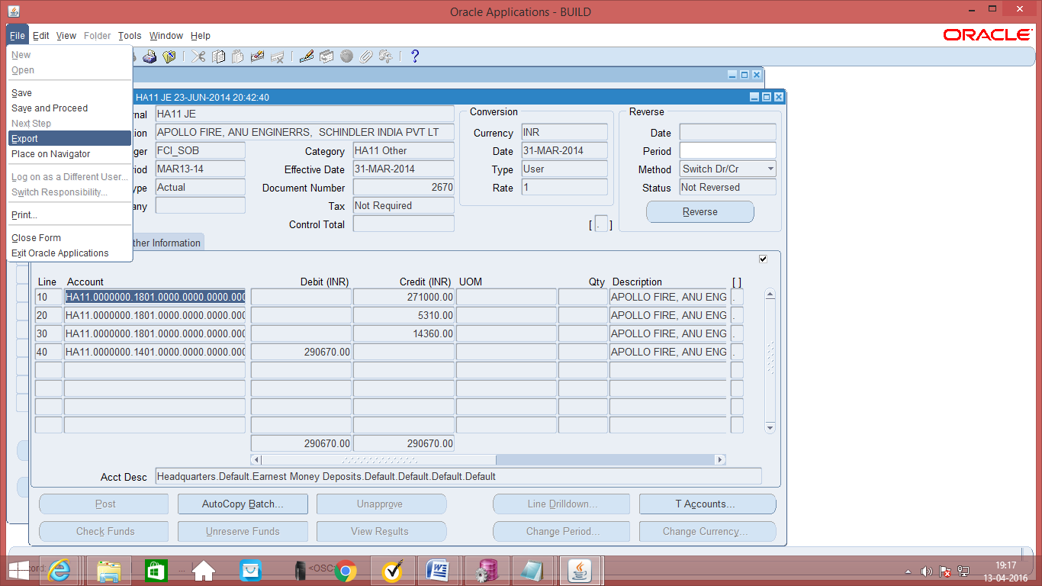
- Export to Excel: On opening the Journal, click the first line of the Journal entry and export the file to Excel by clicking on the file menu and then export. IMPORTANT: Please keep the control key pressed while exporting to excel.
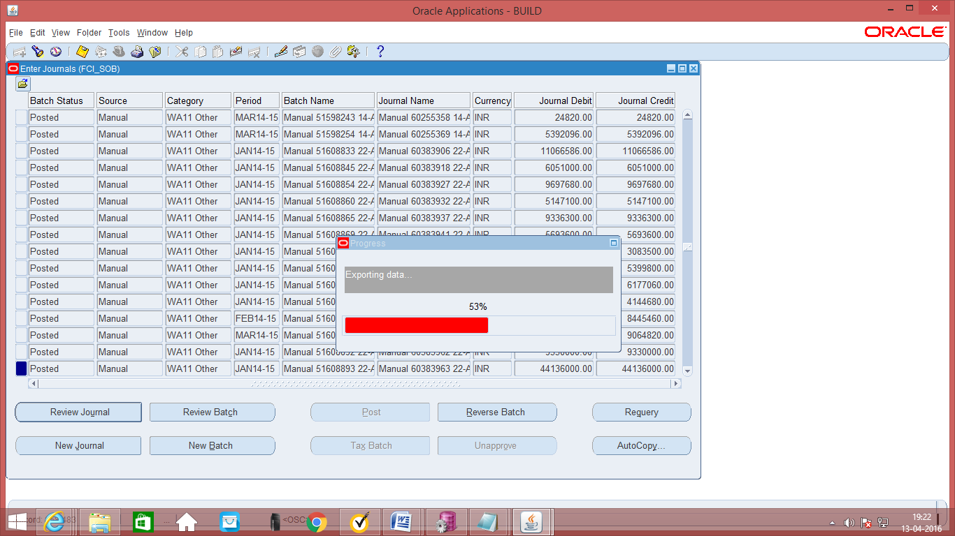

- Continue to End: If you get a message box, press continue to end to continue exporting. System will start exporting data.
- Save the TSV: The file format is of the type tsv, save it in the requisite folder. The file can be changed to WA11_TB_EXPORT.tsv.
- Convert the tsv to xls: Open Microsoft excel and open the csv. Please ensure that the file type at the bottom is all files or else the files with the type csv will not be seen.
- Type Delimited: Select the type as delimited.
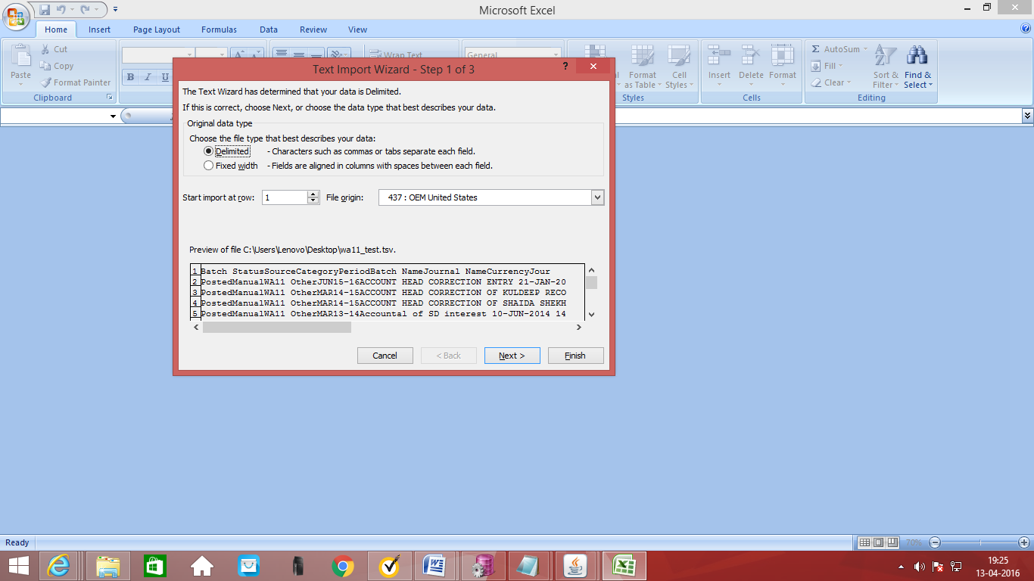

- Complete the tsv to excel conversion: Click on next to complete the conversion to excel.
- Compare excel to excel: Since the trial balance from the system is available in excel now and the original trial balance provided to Headquarters is also available in excel, the two may be compared. The excel can be sorted on any basis like sort on debit amount and then sort on credit amount to facilitate comparison.

System report on trial balance
Log in to the system with General Ledger Responsibility
Function Path: View>> Requests >> Submit a new request.

- New Request: Click on Submit a new request.
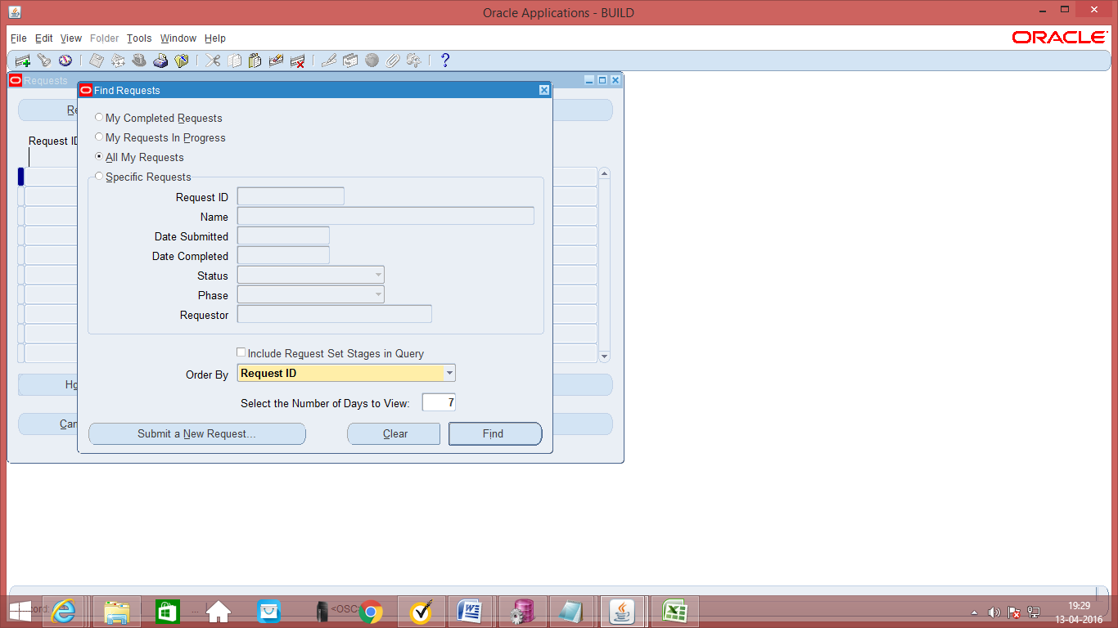

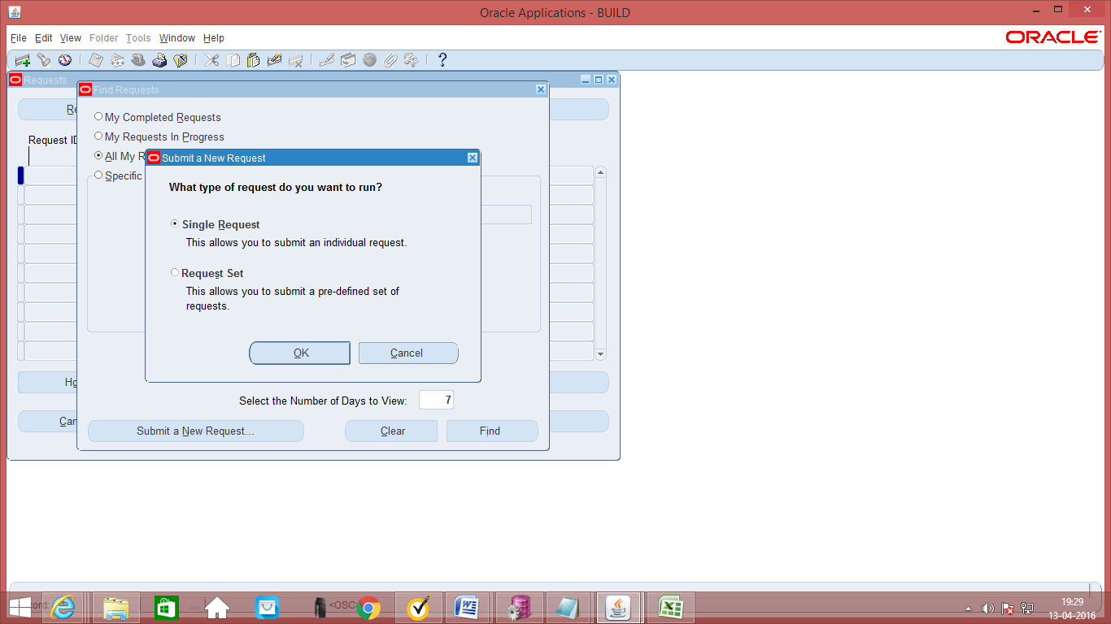
- Trial Balance Detail: Select the report Trial Balance - detail.
- Parameters: Enter the requisite parameters
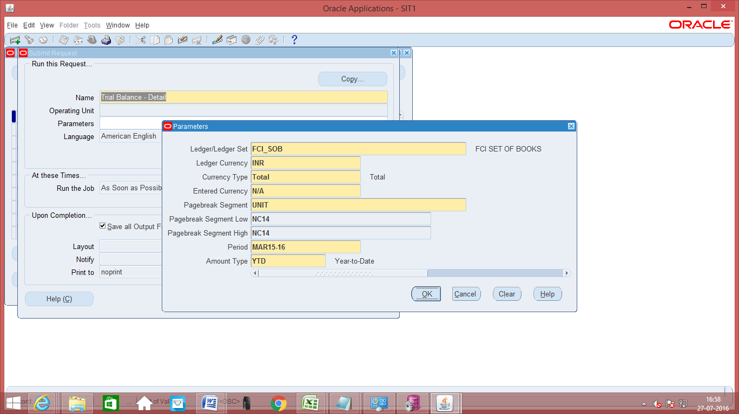

- View Output: Click on view output to see the output. The output is available in rdf format and cannot be exported to excel. Compare the output with the excel provided to head quarters.
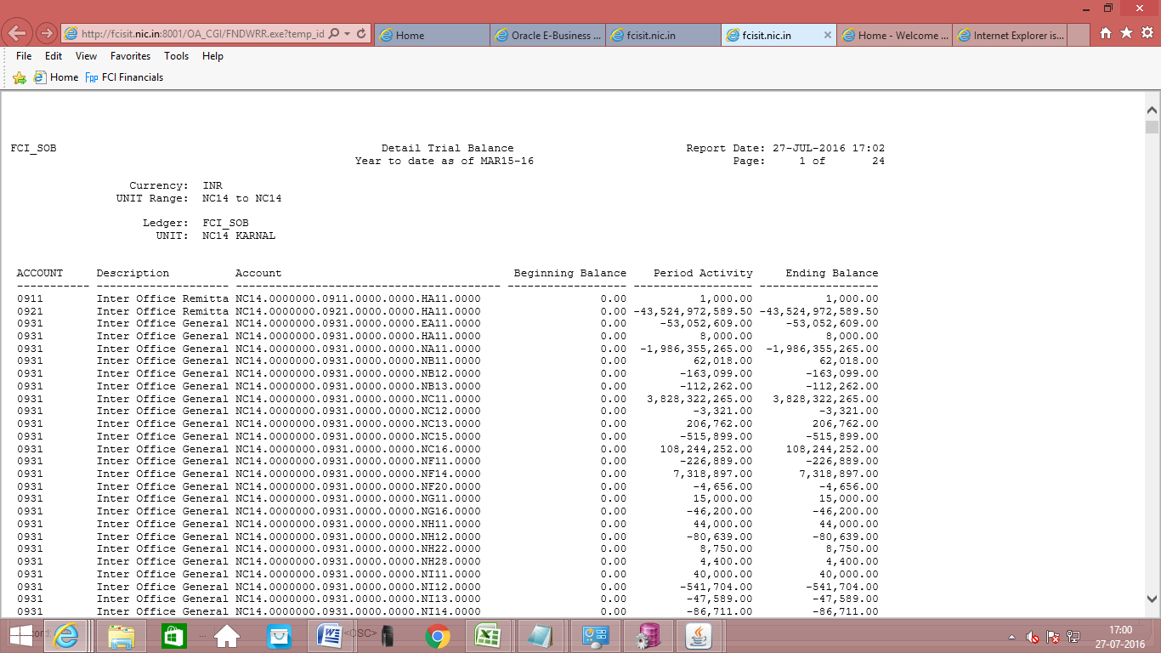

Verification Procedure for General Ledger Stock Ledger Summary

There are two ways to verify the Stock Ledger Summary. The first method involves exporting the Journal Entry of the Stock Ledger Summary to excel and the second approach involves taking a report from the system.

Exporting the Journal ENTRY TO excel
Log in to the system with General Ledger Responsibility
Function Path: Journals >> Enter >> New Journal.
Steps:
- Click on Find and Find the requisite journal. Search parameters may be entered to narrow down the search to the required entry. To facilitate quick finding, you may find on the category for the Trial Balance, which is ‘Unit Name ‘. Stock Ledger Summary is a zero amount entry with the quantity being entered in the statistical amount.
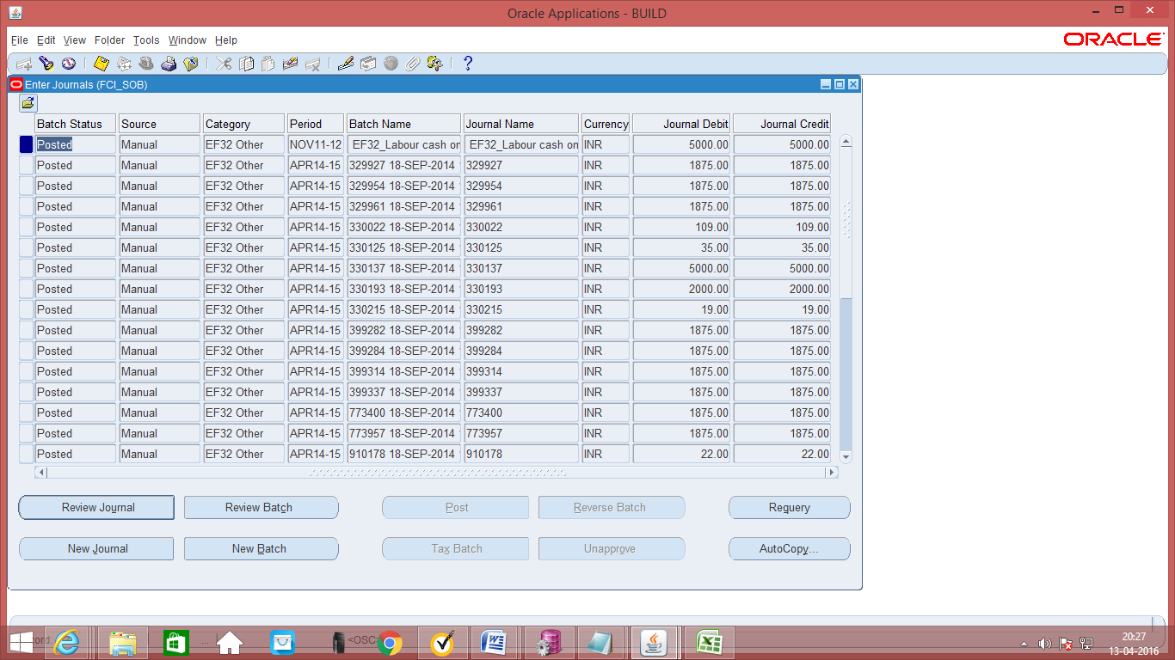

- Review Journal: Click on review Journal to review the Journal.
- Export to Excel: On opening the Journal, click the first line of the Journal entry and export the file to Excel by clicking on the file menu and then export.
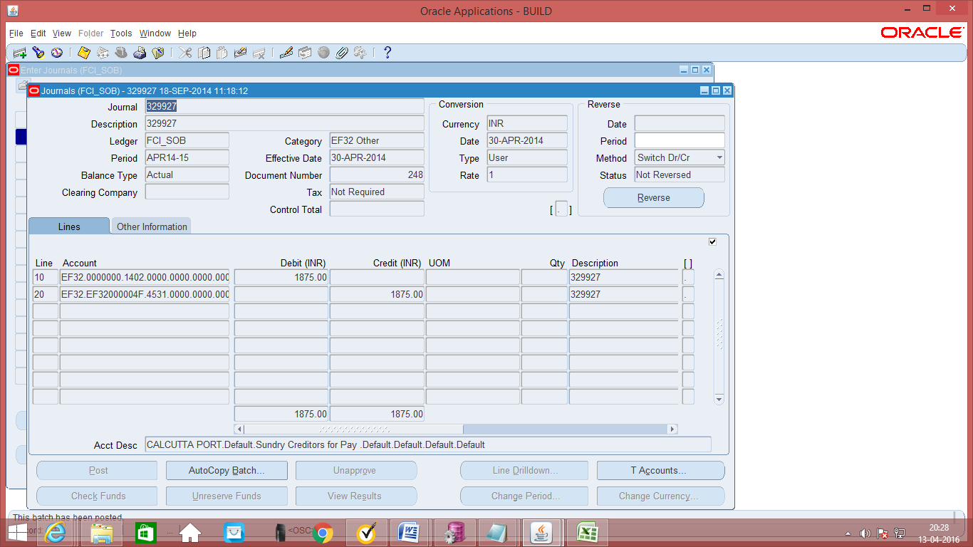
- Export to Excel: On opening the Journal, click the first line of the Journal entry and export the file to Excel by clicking on the file menu and then export. IMPORTANT: Please keep the control key pressed while exporting to excel.
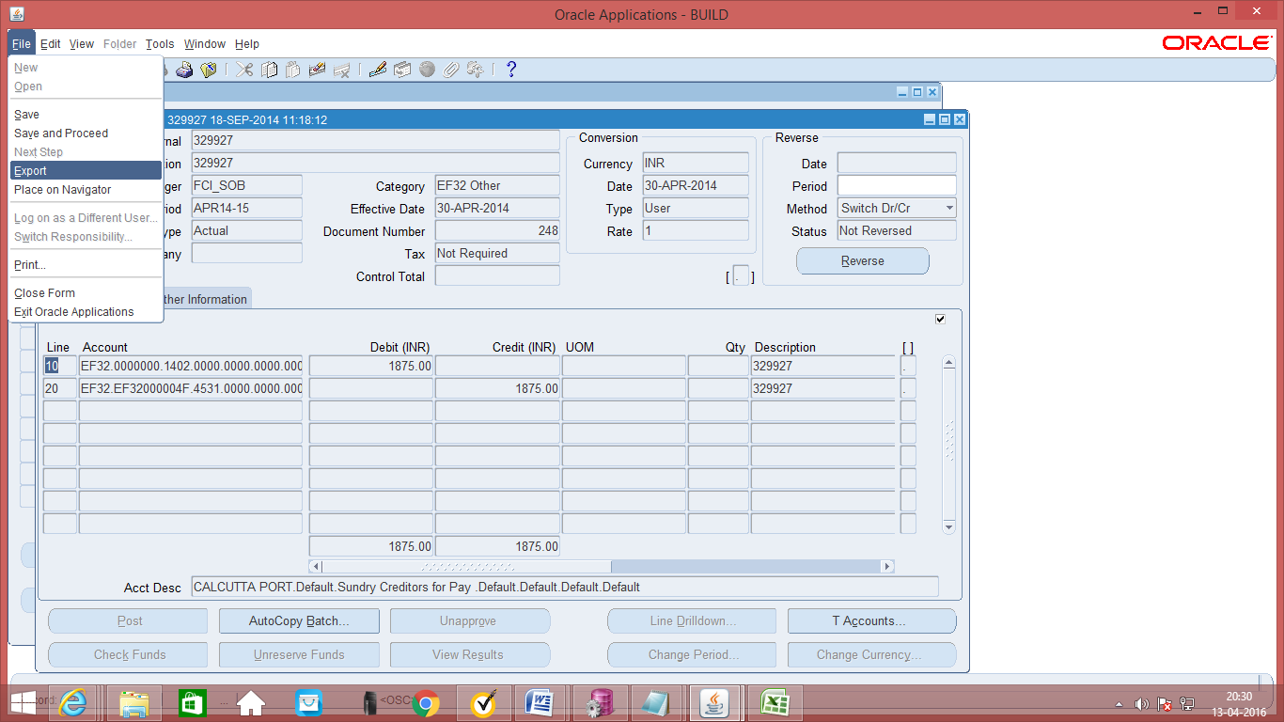

- Continue to End: If you get a message box, press continue to end to continue exporting. System will start exporting data.
- Save the TSV: The file format is of the type tsv, save it in the requisite folder. The file can be changed to EF32_SLS_EXPORT.tsv.
- Convert the tsv to xls: Open Microsoft excel and open the csv. Please ensure that the file type at the bottom is all files or else the files with the type csv/tsv will not be seen.
- Type Delimited: Select the type as delimited.
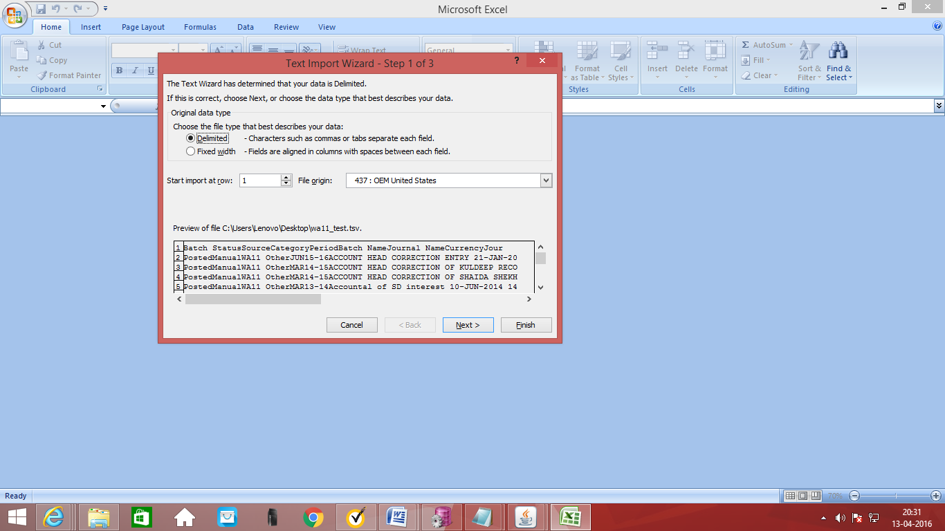

- Complete the tsv to excel conversion: Click on next to complete the conversion to excel.
- Analyse excel: The excel can be sorted on any basis like sort to facilitate comparison.

Journal Inquiry

Note: The journal can only be viewed when first four characters of the Category of the Journal and first four characters of the responsibility being used are same, otherwise it will not let the user view the journal.
There are two ways to query on a Journal. The first way is to press F11 on the Journal entry screen. The second way is through the Inquiry >> Journal path.
First Method
Function Path: Journals >> Enter >> Journal
Steps:
- Just as to create a new manual journal entry, click on new journal in the find journals window.
- Click on ‘F11’ function key. On clicking ‘F11’ function key, the colour of the screen changes to greyish blue as follows.
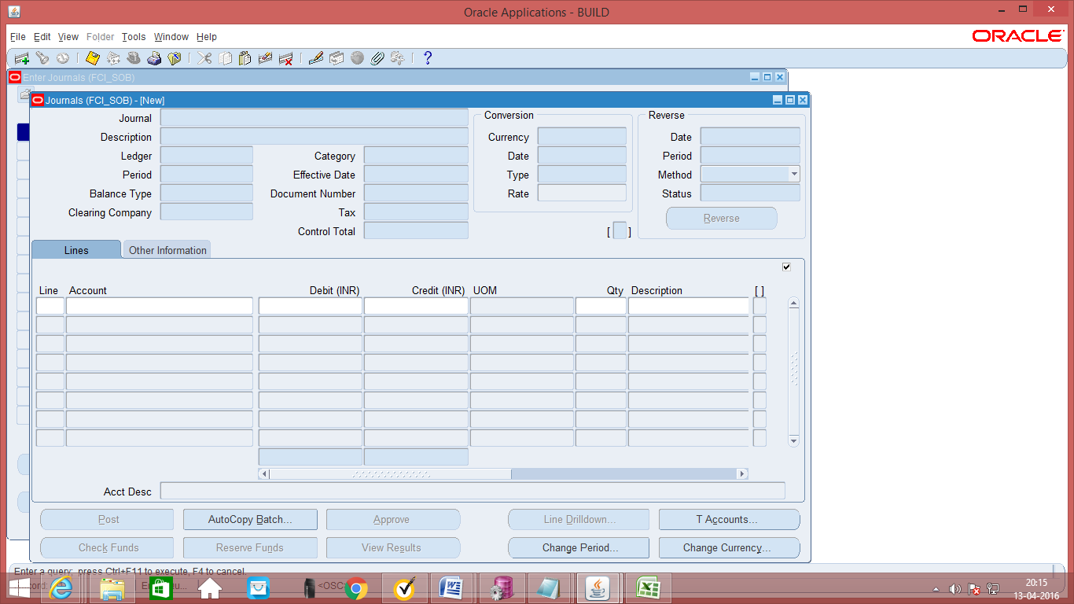
- Enter the search criteria on the basis of which you want to search the Journal entries. The search criteria could be anything for which you want to query the Journal like Journal name, Period, Effective Date, Currency, Category, or even the Status of Posting, status of funds, status of approval, entry reversal criteria etc.
Press ‘CTRL’+’F11’ to execute the query. The results will be retrieved on the basis of the search criteria entered. If you do not enter the search criteria, and just press ‘CTRL’+ ‘F11’ to retrieve ALL the results.

- To query on the basis of DFF: DFFs are dependent on Journal Category. So, first enter in the query mode by pressing ‘F11’ function key. , enter in the category on the basis of which the context sensitive DFF appears.
- 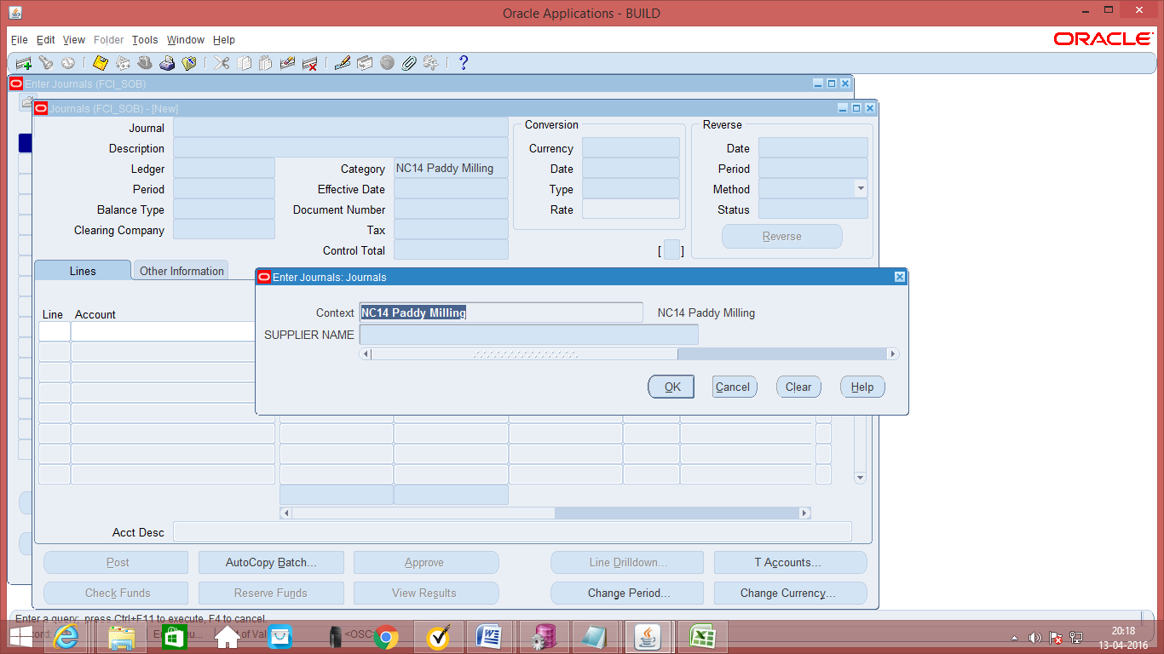
- Enter the criteria in the DFF. Press ‘CTRL’+’F11’ to execute the query.
Second Method
Function Path: Inquiry >> Journal
Steps:
- Enter the search criteria viz. source, category, period and the batch name etc. to find the journal batch (es) which you want to query/review.
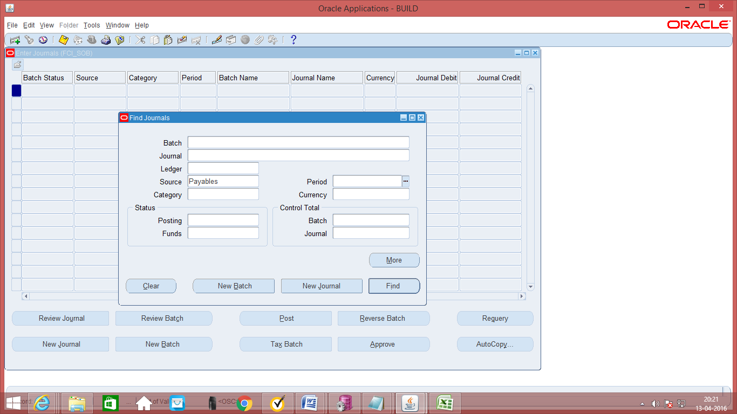
- Now you can review the batch details/ journal details within the batch.
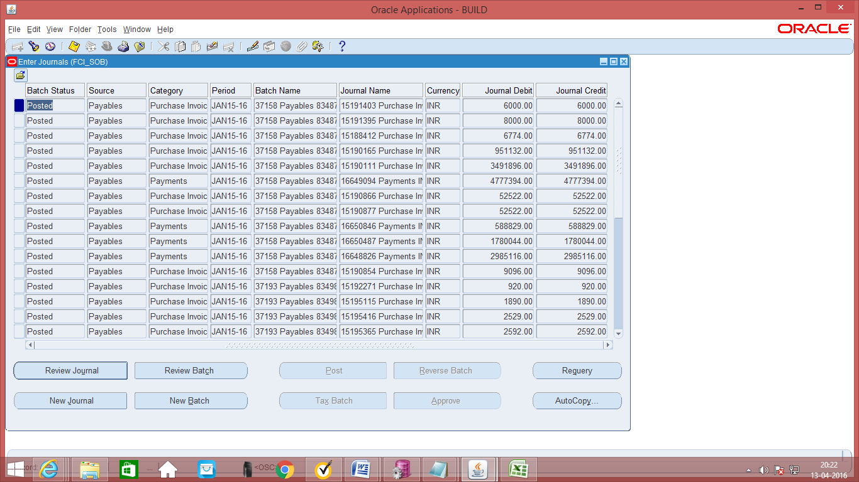

Account Inquiry
Function Path: Inquiry >> Account
Steps:
- Enter selection criteria for the account viz. From/to Accounting period, Currency (Single/ All), Balance Type (Actual / Budget), Account number(s), Currency type (entered).
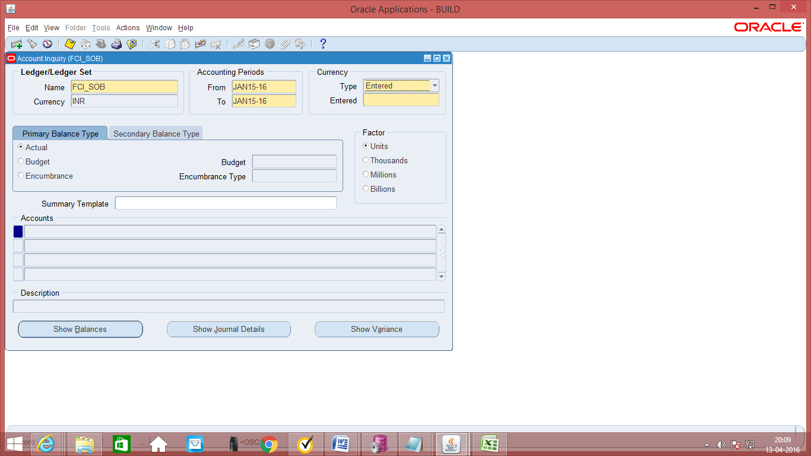

- If you want to check the balance in the account for the period, click on Show Balances, if you want to check the journal details impacting the account then click on Show journal details.
- Click on Journal Details
- For transaction related to oracle sub-ledger, you can also use the drill down feature and check the transaction for that particular journal.
- Accounting for that particular transaction can also be checked

Parent/ Summary Account Inquiry
Function Path: Inquiry >> Account
Steps:
- Enter selection criteria for the account viz. From/to Accounting period, Currency (Single/ All), Balance Type (Actual / Budget), Account number(s), Currency type (entered).
- Select the Summary Account to be queried. Click on ‘OK’ to see all the accounts in the summary template. Click on ‘Show Balances’ to see the account balance. To see all accounts of a summary template, just check on ‘OK’ without selecting anything as seen in the snapshot below:
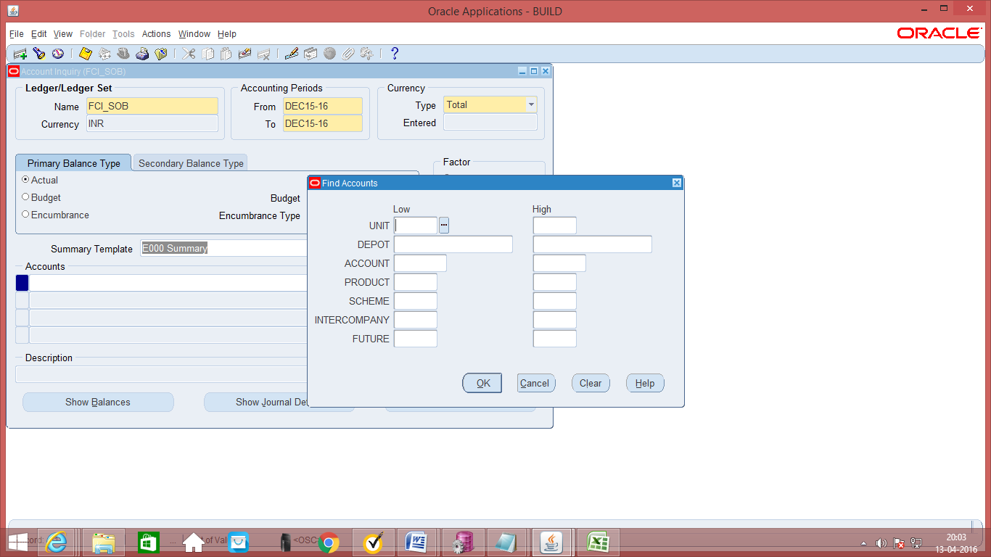

This will display all the accounts of the specified summary template. To see a particular account, enter the account value.
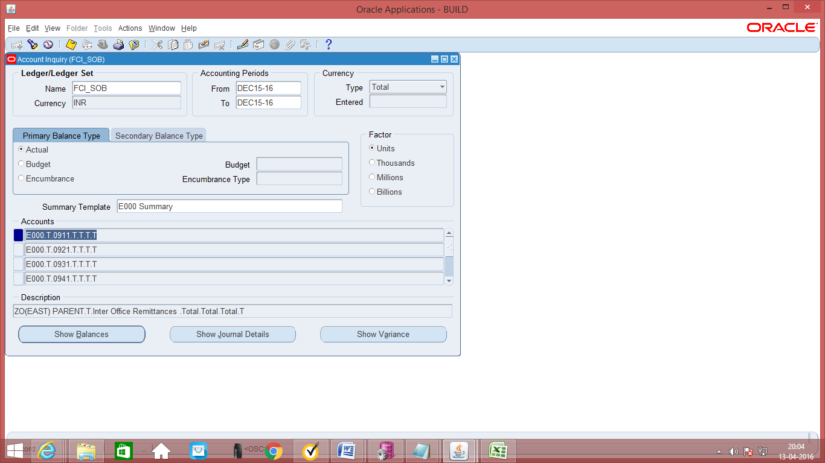

- Click on Show Balance to see the balances

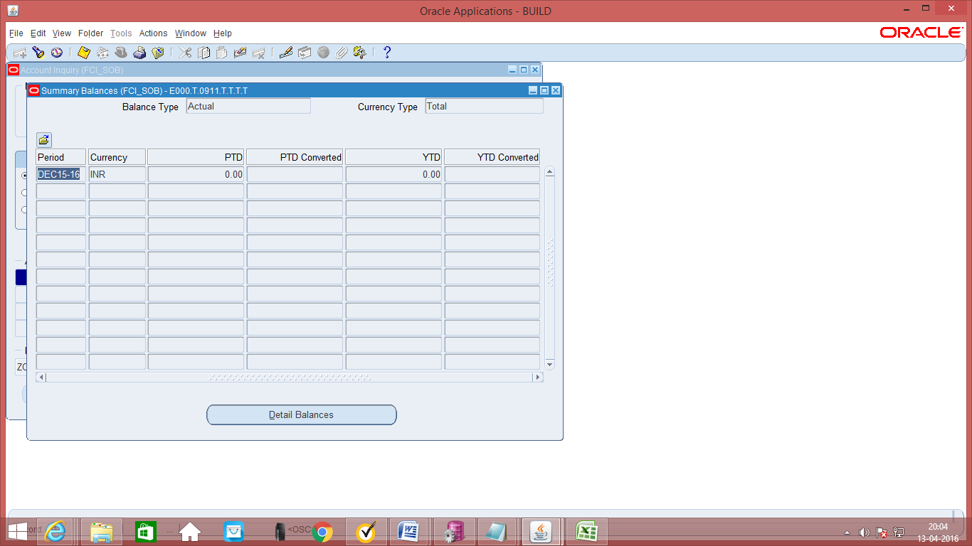

- Click on Detail Balance to see the details
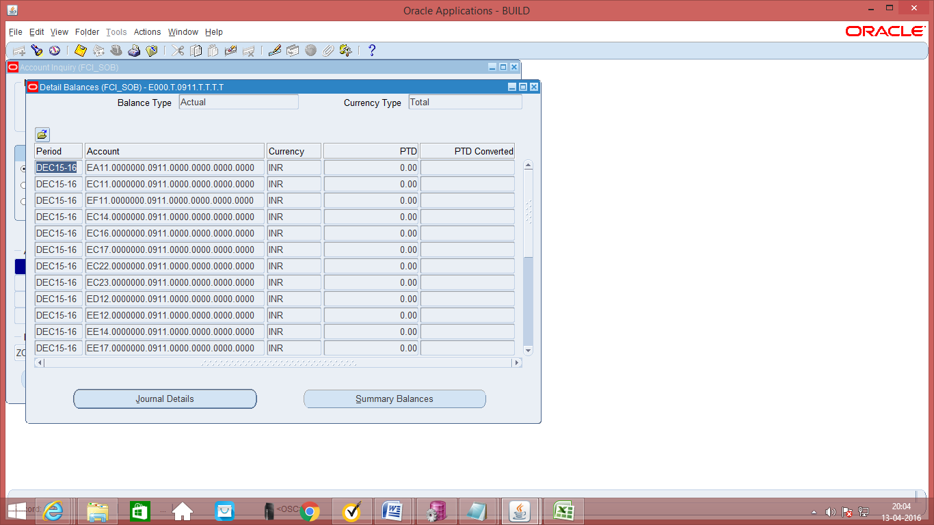

gl rECONCILIATION

GL Entry Reconciliation is a set of forms and reports that enable the user to selectively cross-reference transactions in the General Ledger. Once the balance of a group of transactions is zero, the user can mark them as reconciled.
This functionality enables the transactions in any account that should balance to zero to be reconciled. With this, the unreconciled lines are the justification of the account net balance.
The natural account for which the reconciliation is to be enabled has to be marked as reconcile in the natural account definition. Once this has been done, the reconciliation reference column in the Journal entry form will become enabled for data entry.

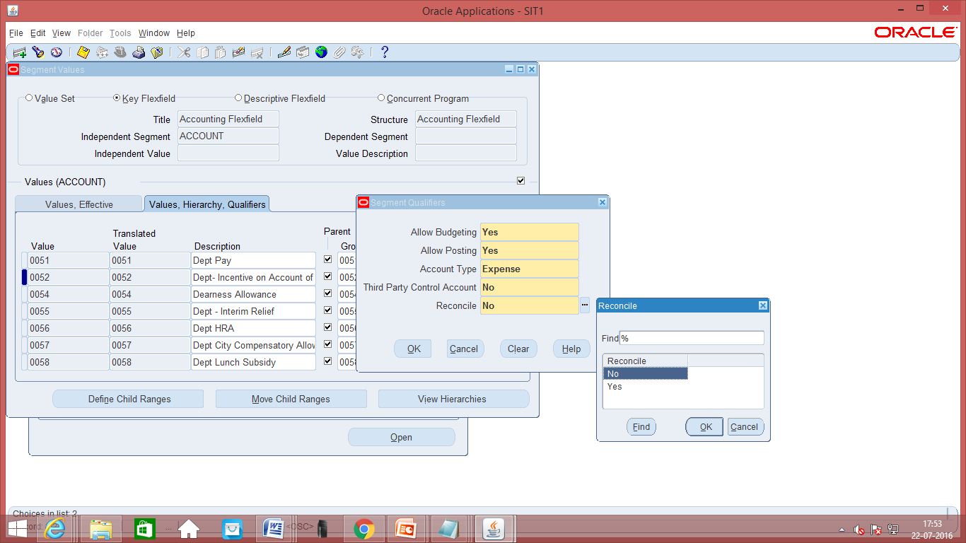
Fig: Natural Account Definition
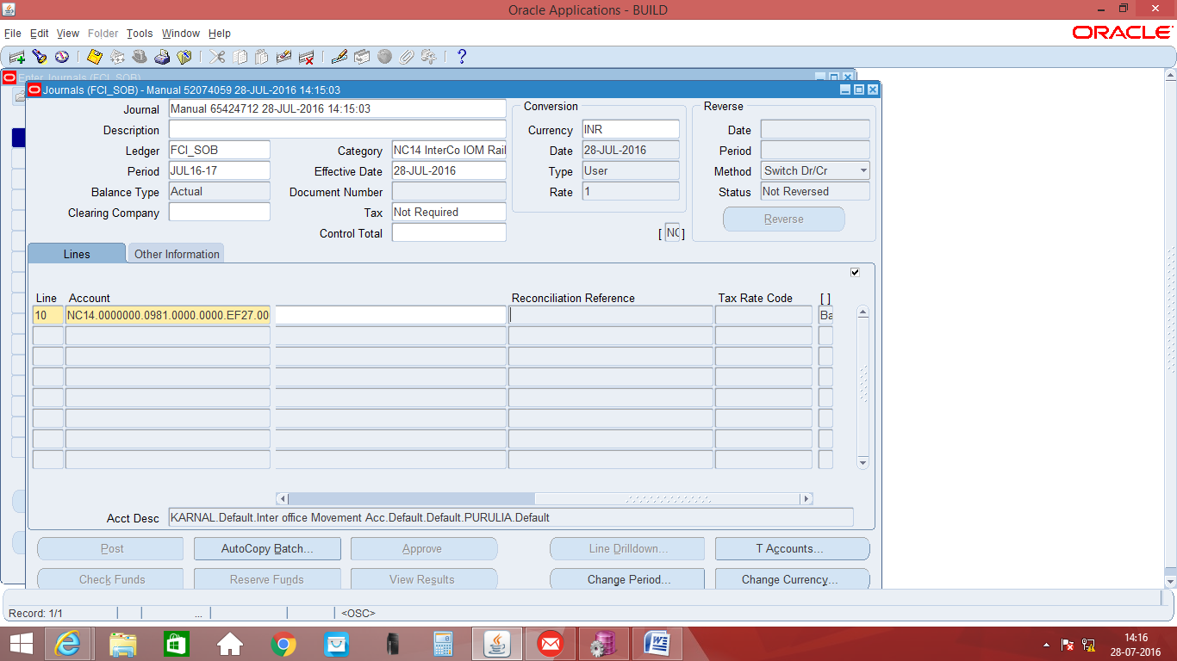
Fig: Journal Entry Screen – Reconciliation Reference
Manual as well Automatic reconciliation is available. The transactions which have been marked as reconciled can also be reversed.
Manual Reconciliation
Function Path: Journal->Reconciliation->Reconcile
Steps:
- Navigate to Reconcile form. Enter the selection criterion and click on the search button. All the unreconciled lines for the criterion will appear on the form.
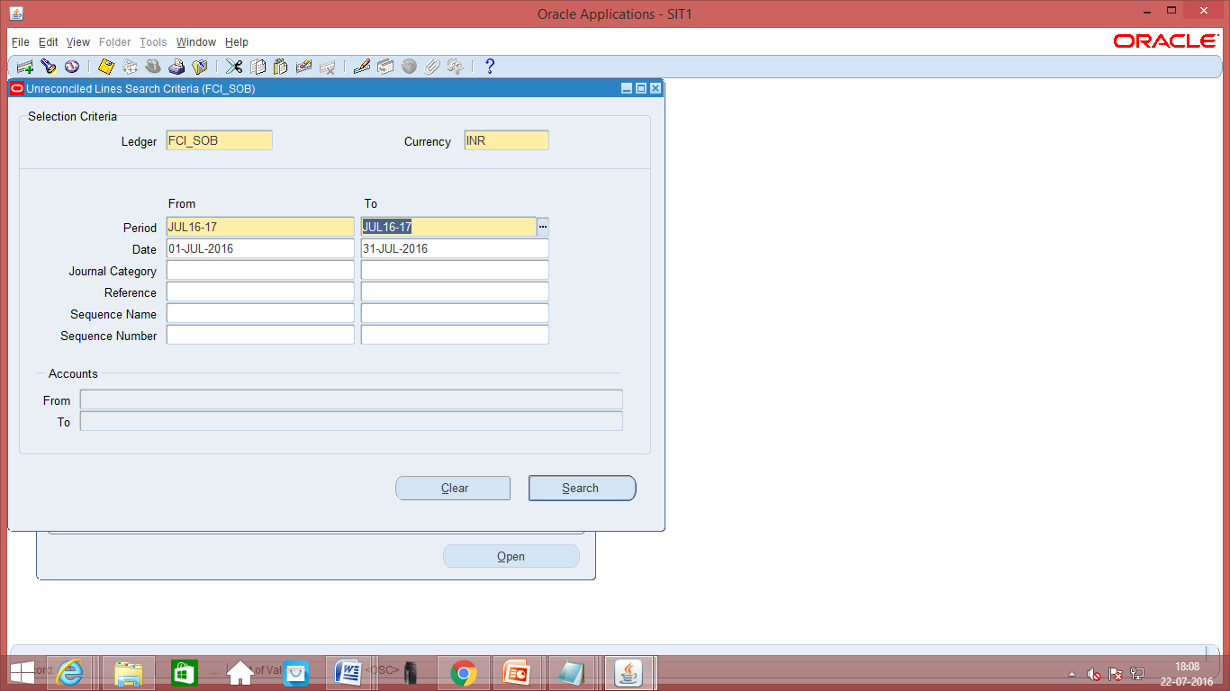
Fig: Reconcile Form – Search Window
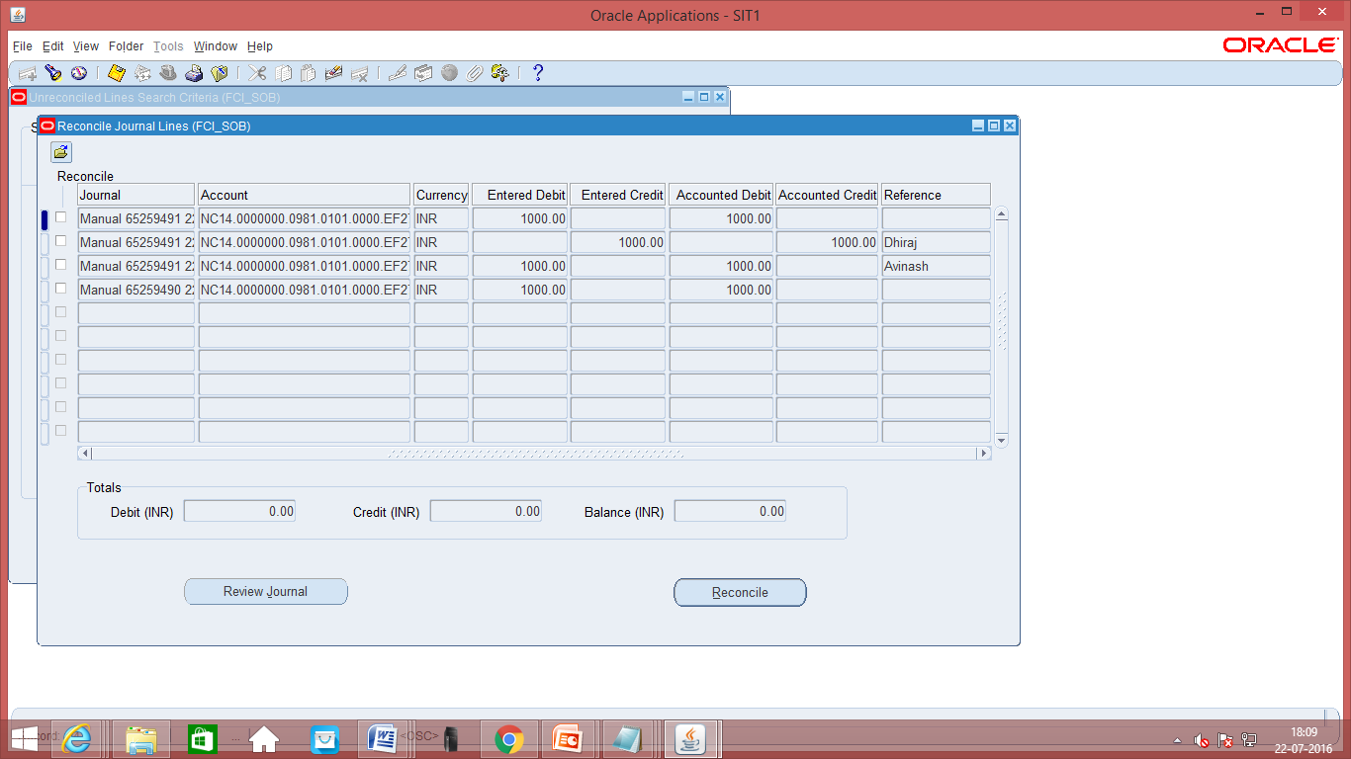
Fig: Reconcile Form
2. Check the reconcile check box for the lines to be reconciled and click on the reconcile button. The lines will be marked as reconciled if the credit and debit tally.
Reverse Reconciliation
Function Path: Journal->Reconciliation->Reverse
Steps:
1. Navigate to Reverse form. Enter the selection criterion and click on the search button. All the reconciled lines for the criterion will appear on the form.
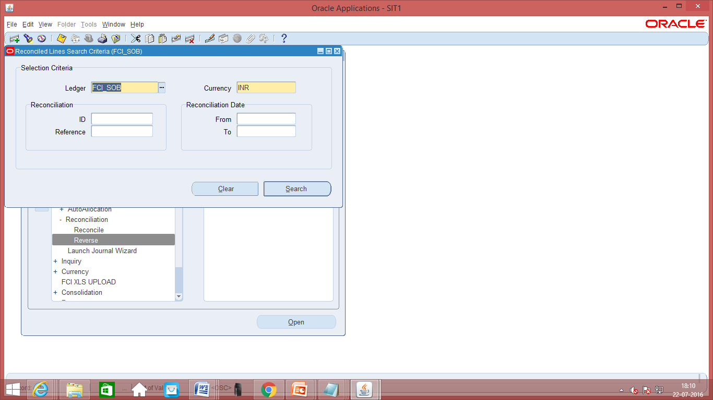
Fig: Reconciled Lines Search Window
2. Check the Unreconcile check box for the lines to be Unreconciled and click on the Unreconcile button. The lines will be marked as Unreconciled if the credit and debit tally.

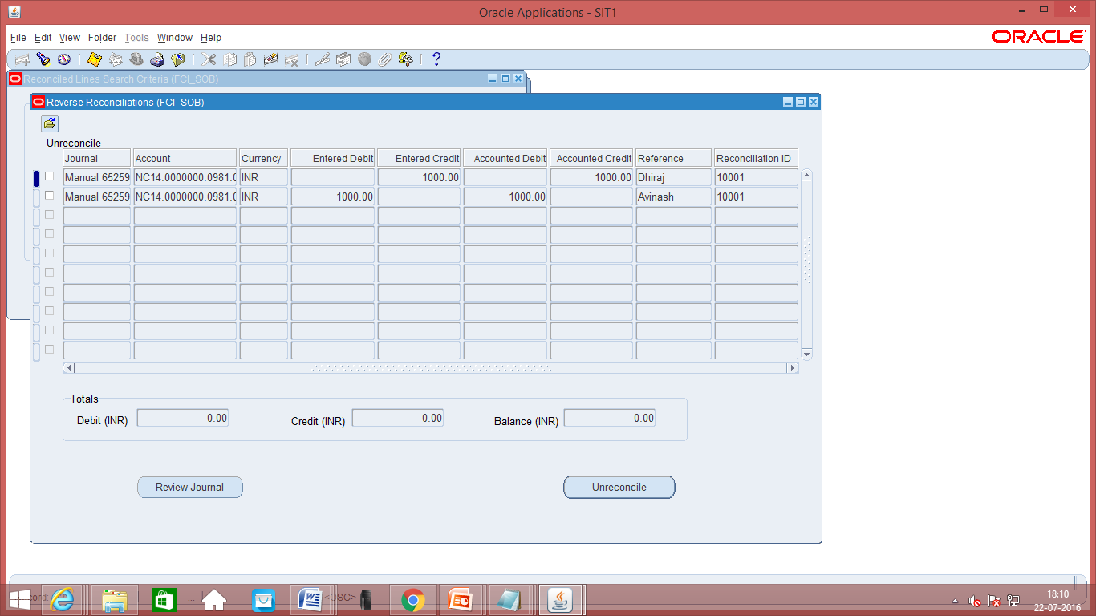
Fig: Reverse Reconciliation

Automatic Reconciliation
Function Path: View->Requests->Run
Steps:
- Navigate to View -> Requests -> Run, then choose single request.
- Select the request Reconciliation – Automatic Reconciliation. Enter the Reconciliation criterion and submit the request.
- The lines reconciled by the request can be viewed in the output of the request.

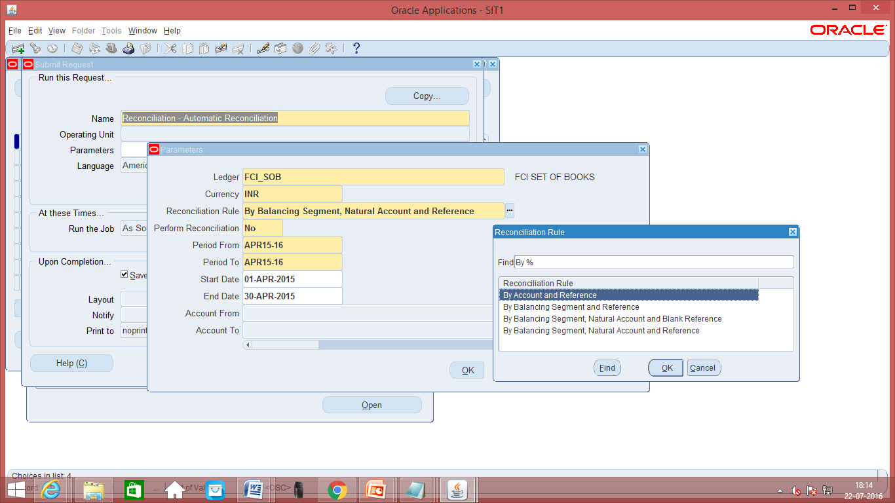

Note:
1. Reconciliation references will auto generated for Transfer Out and Transfer In category.
2. Reconciliation rules in Automatic reconciliation have been customised to allow reconciliation only on the basis of references.

rECURRING jOURNALS

Define recurring journal formulas for transactions that you repeat every accounting period. Your formulas can be simple or complex. Each formula can use fixed amounts and/or account balances.
Define Recurring Journals
Function Path: Journals->Define->Recurring
Steps:
1. Enter the Recurring batch name, Journal name and Journal Category. Save the details.

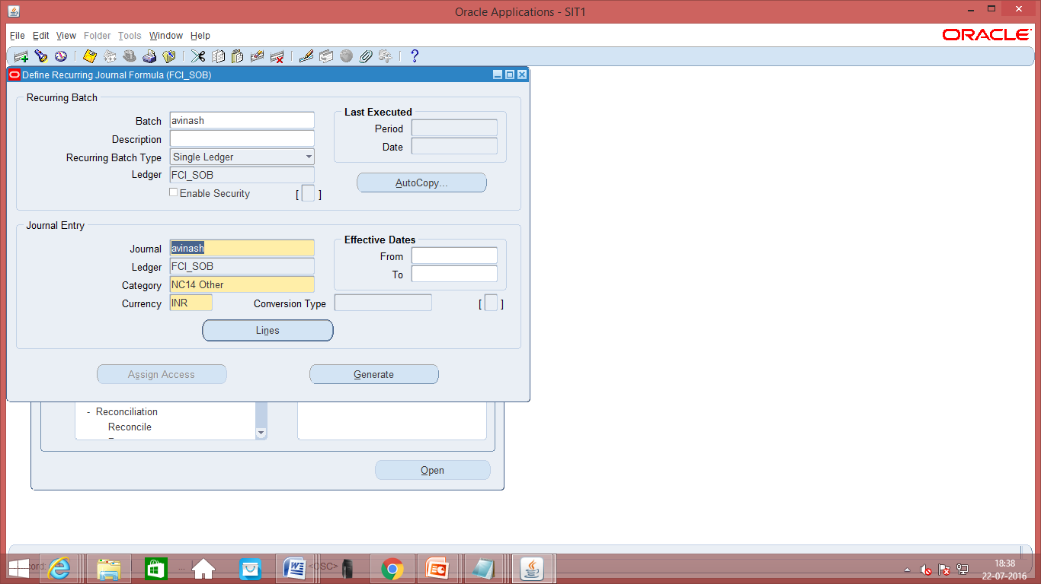
Fig: Define Recurring Journal

2. Click on the lines button. Enter the Line No., Account, Line description and formula. Save the details. Similarly create other lines.

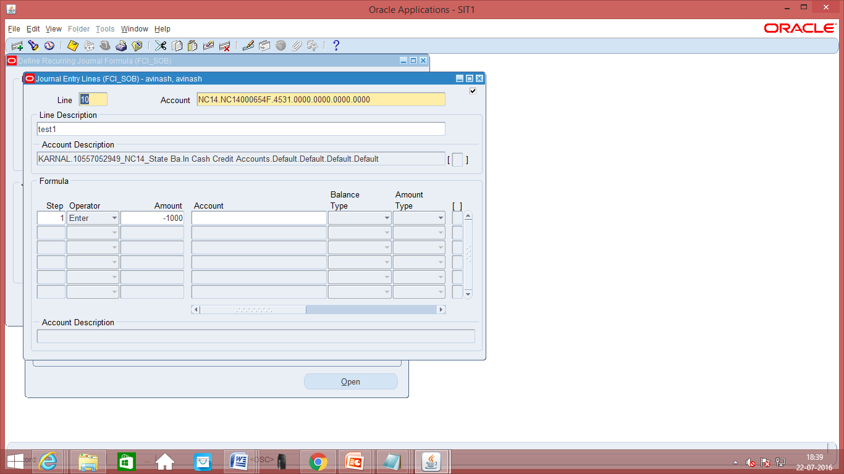
Fig: Define Recurring Journal

Generate Recurring Journals
Function Path: Journals->Generate->Recurring
Steps:
1. Enter the Period name and the Recurring batch name. Check the box and click on the Generate button.

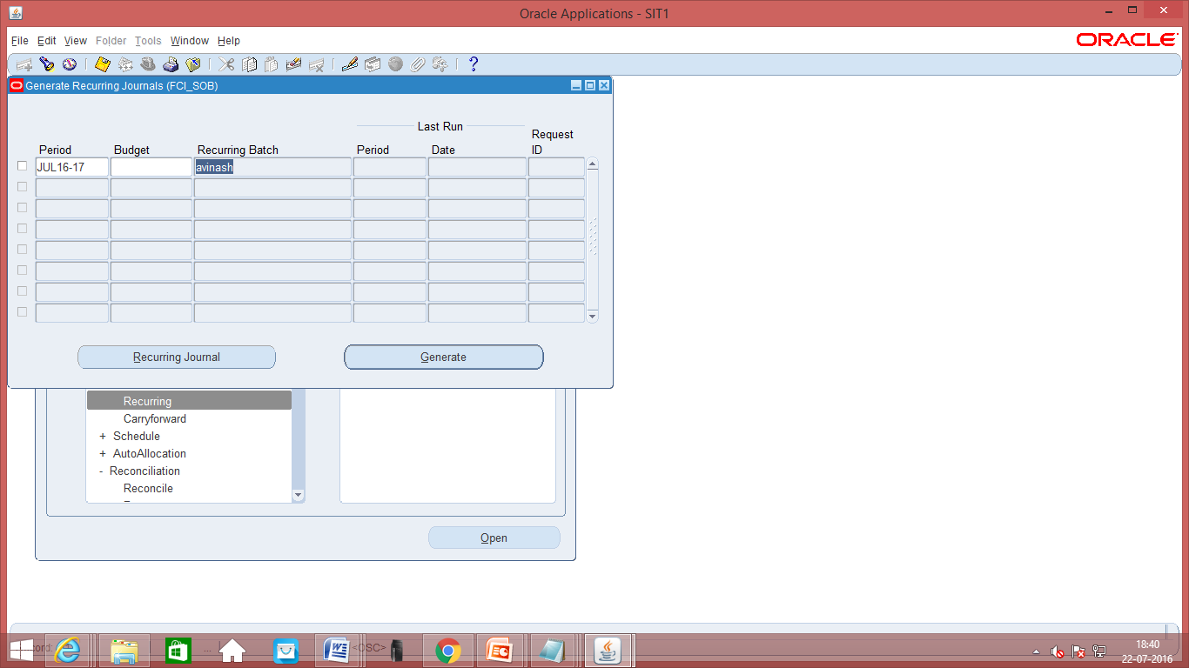
Fig: Generate Recurring Journal
2. Recurring Journal Entry request will be submitted. After completion of request user can query the resultant journal entry and perform Check Fund, Reserve Fund, Approval and Posting.

Note: The source of the resultant Journal will be ‘Recurring’.

Run Reports - Standard
Function Path: View->Requests->Run
Steps:
1. Navigate to View -> Requests -> Run, then choose single request if only one report is required. Else select Request Set.
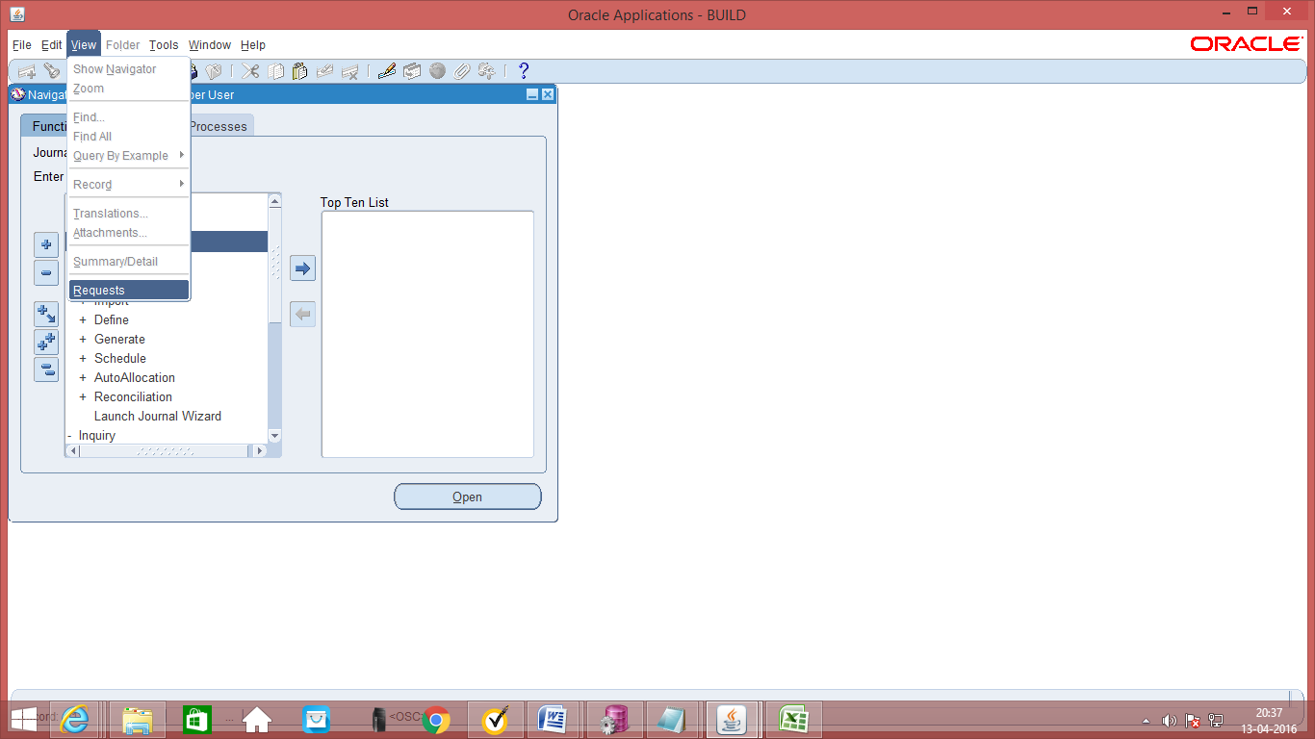

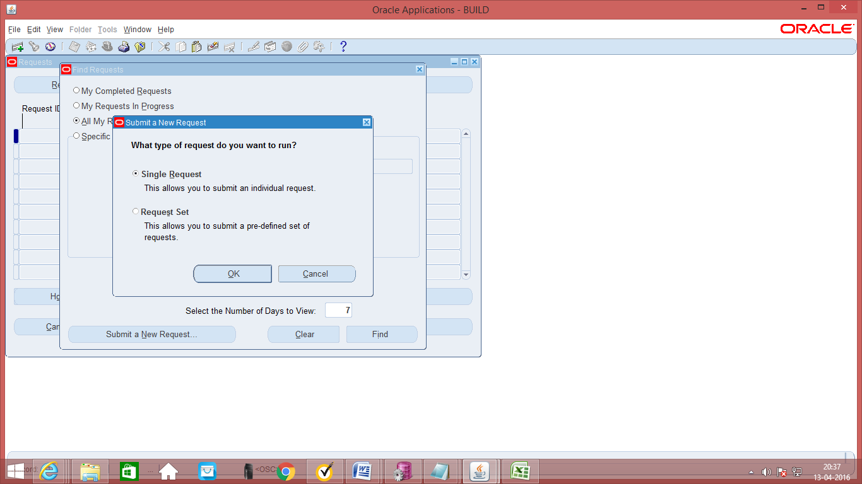
2. Select the report / request set to run and submit the request.
3. Each of the reports for FCI is explained below.

Unconnected Wagon Report

The purpose of this report is to reconcile its unconnected Wagons. For this purpose it needs a report listing out its reconciled and unreconciled unconnected wagon.
Parameters:
There are no parameters required to run this report.
Output:
The output is in Discoverer format. The output has two sheets reconciled and unreconciled.

The key difference between unreconciled and reconciled is that in reconciled entries there would be a debit and a corresponding credit to the account 1408. In unreconciled, there would only be a one sided debit.

Hence if Wagon No, Product and Number of Bags is same in the entry debited and entry credited for the Account No. 2817, it would be in the Reconciled Section of the report. If not it would be in the unreconciled section of the report.

Or if the Original Wagon No (required in case of transshipped Wagon), Product and Number of Bags is same in the entry debited and entry credited for the Account No. 2817, it would be in the Reconciled Section of the report. If not it would be in the unreconciled section of the report.

Reconciled Sheet of Unconnected Wagon Report:

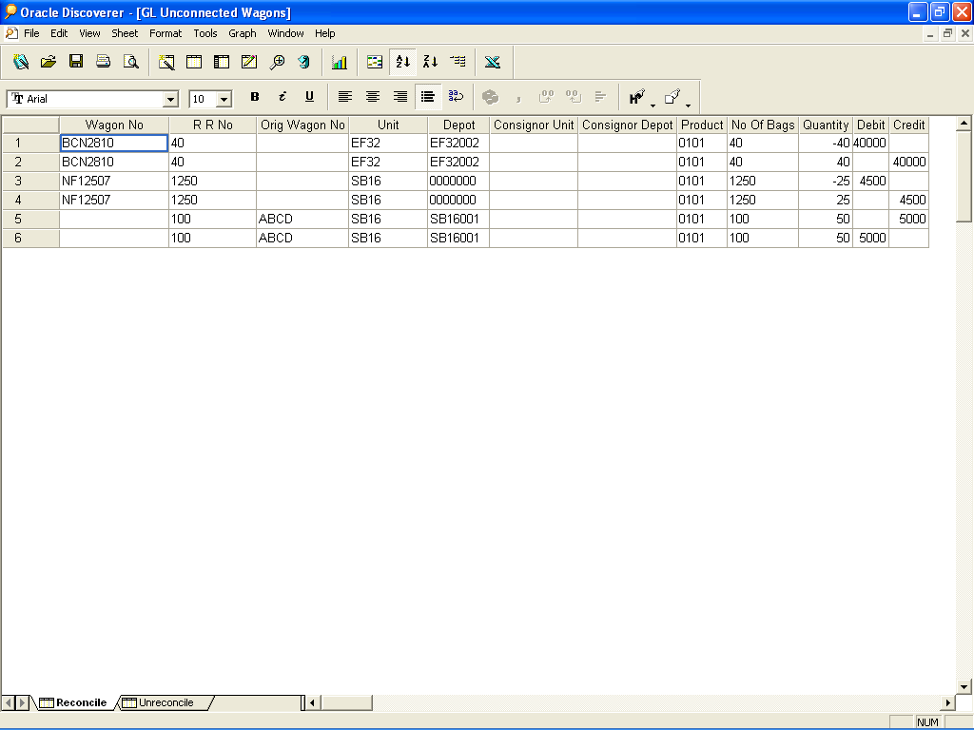

Unreconciled Sheet of Unconnected Wagon Report:

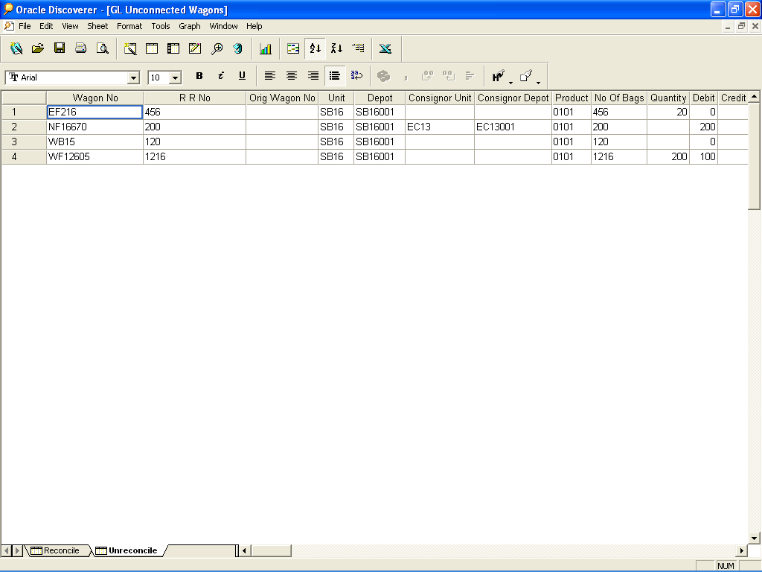

Missing Wagon Report

The purpose of this report is to reconcile its unconnected Wagons. For this purpose it needs a report listing out its reconciled and unreconciled unconnected wagon.
Parameters:
There are no parameters required to run this report.
Output:
The output is in Discoverer format. The output has two sheets reconciled and unreconciled.
The key difference between unreconciled and reconciled is that in reconciled entries there would be a debit and a corresponding credit to the account 2817. In un reconciled, there would only be a one sided debit.

Hence if Wagon No and RR No is same in the entry debited and entry credited for the Account No. 2817, it would be in the Reconciled Section of the report. If not it would be in the unreconciled section of the report.

Reconciled Sheet of Missing Wagon Report:

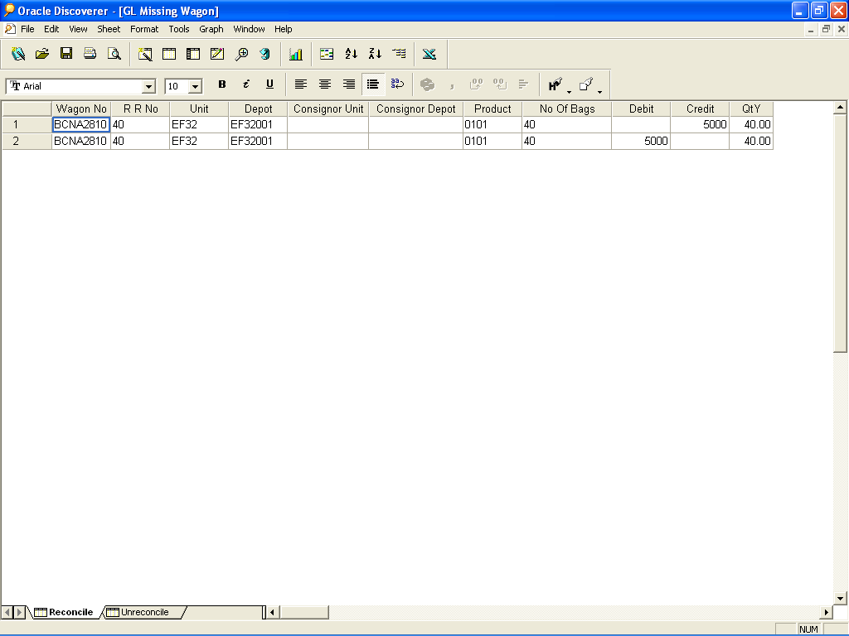
Unreconciled Sheet of Missing Wagon Report:

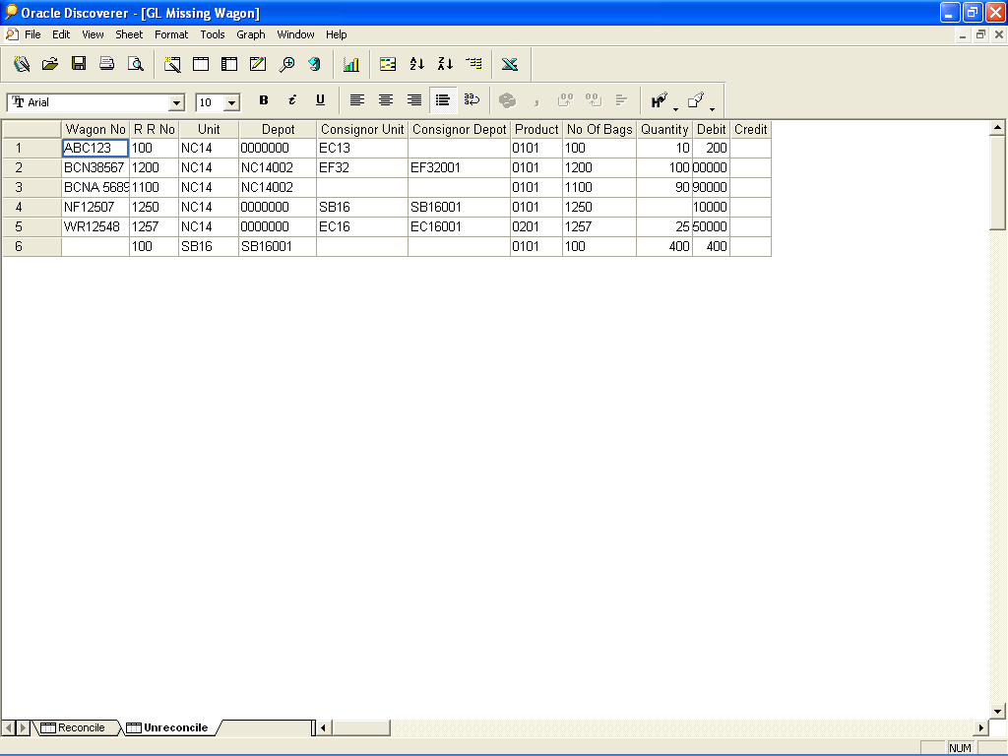

Paddy Milling Report
The purpose of this report is to record the stocks issued and stocks received after conversion.
Parameters: Unit, Depot, Period From and Period To
Output: The output of the report is in Discoverer format. The output is in two sheets Paddy Milling – Issued and Paddy Milling – Received.
Paddy Milling Issued Sheet: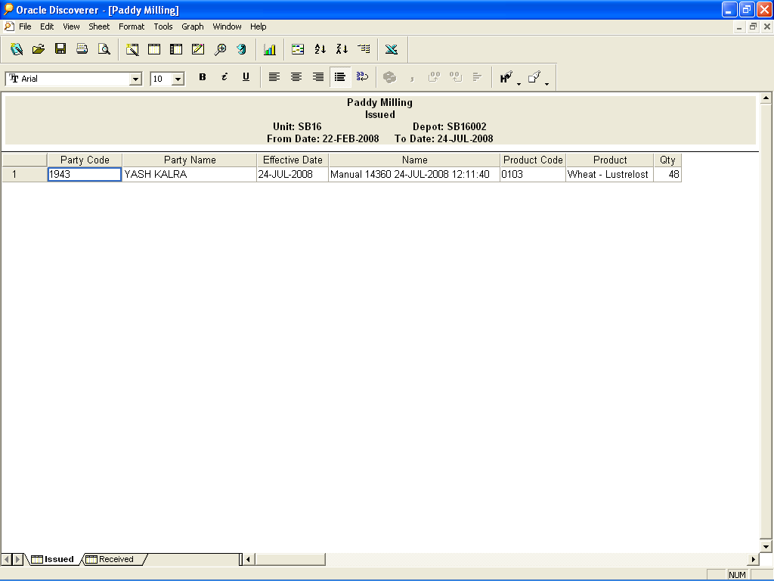
Paddy Milling Received Sheet:
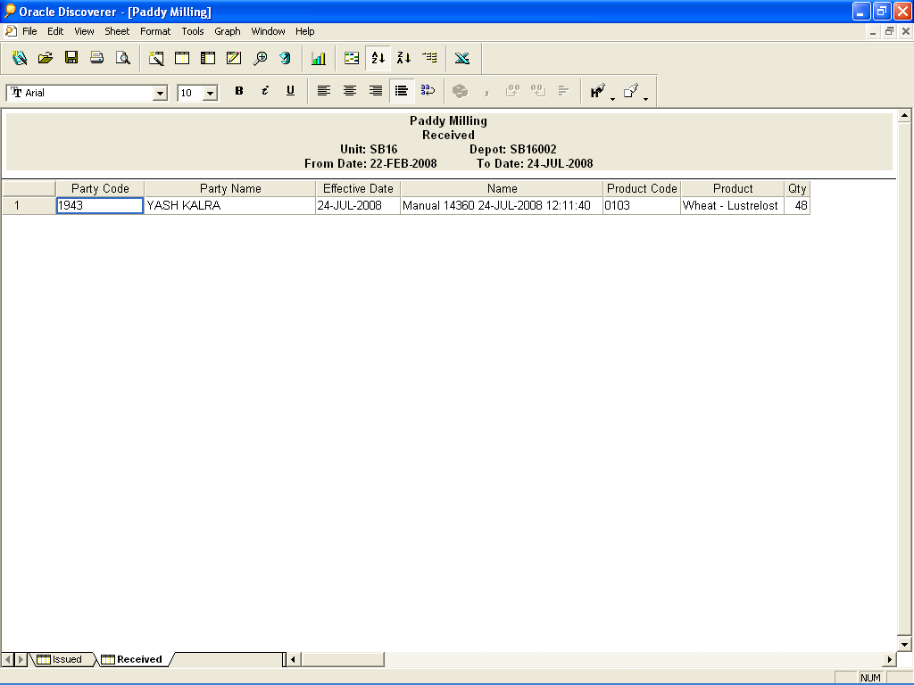

FCI Transfer Out Report
The purpose of this report is to record the Transfer In/ Transfer Out (IOM within same unit and IOM Rail Road till 28-JAN-2013.) from units of FCI.
Parameters:
From Unit
From Depot
To Unit
To Depot
From Account
To Account
From Date
To Date
Product
All the parameters in this report are mandatory.

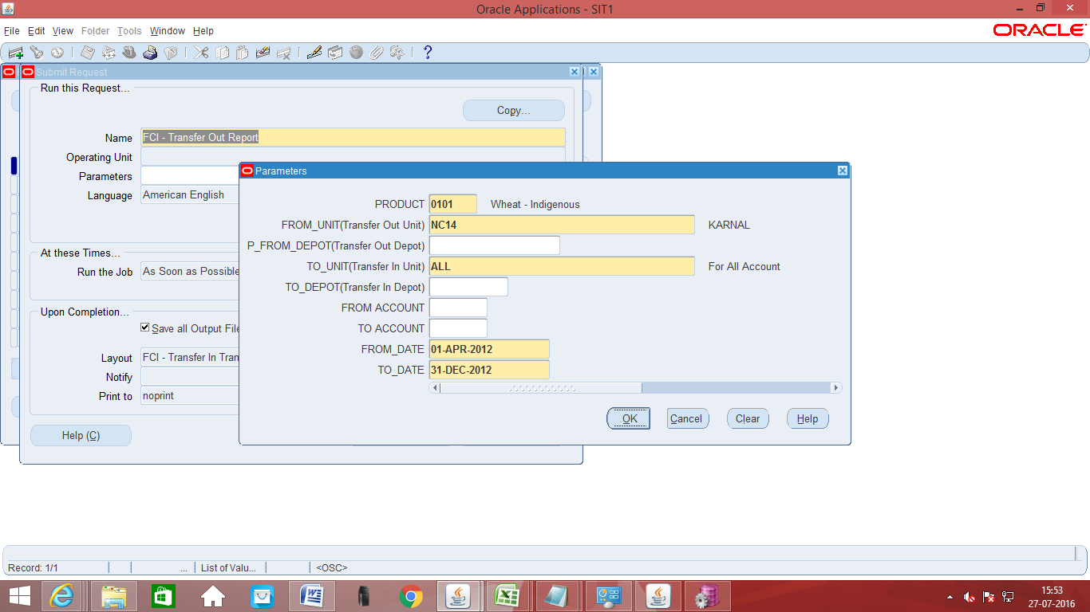
The output of the report is as follows:
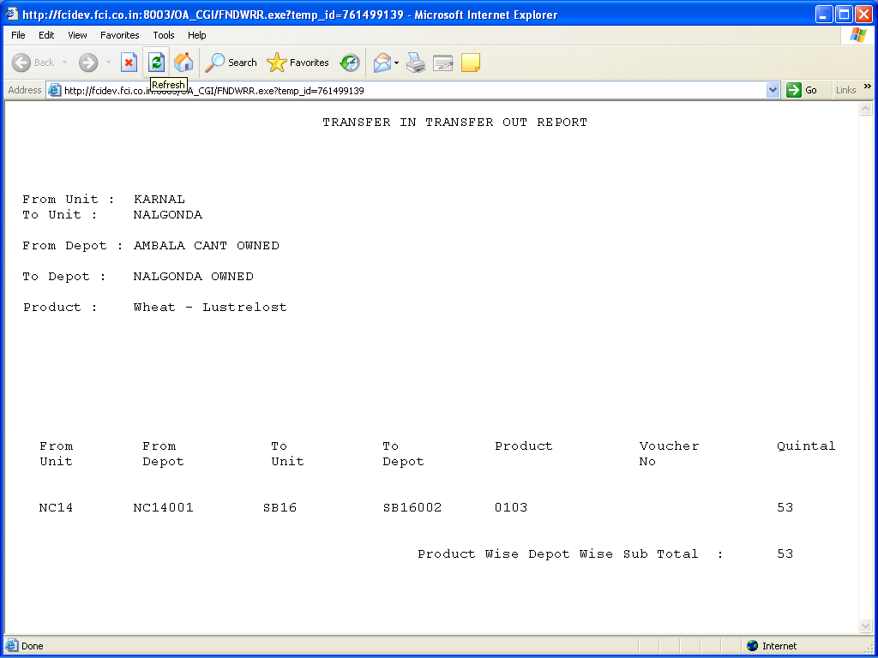
This report has been converted to excel. Please follow the document attached below to run the Excel reports. You can run the excel reports by following the same process.

To run FCI Transfer in transfer Out in Excel format
1. While running this request click on OPTIONS as red marked in the given screenshot.

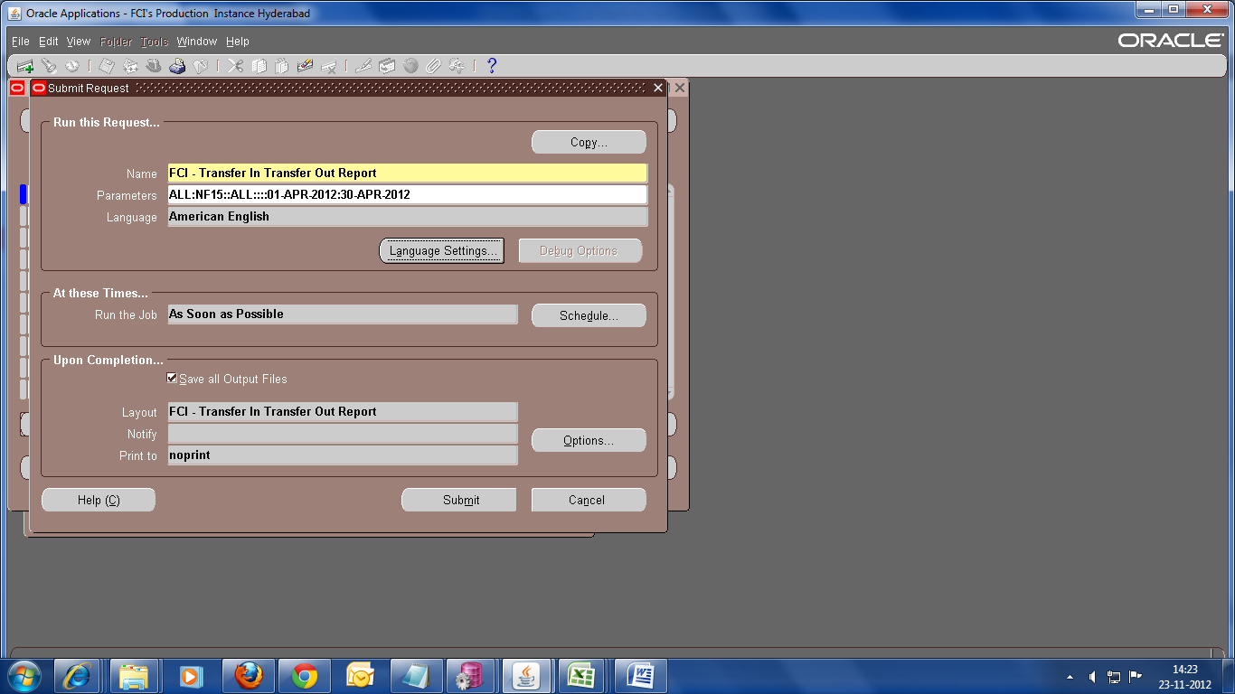

2.Choose format as EXCEL, as shown in the screenshot below:

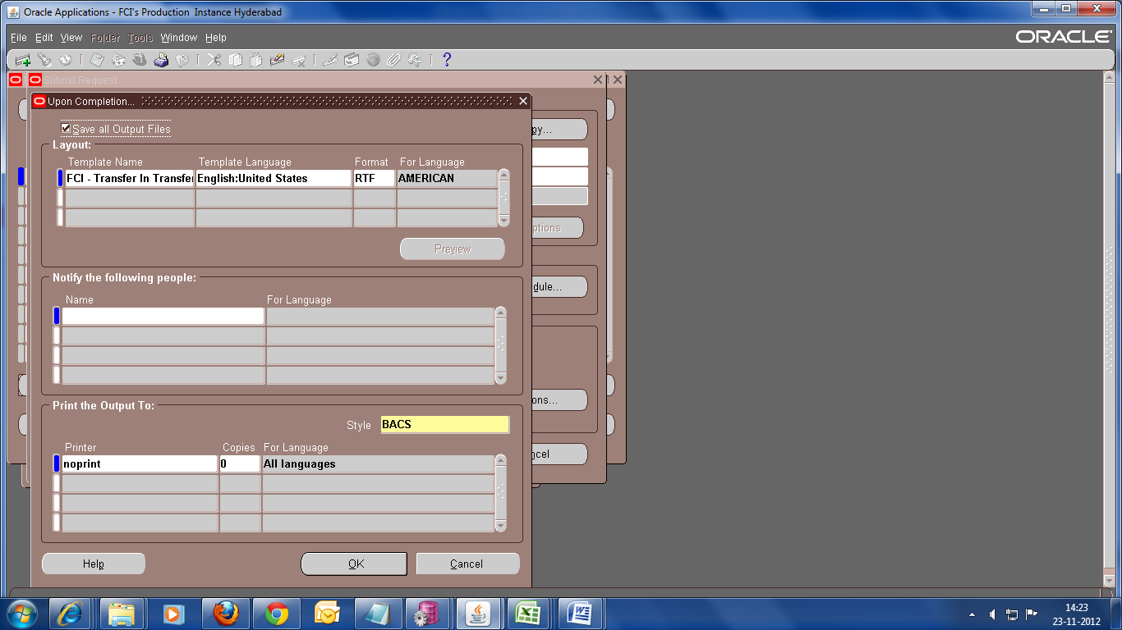

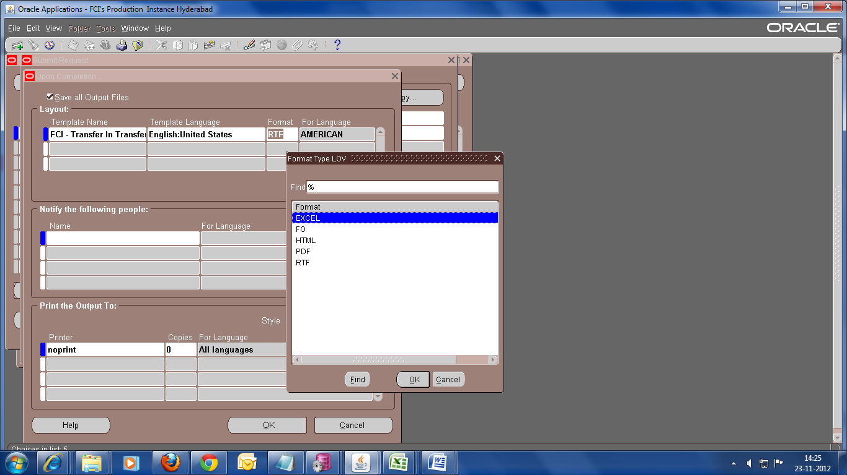

Sample output in excel format is attached below:

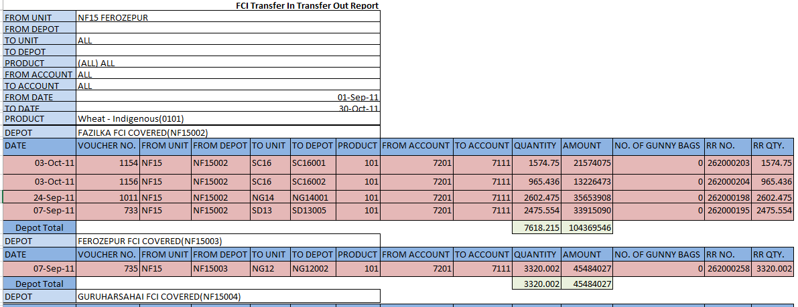

FCI –transfer out report new
The purpose of this report is to fetch the data for IOMs entered by any unit from 29-JAN-2013 onwards. The output will be generated in excel.
Parameters:
1. Product (Mandatory)
2. From Unit
3. From Depot
4. To Unit (Mandatory)
5. To Depot
6. From Account
7. To Account
8. From Date (Mandatory)
9. To Date (Mandatory)

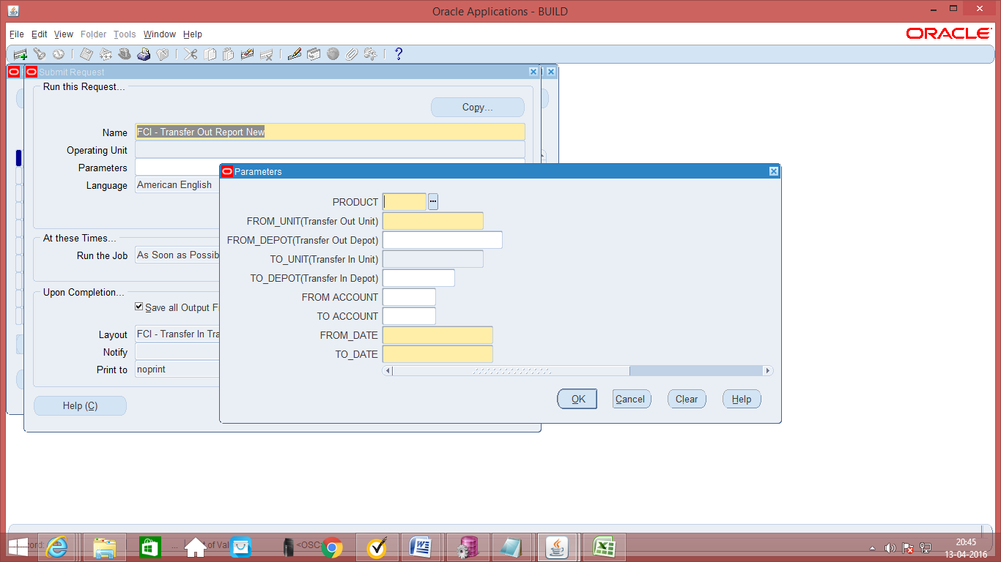
Output is attached here for reference:

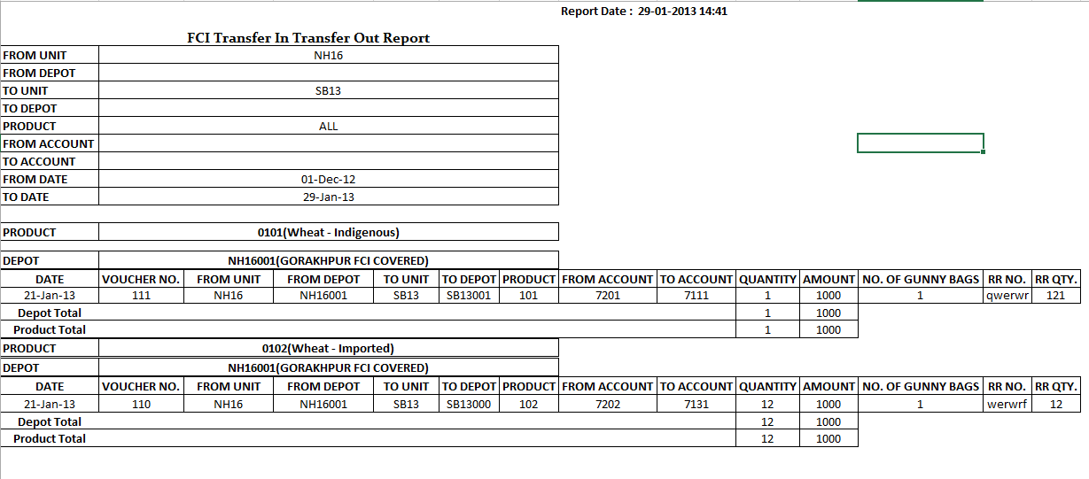

FCI - Transfer In against stocks received
The purpose of this report is to record the Transfer In against Stocks received by units of FCI.
Parameters:
- Unit
- Depot
- Product
- From Date
- To Date
All the parameters except Depot in this report are mandatory.
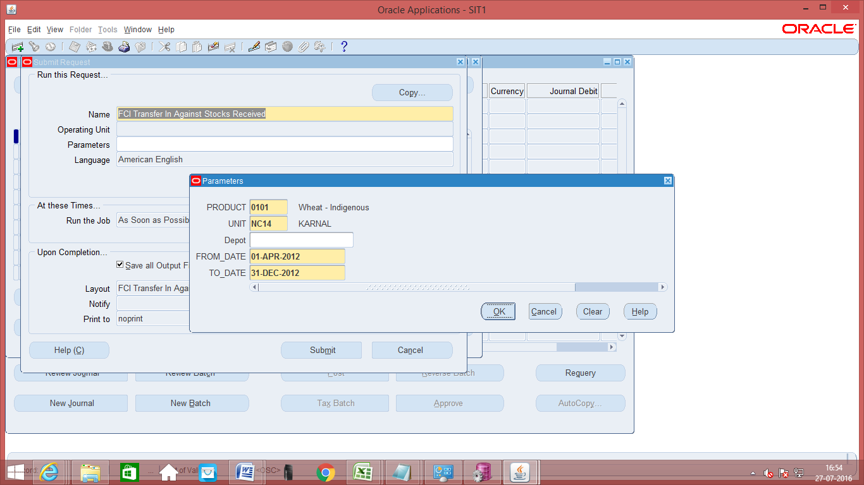
The output of the report is in excel format.

FCI - Transfer In against stocks received new

A new report ‘FCI Transfer In Against Stocks Received New’ have been made for new Intercompany Transfer In against Stocks Received Journals which are entered in the system from 29-Jan-2013. All the parameters in this report are mandatory. The screenshot of the report is shown below:
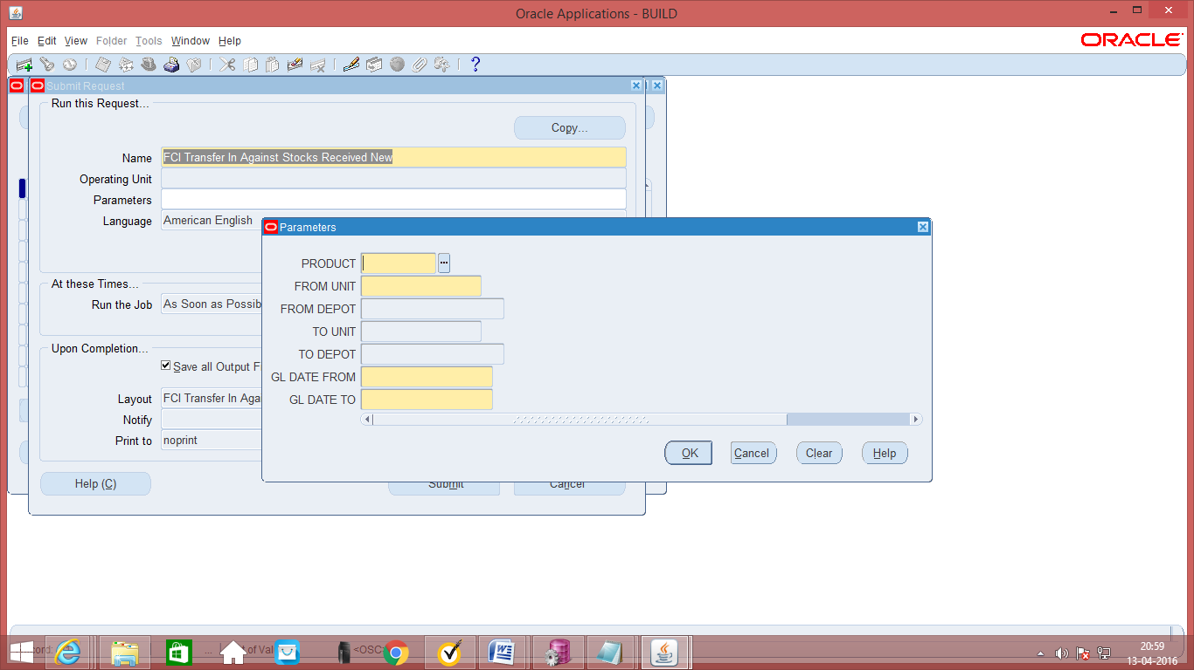
The output of the report is in excel format.

FCI Stock Ledger Summary Report
The purpose of this report is to record the Stock Ledger Summary from units of FCI. It displays the details of stock in particular accounts.
- By default it will run for all schemes.
- Report can be run for a single product only. Multiple products and parent values are not allowed.
- Report will display the consolidation at input location and details.
- Report will show opening and closing balances of stocks.
- Date parameter will be restricted so that user can’t enter date outside a financial year. If user enters the date parameter overlapping two financial year then report will give error message for the same.
- Unit parameter is restricted to a two level hierarchy i.e. users will see only their own as well as their child units.
- Report will not fetch the stocks of journals, in which debit/credit amount is zero.
- Report will fetch details of account and schemes which comes in the report. Also, the report will fetch data for those depots only for which ‘FCI Depot DFF’ has been entered otherwise not.
- Report will only fetch the quantity of stocks, and not the values.
- Quantity will not be displayed till 5th decimal place.
- Only those accounts will be picked in reports whose account type (stocks) is updated in the system. For this kindly refer SLS type in Existing vs Final in Final New COA and CR 694.
- Accounts related to stock only will get displayed.
- In parameters, depot option will be available only when unit selected is a district office.
- Report will run only for a single product.
- Changes in the report are done w.r.t CR: 589, new section ‘Reconciliation of Closing Stock as per SLS and Physical Stock’ that has specified accounts under Physical Stock, Goods in Transit, Stocks given on loans and Other Stocks is added.
- As per CR- 3 Changes in existing SLS mapping for account code 5231, Now the entries for the A/C head 5231 is being done only through AP module as per the security rules under referred CR and there are also past entries in the system which has been entered through GL module. So, SLS should reflect quantity of A/C head 5231 irrespective of the module through which it is entered.

Note:
- If the journal category is “Unit_Others” then transfer in and transfer out account heads will appear in Transfer Outside Zone.
- Quantity field will not be rounded off to next 5 decimal digits, otherwise it will reflect in all other sections of the report.
- A single type of labour is present in every depot.
- The existing marking of depots (for labour type and agency code) , will be done by FCI , in the DFF which will be provided in ‘FCI DEPOT’ value set in FCI Support User responsibility.
- Report will fetch data of labour type and Agency Code for only those depots, in which the marking is already done.
- The SLS report will fetch data based on current labour type and agency code of the depot. Hence, the data might change for a depot.

The report parameters will be as follows:
- From Date (mandatory)
- To Date (mandatory)
- Unit (mandatory)
- Depot (mandatory with ’All’ option)
- Product (mandatory)
- Agency (optional)
- Labour Type (optional)

Screen shot of Report Parameters:
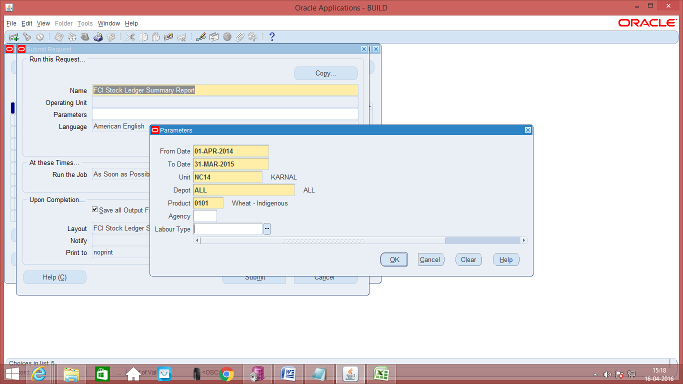

Prior Period Item Report
The output of the report is in discoverer format.
The purpose of this report is to record the prior period items within a date range.
Parameters:
- Financial Year
- From Date
- To Date
- Unit
- Account Number
The report will list out the prior period expenses and revenues.
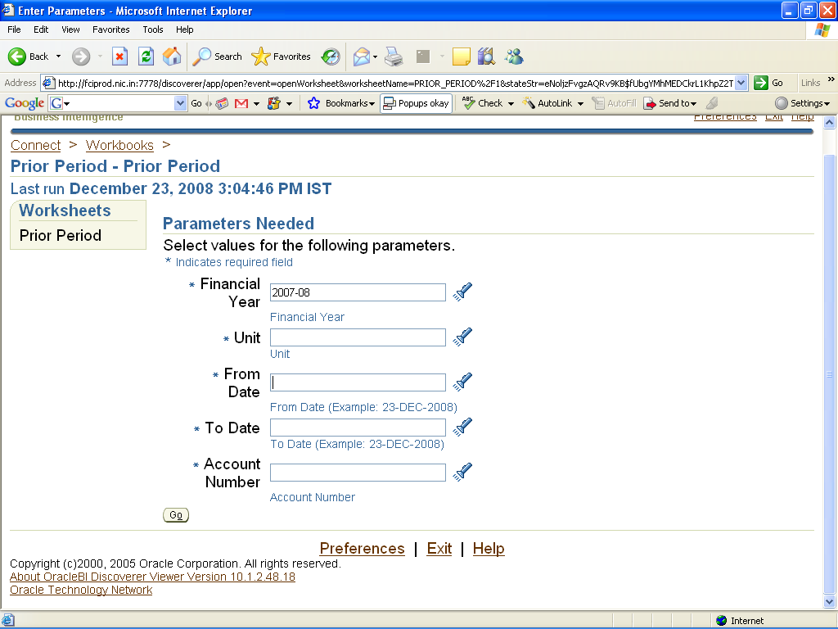

FCI Journals by Document Number
Review detailed information for each journal associated with a specific document Sequence.
General Ledger prints the journals in ascending order by document number. For each Journal, the report prints the creation date, batch name, and journal name, category, posting Status, posted date, currency, and journal amounts. The report also indicates which document numbers do not have an associated journal.
This report lists all the journals by sequence numbers. The deleted Journal entries are also indicated.

The parameters required for this report are:
Parameters: Sequence Name, Document Number From, Document Number To
All the parameters for this report are optional.
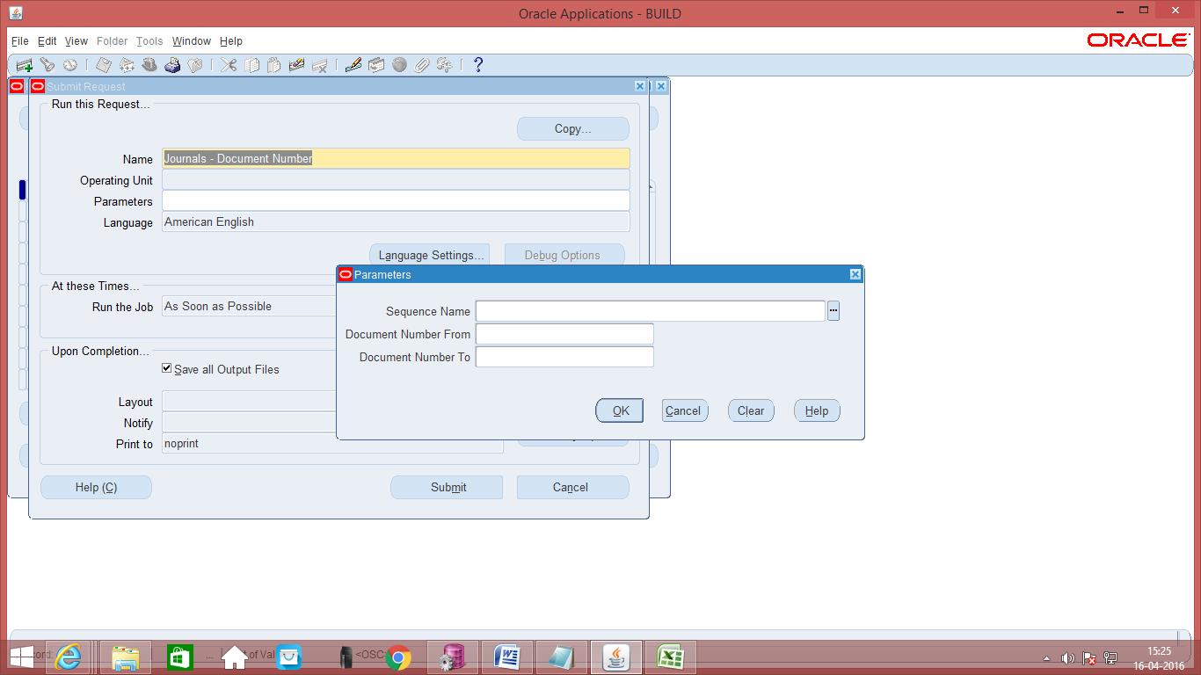
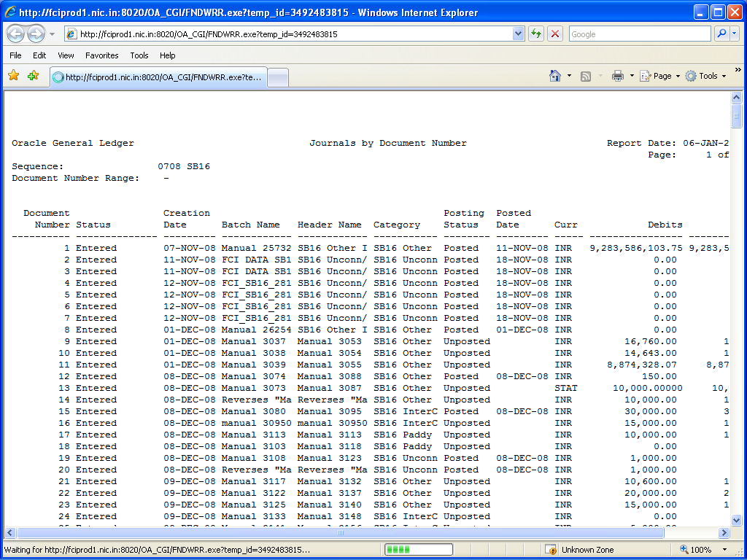

Journals Day Book
Review posted journal entries and journal details chronologically by accounting date for a specified range of dates, journal source, and journal category.
General Ledger prints journal entries in ascending order by accounting date. For each accounting date, journal entries are sorted by document number. General Ledger prints the accounting date, document number, journal entry name, journal source and category, sub ledger document name and number, currency, and exchange rate. For each detail journal line, General Ledger prints the line number, account segment value and description, functional debit and credit amounts, description, and cost centre segment value.

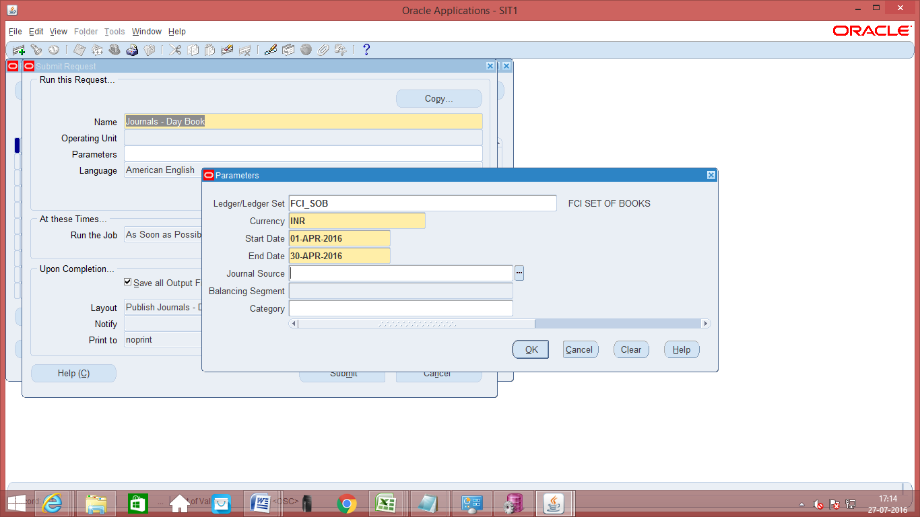

The following parameters are mandatory: Start Date, End Date, and Balancing Segment.
Journal Source should be Manual only.

General Ledger – 132 Char
Review journal information to trace each transaction back to its original source. General Ledger prints a separate page for each balancing segment value. For each journal line, the report prints the account affected, the concatenated description, the journal line amount, and the beginning and ending account balance. Additionally, for each journal line, the report prints journal details including source, category, journal name, and effective date. The report lists accounts in ascending order by account segment value, and it prints a "CR" next to credit amounts.

The parameters required for this report are:
Parameters: Type, Currency, Balance Type, Budget or Encumbrance Name, Starting Period, Ending Period

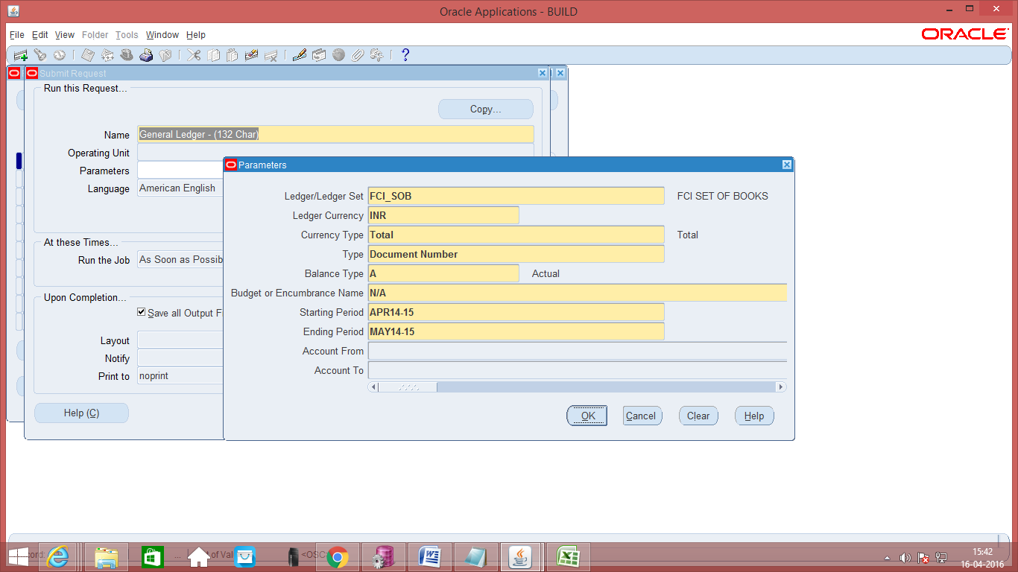
For all accounts give parameters as under:
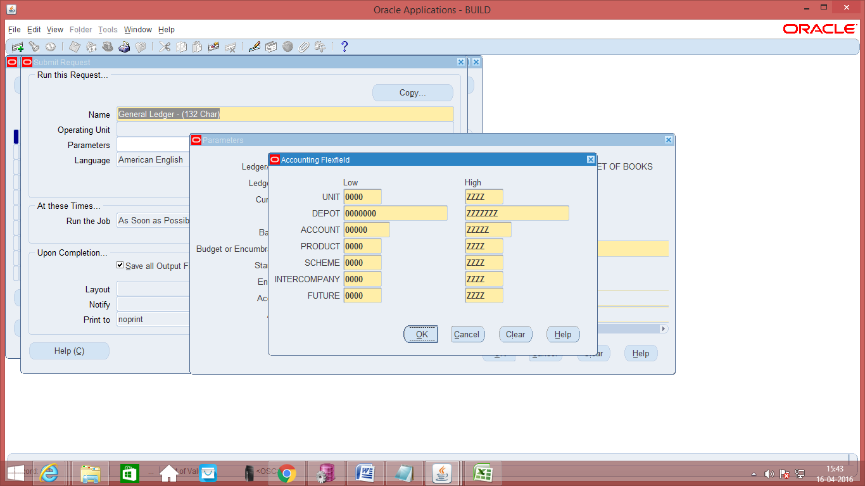
The output of this report is as follows:
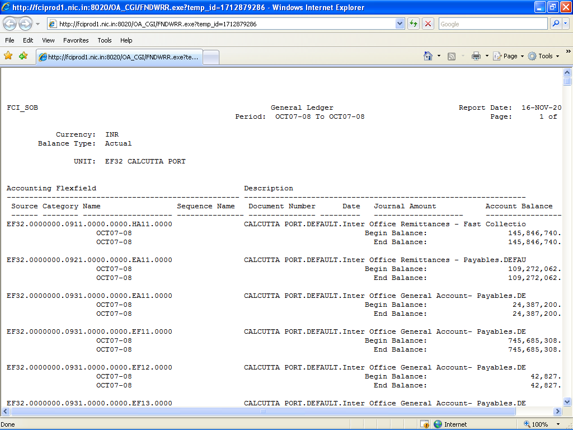

FCI Users Detail

The purpose of FCI Users Detail is to provide the User details like User Name, Last Logon date, Date of Birth, Full Name, User’s Supervisor Name, User’s Status (Active/Inactive).
This report takes no parameters
Navigation to run the report:
GL User Responsibility > Vies > Requests
The Output of the Report is as below:-

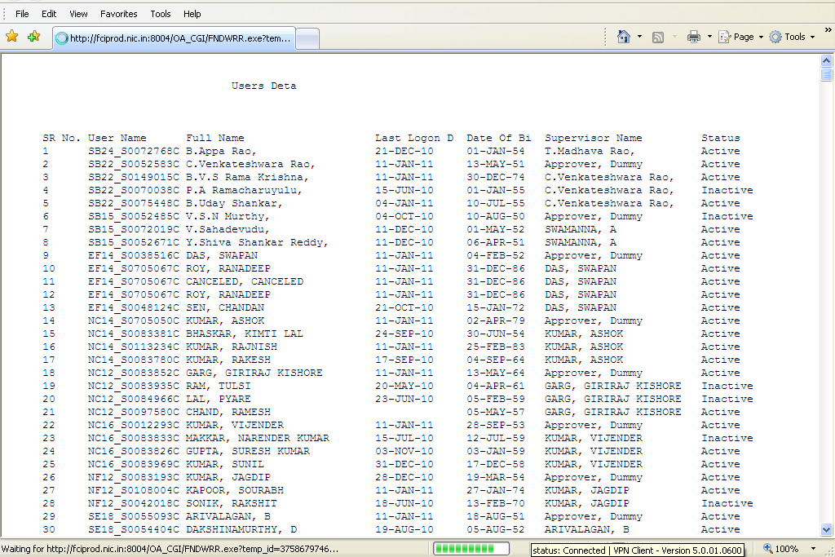

Account ANALYSIS (132 Char and 180 Char)

Review source, category and reference information to trace your functional currency or STAT transactions back to their original source. You can run this report with entry, line or source item reference information to help identify the origin of journals created by Journal Import.
This report prints the journal entry lines and beginning and ending balances of the accounts you request. For each journal entry line, the report prints the source, category, batch name, journal entry name, account, description, entry/line/source item reference information, and the debit or credit amount.

Parameters

When you request this report, General Ledger prompts you to enter the following:
Type: Choose Entry Item to generate a report showing EXTERNAL_REFERENCE from the GL_JE_HEADERS table. This reference appears only if you provided one in the Enter Journals form or if you used Journal Import. Choose Line Item to generate a report showing REFERENCE_1 from the GL_JE_LINES table. Choose Source Item to generate a report showing REFERENCE_4 from the GL_JE_LINES table. These references appear only if you used Journal Import and included a journal voucher number, an invoice date and number, or some other source document information that helps you to identify the origin of this journal entry.

Currency: Choose either the functional currency for your set of books or STAT.
Balance Type: Choose to report on Actual, Budget, or Encumbrance balances. If you select budget balances, you must choose the Budget Name on which to report. If you select encumbrance balances, you must choose the Encumbrance Type on which to report.

Starting/Ending Period: Choose the accounting period range for your report. General Ledger starts a new page for every period in your range.

Flexfield From/To: Enter the account range for your report.

Order By: Choose to sort the journal entry lines of your report by Account Segment, Balancing Segment, or Source name.

FCI Journal approval report
This is a customized report in GL module, in order to get the final approver of any journal batch. This will generate output in excel format.
Parameters:
1. Unit (Mandatory)
2. Category
3. Batch Name
4. Journal Name
5. Document Number
6. From Date (Mandatory)
7. To Date (Mandatory)
Screenshot is attached for reference:
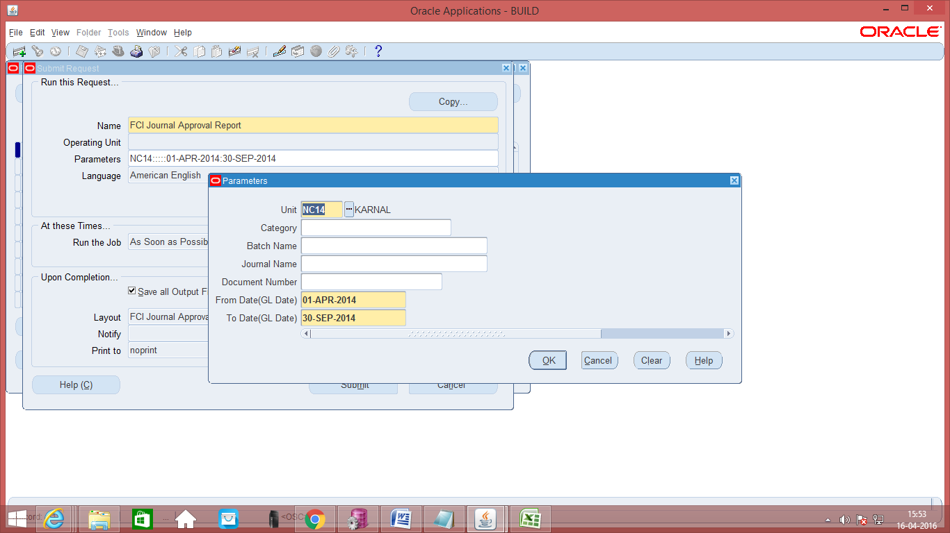

Output is attached below:
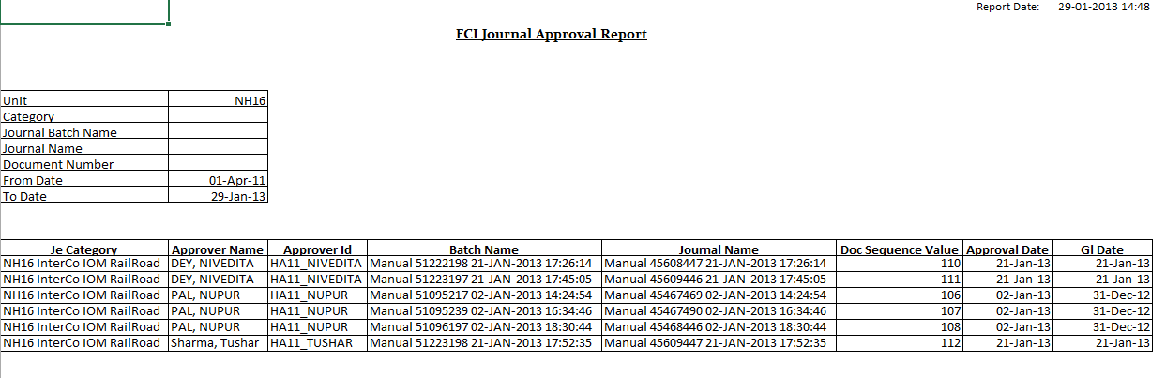

FCI Journal BATCH APPROVAL Status Correction Program

A new program is created through which the support team can set the workflow approval status of journals having workflow Approval State ‘In Process’ to ‘Required’ and so further delete or initiate the approval for the journal again.

- The user will have to provide the Batch Name in parameter for the request. The program will pick the Batch by name provided that is having Approval State ‘In Process’ and set its status to ‘Required’.
- In case there are more than one journal Batch with same name and more than one of them has Approval State ‘In Process’ , the program will pick one of the journal Batch and set its status to ‘Required’.
- User will have to run the program again to set the status of another Journal Batch with same name to ‘Required’.
- The Fund Status of the journal will remain the same as it was before running the program.
- Also the request will only pick the Journals having source ‘Manual’.
This request is only accessible to the FCI Support Team through FCI Support Team Responsibility. The Screenshot is given below:

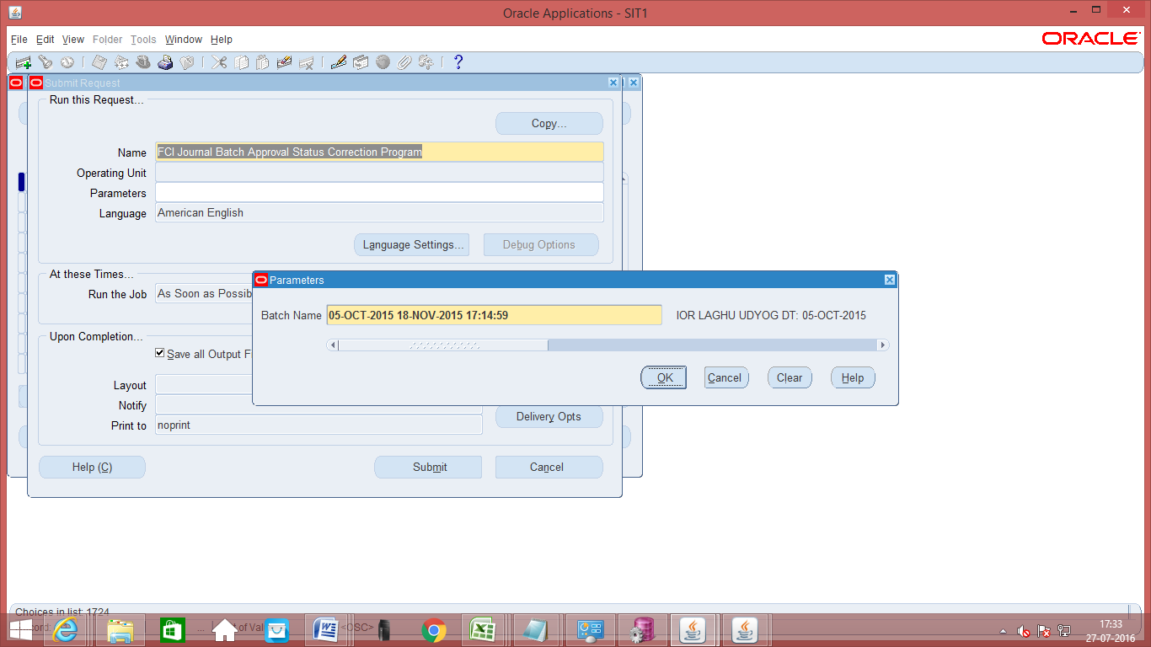

FCI Intercompany Reconciliation Report

FCI Intercompany Reconciliation Report picks all the intercompany accounts that are used in Unit’s transactions (Unit-Like “HA11’ in balancing segment) and its totals (Debit - Credit). The report also shows the account and the amount corresponding to the given accounts booked in transactions of the other unit involved (Unit-Like “HA11’ in intercompany segment).
Differential amount between the amounts booked by both the units and quantity will also be shown in the report. Report picks data on ‘Period From’ and ‘Period To’ basis. For ex if the report is ran with Period From as ‘APR15-16’ and Period To as ‘DEC15-16’, it will pick records falling between 01-APR-2015 – 31-DEC-2015.
The report can be run from the General Ledger Responsibility. It can be run on hierarchy basis from HA11 responsibility by selecting values from unit’s LOV. The report will fetch blank column for account2 if there is no data for the same in the system.
The input parameter: Unit will fetch the first four characters of the responsibility with which user is executing the report, it will fetch, ‘WB12’ if user is executing the report from ‘WB12 General Ledger User Responsibility’.
All four parameters I,e; Unit , Natural Account , Period From and Period To are mandatory. The screenshot is given below:
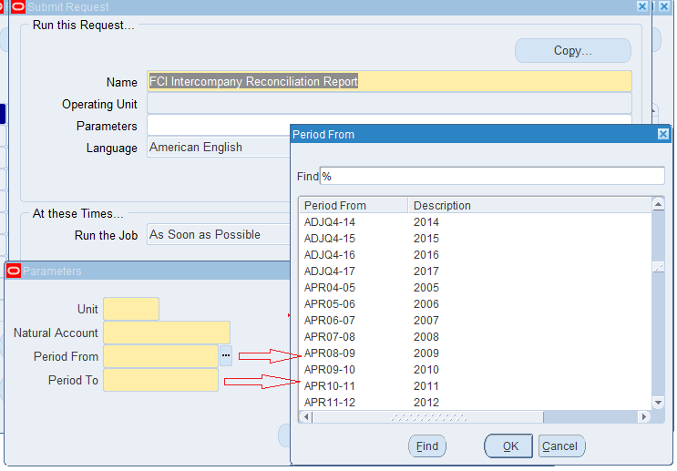
Sample output is attached herewith.
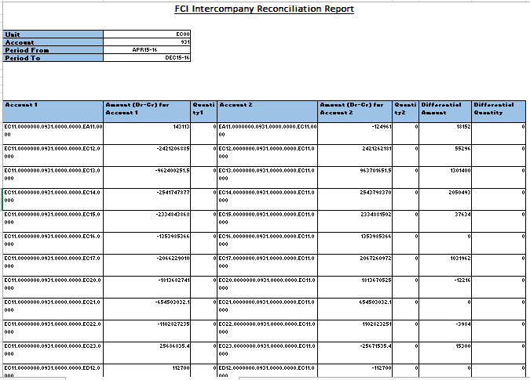

FCI Interco IOM Voucher
A new report ‘FCI Interco IOM Voucher’ has been created which fetches the detail of the ‘InterCo IOM RailRoad’ journal.
The input parameters for the report are:
S.No. | Parameter | Required/Optional | Description
1 | Document Category | Required | User has to select the IOM category from the LOV for which the report is to be executed.
2 | Start Document Number | Optional | User has to give the range of document number of the journal which is to be fetched
3 | End Document Number | Optional | User has to give the range of document number of the journal which is to be fetched
4 | Start Date | Required | User has to give the starting range of default effective date of the journal.
5 | End Date | Required | User has to give the end of default effective date of the journal.
The output of the report is in pdf format.
Kindly follow the steps mentioned in the document below to run a pdf report
1. While running this request click on OPTIONS as red marked in the given screenshot.

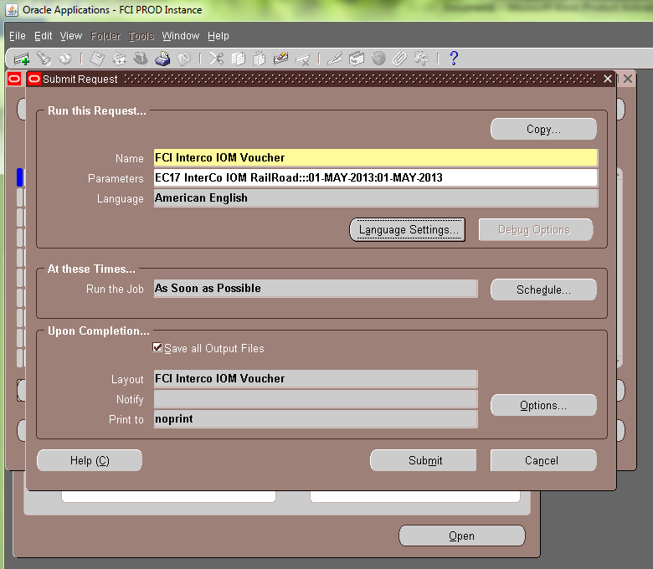
2.Choose format as EXCEL, as shown in the screenshot below:
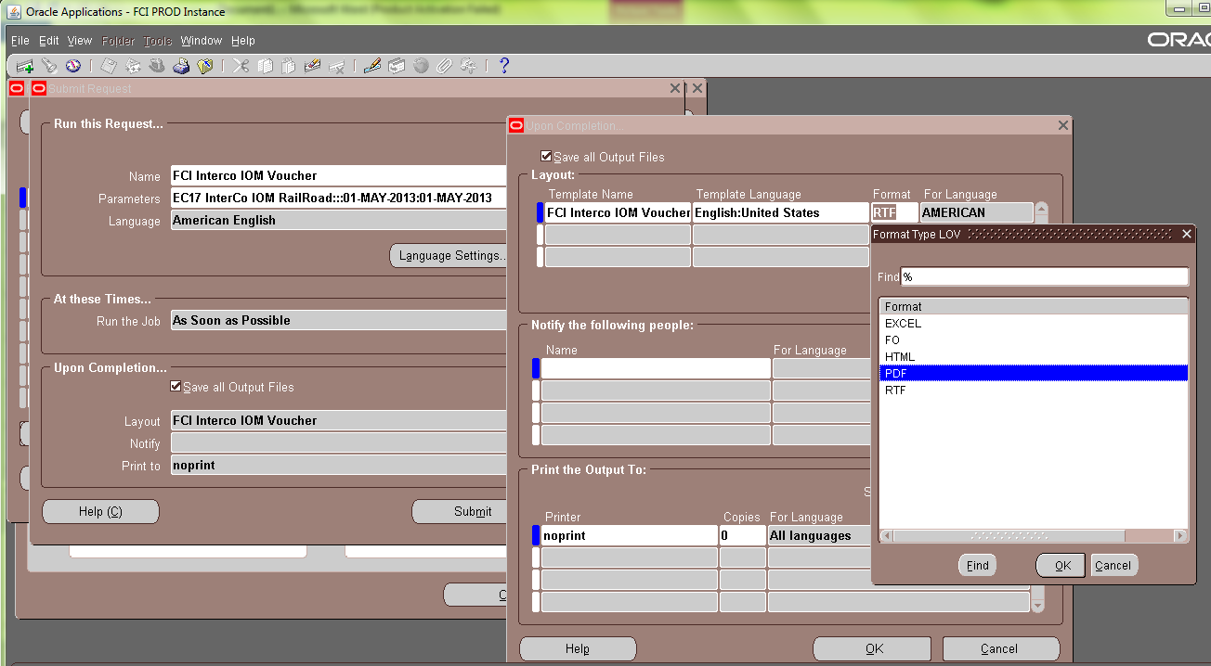
You will get the output of the report in PDF form.

The sample output is attached below,
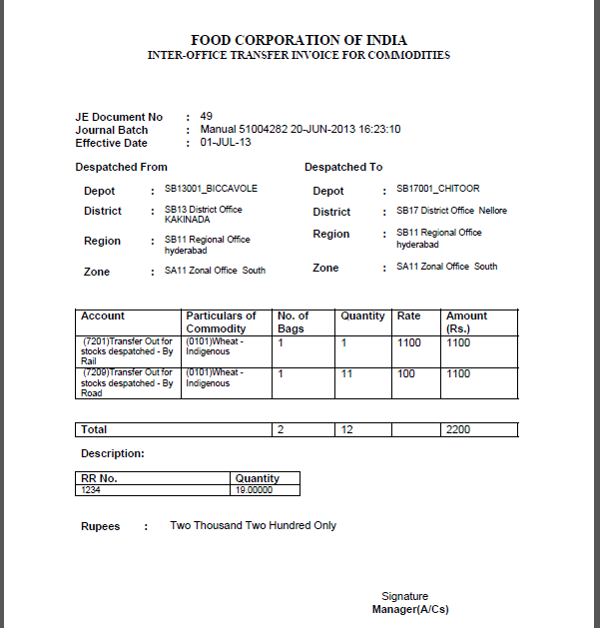
Note: The report will not fetch detail of 0981 account head.
Note: The report will display the rate as zero, if the quantity entered is zero.

FCI GL balance reconciliation Summary report
- The report ‘FCI GL balance reconciliation Summary report’ is in Excel format.
- The report will fetch the summary data from GL, AP and AR module and report will show data of GL module, then AP module and then AR module.
- Data will be fetched for closed period only(FCI custom closed)
- The input parameter for the report will be:

Sl No. | Parameter | Mandatory/Non Mandatory
1 | Period | Mandatory –Period for which data is to be fetched from GL,AP and AR module
2 | Account | Mandatory–Account for which data is to be fetched
3 | Unit | Mandatory–Unit for which data is to be fetched

Output:
Module | Source | Section | Credit Amount | Debit Amount | Net Amount

Module: To show from which module the data is fetched. (GL , AP , AR).
Source: To show from which source the data is fetched.
- For Payables:
- FCI Payroll
- Payables
- Receivables
- Manual
- For Receivables
- Manual
- FCI Import
- Credit Memo
- For General Ledger
- FCI Payroll
- Payables
- Receivables
- Manual
- Assets
Section: To show where the account is Liability, Expense, Revenue, Receivable etc.
Credit Amount: Sum of credit amount based on module, source and section.
Debit Amount: Sum of debit amount based on module, source and section.
Net Amount: (Debit Amount-Credit Amount)
The report will fetch total based on source and module.

Note: The report can executed for asset accounts (excluding bank accounts) and liability accounts only.

FCI GL Balance Reconciliation Detail
The report will fetch the detail of Payables invoice distribution and revenue and tax detail of transaction in AR.
- The report will be in excel.
- Data will be fetched for closed period only(FCI custom closed)
- The input parameter for the report will be:

Sl No. | Parameter | Mandatory/Non Mandatory
1 | Unit | Mandatory – Unit for which data is to be fetched
2 | Account | Mandatory–Account for which data is to be fetched
3 | Period Name | Mandatory– Period for which data is to be fetched from GL,AP and AR module
4 | Module | Mandatory–Module from which data is to be fetched eg Payables, Receivables
5 | Source | Mandatory– From which source data has come to the module
6 | Section | Mandatory–whether payment or liability etc

The output:
Gl Date |  | Party Name | Invoice Number | Vouc her Number | Entry Type | Transaction Type | Description | Debit | Credit | Net | Unit | Depot | Account | Product | Scheme | Intercompany

Note: The report can executed for asset accounts (excluding bank accounts) and liability accounts only.

FCI Consolidated Trial Balance Report
This report will fetch the balances in different account head on the basis of grouping given in Existing v/s Final sheet under the head S.No for TB. (The balances will be consolidated if the report is executed at parent level unit).
It will be based on three segments of the code combination that are Account, Product and Scheme. The description of all three will be fetched in the report. The report will be governed by the following input parameters:

Parameter Name | Optional/Mandatory | Description
Unit | Mandatory | Unit for which report has to be executed, can be executed for RO, ZO and at parent level.
Period Name | Mandatory | Period for which report has to be executed.
Balance Type | Mandatory | YTD/PTD/PJTD

The output will be fetched group wise and totals will also be done group wise. This report will also fetch last document sequence details at sub – ledger level.
Note: this sequence will be fetched only when the report is executed for the child unit and not at any parent level.
As per CR 454, following modifications are done:
    - There will be two divisions introduced in the report namely Part I Trial Balance and Part II Trial Balance.
    - Part I TB will be containing all those accounts under grouping 1 to 195 and 300. Sub Total should come for this part before Part II starts.
    - Part II TB will be containing all those accounts under grouping 196 to 299. Sub Total of this part should also come.
    - Report Total will be provided at the end of report i.e. total of Part I TB and Part II TB.
    - Account Head 0981 from group 1 will be in Part II TB as refer to CR 455.
As per CR 631, the report can be fetched in PDF format also, as after 14 digits excel starts rounding the number, due to which exact balance could not be seen.
For executing report in PDF format, select the report to run, fill in the parameters and click on Options.
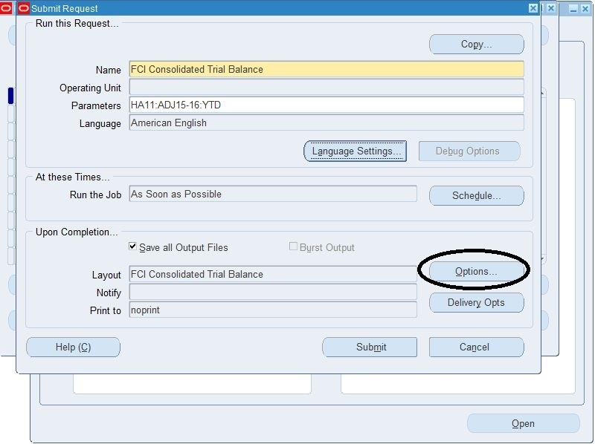

Change the format to PDF. You will have to click it twice, as in one go, it will give an error, and will open the LOV in second click only. Now execute the report, to get the below PDF output.
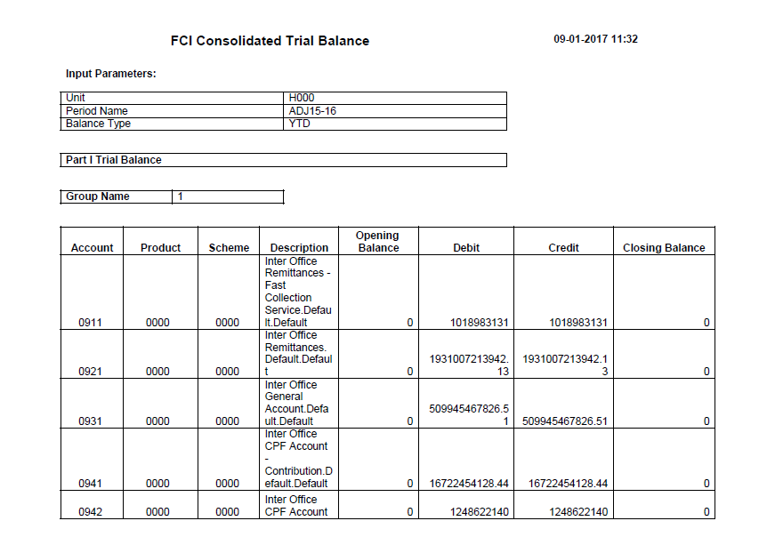
The option of running the report in PDF format is available only for FCI Consolidated Report Only, and not for any other report, as it affect the performance of the report.

Sample output in excel is also attached for your reference:
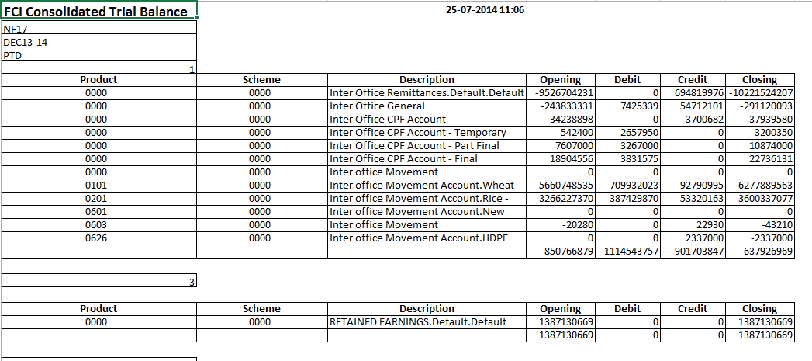
Updated Sample output is attached for your reference:
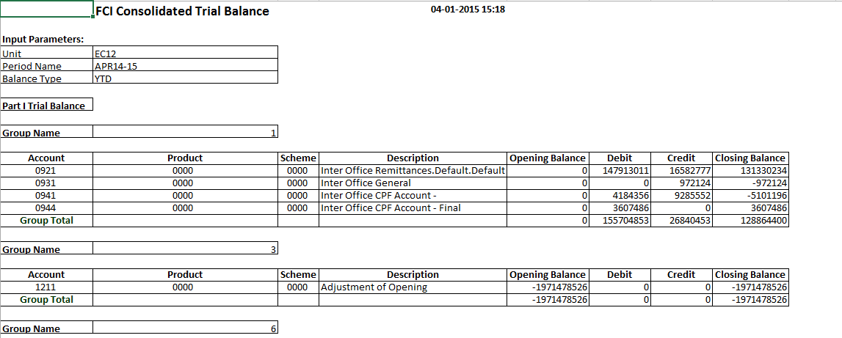

FCI Trial Balance Detail with document sequence
A new report FCI Trial Balance detail with document sequence has been created to display Last document sequence used in all modules at the time of running report.
It will be displayed as below at the end of the existing report.
Sequence Name | Module | Last used Document Number

As per CR- 641 following changes are incorporated in “FCI Trial Balance Detail with Document Sequence Report”
- Four new columns are included in “FCI Trial Balance Detail with Document Sequence Report”.
- Balance Sheet Group- It will display the Balance Sheet group the Code Combination is mapped with. (Nomenclature- Only Group Name will be displayed, E.g.- ‘A’)
- AtoS Group- It will display the AtoS group the Code Combination is mapped with. (Nomenclature- Statement: Column-Group Name, Statement: Row- Group Name, E.g. – ‘F:C-Admn.,F:R-K Audit fees’)
- P and L Account- It will display the Profit and Loss account the Code Combination is mapped with. (Nomenclature- Only group Name will be displayed, E.g.- ‘PD67’)
- P and L Statement- It will display the Profit and Loss statement account the Code Combination is mapped with. (Nomenclature- Only group Name will be displayed, E.g.- ‘PD67’)

- Unit parameter has been discarded; instead, Two Additional Mandatory Report parameters- From Unit and To Unit are introduced to provide User option to generate the Trial Balance for a Unit Range.
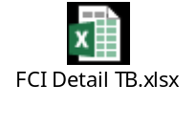

FCI SLS For Stores And spares
This report will fetch the balances booked in account heads for stores and spares. It is provided in the normal general ledger responsibilities.
It will be based on three segments of the code combination that are Account, Product and Scheme. The description of all three will be fetched in the report .Following points are to be considered:
- Report Shows balances at unit level given and breakup of that sub unit wise or depot wise will be not available.
- The report for stores and spares will contain grouping and sorting similar to SLS- for Gunnies and Food Grains.
- Balances in report will be fetched after posting in GL only.
- Stores and spares report do not contain within zone or outside zone bifurcation for transfer in and transfer out.
- Balances will be shown with similar sign conventions as in SLS- for Gunnies and Food Grains report.
- Sign convention will be applied for Opening, Net and Closing balances.
- Group total will be based on amounts for display and Report total will be based on totalling sign convention.
Note:
- Only those account heads will occur in this report, which are marked for stores and spares, provided by FCI in the annexure attached with the CR and and CR 694.
- As per CR-664, Modifications are done in 'FCI SLS for Stores and Spares' report to generate the details Unit hierarchy wise.

The report will be governed by the following input parameters:

Parameter Name | Optional/Mandatory | Description
Unit | Mandatory | Unit for which report has to be executed , can be executed for RO, ZO and at parent level.
Depot | Mandatory | Depot for which report has to be executed
Period Name | Mandatory | Period for which report has to be executed.
Balance Type | Mandatory | YTD/PTD/PJTD
Product | Mandatory | Product for which report has to be executed
The output will be fetched account type wise and totals will also be done in the same manner.
Sample output is attached for reference:
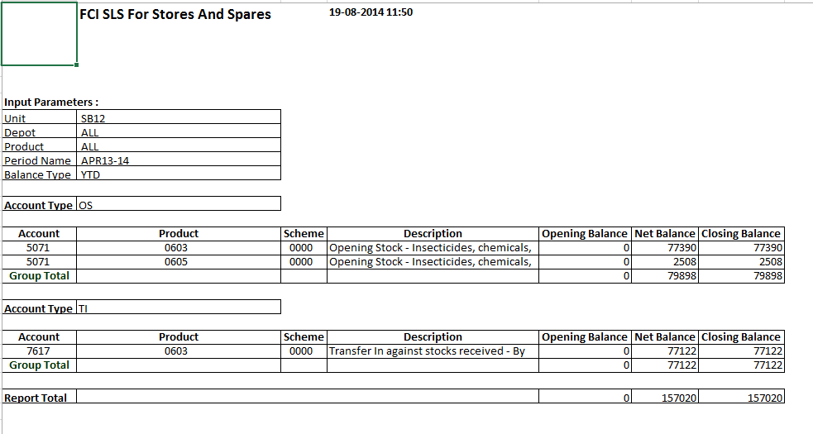

FCI Profit & Loss Statements Report
This is an excel report which will bring the balances as per the grouping provided by FCI for Profit And Loss Statement. This grouping will be based on three segments that are account head, product and scheme. The account combinations with opening balance, period activity and closing as zero will not be fetched in the report. The input parameters are:

Parameter Name | Optional/Mandatory | Description
Unit | Mandatory | Unit, for which report has to be executed, can be executed for RO, ZO and at parent level.
Period Name | Mandatory | Period for which report has to be executed.
Balance Type | Mandatory | YTD/PTD/PJTD
The report is provided in normal General Ledger, Fci support user and audit user responsibilities.
The output will be fetched group wise and totals will also be done group wise
Sample output is attached for your reference.

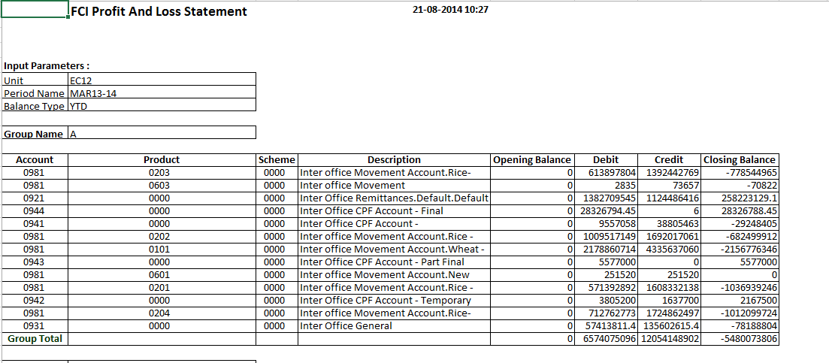

As per CR 445, the grouping of above report has been changed (as per annexure attached in the CR), and the sorting has been done on group name, account, product and scheme.
As per CR 572 (MID:40339), the grouping of above report has been changed (as per annexure attached in the CR), and the sorting has been done on group name, account, product and scheme. This will bring all the combination which are available as per mapping in Balance Sheet as well as PNL Report).

FCI A2S Report: Statement A to S
The reports are in excel format which will be generating output in below mentioned formats,

- product in the verticals and accounts in the horizontals
- product in the horizontals and accounts in the verticals
- account in the verticals with products where ever applied
- accounts in the verticals and accounts in the horizontals where ever applied
- account in the verticals with combination in all products
- Schemes in the horizontals and accounts in the verticals.
This grouping will be based on seven segments.
The input parameters are:

S. No | Parameter Name | Optional/ Mandatory | Description
1 | Period Name | Mandatory | The period for which statement has to be viewed.
2 | Balance Type | Mandatory | YTD/PTD
3 | Statement Type | Mandatory | Type of statement starting from A to S. Consolidation of All statements will come under option of “FCI Costing Reports” in this LOV.
4 | Unit | Mandatory | Unit hierarchy will be followed.

The report is provided in normal General Ledger User responsibility, Fci support user.
The output will be fetched unit wise and totals will also be done vertical and horizontal wise.
Sample output is attached for your reference.

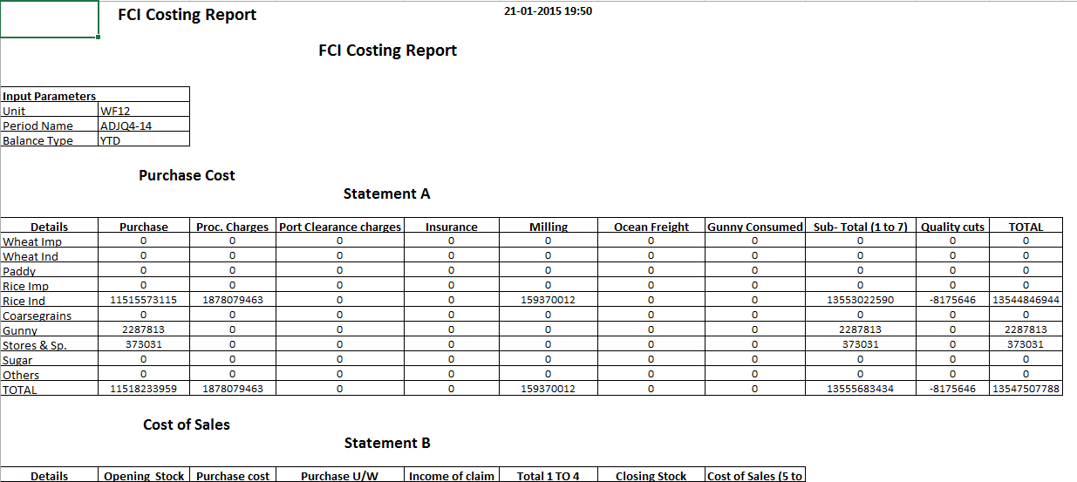

Screen shot of FCI A2S Report:
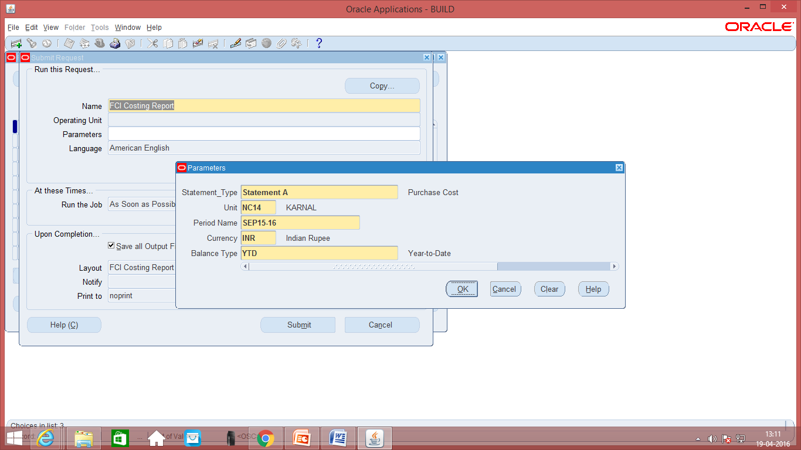

Program - Maintain Summary Templates
Use this program to ensure that summary account balances reflect new detail accounts that may have been added to that summary account. The posting process automatically maintains summary accounts but running this program is beneficial if many new detail account combinations have been created since the last posting. Run this program when there are changes in detail accounts to improve the performance of the posting

Program - Incremental Add/Delete Summary Templates

Run the Incremental Add/Delete Summary Templates program to update your summary account balances. This program allows making changes to account hierarchies without having to drop and recreate the summary template.
The following actions cause changes in the summary account reporting structure:

• Addition of child ranges assigned to a parent value.
• Removal of child ranges assigned to a parent value.
• Assigning a new parent segment value to a rollup group.
• Removing a rollup group assignment from a parent segment value.
• Changing rollup group assignment for a parent segment value.

FCI Account Head Balance Report

- The report is executed for actual balances only.
- The sums of amounts of the transactions which are posted in General ledger are fetched.
- The sum of balance for parent unit is based on the sum of balance in child units.
- The output considers the sum of balance existing in disable code combinations also if any.
- Format for account, product and scheme in the output is: “Code - its description”.
- Report presents the data for level 2 child when the report is executed All India and zonal level (based on parent child relationship exist in FAP system).
  - For e.g. If user is executes the report for H000 then balance for EA00, EC00, ED00, EE00, EF00, FA00, FB00, FC00, FD00, FE00, HA11, HC11, NA00, NB00, NC00, ND00, NE00, NF00, NG00, NH00, NI00, SA00, SB00, SC00, SD00, SE00, WA00, WB00, WC00, WD00, WF00 and HQ11 will be fetched in report output.
  - If user is executing the report for F000 then balance for FA11, FB11,FB12, FB13, FB14, FB15, FB16, FB17, FB18, FB19, FB20, FB21, FC11, FC12, FD11, FD12, FD15, FD16, FE11, FE13 and FE14 will be fetched in report output.
- Report presents the data for level 1 child when the report is executed Regional level (based on parent child relationship exist in FAP system).
- For e.g. If user is executes the report for FB00 then balance for FB11, FB12, FB13, FB14, FB15, FB16, FB17, FB18, FB19, FB20 and FB21 will be fetched in report output.
- If report is executed for District office then the data is fetched for that particular district office
- The report output is sorted on Unit Office.
- The input parameters are :
S.No | Parameter | Mandatory | Description
1 | Unit Code | Yes | The unit for which user wants to review the balance. The report can be executed for parent units also
2 | Depot | No | The depot code (only child) for which user wants to review the balance.
3 | Account Head | Yes | The account code (only child) for which user wants to review the balance.
4 | Product Code | Yes | The product code (only child) for which user wants to review the balance.
5 | Scheme Code | Yes | The scheme (only child) for which user wants to review the balance.
6 | Intercompany | No | The intercompany segment (only child) for which user wants to review the balance.
7 | Period | Yes | The period for which user wants to review the balance
8 | Balance Type | Yes | Only two value YTD/PTD

- Report total is displayed at the end of the report.
- The output of the report have the following columns:
S.No | Parameter | Description
1 | Account | Description of the account code along with account code
2 | Product | Description of the product code along with product code
3 | Scheme | Description of the scheme along with the value of scheme
4 | Unit Office | The value of unit. For two level of child values data will be fetched.
5 | Opening Balance | Opening balance for the unit based on balance type input parameter.
6 | Debit | The total amount debited for the unit in the period for which user is executing the report
7 | Credit | The total amount credited for the unit in the period for which user is executing the report
8 | Closing Balance | Opening balance +(debited-credited)

The report is in excel format.
Sample output:
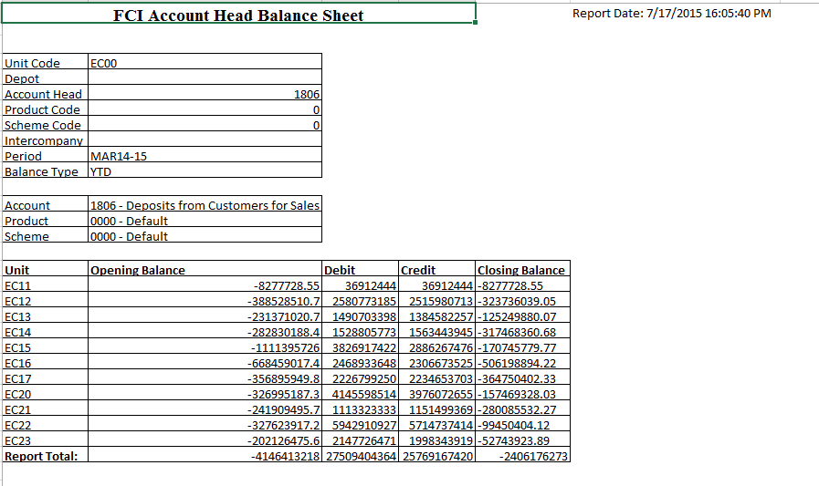

FCI Part I & Part II Account Variance Master (REQUEST SET)
This request set can be used, to view the transactions in which part 1 and part II accounts are used together. In all, this report can be used to view the variance in part1 and part2 accounts. It is a request set which contains below two reports
1. FCI Part I & Part II Variance Marking Program
This program is used for marking all the lines of journals of a given period , that whether the combination belongs to Part1 or Part2.
Input Parameters are:
- From Date : Starting Date
- To Date : Ending Date

2. FCI Part I & Part II Variance Report
This will fetch the output for all the transactions which are containing both the reports. The input Parameters are:
- From Date : Starting Date
- To Date : Ending Date
- Unit : Unit for which report has to be executed. Can be given for hierarchy.
Sample output is attached for reference:
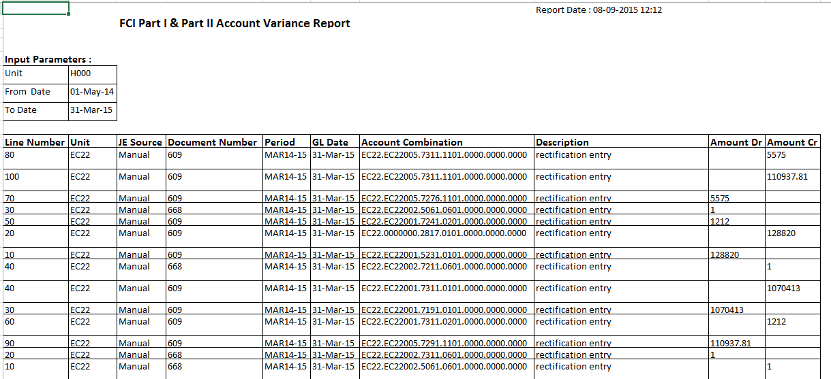

FCI Stock Detail Report

- The new report can be executed using Unit specific General Ledger responsibility.
- The output columns “Depot Code with Nomenclature”, ”Labour Type” and ”Agency Type” are fetched for all input parameters.
- Any one of the output column “Opening Stock”, “Purchase”, Unconnected Wagons”, “Transfer In”, “Transit Gain”, “Storage Gain”, “Sales”, “Transfer Out”, ‘Internal Consumption”, “Transit Loss”, “Storage Loss” ,”Closing Stock” and “Missing wagon” will be fetched based on ‘SLS Type’ input parameter.
- The report cannot be executed for multiple SLS type at a time in a single request.
- The report can be executed for child products only.
- The list of SLS type for which report can be executed is:
SLS Code | Description
MW | Missing Wagon
OS | Opening Stock
S | Sales
PU | Purchase
SH | Shortages
TG | Transit Gain
TI | Transfer In
TL | Transit Loss
TO | Transfer Out
UW | Unconnected Wagon
SG | Storage Gain
IC | Internal Consumption
SL | Storage Loss
CS | Closing Stock
- PI and PE will be removed from the list of SLS type as it is not required by FCI
- The output of the report will be in excel. Sample output format:
Food Corporation of India
FCI Stocks Detail Report |  |  |  | Report Date:
Unit Code
Product
SLS Type
From GL Date
To GL Date
Depot Code with Nomenclature | Labour Type | Agency Type
Depot Code with Nomenclature | Labour Type | Agency Type | account1.scheme1 | account2.scheme1

- In the output of the report for column SLS type the output is of the form : Code – Description of SLS type
- The report fetches Stock detail based on the input parameter.
- The output shows the sum of stock based on Depot, account, scheme.
- The depots which do not have any stock in the given period for the SLS type will not be fetched in the report output.
- If no transactional data exists for the input parameter then data will not be fetched in the report. The output columns will be blank
- Input parameters:
Sl. No | Parameter | Mandatory | Description
1 | Unit Code | Yes | The unit code for which data is to be fetched. The unit can be parent or child
2 | Product | Yes | The product code for which data is to be fetched. The product code will be child value only
3 | SLS Type | Yes | The SLS type for which data is to be fetched.
4 | From Date | Yes | The Gl date of the transactions for which data is to be fetched. This “From Date” parameter will used in combination with “To Date”. “From Date” will be the lower range for the GL date
5 | To Date | Yes | The Gl date of the transactions for which data is to be fetched. This “To Date” parameter will used in combination with “From Date”. “To Date” will be the upper range for the GL date.

account analysis REPORT (sla)

The Account Analysis Report provides drill-down information about the movement on a particular account for a period or range of periods. It only includes journal entries transferred to and posted to General Ledger.
The output of the report is in excel.
Account Analysis - Subledger Detail (180 char) has been replaced by Account Analysis report.

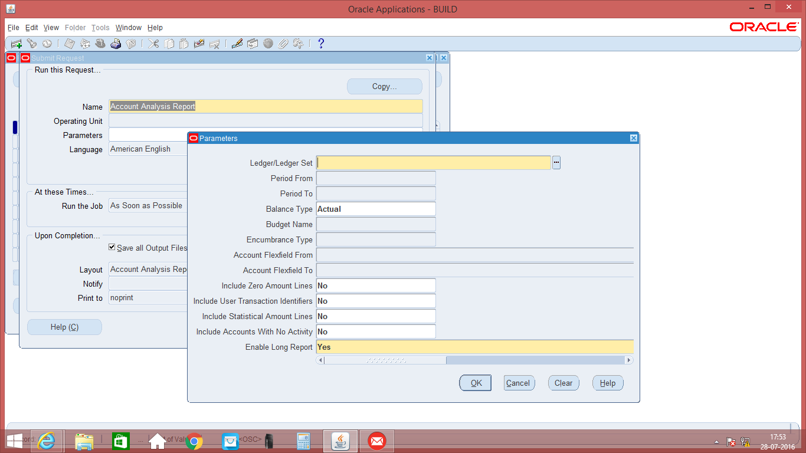
Fig: Account Analysis Report

RECONCILIATION - RECONCILED Transactions

This report displays the list of transactions which have been marked as reconciled either through Manual or Automatic reconciliation process.
The output of the report is in text.

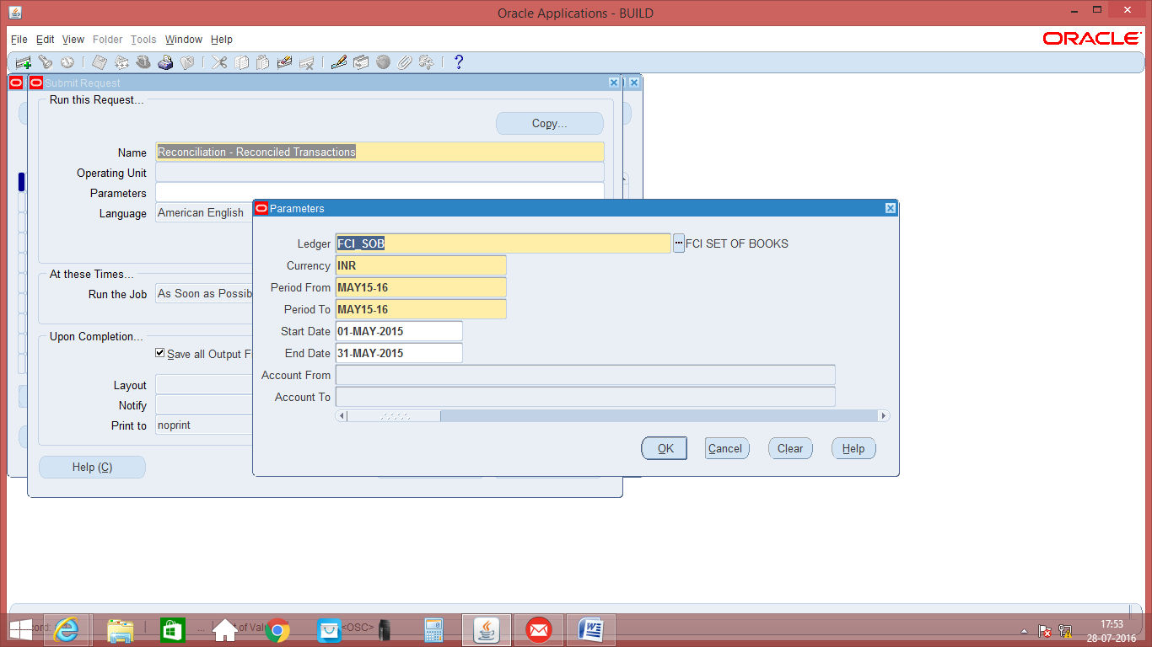
Fig: Reconciliation – Reconciled Transaction

Reconciliation – unreconciled transaction

This report displays the list of GL lines which have not been marked as reconciled either through Manual or Automatic reconciliation process.
The output of the report is in text.

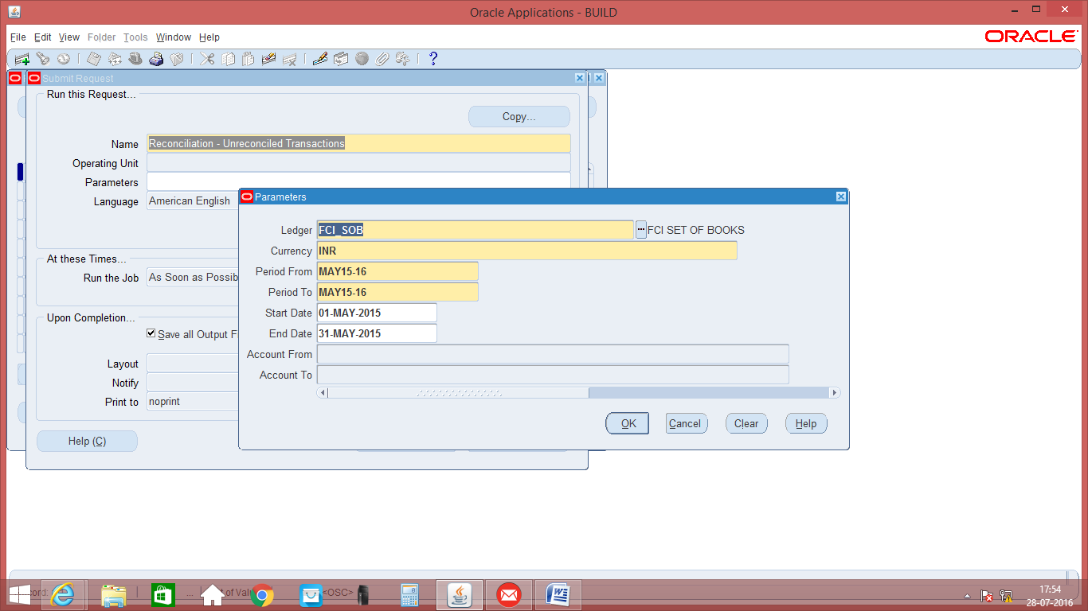
Fig: Reconciliation – Unreconciled Transaction

FCI Data Entry Report
This is a discoverer report which brings count of transactions created by users in AP, AR and GL. User needs to run FCI Data Entry Program from “FCI Support User” in order to fetch data in report. Once program is run report will fetch data for last 10 days, moreover first date (smallest date) in report will bring all transactions created till date by that user.
For e.g. As shown in below o/p for user “EA11_SE047128C” on 10 December count of 2043 means user has created these number of JE till date.

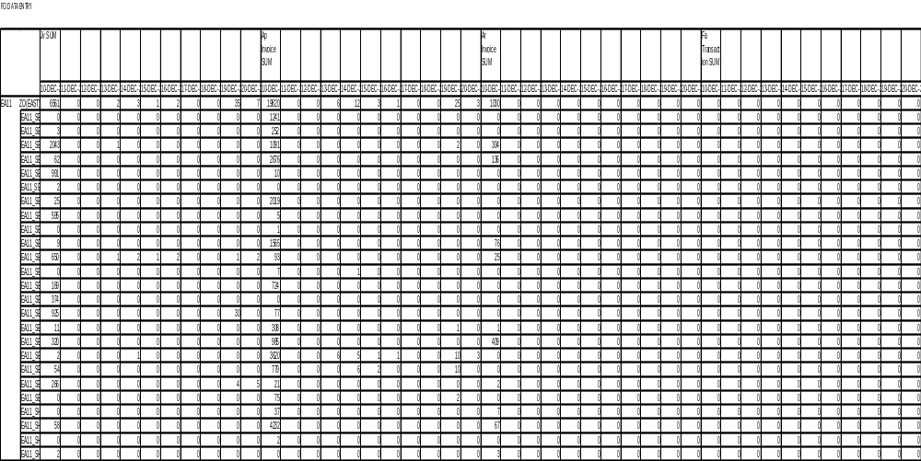

FCI Account Analysis Report

The FCI Account Analysis Report provides drill-down information about the movement on a particular account for a period or range of periods. It only includes journal entries transferred to and posted to General Ledger.It prints the journal entry lines, beginning and ending balances of the accounts you request.
As per CR-625 some changes have done in account analysis report which is oracle seeded report. Some columns have been added and some parameters are removed from report.

Existing_Account_Analysis_Report_Format:
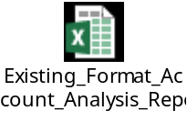

Revised_FCI_Account_Analysis_Report_Format:
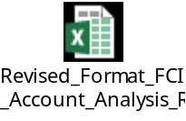
List of parameters in FCI Account Analysis report :-

S.no | Parameter name | Description |  | Optional/Mandatory
1 | Ledger / Ledger Set | Ledger set name |  | Mandatory
2 | Period From | Begin period |  | Mandatory
3 | Period To | Ending period |  | Mandatory
4 | Accounting Flex field From | Begin account range of report |  | Mandatory
5 | Accounting Flex field To | ending account range of report |  | Mandatory
6 | Balance Type | the functional currency of report |  | Mandatory
7 | Encumbrance Type / Budget Name | Encumbrance type or budget name |  | Optional
8 | Include Zero Amount Lines | To include Zero Amount lines or not |  | Optional
9 | Include Accounts With No Activity |  | To include accounts with no activity or not | Optional
Parameter’sWindow: 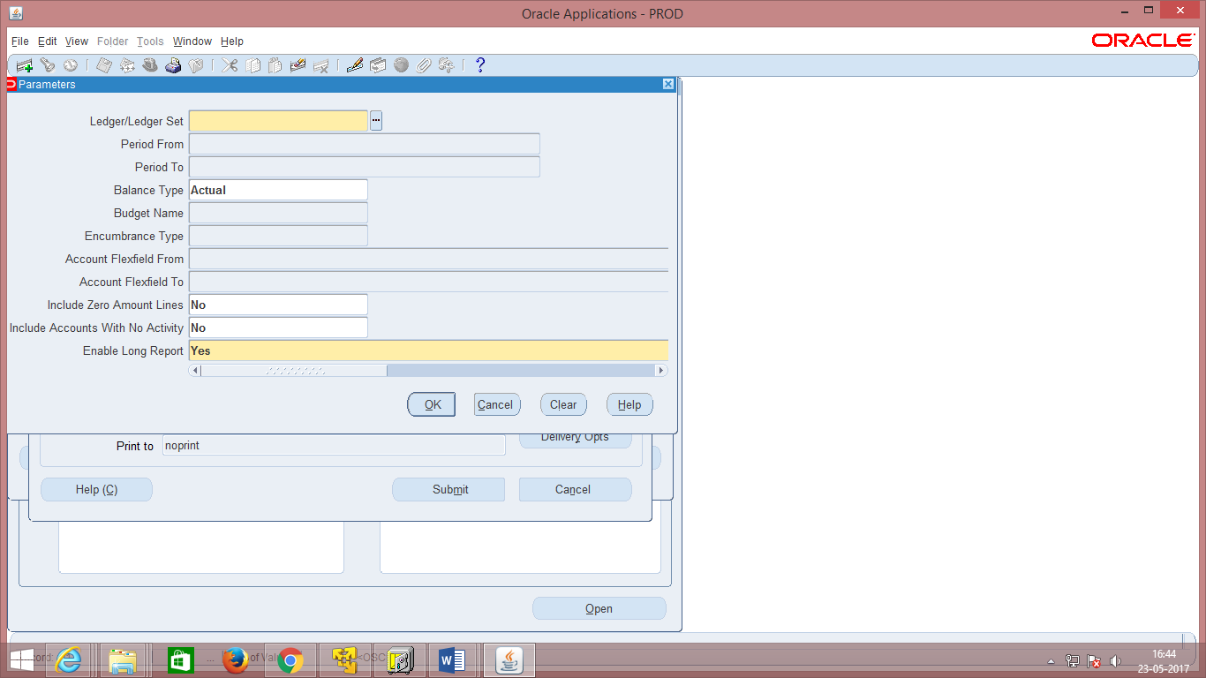
Fig: FCI Account Analysis Report Parameter’s Window

Report Output
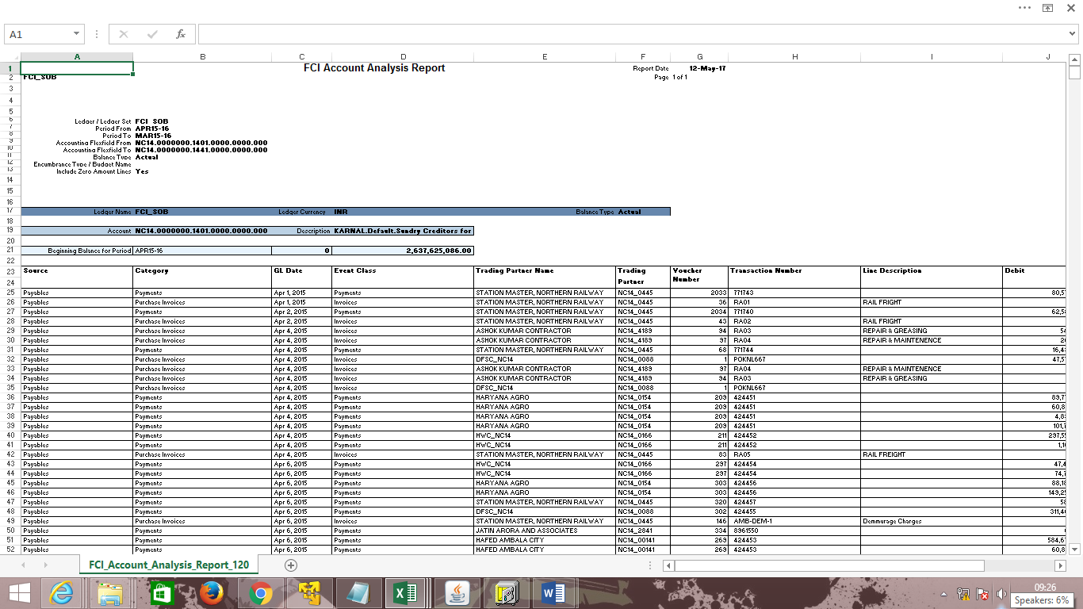
Fig: FCI Account Analysis Report

FCI Receipts and Payment Summary Report
This Report will provide the information about amount disbursed/Received through FAP based on input parameter.

- It will show the amount disbursed/received by FCI via payment method i.e. Cash and Digital (all Non-Cash transactions).
- The Output of the Report will be in MS Excel.
- It will bring the data based on creation date as entered in input parameter.
- Three input parameters – Unit code, Date from, Date to are mandatory and one input parameter “Supplier Type” has been added as optional parameter.
- Unit code will consist of LOV.
- This report will show total number and Sum of payments in AP & AR modules via payment method i.e. Cash and Digital (All Non-Cash transactions).
- This report will be assigned to FCI Audit User and FCI Support User Responsibility.

The input parameters of report are as follows:

S No. | Parameter | Description
1 | Unit Code | Can be a child and parent unit of hierarchy
2 | Date From | Creation Date of Payments and Receipts
3 | Date To | Creation Date of Payments and Receipts
Report Output:
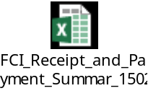

FCI Receipts and Payment Detail Report
FCI Receipts and Summary Report has been developed which will contain all the data about the amount disbursed/received through payment methods.

- The output of this report will be in MS Excel.
- This report will give the detailed information about the data disbursed/received from AP & AR in given event creation date range.
- This report is used to verify the ‘FCI Receipts and Payment Summary Report’.
- It will bring the data based on creation date as entered in input parameter.
- This report will consists of three input parameters – Unit code, Date from and Date to.
- All parameters will be mandatory and Unit code will consist of LOV and one input parameter “Supplier Type” has been added as optional parameter.
- This report will show the desired detailed information of payments done in AP and AR modules as per the format desired by FCI.
- This report will be assigned to FCI Audit User and FCI Support User Responsibility.
- The input parameters of report are as follows:

S No. | Parameter | Description
1 | Unit Code | Can be a child and parent unit of hierarchy
2 | Date From | Creation Date of Payments and Receipts
3 | Date To | Creation Date of Payments and Receipts
- The Output parameters of report are as follows :

S No. | Parameter | Description
1 | Unit Code | Can be a child and parent unit of hierarchy
2 | Module | Creation Date of Payments and Receipts
3 | Supplier Name | Creation Date of Payments and Receipts
4 | Supplier Number | It will contain Supplier/Customer number
5 | Receipt/Check Number | It will contain Receipt/Check number
6 | Receipt/Check Dates | It will contain Receipt/Check Date
7 | Bank Account Name  n | It will contain bank account name
8 | Count | Number of event on Payment/Receipt within given date range
9 | Creation Date Event 1 | Creation Date of Payment / Receipts
10 | Creation Date Event 2 | “Reversal/Voiding Date” of “Payment / Receipts”
11 | Amount | Amount of Payment or Receipt.
12 | Supplier Type | It will show the classification of supplier type.
Report Output:
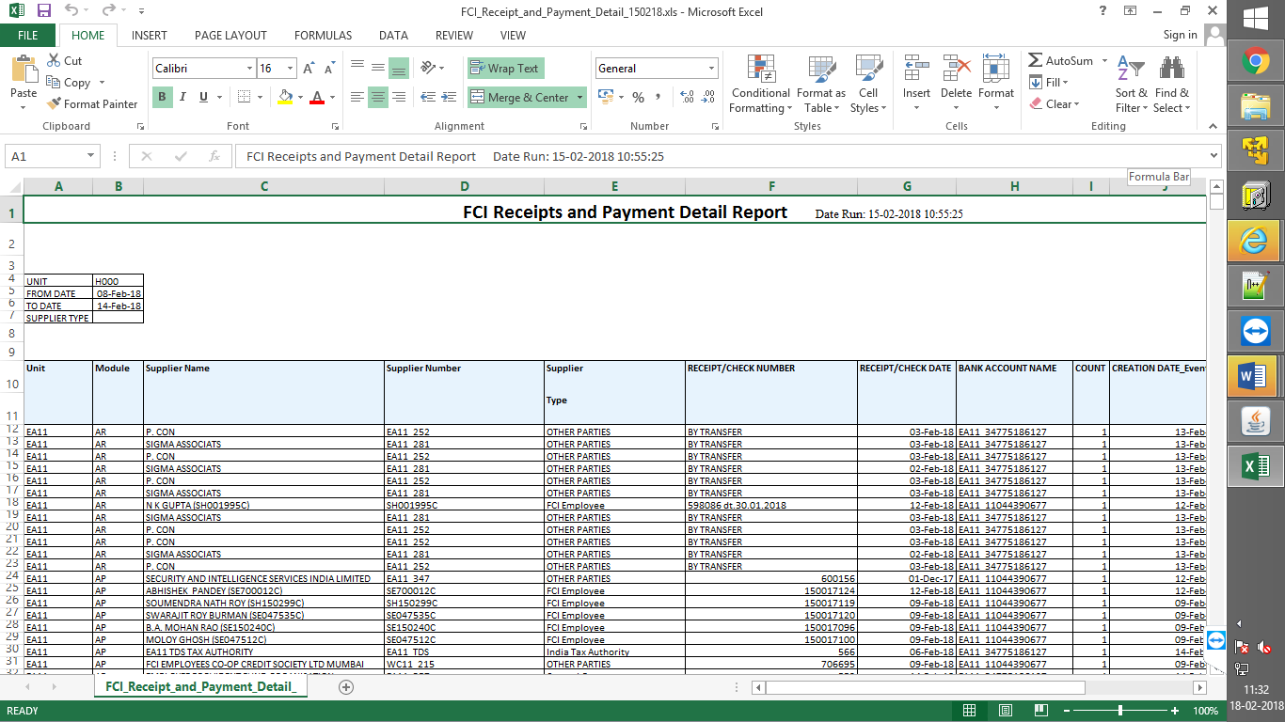

FCI Stock Ledger Summary Report for ALL products
FCI Stock Ledger Summary program will submit the 'FCI Stock Ledger Summary Report' for 'n' number of times. Here 'n' will be number of products mapped with input value as entered in product parameter.

- In “Product” parameter only 7 values will be available
- All food grains- issuable: 0101 - 0103, 0201 - 0205, 0301-0302, 0401-0402, 0501 -0506.
- All food grains- non-issuable: 1101 to 1103, 1201 - 1205, 1301-1302, 1401-1402, 1501 -1506
- All pulses- issuable: 0451-0463
- All pulses- non-issuable: 1451-1463
- All gunnies and other- issuable- 0601-0602, 0626-0627, 0902-0903
- All gunnies and others- non issuable- 1601-1602, 1626-1627
- For all Products
- Format of the output will remain same as for “FCI Stock Ledger Summary Report”.
- Output of each product will be generated separately.
- 'FCI Stock Ledger Summary Report for ALL products’ program will be available FCI General Ledger user, FCI audit user and FCI support user.
- Product- Request ID mapping will be displayed in the log file of the submitted Program.

FCI GST Inward Supply Register
- Report covers all the aspects important for filing GST returns and for analysis before filing returns. Report can be run using the respective Account Payables responsibility.
The input parameters are:

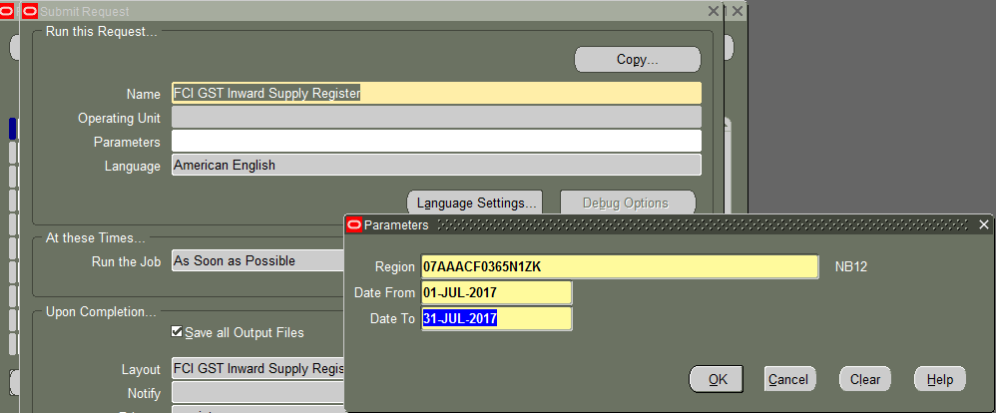
Sl. No. | Parameter | Description
1 | GSTIN Number | On the basis of Unit GSTIN Registration
2 | From Date | Date Range From (Period start for which report has to run e.g. ‘01-JUL-2017’)
3 | To Date | Date Range To (Period End for which report has to run e.g. ‘31-JUL-2017’)

Sample Output File Snapshot: The output of this report will be in excel format
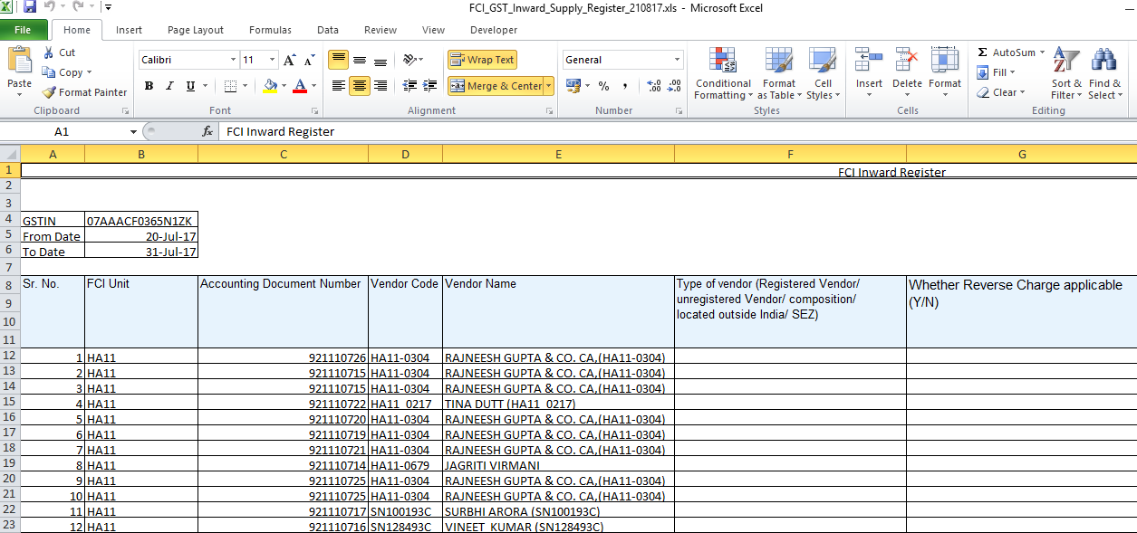

Sample Output File:
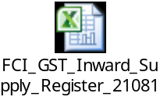

FCI GST Outward Supply Register
- Report covers all the aspects important for filing GST returns and for analysis before filing returns. Report can be run using the respective Account Receivables responsibility.

The input parameters are:
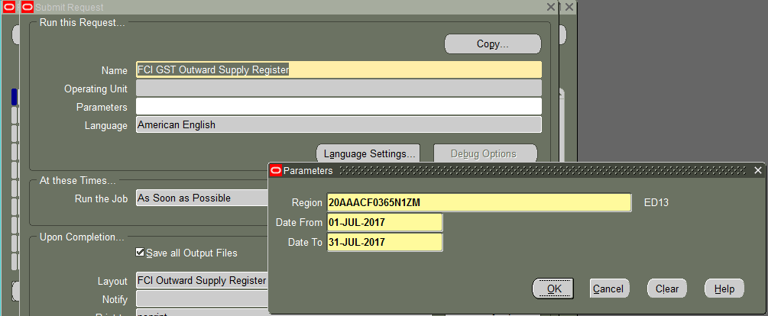

Sl. No. | Parameter | Description
1 | Region | On the basis of Unit GSTIN Registration
2 | From Date | Date Range From (Period start for which report has to run e.g. ‘01-JUL-2017’)
3 | To Date | Date Range To (Period End for which report has to run e.g. ‘31-JUL-2017’)

Sample Output File Snapshot: The output of this report will be in excel format
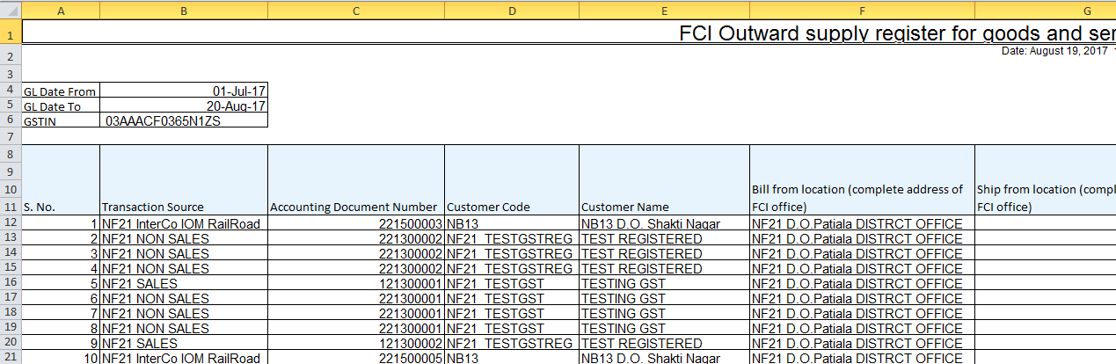

Sample Output File:

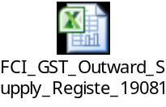

FCI Journal Voucher Detail Report
Journal Voucher Detail report runs on unit hierarchy to bring JE line details like amount, status etc. The report is helpful in identifying amount booked by user in different account code combinations in JE Line.
Input Parameters:
Parameter Name | Type | Description
Unit Code | Mandatory | This is the Balancing segment at Journal line level.
From Period | Mandatory | Starting period parameter.
To Period | Mandatory | End Period Parameter
Category | Optional | Category of JE
From Amount | Optional | Smallest amount used in Journal Line
To Amount | Optional | Largest amount used in Journal Line
From Document No | Optional | Starting Document Number
To Document No | Optional | Ending Document Number

Output Parameters:
Serial No. | Parameter Name | Purpose
1 | Journal Category | Journal Category of the JE line.
2 | Batch Name | Name of Batch for the JE Line
3 | Journal Name | Journal Name which belongs to the JE Line.
4 | Document Number | Document Number for the JE Line
5 | Account Combination | The code combination used at JE Line
6 | Description | Description of JE Line
7 | Amount (dr) | Amount on JE Line in debit.
8 | Amount (cr) | Amount on JE Line in credit
9 | Status (Posting/Reversal) | Status of JE either Posted or Reversed only.
10 | Reversal Period | Period of reversal if exists.
11 | Created By | Username of creator of JE
12 | Updated By | Last Updated by Username

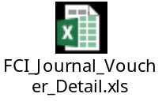

FCI Comparative Analysis Report
The report brings closing balance for same period of two corresponding financial years for a combination of inputs provided by the user. It can be used to perform comparative analysis of closing balances between the same periods of two corresponding financial years.
• The report will bring this data in the form of row wise combination of FCI account, FCI product and FCI scheme values.
• If for a particular combination of account, product and scheme no balances exist for current or previous financial year, then the balance will reflect as zero.
• The report is available with following responsibilities:
General Ledger User Responsibilities
FCI Support User
FCI Audit User

Report Parameters:
Input Parameter | Description | Mandatory
Unit | Hierarchy basis | Yes
Account Type | Expense/Revenue/Asset/Liability/etc. or Skip for All | No
Period Name | Period name | Yes
Balance Type | YTD or PTD | Yes
Account From | From accounting code combination except Unit segment | Yes
Account To | To accounting code combination except Unit segment | Yes
Report Format:
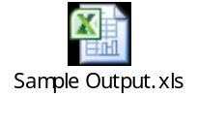

EXPORT THE REPORT OUTPUT IN EXCEL FORMAT
- Save the file in the Browser as a text file.

- Edit the saved file to remove the Report headings. You can leave the column headings.
- Save the edited text file.
- Start Excel (Tested with Microsoft Excel 2000 9.0.6926 SP3)
- Choose Open and select the edited text file
- Allow the text import Wizard to run(This might not be your default option)
- In Step #1 - Choose ¿fixed Width¿ and the Row to start at. Click Next
- In step # 2 uses your mouse to drag the column indicators. You can add and remove columns here. Click Next

- In Step #3 choose the data type of each column. You can omit columns here. Click Finish to import

- Columns will appear as standard width but you can adjust within the spreadsheet by dragging the column markers. The data will be correctly sized.

- Modify and save

Super User Activities - Journal Import
Function Path: Journals >> Import >> Run
This function has to be run for importing into GL the transactions which have been entered in the subledgers.
Steps:
- Enter the Source from where you want to import the journal entries for the transactions.
- Enter the selection criteria, if the source being entered groups the entry created by it by group ids then enter all group id or if you want to import journal entries of a particular group id then give the specific value for that group id. For this in the Selection Criteria as Specific Group Id and the Specific Value would be shown as an LOV.
- Click on Import Button
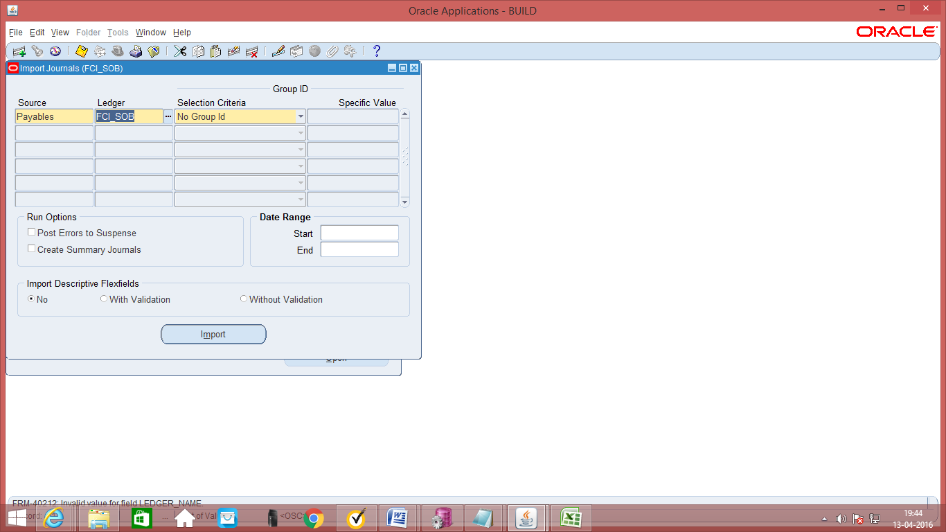

Journal Entries will have to be imported from other modules like AP, AR.
In the receivables module, Journal entries will be imported under the
Source: Receivables and
Categories like Sales Invoices, Trade Receipts, Misc Receipts, Credit Memos, Credit Memo Applications, Debit Memos, and Debit Memo Applications.
The description of the imported journals gives the details like the Receipt numbers etc. Line Drilldown button is available at the bottom right hand corner of the Journal to show the specifics of the transaction being imported.
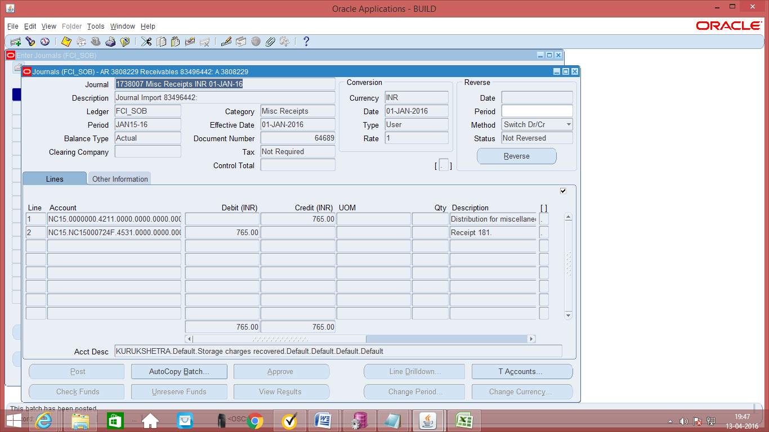
In the payables module, Journal entries will be imported under the
Source: Payables and
Categories like Purchase Invoices, Payments.
The description of the Purchase Invoice journals gives the details like the Voucher numbers etc.
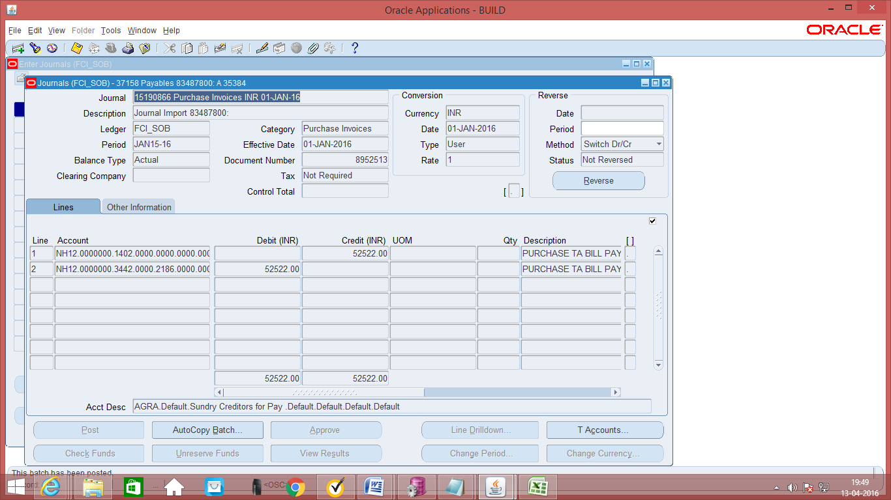

The description of the Payments journals gives the details like the Document sequence numbers etc. In AP also, Line Drilldown button is available at the bottom right hand corner of the Journal to show the specifics of the transaction being imported.

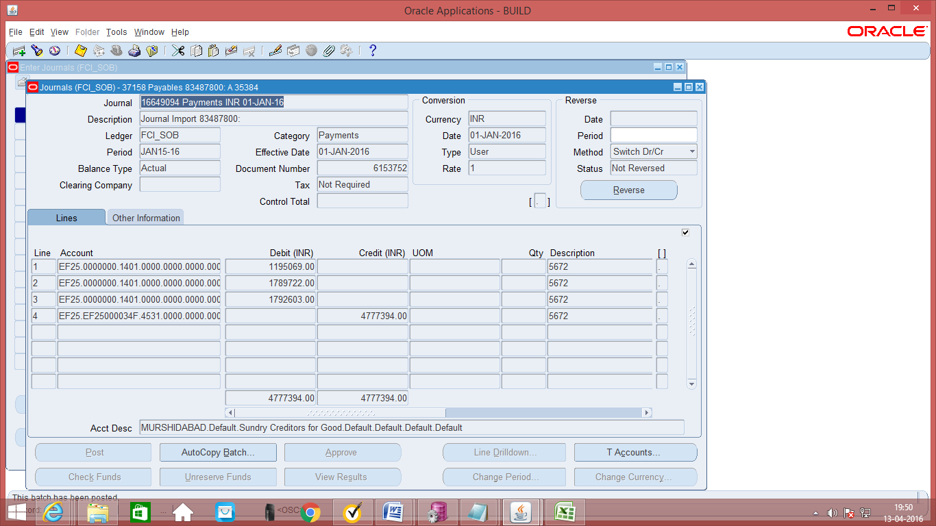

Super User Activities - Open/ Close Accounting Periods

Function Path: Setup >> Open/close
Steps:
- Click on Open Next Period to open the next period.
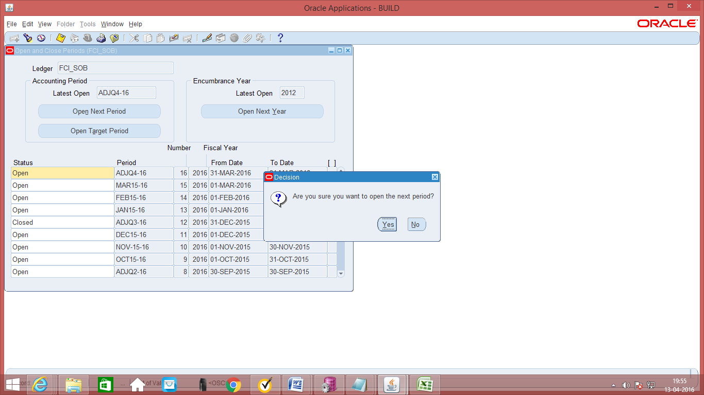
- Click on Status where the period is open and you want to either close it or permanently close it. Don’t close a period permanently because it is irreversible. If you close a period, then you can reopen it, if required.
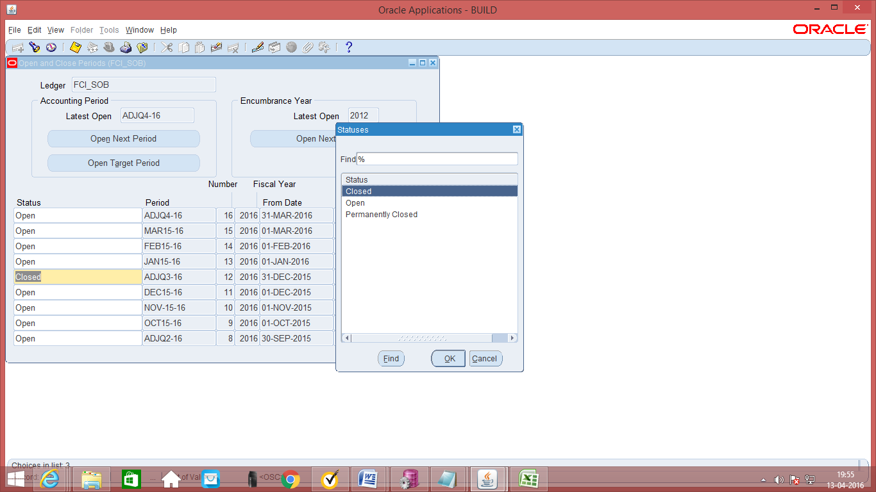

Custom Closure of periods
Customizations have been added in the system for opening and closing of periods. Periods will be opened and closed separately for all units.
Also, only HQ will handle opening and closing of periods. Units will have to contact HQ for getting any period opened or closed.

The period will not be closed until and unless all the entries are posted. Once a period is closed users will neither be able to perform any operation on the journals of closed period, nor will they be able to create any entries in closed period. Only the following could be done in closed period:
- After the closure of period, users will only be able to reverse the journal entries, on the date of open period.
For Example: A journal entry of closed period (say March 2012) can be reversed on the date of April (April as open period.)
In case a custom closed period needs to be opened, the provision has been provided to HQ. Units will have to contact HQ for the same.
- 5 Adjustment period will be provided in custom close 4 are quarter Adjustments and 1 is year adjustment period.
- Period names will be added to Status of custom period closure.
- Custom closure functionality will be provided to zones (SA11, EA11, FA11, NA11, WA11, HA11) also for their own period closure, Currently Regions have access to close their own units and underlying Districts , Support team have the access to close any unit in FCI.
NOTE: In addition to FCI Support team having access to close any unit in FCI. Users posted at SB11 (RO Heydrabad ) have access to close all the units of SF region i.e, SF11, SF12, SF13, SF14, SF15, SF16, SF17 and SF18 (Via CR 792).
- Adjustment period closure process has to submit same as main periods sequentially with other periods.

FCI Sub ledger Exception Report:

This report lists all accounting events and journal entries that fail period close validation. This report helps in resolving exceptions quickly so that exceptions are not left to slow down the period-end close. Custom Period Closure automatically submits it. If there are unprocessed accounting events or non-transferred journal entries user need to take action.

Since this is, a wrapper process user need to clear first exceptions presented in:
- FCI Custom Period Closure Report - Auto invoice & Interface.
- FCI AP Custom Period Close Execution Report
- FCI GL Period Closure Execution Report
- FCI AR Period Closure Exception Report

If still any unprocessed data is there in FCI Sub ledger Exception Report, user should analyse the transaction and get it cleared too.

Role creation and assignment of roles to users

For using this functionality, please login using ‘User Management’ responsibility, and with a user who has system administrator privileges.

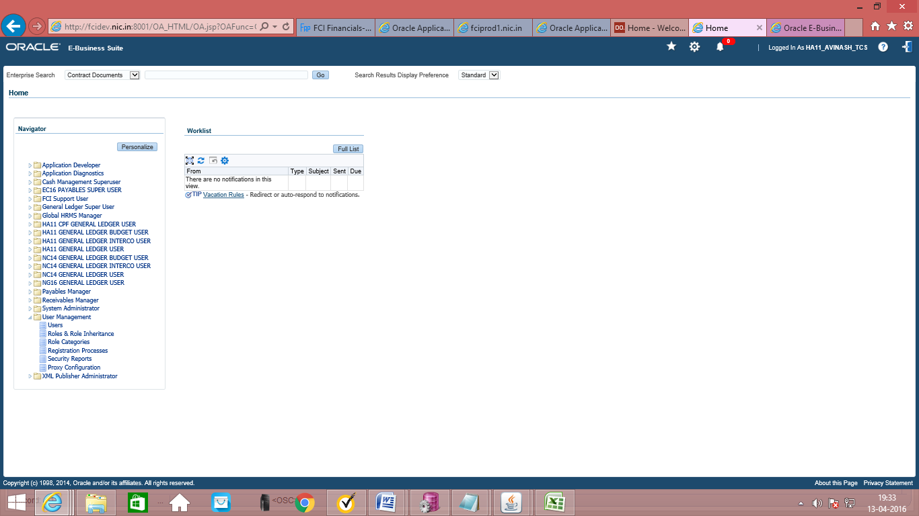
User Management Responsibility Main menu

41.1 Creation of Roles

- For creation of roles, go to ‘Roles and Role Inheritance’ Form:

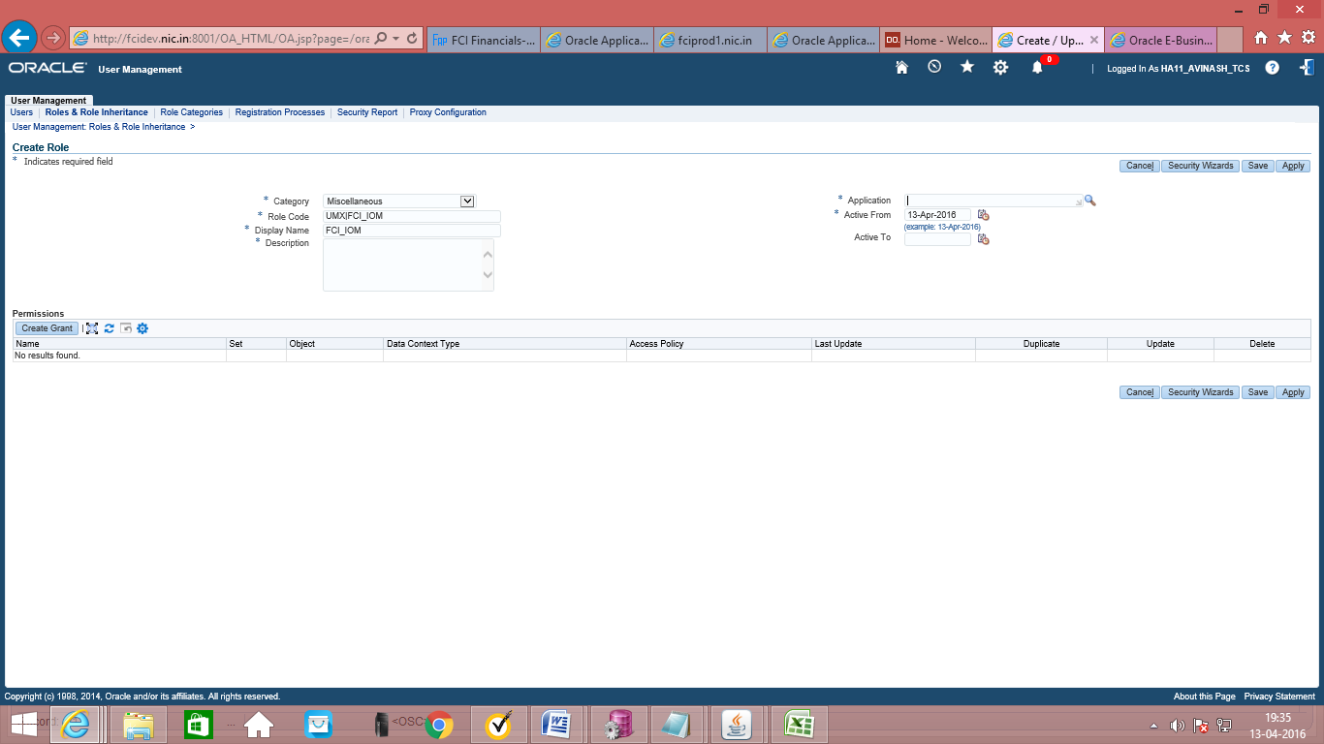

- Select Miscellaneous in category, Application Object Library in Application, Give Role code, name and description and click on the SAVE button.

41.2 Assignment of Users to Roles

- Navigate to the Users tab.
- Search the user using the last/ first name.
- Click on Update link.

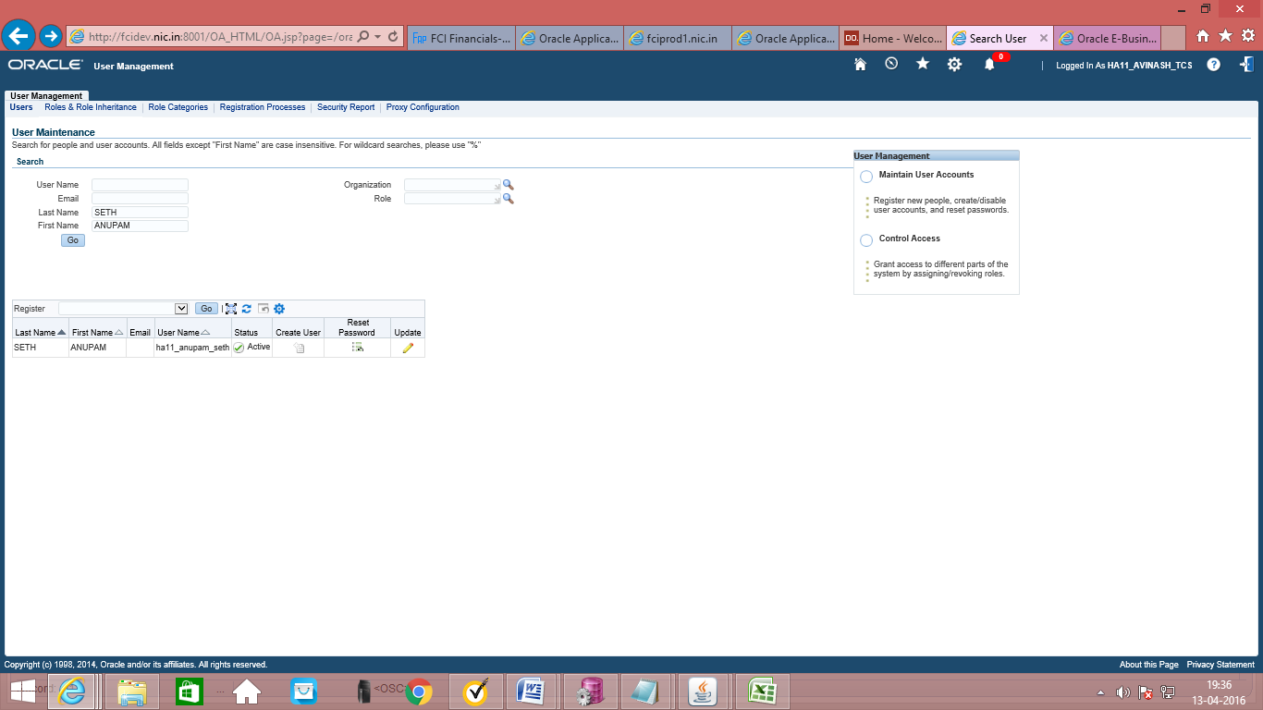

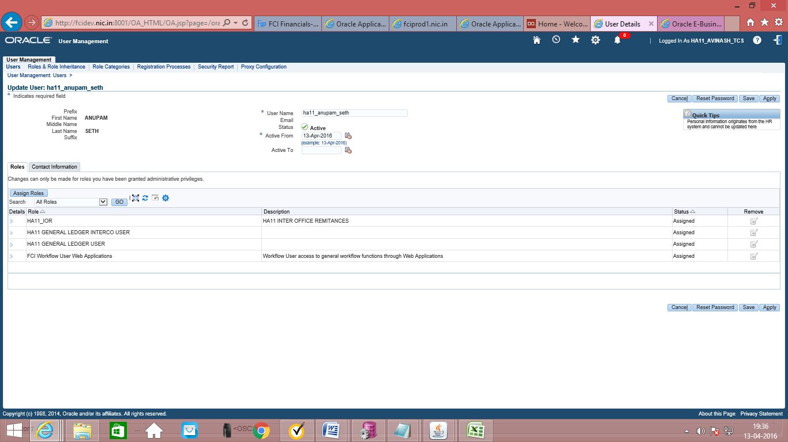
- Click on Assign Roles button.
- Search for the Role, and select it. Write some text in justification. And click on save button.

The user has been assigned the role. Now, whenever a notification is sent to the role, the user will receive it. A role can be assigned to multiple users.

41.3 Solution For NO ROLE FOUND PROBLEM

- Sometime when we try to approve a journal entry received through role.
We got an error message that <<NO ROLE FOUND>>.

- To approve such type of journals please click reassign tab.
And following screen will come.

- Now as shown in previous fig. click delegate button
And fill the person name, or id of any other Super User in your Unit.

- Now This Notification is transferred to that person.
And from the Id of that person This Gl entry can be approved.

Summary Template

General Ledger uses summary templates to create summary accounts, whose balances are the sums of multiple detail accounts.
Prerequisites
• Account segments are defined
• Rollup groups are defined
To define a new summary account template:
- Navigate to the Summary Accounts window.
- Enter a Name for the summary account template.
- Enter the Template.
- Enter the Earliest Period for which General Ledger has to maintain the actual, encumbrance and budget summary account balances. General Ledger maintains summary account balances for this accounting period and for subsequent periods.
- If budgetary control is used then, set the budgetary control options for the summary template.
- Save the work. General Ledger submits a concurrent request to add the summary accounts, and displays the Status of your summary template.

Current: The summary accounts are active.
Adding: The concurrent request to create summary accounts is pending or running.
Deleting: The concurrent request to delete summary accounts is pending or running.

Entering Summary Account Templates
Summary account templates are entered to create summary accounts. General Ledger uses the templates in combination with parent segment value definitions to create summary accounts.

To enter a summary account template:

From the Summary Accounts window, enter the summary account Template using one of the following values for each segment:

D: The template creates and maintains a summary account for every detail segment value. This value creates the most summary accounts of any template value.
Note: General Ledger will not allow defining a summary account template using only D template values.

T: The template creates and maintains a summary account that sums balances of all detail segment values. This value creates the fewest summary accounts of any template value.
Note: Do not define a summary account template using only T template values. A template using T values for every segment will have a zero balance if the general ledger is in balance.

Rollup Group Name: The template creates and maintains a summary account for each parent segment value assigned to the rollup group which is specified. The more parent segment values in a given rollup group, the more summary accounts the template creates.

GOODS AND SERVICES INCLUSION IN GENERAL LEDGER (AS PER PLAN B)

Introduction of a new category and new DFF fields at JE Line Level.
For some of the journal categories, new DFF fields are provided at JE Line Level and user will enter the details in DFF for each line.
Journal Categories where DFF is required: -
- IOM Within Same Unit
- InterCo IOGA
- InterCo IOM RailRoad
- Paddy Milling
- Trf In Stocks Recvd
- Unconn/Missing Wagon
- Transfer of Assets (New category)

Following are the new DFF fields (exempted & taxable) in manual Journal Entry:
- From GSTIN (LOV from value set "FCI_Unit”)
- To GSTIN (LOV from value set "FCI_Unit”)
- HSN of the goods
- Place of supply (LOV)
- Tax Rate (LOV)
- Future

Below mentioned are the steps to create a Journal:
Function Path: Normal General Ledger responsibility>> Journals >> Enter >> New Journal.
1. Category: Trf In Stocks Recvd
1. To create a new manual journal entry, click on new journal in the find journals window.
2. Journal Name: Leave the Journal name blank. It will automatically take the system date and time as Journal name.
- Period: Enter the Period, effective date. Adjusting periods are available at the end of each quarter and year beginning with ‘ADJ’
- Currency: Enter currency details. The currency will be ‘INR’.
- Category: Enter the category as ‘Unit name (eg SB16, WD12) Trf IN Stocks Recvd’

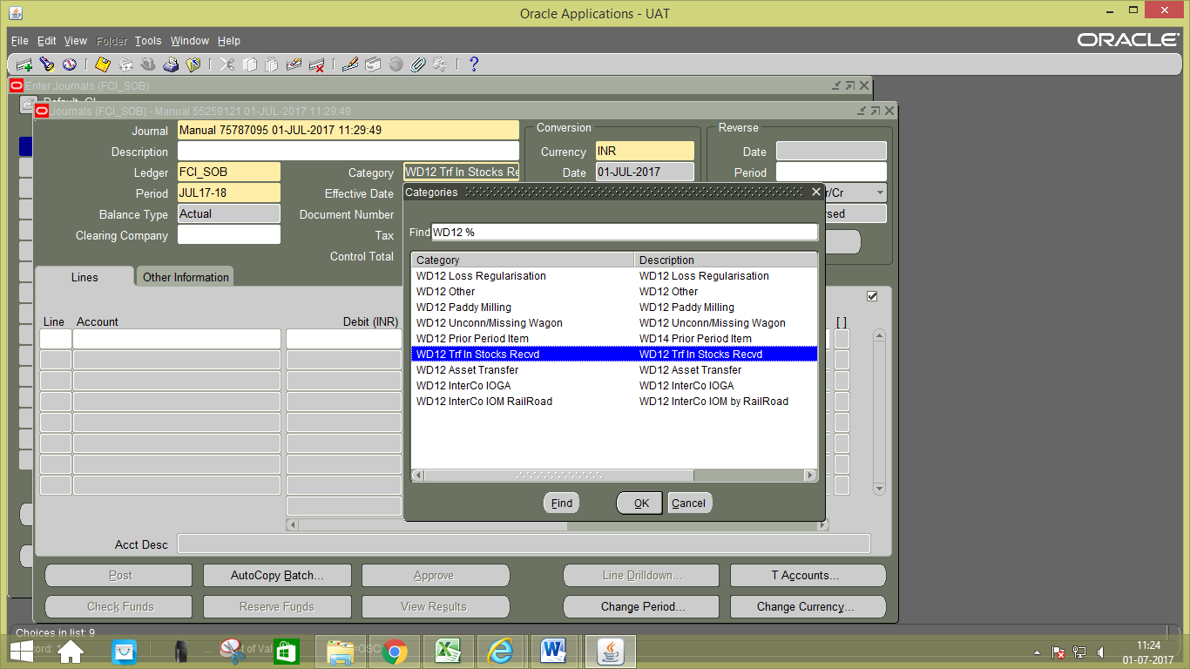

- Data entry in the Header Level DFF (Descriptive Flex field): On clicking the DFF symbol, fields to capture the following fields will appear to capture the Railway Receipt number and the Railway receipt number quantity. From account and Depot from which the stock has been received has to be also entered.
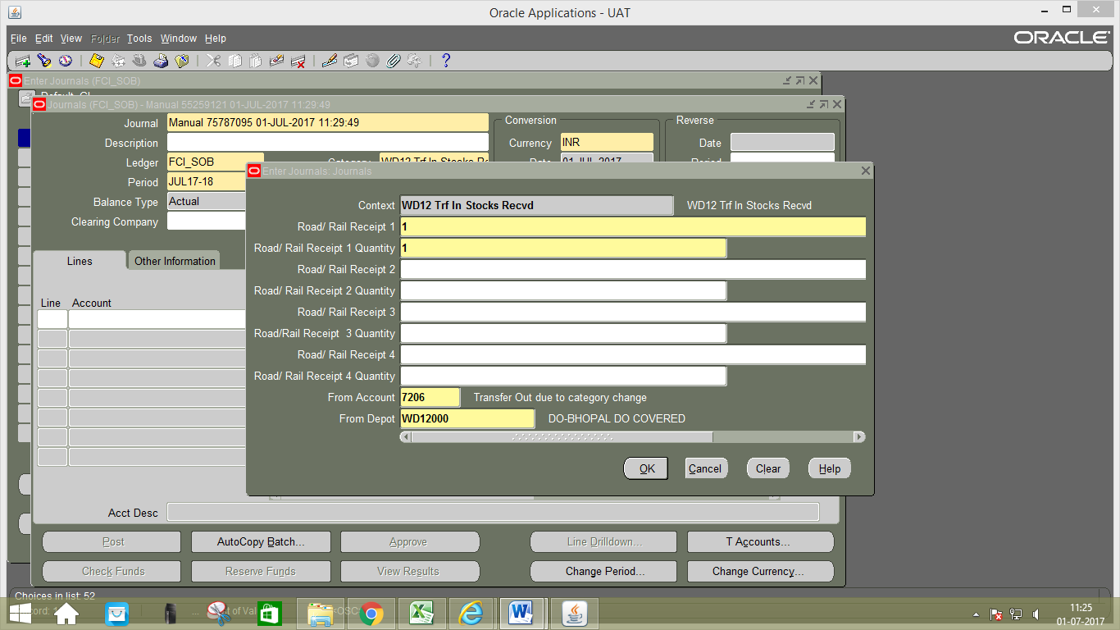
- Data entry in the Line Level: Enter the JV in the lines.In the Line Number column of the Journal Entry, the numbering to be followed is in series of 10, i.e. numbering would be 10, 20, and 30 and so on.
- Line Level DFF (Descriptive Flex field): New DFF fields are provided at JE Line Level and user will enter the details in DFF for each line. Otherwise system will prompt an error message and would not allow user to proceed unless details in DFF are filled.
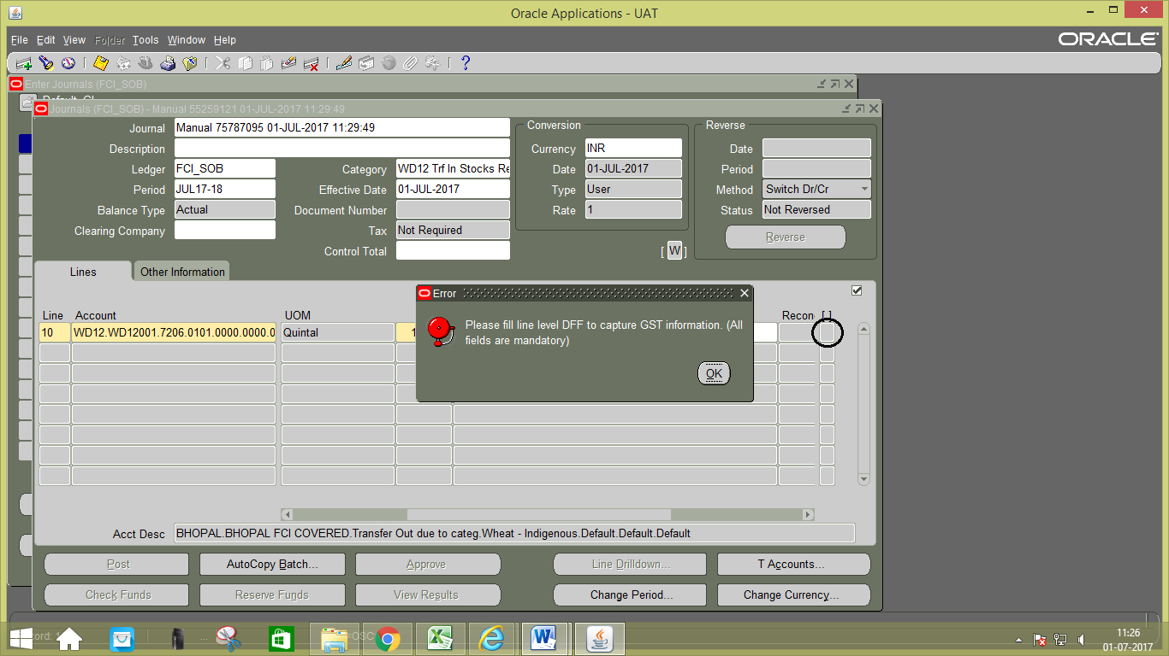
Fill the details in DFF at line, click on OK.
From GSTN: Enter the unit from which stock is transferred.
To GSTN: Enter the unit to which stock is transferred.
HSN code: Enter the HSN code of the product transferred.
Place of supply: Enter the place where stock is supplied.
Future: It is mentioned for future use.
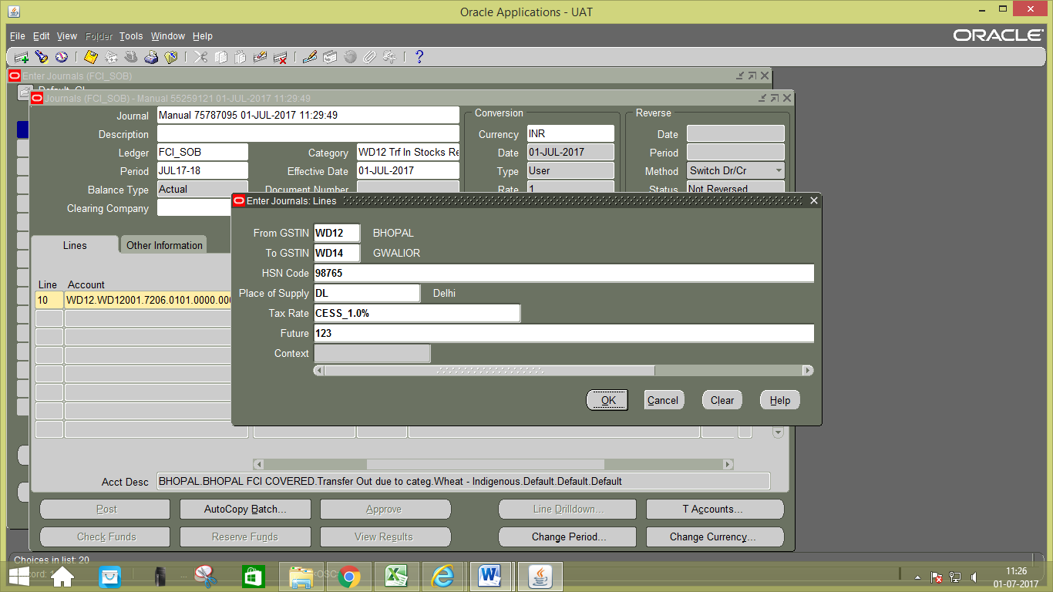

Fill the details in DFF at line 2.
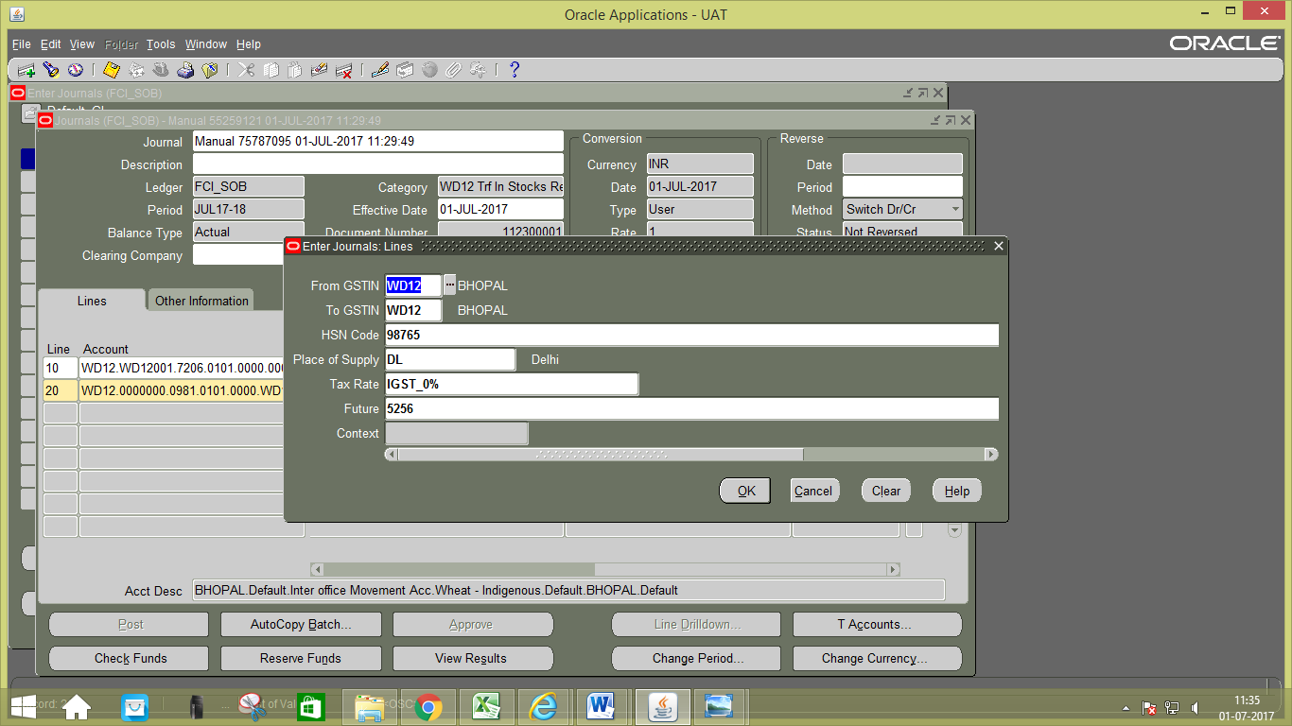

- Save you work.
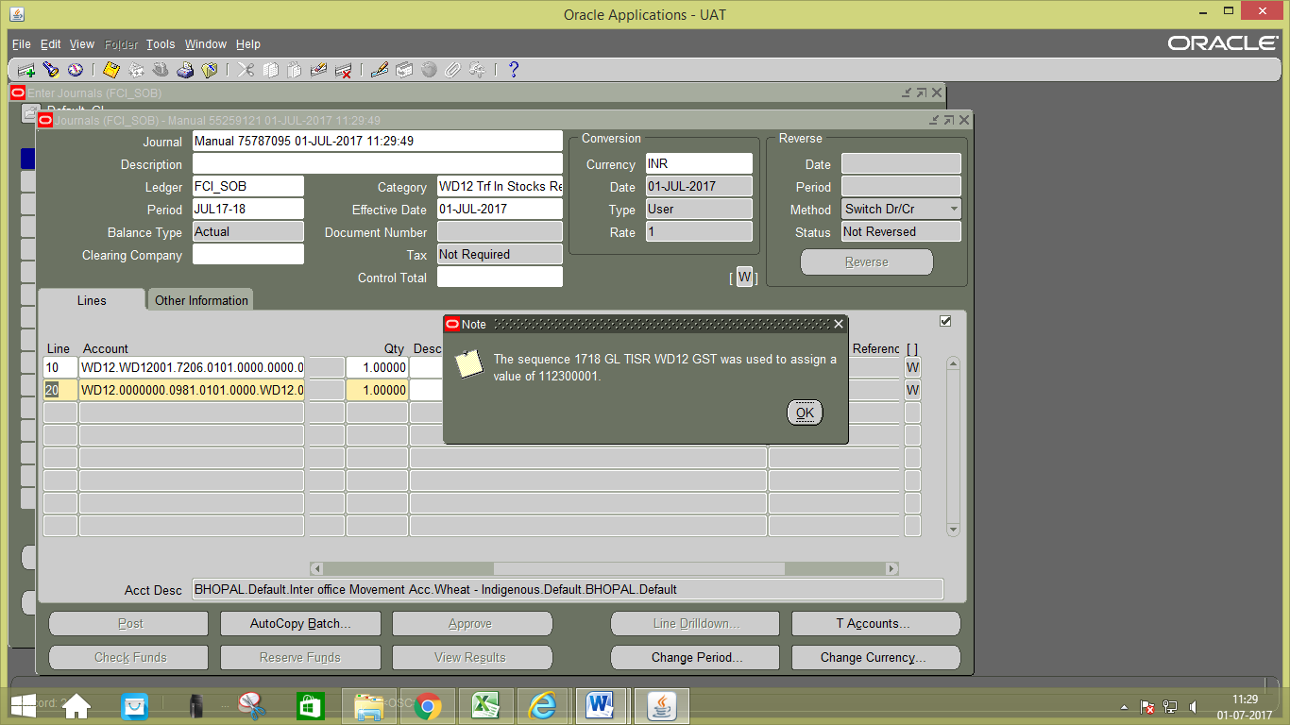

2. Category: Transfer of Assets.
Transfer of Assets is the new category which is introduced in GST.
- To create a new manual journal entry, click on new journal in the find journals window.
- Journal Name: Leave the Journal name blank. It will automatically take the system date and time as Journal name.
- Period: Enter the Period, effective date. Adjusting periods are available at the end of each quarter and year beginning with ‘ADJ’
- Currency: Enter currency details. The currency will be ‘INR’.
- Category: Enter the category as ‘Unit name (eg SB16, WD12) Asset Transfer’
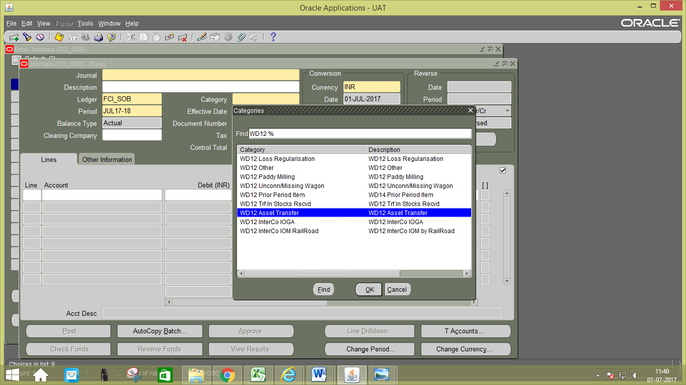
- Data entry in the Line Level: Enter the JV in the lines.In the Line Number column of the Journal Entry, the numbering to be followed is in series of 10, i.e. numbering would be 10, 20, and 30 and so on.
- Line Level DFF (Descriptive Flex field): Entering details in DFF is mandatory for each line. Otherwise system will prompt an error message and would not allow user to proceed unless details in DFF are filled.
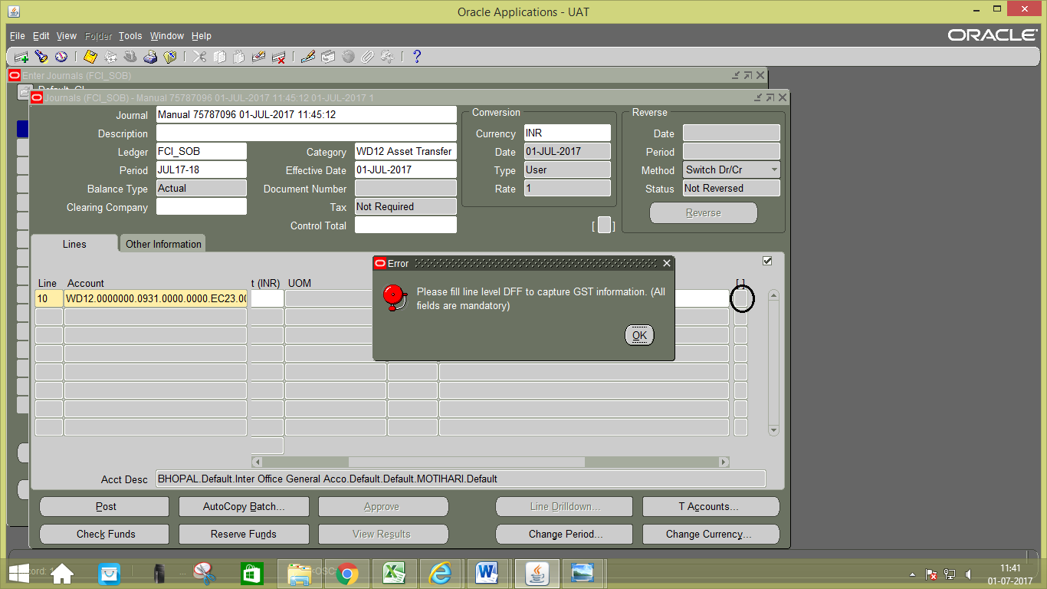
Fill the details in DFF at line1, click on OK.
From GSTN: Enter the unit from which asset is transferred.
To GSTN: Enter the unit to which asset is transferred.
HSN code: Enter the HSN code of the product transferred.
Place of supply: Enter the place where asset is supplied.
Future: It is mentioned for future use.
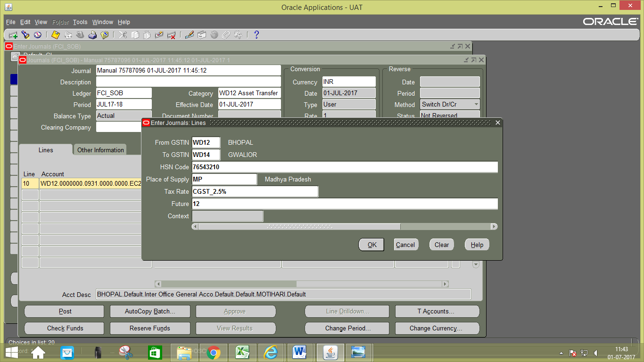

Fill the details in DFF at line 2, click on OK.
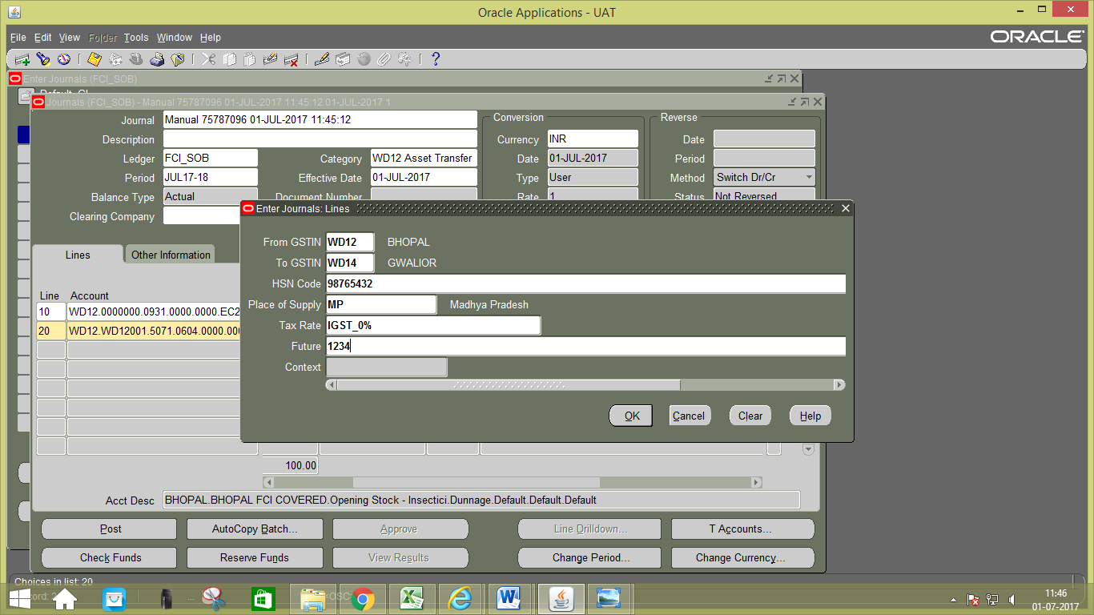

- Save your work.
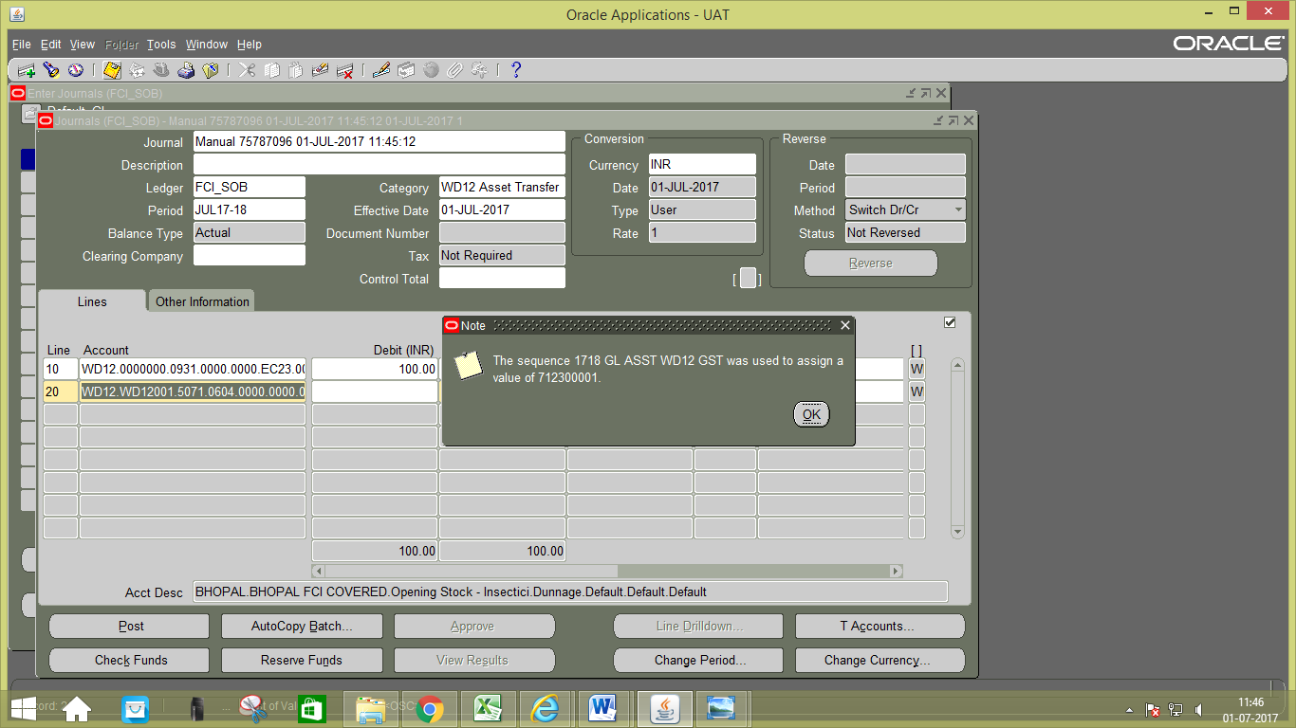

Appendix 1: List of Accounts for which Unit of Measure is allowed
Account | Unit Of Measure | Account Head
7261 | Quintal | Transit Losses - recovery effected Quantity
7271 | Quintal | Storage losses due to post landing at ports Quantity
7272 | Quintal | Storage losses due to shortage in storage Quantity
7273 | Quintal | Storage losses due to fire, natural calamities etc. Quantity
7274 | Quintal | Storage losses due to theft/pilferage Quantity
7275 | Quintal | Storage losses due to misappropriation Quantity
7276 | Quintal | Storage losses due to dumping Quantity
7277 | Quintal | Storage losses due to cleaning operations Quantity
7278 | Quintal | Storage losses due to physical verifications Quantity
7285 | Quintal | Storage losses on Millers/Agents/Storing agencies A/c for which claims lodged Quantity
5061 | Quintal | Opening Stock Quantity
5161 | Quintal | Purchases Quantity
5701 | Quintal | Sales Quantity
7111 | Quintal | Transfer In against invoices received Quantity
7121 | Quintal | Transfer In due to re organsiation of District Quantity
7131 | Quintal | Transfer In - Stocks received after conversion Quantity
7141 | Quintal | Transfer In due to reclassification of variety Quantity
7151 | Quintal | Transfer In due to category change Quantity
7166 | Quintal | Transit Gains - Withtin region Quantity
7171 | Quintal | Transit Gains - Within zone Quantity
7176 | Quintal | Transit Gains - Outside Zone Quantity
7181 | Quintal | Voyage Gain - on ship movement Quantity
7182 | Quintal | Voyage Gain - on steamer movement Quantity
7191 | Quintal | Storage Gain - on FCI Account Quantity
7192 | Quintal | Storage Gain - on stocks passed on by State Govt./ procuring agencies FCI Account Quantity
7201 | Quintal | Transfer Out for stocks despatched Quantity
7202 | Quintal | Transfer out for diverted stocks Quantity
7203 | Quintal | Transfer Out due to re organisation of District Quantity
7204 | Quintal | Transfer Out - Stocks issued for conversion Quantity
7205 | Quintal | Transfer Out due to reclassification of variety
7206 | Quintal | Transfer Out due to category change Quantity
7211 | Quintal | Internal consumption Quantity
7226 | Quintal | Voyage Losses - on ship movement Quantity
7227 | Quintal | Voyage Losses - on steamer movement Quantity
7231 | Quintal | Transit Losses - Missing wagon Quantity
7241 | Quintal | Transit Losses other than missing wagon - Within region Quantity
7242 | Quintal | Transit Losses other than missing wagon- Within zone Quantity
7243 | Quintal | Transit Losses other than missing wagon- Outside zone Quantity

As per CR-678 to enable correct entry in the system following security has been applied for the accounts listed in the file attached below:

  - For Account Heads which are marked as SLS Type-Sales(S): Allowed for use in AR Module only.
  - For Account Heads which are marked as SLS Type-Purchase (PU): Allowed for use in AP Module only.
  - For Account Heads of 52 Series: Allowed for use in AP Module only.

The accounts listed below are not allowed to use in GL module.

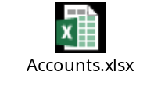

To change NA11 for ZCC Account (40637198512) of Zonal Office(NA!!) instead of existing practice i.e. HA11.
FCI wants that North zone should also follow the same practice of IOR which is being followed in other regions. I.e. units from North Zone should be allowed to send IOR to ZCC Account (40637198512) of North Zone (NA11) only and vice versa.
Also, HC11 should also send it’s IOR to NA11 only and vice versa.

Following solution got implemented:
The existing check on the journal entry workbench in general ledger module modified as per following requirements:
- Units from North Zone allowed to send IOR to NA11 (ZCC Account 40637198512) only and vice versa.
- HC11 allowed to send IOR to NA11 only and vice versa.
- HA11 can send IOR to all ZO’s and units starting with ‘H’ except for HC11 and vice versa.
- RO Punjab and RO Rajasthan can no longer send IOR’s to the units starting from ‘N’ and HA11 or vice versa.
- All the units under a particular ZO can send IOR to their respective ZO’s only and vice versa.

allow Product Codes of fortified rice i.e. 206 to 209 in J.E. Category "Paddy Mill - Rice in".
There are need to allow product Code 206 to 209 in J.E category PADDY MILL-RICE IN. Following are the details-
- For Modification of Dependent Product under HOA 7131- Transfer In - Stocks received after conversion.
- Addition of Dependent Product (0206-0209) to dependent unit Code for Account Code 7131.
as per below template
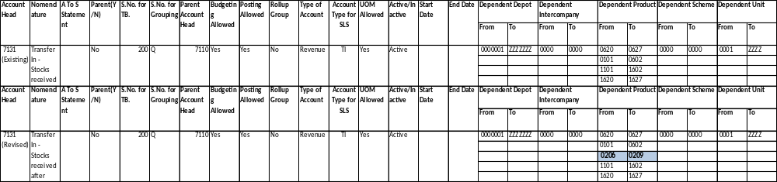

Generation of QTD ( Quarter to Date) Balance Report.
Generation of “FCI Consolidated Trial Balance” , ”FCI Trial Balance Detail With Document Sequence” reports for QTD(Quarter-to-Date) Balance type .
- In “FCI Consolidated Trial Balance” and “FCI Trial Balance detail with document sequence” in existing “Balance Type” input parameter name is added one more value as “QTD(Quarter-to-Date)” type. “QTD(Quarter-to-Date)” value in Balance type parameter will be taken by user to run report for "QTD (quarter -to-Date).
- In “FCI Consolidated Trial Balance” and “FCI Trial Balance detail with document sequence” logic is added in report to generate “QTD(Quarter-to-Date)” Balance type.

modify “FCI Profit And Loss Annexures” and “FCI Balance Sheet annexures”

Modify “FCI Profit And Loss Annexures” and “FCI Balance Sheet annexures” by creating some new groups and splitting some existing groups in to new groups.
Following are the approach followed to implement these changes –

- Some existing groups from PNL and BS mapping are modified to create new groups based on specified combination of account; product and scheme as specified by FCI.
- The mapping for all the reports that use BS/PNL mapping as source is updated as well.
- The mapping of the groups and structure of the reports “FCI Profit And Loss Annexures” and “FCI Balance Sheet annexures” are modified as per the revisions specified by FCI.

